Four Creeks
Elementary
Technology Skills for Smarter Balanced Assessment



Smarter Balanced Overview:

The Smarter Balanced Assessment assesses students in English Language Arts (Reading, Writing, Listening, and Research) and Mathematics. The ELA and Mathematics assessment will each have two parts. These parts consist of CAT Test (Computer Adaptive Test) and a Performance Tests.

CAT Test (Computer Adaptive Test)
- Item Types:
  - Selected Response (Multiple Choice)
  - Technology-Enhanced/Enabled Items
  - Short Constructed Response

- Performance Task

There are several technology skills that can be taught to better prepare students for the Smarter Balanced. These skills include:
- Keyboarding
- Mouse Skills
- Navigation
- Drag & Drop

Recommended Teacher Prep for SBAC
- You’ve already started! The best way to prepare your students is by making sure you have shifted to the mathematics and ELA practices outlined in the CCSS so that what they are tested on is aligned with their instruction.
- Include technology-rich instruction that teaches students the digital skills they need to be successful on the test and allows them to practice these skills.
- Use the practice and training tests and released items with students to help them be familiar with the types of test items and the computer platform so they are prepared for a test that is very different from tests they’ve taken in the past. Model how to approach problems and how to use the tools.
- Try out some interim assessments with students (when they become available).
- Be a cheerleader for the test. We need them to have buy-in, and they take their cues from you!

Recommended Lesson Schedule:

Each SBAC Tech Skills lesson should be 20 minutes in length. You can check the student's understanding and mastery of this skill by asking the three guiding questions provided in each lesson. The following activities target these technology skills, and whenever possible align with the ELA and/or Math CCSS.
- Introduction by teacher/lab assistant about the day’s activities and expectations
- Keyboarding activity (15 minutes)
- Lesson (20 minutes)
  - Mouse Skills
  - Navigation
  - Drag & Drop
- Closure

Lessons and Resources:

Below are lessons by week and associated teacher resources.

3rd-6th

Lesson | Lesson Overview
1: Week of Jan. 11th | - Keyboarding: Type to Learn (15 Minutes)  - Review Keyboarding Skills  Choose a site from the skills areas below
2: Week of Jan. 18th | 1. Keyboarding: Type to Learn (15 Minutes)  2. Review Word Processing Skills  Choose a site from the skills areas below
3: Week of January 25th | - Keyboarding: Type to Learn (15 Minutes)  - Selecting Text/Navigation Skills  - Choose a site from the skills areas below
4: Week of Feb. 1st | - Keyboarding: Type to Learn (15 Minutes)  - Selecting Text/Navigation Skills  - Choose a site from the skills areas below
5: Week of Feb. 8th | - Keyboarding: Type to Learn (15 Minutes)  - Drag and Drop Skills  - Choose a site from the skills areas below
6: Week of Feb. 15th | - Keyboarding: Type to Learn (15 Minutes)  - Drag and Drop Skills  - Choose a site from the skills areas below
7: Week of Feb. 22nd | - Keyboarding: Type to Learn (15 Minutes)  - Scavenger Hunt
8: Week of February 29th | Smarter Balanced ELA Practice Test - Day 1
9: Week of March 7th | Smarter Balanced ELA Practice Test - Day 2
10: Week of March 14th | Smarter Balanced Math Practice Test - Day 1
11: Week of March 28th | Smarter Balanced Math Practice Test - Day 2
April 1st : SMARTER Balanced Assessment Window Opens

What about Accommodations and Supports?
There are three levels of support. Universal tools are available to all students—many of these are built in to the computer program but some, like breaks and scratch paper, are necessarily separate. Designated supports are available for any student for whom the need has been determined by an educator or team of educators (along with input from students and parent/guardians). Which students need these supports must be determined in advance and entered into the testing system (TIDE). Accommodations are changes in procedures or materials that increase equitable access for students with IEPs or 504 plans. These must be documented in students’ plans, and a parent/guardian must receive a report that makes them aware of the conditions under which their child participates in the assessment. Also accommodations must be entered into the testing system (TIDE). The chart below indicates the three levels. For more details, refer to the Usability, Accessibility, and Accommodations Guidelines document.

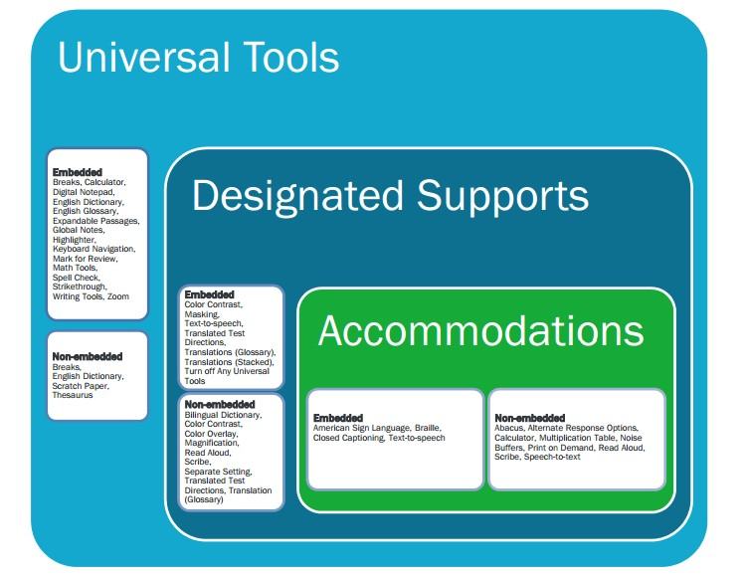

How long does the SBAC take?

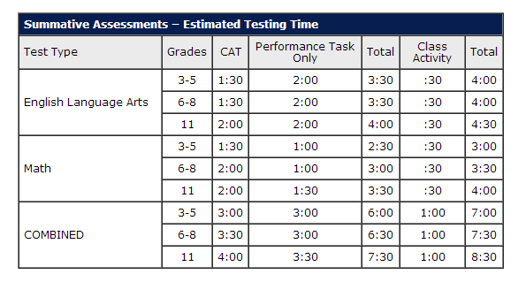
The tests are not timed. Students have as much time as they need to complete the test. The chart below indicates estimated testing times. CAT stands for Computer Adaptive test.

Technology Practice Skills For SBAC Grades 3-6
Skills | Description | Activities | Internet Links/Activity
Keyboarding | Type to Learn or one of these | Keyboarding Number Pad Practice | - Keyboard Invasion  - Sky Chase  - Dance Mat Typing  - Typing Club  - Number Pad Practice  - Math Quiz
Mouse Skills | Download: Mouse Practice Lesson | Students can practice multiple mouse skills, including scrolling, using drop down menus, radio buttons, and accessing links to build their navigation skills. | - Mousing Around  - Moucercise  - Mouse Practice  - Math Mavens  - Mouse Practice Bubble Activity  - Spelling Bees  - FunBrain: Math Arcade  - Math Arcade: Visit the site and select your grade before playing the game.
Highlight/Select Text | Download: Mouse Practice Lesson | Students will wear headphones to listen to content and follow instructions to highlight/select text.  Students will highlight/select text to make corrections, add text, and delete text. | - Highlighting Practice  - Proof Reading Grade 3  - Proof Reading Grades 4  - Proof Reading Grade 5 and 6
Navigation | Download: Navigation Lesson | Students will learn to navigate a webpage by reading instructions, clicking items, dragging items, viewing videos, and entering text into fields. | - Comic Strip  - Friendly Letter  - Word Clouds  - Study Jams  - Story Starter  - Make an Animation  - Math Videos

Drag and Drop | Download: Drag & Drop Lesson | Students will practice following instructions by dragging and dropping items thus reinforcing the skills of dragging and dropping within a field. | - Thinking Blocks  - Clean-Up Your Grammar
General Math Support | a free assessment and practice website where students have an opportunity to practice similar skills to what they will need such as drag and drop, selecting points on a number line or graph, etc. Teachers are able to create a free account and set up their classes to assign and track assessments, and even create their own custom questions | http://www.thatquiz.org/
Smarter Balanced | Training Test and Practice Test | Video to show students prior to taking the Practice Test Training Test and Practice Test

SBAC Technology Skills:

Keyboarding Skills
1 | Properly login/logout of computer
2 | Holds mouse appropriately
3 | Moves mouse on screen
4 | Places cursor on specific location on screen
5 | Uses a mouse to perform single-click
6 | Uses a mouse to double-click
7 | Uses a mouse to right-click
8 | Uses mouse to drag and drop items on screen
9 | Uses mouse to highlight text on screen
10 | Launches a program by activating an icon
11 | Exits a program
12 | When program is running can return to main menu
13 | Can access help features
14 | Open a window
15 | Closes a window
16 | Maximizes a window
17 | Minimizes a window
18 | Uses the scroll bar to move up and down on a screen
19 | Uses the scroll bar to move left and right on a screen
20 | Scrolls in multiple windows

Keyboarding Skills
1 | Can locate letters and type letters
2 | Uses enter/return key
3 | Appropriately uses space bar
4 | Uses delete key
5 | Uses backspace key
6 | Uses shift key
7 | Uses tab key
8 | Appropriately uses number pad
9 | Enters characters with reasonable speed
10 | Can locate and type punctuation keys
11 | Uses shift key to appropriately capitalize letters
12 | Uses correct posture (shoulders parallel to screen, both feed on floor)
Word Processing Skills
1 | Uses cursor to type/insert text in specific location or field
2 | Uses keyboard to type words/sentences/stories
3 | Locate and enter appropriate punctuation
4 | Composes at the keyboard (responds to prompt without first using paper)
5 | When editing, inserts letters/words
6 | When editing, deletes letters/words
7 | When editing, replaces letters/words
8 | When editing, changes case appropriately
9 | Enters characters with reasonable speed
10 | Locates and enters punctuation marks
11 | Copies letters/words
12 | Paste letters/words
13 | Uses spacebar correctly to separate words
14 | Uses the shift key for capitalization
15 | Makes additional revisions to typed piece (identifies misspelled words and chooses appropriate correction)
16 | Can undo last entry
17 | Can redo last entry
18 | Formats text
Navigation Skills
1 | Identifies symbols for advancing screens
2 | Identifies symbols for moving back screens
3 | Can play video
4 | Can stop video
5 | Can pause video
6 | Can rewind video
7 | Can adjust volume
8 | Identifies symbols and their functions

SBAC Training/Practice Test Skills
1 | Enter student login ID
2 | Enter password
3 | Can access/change preferences
4 | Enters practice area
5 | Accesses directions
6 | Clicks in text box and types
7 | Flags questions to be reviewed later
8 | Scrolls to view questions/answers
9 | Scrolls to navigate to response section
10 | Resize windows in a split screen
11 | Scroll within each box of a split screen
12 | Selects appropriate answer
13 | Deselects inappropriate answer
14 | Click arrows to navigate through test
15 | Opens/closes dialogue box
16 | Click an underlined text to activate link
17 | Understands and appropriately uses ‘Settings’ options
19 | Understands and appropriately uses Zoom In/Zoom Out features
20 | Can delete objects and numbers
21 | Can access information button to support in how question should be answered
22 | Understand when more than one answer is possible
23 | Can appropriately navigate and enter equation
24 | Can select/deselect objects
25 | Can flag question and advance without accurately answering question
26 | Can create graph
27 | Can drag and drop text and move in appropriate sequence
28 | Start audio
29 | Stop audio
30 | Can draw line segments

Accessing the Training and Practice Tests

  - Browse to: practice.smarterbalanced.org
  - Click the ‘Sign in’ button
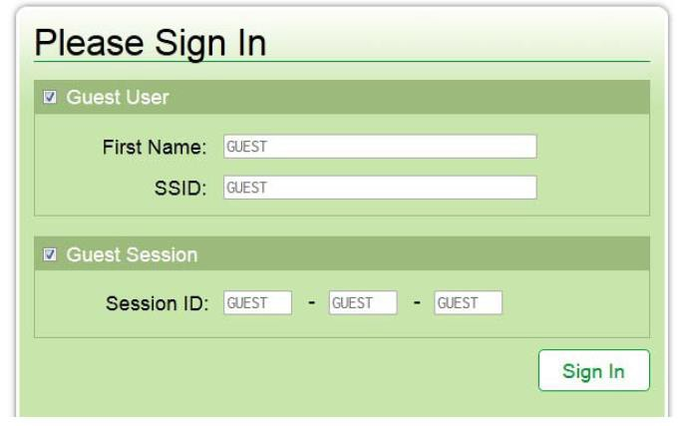

  - Select the desired grade level

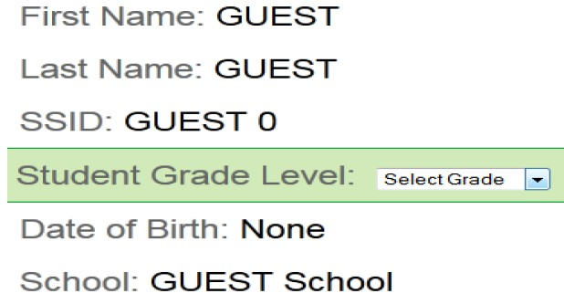

  - Select the a Smarter Balanced Assessment:
    - Training Test: Interact with the types of questions on the SBAC Assessment
    - Practice Test: Take a ‘Mini’ SBAC Assessment

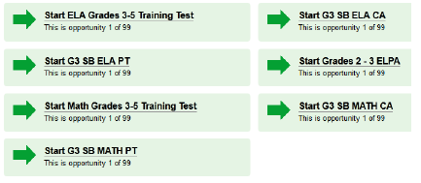

  - Select the desired supports

