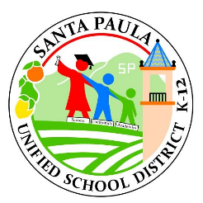
Board of Trustees
Chris Wilson, President
Daniel Sandoval
Gabriela Ornelas
Anna Villicana-Arroyo
Jeri Mead
Superintendent
Jeffrey Weinstein
SANTA PAULA UNIFIED
SCHOOL DISTRICT
Committed to Serving Every Student Every Day

PRESS RELEASE
FOR IMMEDIATE RELEASE
May 11, 2022
RE: Unloaded Pellet Gun Found Under a Drainage Grate at Isbell Middle School

Dear SPUSD Community,
Yesterday, Tuesday, May 10th, at Isbell Middle School, an unloaded pellet gun was found under a drainage grate. The student who brought the pellet gun to school was quickly identified and severe corrective action with the student involved was taken. SPUSD has zero tolerance for violence or any behavior that may place other students in danger.
Respectfully,
Jeffrey Weinstein, Superintendent

