


Watershed Charter School
2021–2022 Annual Report
Submitted by: Jarrod Decker, Principal
4975 Decathlon Avenue
Fairbanks, AK 99709
(907) 374-9350
http://www.k12northstar.org/watershed

 | Watershed Charter School  4970 Decathlon Avenue Fairbanks, Alaska 99709  (907) 374-9350

May 2, 2022

Fairbanks North Star Borough School Board
520 Fifth Avenue
Fairbanks, AK 99701

President Luke and School Board Members,

Watershed Charter School is in the final weeks of another challenging, yet successful school year. I have included some of the initiatives and accomplishments the school experienced this year. The report also includes data regarding student enrollment and performance on standardized assessments.

I look forward to formally presenting this report and answering any questions you may have at the May 17th Board of Education meeting.

Sincerely,
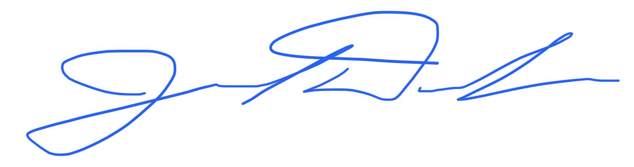
Jarrod Decker
Principal
Watershed Charter School

Philosophical Foundation of Watershed Charter School
Watershed Charter School offers an education rooted in the philosophy and pedagogy of place-based education, defined by the Rural School and Community Trust (2003) as:
…learning that is rooted in what is local – the unique history, environment, culture, economy, literature, and art of a particular place. The community provides the context for learning, student work focuses on community needs and interests, and community members serve as resources and partners in every aspect of teaching and learning. This local focus has the power to engage students academically, pairing real-world relevance with intellectual rigor, while promoting genuine citizenship and preparing people to respect and live well in any community they choose.
Place-based education is closely related to and shares some fundamental elements of environmental education, outdoor education, and community-based education. The model of place-based education used by the staff of Watershed Charter School integrates elements from these disciplines with the curricular content areas of reading, writing, math, science, and social studies.

Watershed Charter School - Year in Review

Curriculum, Instruction, and Professional Growth
- Watershed’s focus for professional growth this year was on reviewing and bolstering reading instructional strategies. Staff also worked on evaluating the alignment of reading instruction and materials with state standards.
- In October, Watershed’s Academic Policy Committee and principal participated in a 2-day Charter APC and Principal Workshop provided by the Alaska Association of School Boards (AASB). The APC developed two goals for this school year:
  - create a principal evaluation tool and perform an evaluation
  - promote and support schoolwide engagement in outdoor and community activities as emphasized in Watershed’s mission and vision statements
- In August, all staff members were recertified in Wilderness First-Aid and CPR.
- In February, all staff engaged in Diversity, Equity, and Inclusion training with the Fairbanks Coalition Builders.
Recruitment and Outreach
Watershed Charter School made several efforts to inform families in the community of the school and its application process.
- Watershed Charter School contacted preschool directors and posted notices about Watershed’s application/enrollment window at local preschools, daycare centers, and the FNA Head Start program.
- Watershed received 307 applications for fall enrollment, 78 of which were for kindergarten. Thirty-nine percent of first through eighth-grade applicants were from outside of the district (non-district homeschool, military PCS, private school).

Community and Outdoor Engagement
Watershed Charter School worked to establish partnerships with community members and organizations to enhance the school’s curricula and fulfill its mission. We are also committed to providing students with experiences that enhance their outdoor skills and connection to the natural world. Each class spent over 50 hours away from the school building fostering a stronger sense of place. Through community partnerships and outdoor adventures, students developed deeper connections to the Tanana Valley, gained self-confidence, strengthened bonds with classmates, and engaged in activities that promote healthy lifestyles. Here are a few examples of community and outdoor learning experiences from this year:
- Eighth-grade students participated again in the annual week-long trip to Kachemak Bay. Students took part in a program led by the Alaska Center for Coastal Studies, experienced sea kayaking, explored tide pools, and learned about Alaska’s marine and temperate rainforest ecosystems.
- First graders participated in a two-week woodworking project with Alex Brede from the Folk School. Students learned how to use a variety of hand tools to create wooden animals.
- Middle school students learned paddling skills and canoed the lower Chena River in September.
- Fourth graders wrapped up their partnership with Alaskan artist Kristin Link in creating a collaborative mural that is hung up at UAF in their School of Education Future Teacher Space classroom. The mural project was also in collaboration with schools from around Alaska: Noatak; Golovin; Shageluk; Toksook Bay; Anchorage; Wrangell; and McCarthy.
- Seventh graders skied to Lee’s cabin for three days of winter camping in the White Mountains this April. As part of the Bureau of Land Management’s Hands on the Land program, students worked with park rangers to mark 5 miles of trail to a future cabin site.
- Middle school students studied and received hunter education certification in the first quarter.
- Watershed’s annual All School Ski Day was held again in March. All students and staff members spent an entire day cross-country skiing and playing ski-related games at Birch Hill Recreation Area. The Watershed PTSA sponsored the event by providing funds for transportation and lunch.
- Fourth graders participated in the Salmon in the Classroom program in partnership with ADF&G. In collaboration with them, students were able to raise salmon from the egg stage to the fry stage in the classroom, go ice fishing at Chena Lakes, and invite ADF&G’s Erik Anderson for several guest speaking engagements.
- Fifth graders got to hear from several community scientists to learn about science careers and how science is conducted in Alaska.
- The kindergarten class continues to raise chickens and use the eggs for a variety of learning and service projects - including cookies donated to Stone Soup Cafe.
- All classes engaged in regular hiking, biking, and ski outings to local trails.

Other Notable Events
- Watershed started a school breakfast and lunch program this year. We serve meals to 60-75 students every day.
- Over 5,700 books were checked out from the school library and 51 poems were entered in our annual poetry contest.
- Over half of all Watershed students participate in the school’s incredibly popular Battle of the Books program coached by Amy Kulp, Watershed’s library media associate.
- Watershed student council coordinated school spirit weeks, Watershed’s Halloween celebration, social bonfires and dances.
- Students participated in a number of after-school clubs at Watershed this year including cross-country running, skiing, archery, and MathCounts.
- Watershed’s newest after school activity, Debate Club, participated in district competitions and traveled to Anchorage in April to compete against other schools from across the state.
- Watershed Charter School hosted cross-country running meets for Interior elementary and middle school students in September.
- The Watershed PTSA continued to support the school community in a variety of ways. Every year they purchase sets of books for Battle of the Books, organize a community-wide 5K fun run, staff appreciation events, “Beat the Principal” ski race, and more.
- Third and fourth graders participate in “Wild and Local Food Friday” every month where the menu is based on a food item gathered, hunted, or fished from Alaska. Students help prepare and clean up after the meals.
- Neighborhood clean-up day is planned for May 17th.

Watershed Charter School Staff
Chasity Perez | Kindergarten |  | Jarrod Decker | Principal
Moira O’Malley | First Grade |  | April George | Administrative Assistant
Peggy Haas | Second Grade |  | Pam Laker | Kindergarten Aide
Dave Merrill | Third Grade |  | Tyrone Burkhead | Custodian
Amy Arneson | Fourth Grade |  | Amy Kulp | Library Media Associate
Alexis Palmer | Fifth Grade |  | Jeff Misel | Aide
Erin Otness | Sixth Grade |  | Danielle Flaherty | Lunch/Breakfast Aide
Lisa Beattie | Math/Science |  | Lynn Malzahn | Recess/Lunch Duty
Becky Hansen | ELA/Soc. Studies |  | Erika Marshal | School Psychologist
Abigail Paul | Special Education |  | Heidi Kubichek | Occupational Therapist
Vacant | Counselor |  | Nuntarat Anderson | ELL Tutor/Instructor
Alex Mihalich/  Stepfanie Alexander | Speech/Language  Pathologist

Academic Policy Committee

Watershed Charter APC Members |  | The APC consists of nine voting members. Five of the members are permanent staff members, at least three of whom must be certified teachers. Four of the members are parents, who are not permanent Watershed Charter School staff members, of the students currently enrolled in the school. The principal is a non-voting ex officio member of the APC, except in the case of a tie vote.
Jason Gillam (Chair) | Parent
Sacha Layos (Vice-Chair) | Parent
Kelly Mansfield | Parent
Renee Rember | Parent
Moira O'Malley | Teacher
Dave Merrill | Teacher
Becky Hansen | Teacher
Abigail Paul (Secretary) | Teacher
Amy Arneson | Teacher
Jarrod Decker (ex-officio) | Principal

Parent-Teacher-Student Association Members
Suzy Fischer | President
Sadie Goddard | Vice President
Marita Bunch | Secretary
Jennifer Humphrey | Treasurer
Jarrod Decker | Staff Representative
Standardized Assessment Performance
Student growth and achievement results on the 2021-2022 Measures of Academic Progress (MAP) and 2021 PEAKS assessments are included below.
MAP Growth Results*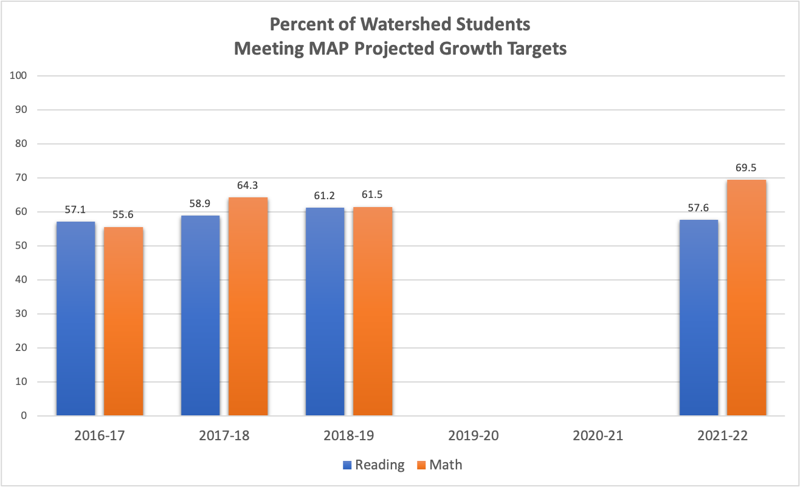
*Please see “Interpreting the Percentage of Students Meeting or Exceeding Their Growth
Projections Dr. Nate Jensen, Research Scientist at Northwest Evaluation Association for guidance on interpreting the data above. https://www.nwea.org/blog/2013/interpreting- percentage-students-meeting-exceeding-growth-projections

2021 PEAKS Achievement Results
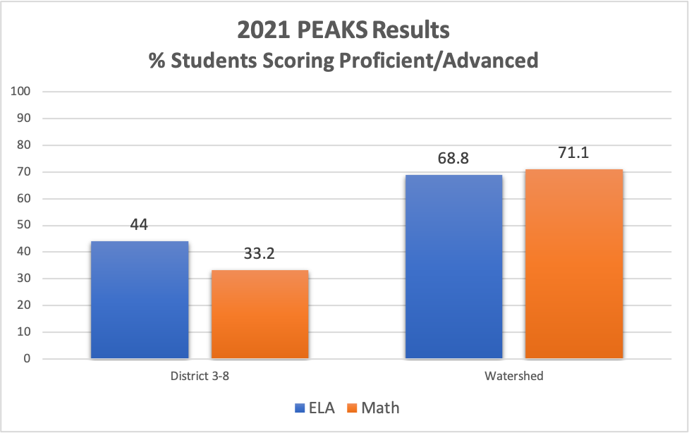

Student Enrollment and Mobility
Demographics 2021-2022
Caucasian only | 67.3%
African-American only | 1.0%
Hispanic* | 7.5%
Asian/Pacific Islander only | 0 %
American Indian/AK Native only | 4.0%
Two or More Races only | 20.1%
Ethnicity reporting data based on October 31
PowerSchool Enrollment Summary
Boys | 57.8%
Girls | 42.2%
Military Connected | 9.5%
Enrolled in Special Education | 11.6%
English Language Learners | 2%
Total Enrollment | 199
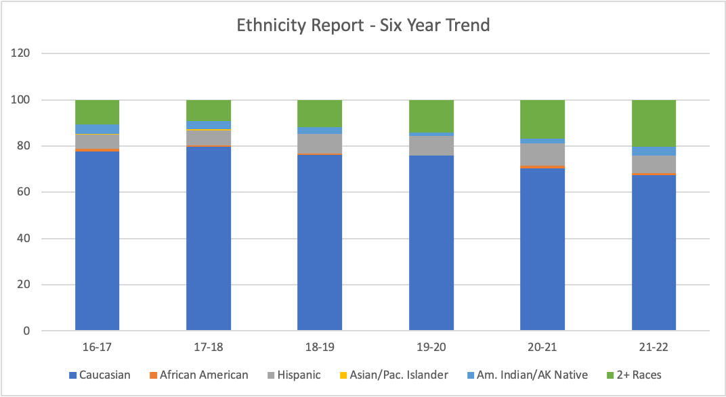

Transiency
Eighty-nine percent of students enrolled during the 2020-21 school year returned to Watershed for the 2021-22 school year. Parents of currently enrolled students have indicated that they all plan on returning to Watershed next year. All of our graduating eighth-grade students are planning to attend a district high school next year.

Appendix: APC Meeting Minutes

The Watershed School

Academic Policy Committee Zoom Meeting Minutes

Special Meeting - July 8, 2021

1) Welcome and call to order
a. Commenced: 6:06 pm
b. APC in attendance: Jason, Jarrod, Amy, Moira, Becky, Abigail, Renee, Dave
c. Zoom total participants: 16

2) Review Minutes
a. No edits
b. Motion to accept: Amy, 2nded: Becky
c. Passes with no objections.

3) Principal Report
a. Start/end times and Busing options
i. Option A: 7:35-2:05 with AM and PM busing using HS/MS shuttles-visiting all neighborhoods
ii. Option B: 8:40-3:10 with PM busing using east side/west side shuttles to elementary schools.
iii. Option C: 8:30-3:00 with AM busing using HS/MS shuttles
iv. Option D: 8:40-3:10 with AM & PM busing using HS/MS shuttles in AM and PM busing using east side/west side shuttles to elementary schools.
v. Option E: 8:30-3:00 with no busing
b. Survey results
i.98 responses, 10 were staff
Option A:
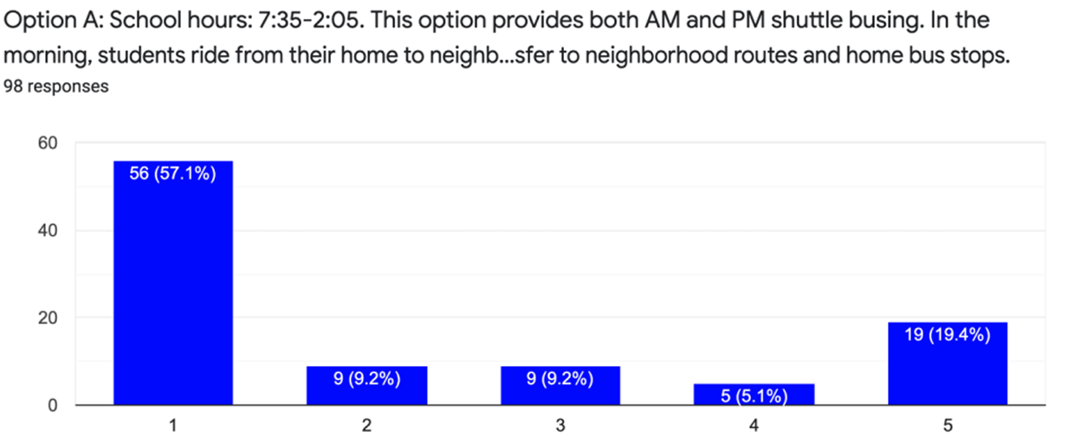

Option B:
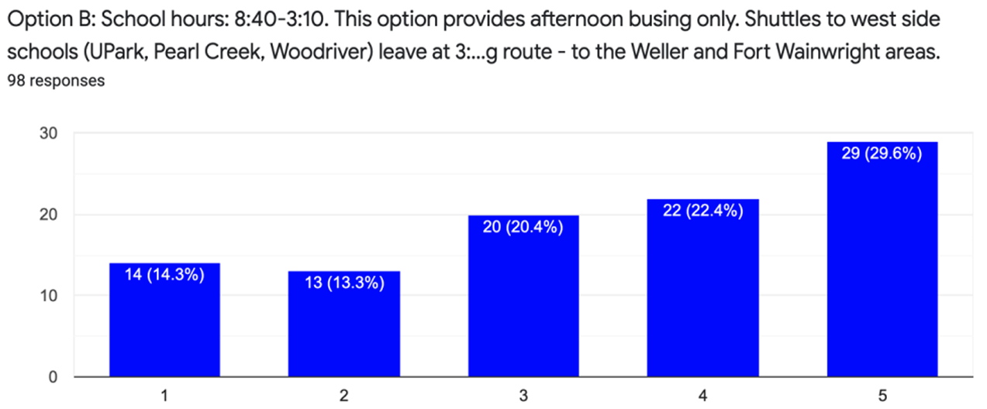
Option C:
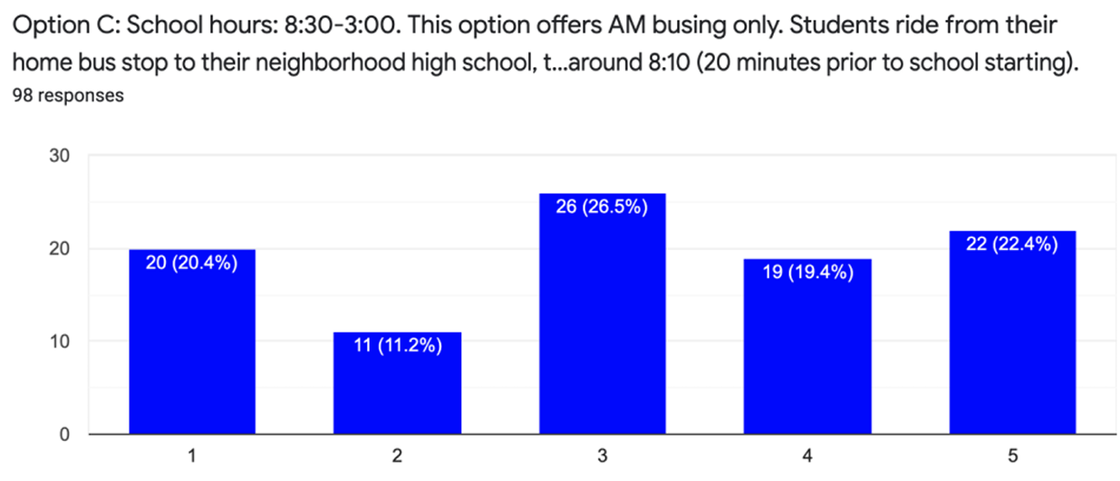

Option D: had the most points
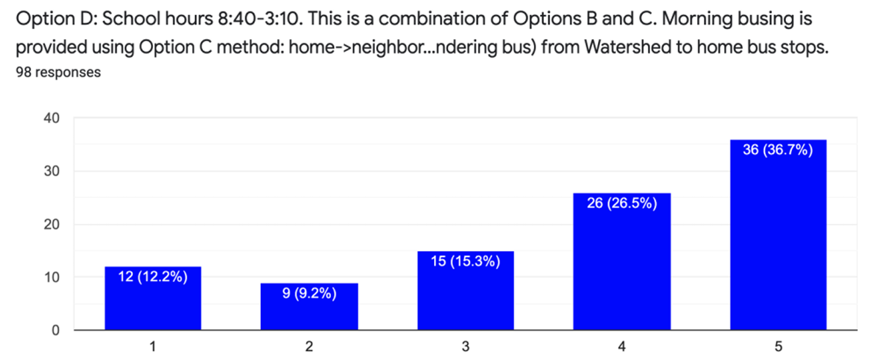

Option E:

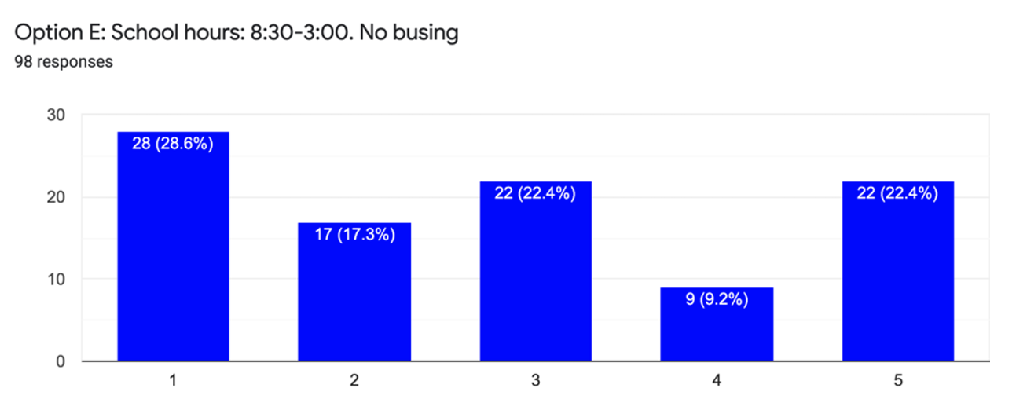

c. Dave asked if the start/stop times with the rest of the district is “set in stone”.
i. Yes, to the best as we can tell. The busing schedule is pretty set.
d. Jason asked, is there a cost consideration for Watershed?
i. District is required to offer busing, so Watershed doesn’t incur any busing fees.
ii. Cost for Watershed would be staffing time for supervision of kids until they got on the bus, but it’s not an additional cost because we’ve been doing this in previous years.

4) Public Testimony
a. Written
i. Reggie: 7:30am start would be awesome for parents that start work at 8:00, whether their child(ren) chose to ride the bus or not. Also, this option clearly provides the most busing opportunities (am and pm) as well as the least amount of bus transferring. This option also provides more afternoon time for students, families, and teachers, thereby enhancing quality of life, and may even encourage families to explore after- school activities they wouldn't have time for otherwise. Because this is also the high school schedule, Watershed students (and families) would be accustomed to school at this time, thus making the transition from Watershed to high school just a little more seamless for all. I ask that the APC please strongly consider the many advantages Option A provides over the other options presented. Thank you! (Please make this public testimony at the upcoming APC meeting.)
b. In-person
i. Sacha: In favor of options that have morning and afternoon busing so that we are accessible to all in the district. But also in favor of Option A for the same reason stated in Written testimony (above).
ii. Jenn H: In favor of offering busing. Prefers Option D. Doesn’t prefer Option A.

5) Action Item: School start and end times for 2021-2022 School Year.
a. APC Discussion
i. Dave: I’m a morning person, but going 10 minutes later than our previous 8:30-3:00 schedule is not terrible.
ii. Jason: Offering as much busing to folks in the community is great. Personally, sticking with schedule as it has been or as closely is best. Also, considering sleep schedule, not in favor of 7:30 start

iii. Becky: It would be hard for middle school kids to start at 7:30 given some already have tardies at 8:30 start time. There may be difficulty for elementary kids to arrive on time if going earlier, too.
iv. Amy: likes AM/PM busing. Working families could utilize the busing in AM and PM. Outings in the winter would be difficult if \e go earlier (buses need to be back by 1pm when we started at 8:30), and we would be missing out on some of the sunshine hours.
v. Kelly: AM/PM busing is good for all in the community. Personally, I prefer the later start.
vi. Jarrod: HS will start at 7:30, so AM busing on Option A would mean probably a 7am bus pick up. Staff kids come with staff, so Option A is real early, especially if they do extra curricular activities in the PM. It would make for a long day.
vii. Moira: Would be great to offer busing.
viii. Renee: Some families live remotely that require 45 min drive, so 7:30 is super
early…lots of tardies could add up. She likes busing.
ix. Abigail: Likes Option A because early riser, but she realizes she doesn’t have kids to
worry about getting to school. Prefers busing to be available.

b. Motion to adopt Option D (8:40-3:10 with AM & PM busing using HS/MS shuttles in AM and PM busing using east side/west side shuttles to elementary schools) for the 2021-2022 School Year.
i. Moved by: Dave, 2nded: Amy
ii. Passes unanimously

6) Next meeting date:
a. August 11.

7) Adjourn
a. Renee moved to adjourn, 2nded: Becky
b. Time: 6:50 pm

The Watershed School

Academic Policy Committee Zoom Meeting Minutes

Regular Meeting - August 11, 2021

1) Welcome and call to order
- Commenced: 6:03 pm
- APC in attendance: Jason, Jarrod, Amy, Dave, Abigail, Moira, Becky, Renee, Sacha
- Zoom total participants: 45

2) Head Teacher Report
- Jarrod shared the FNBSD’s operational guidelines for 2021-22 school year. Masks are encouraged, not required.
- Watershed will have breakfast and lunch available for students at no cost.
- The district will be providing some testing and screening for COVID-19. More information to come.
- Transportation: students are required to wear masks (Federal requirement).

3) Public Testimony for Action Item: Masks
- Live testimony
- Written testimony

4) Action Item Discussion:
- Watershed will do its best to adhere to its mission statement and resume with outdoor field trips. Another part of Watershed’s statement is to be stewards of our community. One way to do that is to adhere to a mask mandate indoors. There was support from members about indoor masking and allowing outdoor masking to be optional. Dr. Stoltz reviewed CDC’s guidance that cohorts will not be necessary with the layer of masking as a mitigation. Lunch mitigation for now will be to eat outside as much as we can. Options are limited when it gets colder.
- Draft statement: In accordance with CDC’s guidelines universal masking will be required indoors at Watershed. Masking will be optional outdoors when social distancing is possible. This policy will be reviewed when CDC guidelines are updated and/or students have the opportunity to be fully vaccinated.
- Motion by to approve: Amy. Seconded by Dave. Motion carried unanimously.

5) Next meeting date:
- Third Thursdays? Decide soon.

6) After meeting notes (Parent Q&A)
- Determine whether to host meetings through Zoom or in person.
- Look at APC member status
- Review 25-day absence policy?
- Carpooling options?
- We don’t record parent volunteer hours
- After school clubs?

6) Adjourn: 7:14 pm

The Watershed School

Academic Policy Committee Zoom Meeting Minutes

Regular Meeting - September 22, 2021

- Executive session (election of officers)
Jason Gillam was elected Chair
Sacha Layos was elected Vice Chair
Abigail Paul was elected Secretary
- Review minutes
Amy A. Moved to approve the minutes
Renee Rember seconded
Minutes passed unanimously
- Head teacher update
  - Budget and enrollment - The second week of school, Mr. Decker looked at enrollment and we were short two students in one grade with no waitlist. The full capacity is 198 so the school wanted to bring enrollment up to full capacity since the adjustment would be relevant after the October count for funding. During a staff meeting, teachers agreed to pull the three siblings in grades 3, 5, 6 from the waitlist. We have 23 in those grades now, bringing enrollment to 199. In Nov. after the Oct. count, there should be an adjustment. The numbers will change in the budget by up to $30,000.
  - Action Plan - The entire district is moving to system-wide accreditation, so we opted into that a couple of years ago. We are now working on the second domain. Links to bylaws, meeting minutes, and school board are being created. Student success, community engagement, student well-being and SEL are some areas of focus. Specific, measurable, attainable, relevant and time-based goals are being made. October 1, we will be reviewing it as a school. Reading is the focus for student success. Growth in reading will be measured by MAP for this purpose. Volunteer hours (measurable) are critical to community engagement as well as outreach and events. The school climate survey is also useful as a measure.
  - Accreditation - See Action Plan notes
  - PEAKS and MAP testing - In the principal weekly newsletter, Mr. Decker included how we perform on tests as compared to other K-8 schools in the district. 71% of students at Watershed are proficient in math. 68.8% are proficient in language arts. Our scores are down slightly from 2019. Only 85% of our students tested. This year, the test will be different from PEAKS and will be through the same company that MAP is a part of.
  - Outdoor learning: hiking, biking canoeing, digging potatoes..every class went on an extended trip (eating lunch elsewhere during the day) before Labor Day Break
  - Questions- Parent volunteering isn’t a part of our accreditation, but it is part of our action plan. Nature art, leaf art, flower art, ecology, sense of place, cooking with local ingredients, cross-grade tutoring and many outdoor trips are all activities that are contributing to the fulfillment of our mission.

- Public Testimony - no live testimony…two email testimonies
Email testimony indicates support for following CDC recommendations and support for including excused absences (the practice of not counting absences against families for reasons that might enhance a child’s life experience outside of school).

- Action Item
  - Reconsideration of the 25-day absence policy (below) - Renee Rember asked if a special meeting would be called. A day in May will be reserved to have a meeting if needed. David Merrill doesn’t want to accidentally incentivise people to attend school sick. Renee Rember believes that students need to be in school to accomplish curriculum goals. She thinks the proposed amendment still allows for family activities. Quarantine is currently being recorded as a sick day.
The current Watershed Attendance Policy:
Unless the APC grants a parent appeal, students who miss 25 days (for any reason) or more by the last full student contact day will be withdrawn from Watershed Charter School. Appeal decisions will be made by The Watershed Academic Policy Committee shortly after the last student day. Students who are late will be counted as tardy. Four tardies will equal one half-day absence and will count toward the 25-day absence limit.

The following movement to amend the attendance policy was made, seconded and approved (unanimously):
“Unless the APC grants a parent appeal, students who accrue 25 days of absences or more by the last full student contact day will be withdrawn from Watershed Charter School. During the 2021-2022 school year, the 25 day absence policy excludes excused absences for illness (including quarantine). Appeal decisions will be made by The Watershed Academic Policy Committee shortly after the last student day. Students who are late will be counted as tardy. Four tardies will equal one half-day absence and will count toward the 25-day absence limit.”
Next meeting date: October 20 (3rd Wednesdays of the month unless a different date is agreed upon)

- Adjourn: Dave Merrill moved, Renee Rember seconded. Meeting adjourned at 6:50 PM with no objections

The Watershed School

Academic Policy Committee Zoom Meeting Minutes

Work Session - October 20, 2021

Meeting started at 6:03 PM

Attendees:

Jason Gillam, Chair
Sacha Layos, Vice Chair
Abigail Paul, Secretary
Jarrod Decker, Principal
Amy Arneson, Member
David Merrill, Member
Moira O’Malley, Member
Rebecca Hansen, Member
Kelly Mansfield, Member
Renee Rember, Member

Creation of an annual APC calendar: The calendar draft was created by Jarrod Decker and shared with the APC at the meeting. The Association of AK School Board’s calendar for charter schools was also viewed by the APC. Adoption of the Watershed School calendar was added to February. Review of the parent-student handbook and policy agreement was added to October. Goal setting and a strategic plan review was added to August. Principal evaluation planning was added to November. The third Wednesday of the month will be our APC meetings.

Setting priorities/goals for the year: The principal evaluation process was set forth as a goal for the year. Tracking and analyzing the outdoor and community activities classrooms was identified as another goal.

Begin outlining the principal evaluation: The principal evaluation tool will be developed in a full APC work session November 3. The committee will have an executive session to perform the evaluation and the completed evaluation will be brought to the full APC in January at a regular meeting.

Committee formation: Renee Rember, Jason Gillam, Kelly Mansfield and Sacha Layos, the non-staff members of the APC, will be the committee members evaluating the principal. They will be holding an executive session and then they will bring their proposal to the full APC at a regular meeting.

Meeting Adjourned at 7:26 PM

The Watershed School

Academic Policy Committee Zoom Meeting Minutes

Work Session - November 3, 2021

Meeting Started: 6:02 PM

Attendees:
Abigail Paul, Secretary
Jarrod Decker, Principal
Kelly Mansfield
Jason Gillam, Chair
Renee Rember
Amy Arneson
David Merrill
Sacha Layos, Vice Chair

Members agreed to start with foundational goals for the principal evaluation and then add to and/or refine the evaluation tool in the future. This year, the focus will be on goals that the principal can reasonably provide evidence for, given the short amount of time that is left this year to assemble that evidence. Goals/evidence will be measurable. Connecting the evaluation goals to align with accreditation data the principal is currently assembling was suggested and members agreed to this plan. Community engagement (as measured by volunteer hours), professional development for teachers (as measured by “coffee cup professional development” links in all-staff emails) and maintenance of the Watershed Master Document that allows teachers to access important information any time and interact with that information, editing and commenting, were given as some examples of evidence of principal performance that currently exists. The APC used, as a template, a principal evaluation instrument designed by a charter school in Hooper Bay, Alaska, tailoring it to Watershed’s needs. The APC identified how each goal would be measured. At the next APC meeting, public testimony will be taken and the evaluation tool will be voted on by the APC. Once adopted, the tool will be used in an executive session to evaluate the principal. Only non-staff members will participate in that executive session (principal evaluation). A committee to proofread/refine the document, without changing its substance, prior to the next meeting was formed. The committee includes Jason Gillam, Sacha Layos and Amy Arneson. That committee will meet prior to the next APC meeting.

Meeting Adjourned: 7:58 PM

The Watershed School

Academic Policy Committee Zoom Meeting Minutes

Regular Meeting - November 17, 2021

Meeting Called to Order: 6:05 PM by Jason Gillam

Attendees: Abigail Paul, Secretary
Jason Gillam, Chair
Sacha Layos, Vice Chair: Not Present
Jarrod Decker, Principal
Amy Arneson, Member
David Merrill, Member
Renee Rember, Member
Moira O’Malley, Member: Not Present
Rebecca Hansen, Member
Kelly Mansfield, Member

Public Testimony: No public testimony submitted in advance. Nobody online submitted testimony during the meeting.

Principal's Report:
- Academic achievement with a focus on reading instruction for professional development day on November 12, 2021.
- Attendance was at about 95% for the most recent round of parent-teacher conferences.
- Tracking place engagement: classrooms engaged in the community and the outdoors, updating their activities to the Watershed Master Page which logs where and when they went and what they did and how much time they spent on the activity.
- COVID update: COVID situation has improved for Watershed in the past few weeks.
- Budget plan: Still need the money from the increased enrollment of three students that has not come through, but the budget is balanced and the enrollment money will be surplus.
- One full-time aide is funded through CARES act money which never appears in our budget.
- Refer to recording for more details on budget

APC Goals:
- Develop and implement a principal evaluation.
- Awareness of mission and better tracking for meeting the mission.
- Develop a future strategic plan.

Approval of Principal Evaluation Tool : See link for details of the principal evaluation tool developed by the APC

Motion to Adopt: Amy Arneson
Motion Seconded: Becky Hansen

Vote: Kelly Mansfield yay
Abigail Paul yay
Becky Hansen yay
Dave Merrill yay
Amy Arneson yay
Renee Rember yay
Jason Gillam yay

Principal Evaluation Tool Passed unanimously

January meeting on 19th will consider the principal’s response to the evaluation tool (evidence). The principal has until January 5, 2022 to submit evidence.

Traditionally, there is no December APC meeting so the APC will not have another meeting until January 19th when we look at the principal’s response to his evaluation and proposed school calendar and any other agenda items that are added. The APC will adopt the school calendar in February.

Motion to Adjourn the meeting: Kelly Mansfield and seconded by Renee Rember and meeting adjourned without objections at 6:43 PM.

The Watershed School

Academic Policy Committee Zoom Meeting Minutes

Regular Meeting - January 19, 2022
- Welcome and call to order: Sacha Layos absent at the time of roll call at 6:05 PM called to order
- Testimony: Non-agenda items: None
- Principal report: budget update and calendar
A. Budget update: $25,250 due to us and we are still waiting for the full amount to be delivered. Our student count was above the projected enrollment. Jarrod sent out the proposed Watershed calendar last Friday. It will be considered and voted on at the next APC meeting.
- 2022-23 School Calendar proposal: Open for public comment
- Enrollment lottery update:
  - Experimenting with a digital process on Google forms and spread sheet for sorting and experimenting with the idea of using a random number generator instead of drawing from a “hat”. Georgiana has reached out to all the preschools in town about the school. If you want to distribute flyers, they have a QR code for easy access to more information about applying. There will be an outreach event with Thrive Alaska happening next week. The informational meeting format will be in person and the lottery will be in person.
- Outdoors and community engagement has been slowed down by the cold, but a log is being kept by staff on those trips and now temperatures are warmer.
- 4) Testimony: Agenda items: No in-person live testimony. Emails were read aloud by Amy Arneson and Jason Gillam.
- 5) Action Agenda Items:
  - Principal evaluation: Review and Recommendation: The decision of the APC is to retain Mr. Decker as the principal and there were no concerns. Motion to accept the evaluation: Kelly M. moved Becky H. seconded: APC unanimously voted to approve the recommendation, retaining Jarrod Decker as principal
  - Reevaluation of masking requirement: Move to maintain the masking requirement by Abigail P. Renee R. seconded the motion. Unanimously passed. The issue will be revisited at the March 23 APC meeting.
- 6) Discussion Items
  - Review liability insurance: Jarrod will reach out to legal counsel and the APC will have a chance to address these concerns during a February meeting, rolling a work session into that regular meeting.
  - School relocation – interest and feasibility: Tabling this discussion until the school district decides if schools are actually being vacated. Joy School is of particular interest due to its location.
New Business: Elections coming up
- 7) Next meeting date: February 16, 2022 6:00 PM
- 8) Adjourn: Dave M. moved to adjourn Moira O. seconded. None opposed.

The Watershed School

Academic Policy Committee Zoom Meeting Minutes

Regular Meeting - February 16, 2022

- Welcome and call to order: 6:04 PM
Abigail Paul: present
Jason Gillam: present
Jarrod Decker: present
David Merrill: present
Amy Arneson: present
Becky Hansen: present
Moira O’Malley: not present
Renee Rember: not present
Kelly Mansfield: present
Sacha Layos: present

- Testimony: Non-agenda items

- Principal report
  - Budget update: District transferred $25, 250 to the school to align with actual enrollment based on the October count. The projected Watershed budget for the coming year is $2,107,280 based on our projected enrollment. The BSA hasn’t increased in six or seven years.
  - Enrollment lottery update: Thrive Alaska meeting for preschool students transitioning to kindergarten next year - gave some information about Watershed. 150 applications have come in already this year. About 40% of the applications are coming from out of district. Georgiana Smith is leaving the school at the end of February because she is moving out of state.
  - Outdoors and community engagement update: March 10 all-school ski day. Birch Hill, Goldstream Valley, UAF, Goldstream Sports Trails are also recent ski destinations.

- Testimony: Agenda items

- Action Agenda Items:
  - 2022-23 School Calendar
Motion to Approve: Kelly Mansfield
Seconded: David Merrill
Vote: Unanimous in favor of the calendar and the motion passed

- Next meeting date: Wednesday, March 23

- Adjourned at 6:34 PM
Motion to Adjourn: David Merrill
Seconded: Becky Hansen
Opposition: None

The Watershed School

Academic Policy Committee Zoom Meeting Minutes

Special Meeting - March 2, 2022

- Welcome and call to order by Chair, Jason Gillam, at 6:00 PM
Abigail Paul: present
Jarrod Decker: present
Jason Gillam: present
Sacha Layos: present
Amy Arneson: present
David Merrill: present
Moira O’Malley: present
Renee Rember: not present
Kelly Mansfield: present

- Public Testimony on Masking at Watershed School
Emails from parents were read aloud at the meeting. There were no signups for in-person testimony.

3) Action Agenda Item - Masking

Discussion: If masking becomes optional, Watershed will return to having lunch in the MPR with large groups of students rather than using hallways and classroom space to relieve congestion at lunch,, but students will have the option of sitting at least six feet away from others in the MPR. The final responsibility for wearing a mask will rest with students to wear or not wear a mask per their family’s instructions. Staff will not be monitoring who is and isn’t wearing a mask on school grounds. Staff will talk to their classes about respecting the decision of others to wear or not wear a mask. The APC worked together to revise a draft motion presented by Abigail Paul. All APC members’ contributions were taken into consideration.

Amy Arneson moved: “The Watershed School will follow current CDC guidelines on indoor masking and the FNSBSD heightened protection protocol with the ultimate goal of maintaining in-person learning.”

David Merrill seconded the motion

All APC members who were present during the meeting, voted in favor of the motion and the motion passed.

- Next meeting date: March 23, 2022

- Sacha Layos moved to adjourn the meeting, Kelly seconded and none were opposed. The meeting was adjourned at 6:48 PM.

The Watershed School

Academic Policy Committee Zoom Meeting Minutes

Regular Meeting - March 2, 2022

- Welcome and call to order (meeting called to order: 6:01 PM)
Abigail Paul - present
Jarrod Decker - present
Jason Gillam - present
Sacha Layos - present
Kelly Mansfield -present
Moira O’Malley - not present
Becky Hansen - present
David Merrill - present
Amy Arneson - present

- Minutes review and approval
Motion to approve: Amy Arneson
Seconded: David Merrill
Passed unanimously

- Testimony: non-agenda items - none received

- Principal report
  - Budget update given as discussion agenda item - see below
  - Enrollment lottery update - strong response (over 250 applicants at this point in time and the window has not yet closed and 250 is historically considered a good response) - informational meeting will be in person again this year and is on the calendar - APC will attend the start of the informational meeting
  - Outdoors and community engagement update - All School Ski has not happened since 2019 because of weather and then the pandemic and was a success this year on the Thursday before spring break - Effie snowshoe race is coming up - Spring camping trips are returning this year as well

- Testimony: agenda items

- Discussion agenda Items:
  - SY 2022-23 Budget: Projected for 198 (enrollment) - inflation - rising heat costs - rising salaries for staffing (step increases) - pay increases due to negotiations could also make the budget tighter - hope legislature can pass an increase to base student allocation - carryover money will be determined after June when teacher’s payment is complete for the school year - the counselor position was not filled and was budgeted for and the 30% counselor position has been included in next year’s budget - discussion centered around whether or not we will try to hire a counselor if the legislature does not raise the base student allocation - if the position goes unfilled, the school can reallocate the money within this same budget year - the board was unanimously in support of posting a counselor position

  - APC elections:

Jason Gillam - plans to continue on the board
Renee Rember - will step down from the board unless there are no applicants for her position

Amy Arneson - Amy stated that she will be stepping down from the board unless there are no applicants for her position

Moira O’Malley - not present at this meeting

-Posting applications on April 4, 2022 - window will be open through April 15, 2022 and April 25, 2022 we will hold an electronic election Monday-Thursday with results posted Friday April 29, 2022 - terms start in August, 2022 and the application process will take place over Google Form

-Roles and responsibilities of the APC will be included as part of the application process via a link to APC information on the website

HB 272 and HB 273 are currently in legislative process - anyone can choose to write or call in their support of these bills which would increase the base student allocation funding and protect against inflation (HB 273)

- Next meeting date: Wednesday, April 20

- Adjourned at 7:06 PM
Motion: David Merrill
Second: Becky Hansen
Unanimously approved

The Watershed School

Academic Policy Committee Zoom Meeting Minutes

Regular Meeting - April 20, 2022
- Welcome and call to order
Time: 6:00 PM

Abigail Paul, Secretary - Present
Jason Gillam, Chair - present
Sasha Layos, Vice Chair - present
Renee Rember - not present
Moira O’Malley - not present
David Merrill - present
Rebecca Hansen - present
Amy Arneson - present
Kelly Mansfield - present

- Approval of minutes
Motion to approve: Sacha Layos
Seconded: Kelly Mansfield
Approved unanimously

- Testimony - None

- Principal report
  - APC election update: Two staff members have applied for the two vacant staff positions so, per charter bylaws, there will be no election - staff members Chasity Perez and Pam Laker will be joining the APC in the fall - there are three applicants for the two open parent positions so there will be an election - see timelines on previous meeting notes
  - Budget/staffing update: Interview will be next week for Watershed’s school counselor position shared with Boreal Sun Charter - Watershed will maintain FEA teaching staff for the coming school year (no involuntary movement due to school closures or budget changes)
  - Enrollment lottery update: Over 300 applications were received this year - Excel random number generator was used for the lottery - there were seven vacancies in the school - 5 in Kindergarten and 2 in 8th grade - they are filled and accepted - the lottery is time-intensive - Jarrod Decker is considering the PowerSchool lottery system Chinook, Discovery Peak and Barnette are currently using (for next year) - 40% of Watershed applicants were from outside the district - Jarrod could use some help from APC members or parent volunteers with logistics at the lottery next year.
  - Outdoors and community engagement update - the 7th grade went winter camping in the White Mountains for three days - many other classes are going outdoors and into the community and these outings are being logged on a shared document

- Discussion Agenda Items:
  - District-Charter contract revision update: A new contract has been drafted - charter leaders were in a meeting with district leadership today (April 20, 2022) - May 17th, 2022, Watershed Charter will give the annual report to the board - May 6th, 2022 is the day the contract for our school needs to be ready to present - the charter schools in the FNSBSD are in agreement that they should be as unified as possible while still considering their individual needs - contract revisions led by Jarrod Decker at this APC meeting and were reviewed and discussed with the APC - APC members contributed to the revision of the draft contract - refer to the actual contract document for edits made - all members were in agreement to allow the contract process to move forward with the suggested edits
  - APC self-assessment - there will be a shared document and APC members will contribute the self-assessment on their own time - at the August meeting we will be taking the suggestions and reflections made by APC members and then will use that for a professional development session
  - Possible relocation to closed schools - no interest was expressed by the APC in pursuing a new location such as the former location of Joy School based on political and financial issues as well as the mission of the Watershed Charter being based on keeping our school community small and familiar rather than sharing a building with another program or similar options - no further discussion warranted.

- Next meeting date
An APC work session pending contract approval by the district will be held May 18, 2022 at 6:00 PM

- Adjournment
Motion to Adjourn: Sacha Layos
Seconded: Rebecca Hansen
APC voted unanimously to adjourn at 7:45 PM

