Differentiation and Accommodation strategies
Terms:
Differentiation:
refers to a wide variety of teaching techniques and lesson adaptations that educators use to instruct a diverse group of students, with diverse learning needs, in the same course, classroom, or learning environment.

Accommodations:
A change or alteration, that does not change the expectation of content, just how the student shows or gains that content. This does not change the grading from any other student.

Class Set Up:

Student Seating-
Arrange students to be away from as many distractions as you can. Or distractions that are easier to manage.

Desk layout-
Desks help to focus student attention, if students need more help paying attention, the placement of desks can be moved so that the focus of the student is directed.

Grouping-
Some students work better in groups of peers that will support and help them learn the information. Think about who in your classroom would work well together and who would not

Content:

First Step is distinguishing between:

Enduring Understandings
-what students should understand—not just know or do—as a result of studying a particular content area.

Important to Know and Do
-What students should known for an assignment/standard or test or be able to perform, such as writing a well-rounded paper.

Nice to Know
-Information or abilities that would be nice if the student knows but it is not required information.

Strategies to try:
- Add another modality to learning, such as kinesthetic activity or alternative project that is more engaging for the targeted student.

- Brain Breaks- if the students seem to be unable to pay attention even if they did for most of the lesson, they may just need a little break. Brain breaks are up to two minutes and usually don’t have anything to do with content, they can be a variety of things such as physical activates like stretching and jumping jacks to social activities where they can talk to their neighbors or get to share to the class about something that they are excited about.

- Assignments, that involve multiple-modalities of learning. Such as kinesthetic, audio and visual assignments/projects.

Differentiation Strategies:
- Worksheets
  - Number of problems
  - Different level of problems
  - Scaffolding information
  - Choice of problems
  - Examples
- Showing subtitles when watching a movie
- Guided notes example below
- Scaffolding examples below
- Choose boards examples below

Presentation accommodations allow a student to:
- Learn content from audiobooks, movies, videos and digital media instead of reading print versions
- Hear instructions orally
- Be given an outline of a lesson
- Use visual presentations of verbal material, such as word webs and visual organizers
- Be given a written list of instructions
- Guided Notes with the focus being on the Important to Know and Do content.

Response accommodations allow a student to:
- Give responses in a form (oral or written) that’s easier for them
- Write answers down instead of being called on in front of the whole class

Timing accommodations allow a student to:
- Take more time to complete a task or a test
- Have extra time to process oral information and directions
- Take frequent breaks, such as after completing a task
- To use the comment box on Q to show what is used for testing purposes

More accommodations can be found in the Colorado Accommodation Manual found at www.cde.state.co.us/cdesped/iep-resources at the bottom of the page.

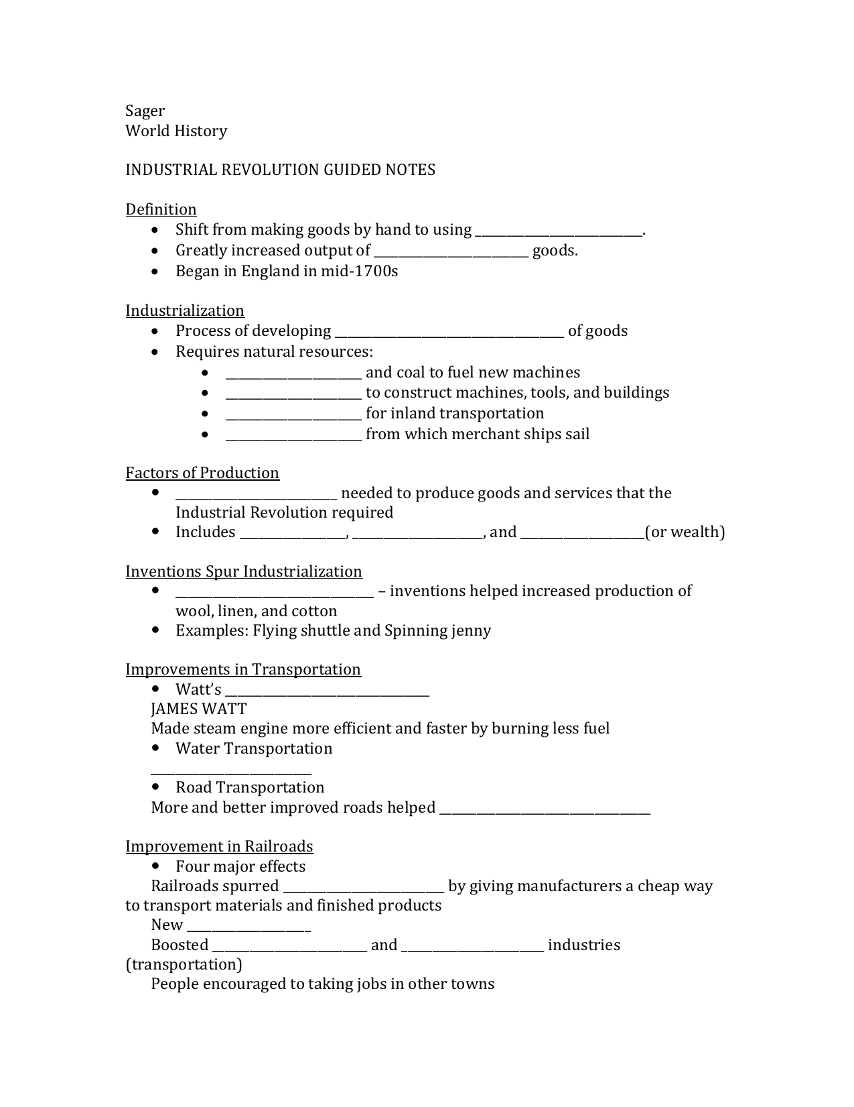http://s1.studylib.net/store/data/008971921_1-94d01ac28bc194ddac0ded3bf2b08286.pnghttps://www.edutopia.org/sites/default/files/styles/responsive_600px/public/nieves-inset-specedgafe-author.jpg?itok=PQObE0eW&timestamp=1478548927

https://www.google.com/url?sa=i&rct=j&q=&esrc=s&source=images&cd=&ved=0ahUKEwjE7N6bvK7TAhVC6WMKHf0-ASYQjRwIBw&url=http%3A%2F%2Fwww.infiniteminds.info%2FProblem-Solving-and-Creativity%2FHow-to-use-Mind-Maps.html&psig=AFQjCNFXmDj9rjgDVrHZgwUhlxAaNlSUKA&ust=1492619143560121

