UCAS FAQs - A U.S. Perspective

As a student applying from the U.S. you may find a couple of sections on the UCAS app that need clarification. Below are some tips as you fill out your application.
Explore all Universities on the UCAS application here!.
List of Russell Group Institutions here.

WHAT IS UCAS?

- A centralized service that students use to apply to universities in the United Kingdom
- You can choose up to five courses (majors/programs) from five universities
- There’s no preference order and your universities/colleges won’t see where else you’ve applied until after you reply to any offers you get
- There is no early action or early decision process/system
- UCAS is used to apply for all universities in England, Scotland, Wales and Northern Ireland. A small number (York not among them) will allow you to apply directly to the university but this is rare
- The full application fee (up to five course choices) is £26.50 ≈ $35. If you are 100% certain you want to choose just one course (and that you’ll be accepted) the fee is £22 ≈ $30
- No upload feature for documents - you send these in (or have the relevant body such as College Board send them in) when a university directly asks you for them
Terminology
•Course/programme = major
•Qualifications = academic achievements such as standardised test scores, High School GPA, HS diploma classes and grades, Associates Degree etc
•Referee = counsellor/teacher providing reference
•Faculty = group of academic departments/schools

BUZZWORD: PROMPTING QUESTIONS

Do I enter or link my buzzword for a 2022 undergraduate application?

Once you have registered, completed the onboarding steps and created your Hub account, the app will prompt you to add your “buzzword” once you start your application. Most U.S. schools do not have a buzzword since they are not UCAS centres. It is okay to pass this section by hitting “cancel” or equivalent whenever asked about a buzzword and your application can proceed just fine.

EDUCATION SECTION

What is the highest level of qualification I expect to have before starting my course?
If you are a current high school student, have graduated from high school, are currently at community college or have an Associate’s Degree, you should indicate “Below honours degree level qualifications”. In the UK, Bachelors degrees are known as an Honours level degree. So unless you already have a Bachelors degree (or will have by the summer before you intend to start university), you should indicate the 2nd option.
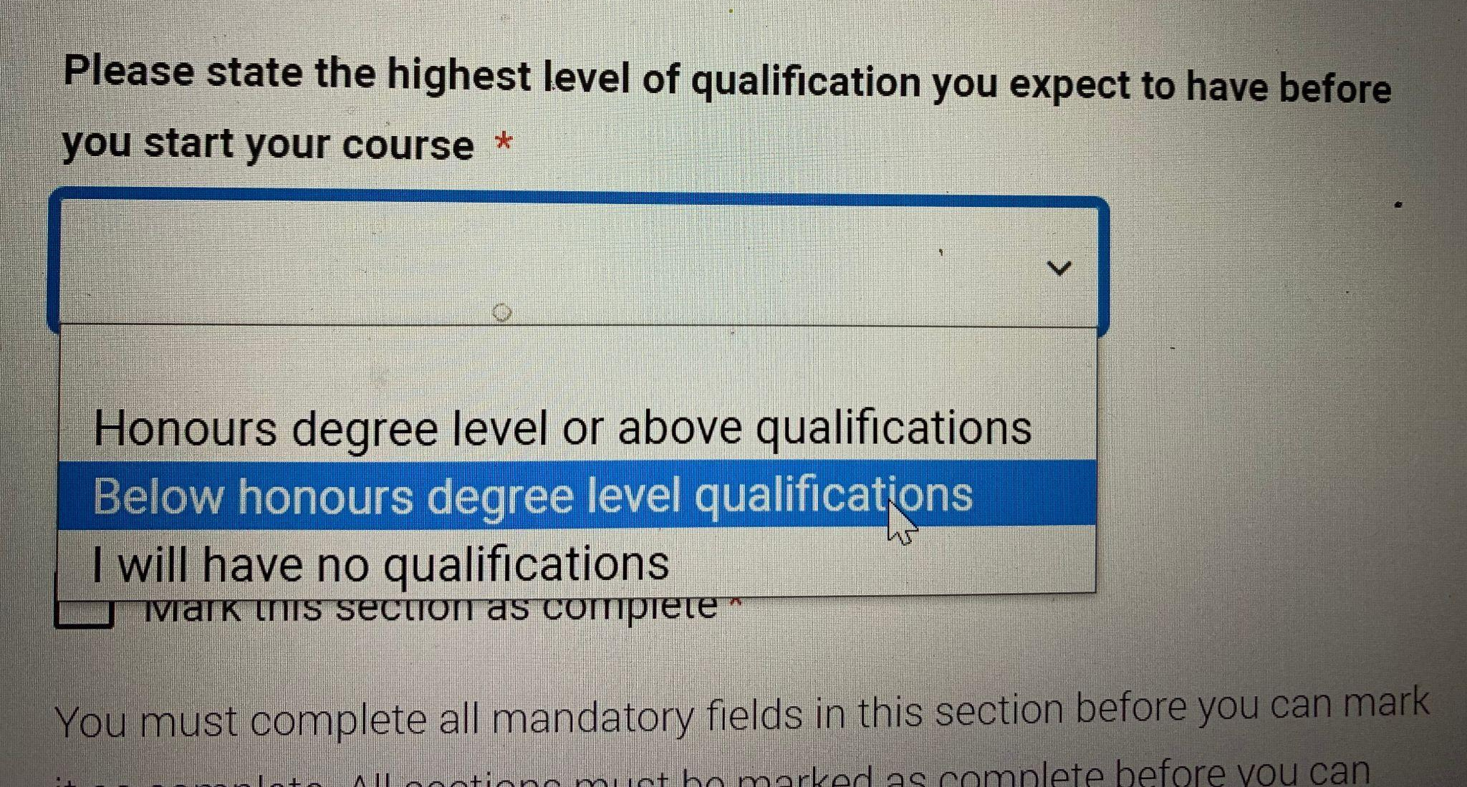

How should I fill out my places of education & qualifications?

First, it is very important to fill in as much education history as possible.

Typically, a U.S. high school will not come up as an automatic option when you add a place of education. If it does, great! If not, type in your high school name and add it manually.

What is a qualification in U.S. terms?

A qualification means any and all of your educational achievements/accolades. This includes but is not restricted to: high school diploma; Standardised Test scores (AP Subject Tests, SAT Subject Tests); college level courses; ACT and SAT scores; International Baccalaureate grades; Associate’s degree; Bachelor’s Degree etc

Let’s take adding your high school diploma (called USA-High School Graduation Diploma in UCAS) as an example. You will add this under your high school and you must search for your qualification:
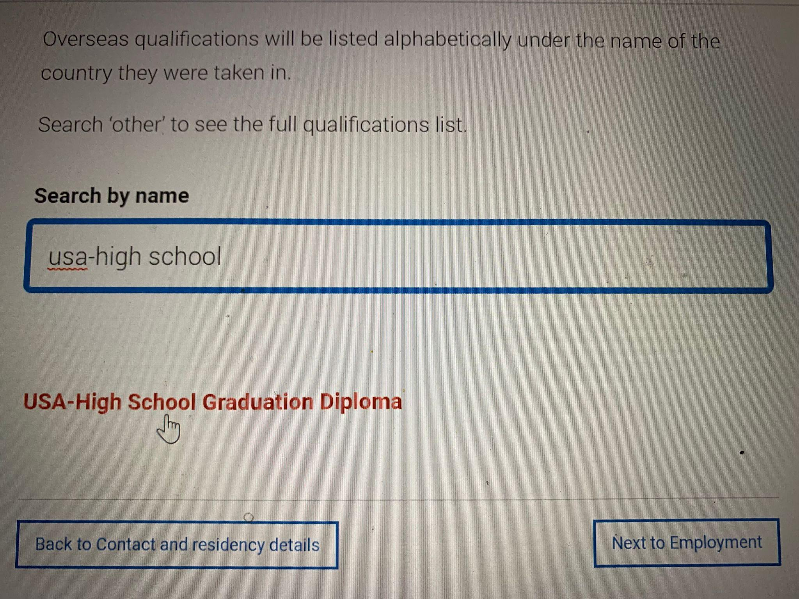

If you are graduating in the future, you will enter the future date and “Pending” in this section as the Grade. This will allow you to mark the section as complete.

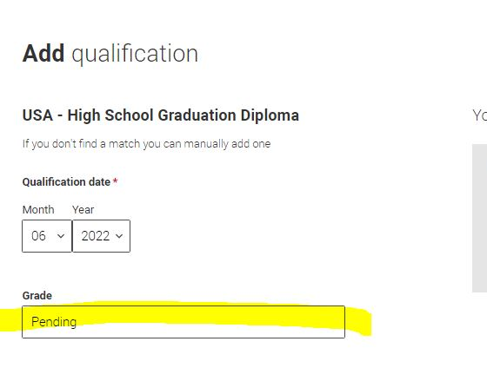

Continue to add your qualifications accordingly, which may include; AP tests, SAT/ACT, and College Level Coursework. Again, you must search for these qualifications - it helps to type in USA in the search bar.
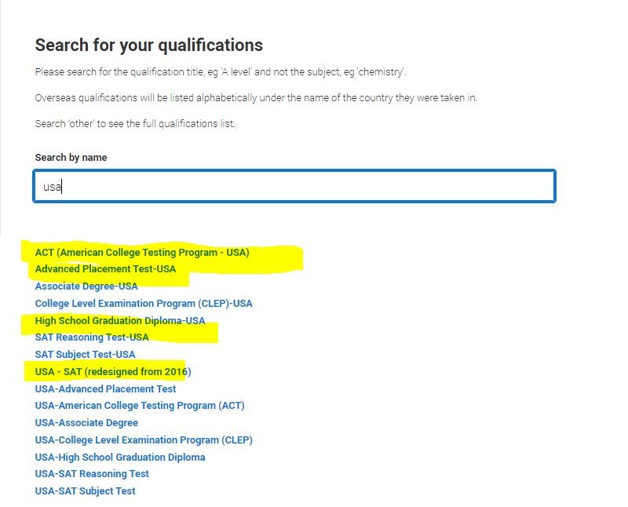
How do I indicate my dual enrollment coursework?

What if I’ve taken College courses at community college or a university but did not receive a degree?

To add Community College Coursework or additional units you’ve taken outside of your high school at a local college/university if you did not graduate with an Associates Degree, you will add your credits under Other (International Non-EU Qualifications). Add each class as a qualification to the community college.

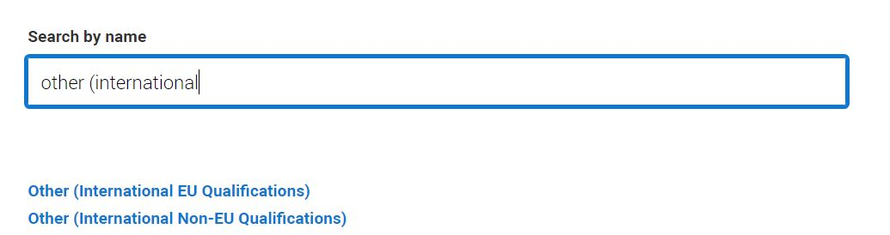
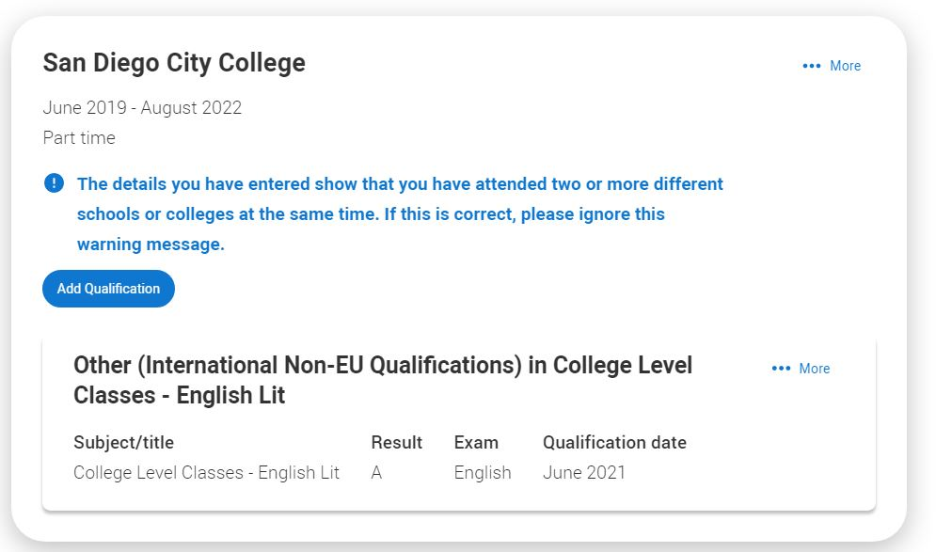

NATIONALITY SECTION

What does my “first date of entry to UK” mean?

This is confusing! It refers to your point of entry into the UK for your degree, which you should put in the UK format as 01-09-2022 (that is, September 1st 2022)

What if I don’t have a passport & I’m asked for my passport number?

If you don’t have a passport currently, indicate “no.” It is okay to indicate “no” at this time, just be sure to look into getting a passport as soon as possible, as it can take up to 3 months to receive it in the mail.
If you do have a passport, indicate “yes.” It will then prompt you to insert your passport number accordingly.

PERSONAL STATEMENT
What should I write in my personal statement, should I focus on anything in particular?
- This video should help you better understand how to write your personal statement.
- Overall, your statement should show your true passion for the particular subject and how you have and will demonstrate your passion.
- Remember you have extensively filled in your Education and Qualifications information elsewhere in the application so you don’t need to mention them here - especially as you have a limited amount of characters to play with.
- You should showcase any relevant achievements outside of the classroom, extra curriculars etc but always relate things to the subject area to which you are applying. This is the major point where UK and US college applications differ and you want to show the reader that you’ve put some background research in and you know this!

REFERENCE
Does my reference need to be in before I can submit my application?
Yes!!
What should I expect from the reference and how should my referee write their recommendation?
A UCAS reference is equivalent to a U.S. letter of recommendation. There are a couple of areas to highlight as reference below:
- This should give you more insight on your reference!
Advice for references - how and what to write
- Here’s an overview, so you know what to discuss with your referee:
a. It might include your career goals and work experience – so talk these through with them first – as well as how well you’ve done in specific modules or course components.
b. If your referee is one of your teachers, they can add your predicted grades for any pending qualifications you’re studying now.
c. With your permission the reference could include circumstances that have affected your academic work or achievements, such as a personal problem, illness, or any individual needs you have. This may include any adverse impact the coronavirus (COVID-19) pandemic has had on your studies or assessments due to illness, personal circumstances, or challenges with learning at home.
Note for all references: the system may time out after 35 minutes, continually save your reference so it does not disappear after timing out.
​What are predicted grades?
A predicted grade is the grade of a currently unfinished qualification your school or college believes you’re likely to achieve in positive circumstances.
These predicted grades are then used by universities and colleges, as part of the admissions process, to help them understand an applicant’s potential.
Click here for more guidance on predicted grades!
Note - be sure that these grades are in fact pending (currently unfinished) and that all qualifications in your education history have been clearly labelled complete or pending.
Other Helpful Notes - Differences
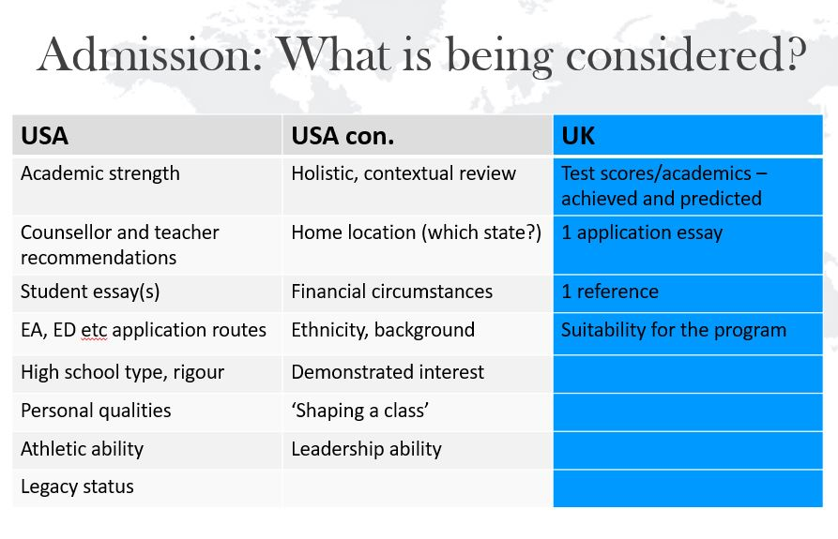

SUBMITTED - What happens now?
Am I able to send my test scores and academic transcripts to York?
Yes, but only when requested and only digitally. You can send all of your supporting documents: full test score reports & transcripts to our UG admissions email: ug-admissions@york.ac.uk.
How long will it take to hear back from York?
York has rolling admissions so you will normally hear back a couple of weeks after submitting your application. All students must hear back by March 2022, however it is likely you will receive an answer sooner.
Acceptance: Conditional vs Unconditional?
If you are still finishing high school or community college in 2021-22 or have test scores in progress, you will receive a conditional offer until you fully finish your degree. Once you’ve sent in all remaining documents and have scored accordingly on your test scores, you will receive an unconditional offer.

GENERAL UCAS GUIDANCE
FILLING IN YOUR UCAS UNDERGRADUATE APPLICATION

