Below are the editions and ISBNs for your American Literature summer reading list. Please be sure that you purchase the correct edition, especially with The Great Gatsby, since there are many different versions out there. Failure to purchase the correct edition will result in a loss of points to your class participation grade and will cause you to be lost during class when your page numbers are incorrect! E-books are not permitted for use during class. All these books should be available on Amazon and on Thrift Books if you prefer not to use Amazon.
The Crucible by Arthur Miller. ISBN: 9780143129479. Penguin Orange Collection
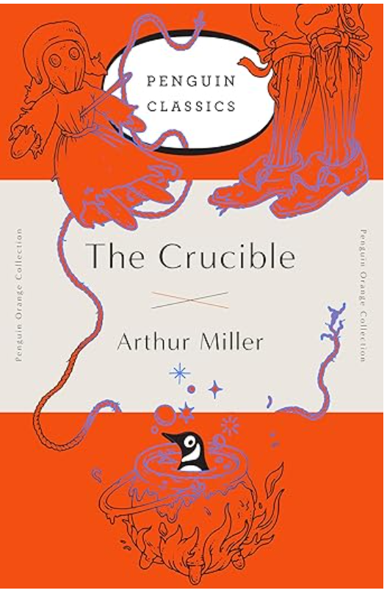
The Great Gatsby by F. Scott Fitzgerald: ISBN: 979-8745274824. Original 1295 Edition
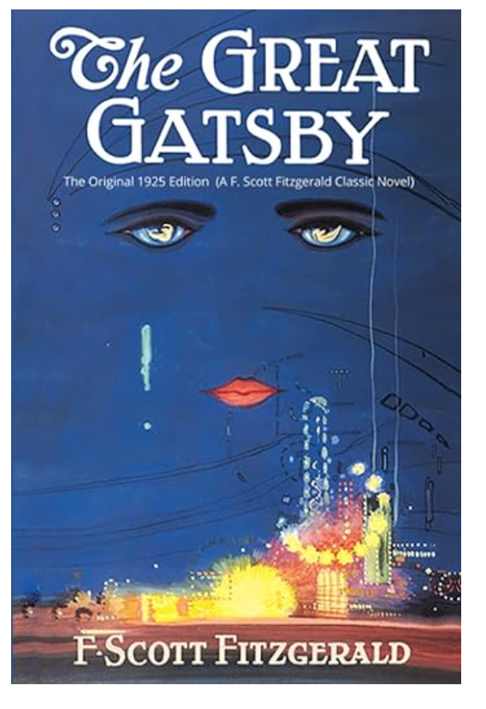

Ethan Frome by Edith Wharton: ISBN: 978-0486266909, Dover Thrift Editions
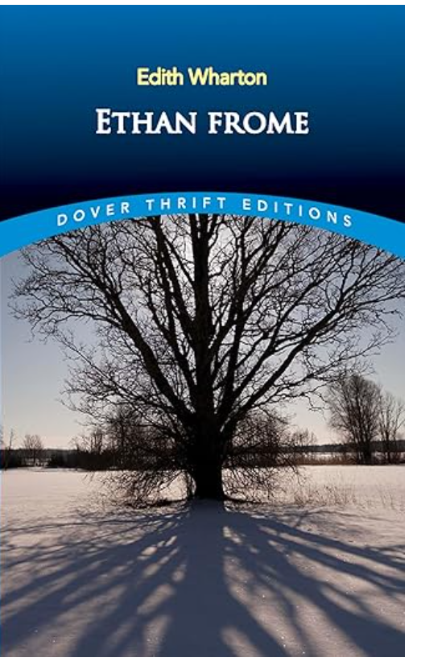
Unaccustomed Earth by Jhumpa Lahiri: ISBN: 978-0307278258. Vintage Contemporaries
