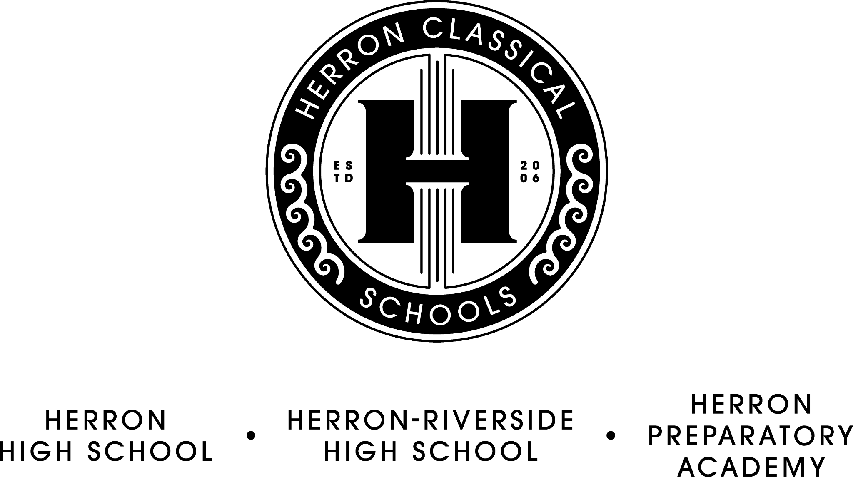

Herron Classical Schools Board Meeting Agenda
June 18, 2024, 7:30am
HCS Admin building 1715 N. Meridian

7:30 Board Meeting Agenda

- Call meeting to order (Roy)

- Approve minutes (Roy)

- Executive Committee report (Roy)
- OEI Board Assurance Form Accountability Reports

- Treasurer’s report/Fiduciary Committee report (Miller)
- Budget 2024-2025
- Financials
- Vouchers

- Development Committee report (Sternberg)
- Annual Fund/Campaign update

- Education Committee Report (McNeal)
- Summer Academy (Dorsey)
- CSGF Project ABC opportunity
8). President’s Report (McNeal)
- Hiring status
- Enrollment update and initiatives (Lowery)
- HPA construction update (Osterkamp)

Adjourn

Executive Session
- staff evaluation

The next board meeting will be on August 20, 7:30 AM.

