Warehouse Requisition Approval & Process/Print Instructions

In eFinance

Approval Steps
From Main Menu drop down select Warehouse Inventory
From side menu under Warehouse Inventory select Approve Requests (Select Request Approval in your Favorites)
A new window will pop up (if this doesn’t happen check for a pop up blocker)
Click Find button
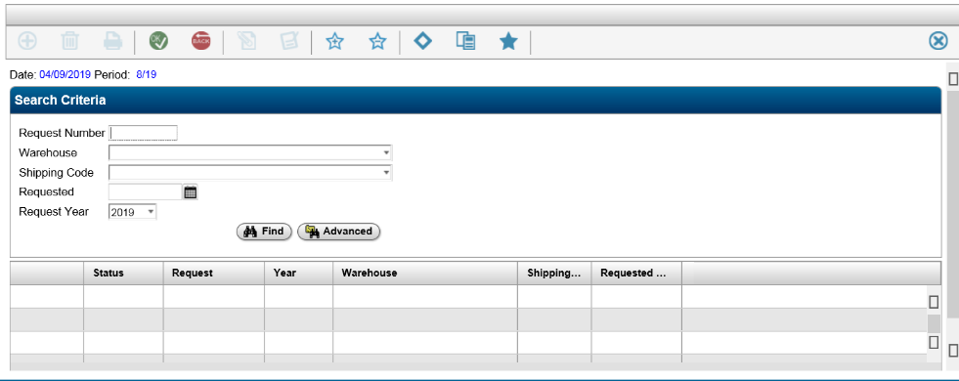
Any requisitions that have been entered will populate below.
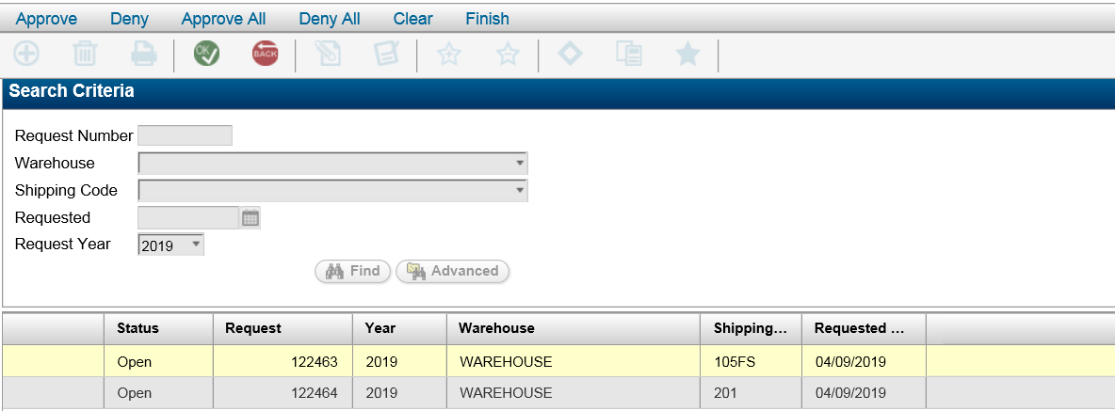
Double click each req and review each item to ensure they haven’t entered a mistake: 1000 paper clips
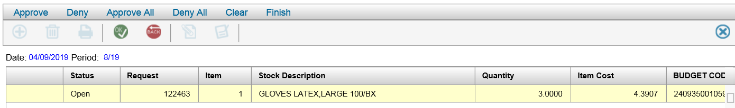
If no obvious errors then click Approve/Approve All click OK and repeat with each request.
Once you have reviewed all orders I write down the Request numbers then click Finish

Back out of this window.

Processing/Printing Steps
From Main Menu drop down select Warehouse Inventory
From side menu under Warehouse Inventory select Warehouse Administration (or select Warehouse Administration from your favorites)
Click Fill Requests
Select Warehouse: 923 then click OK at top of screen
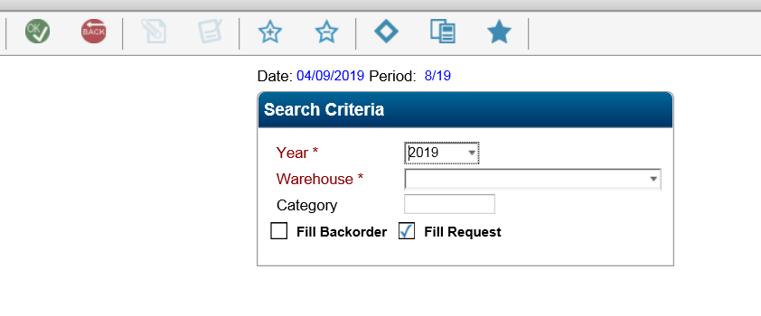
It will ask to Enter Criteria for Request Fill - leave this blank and Click OK
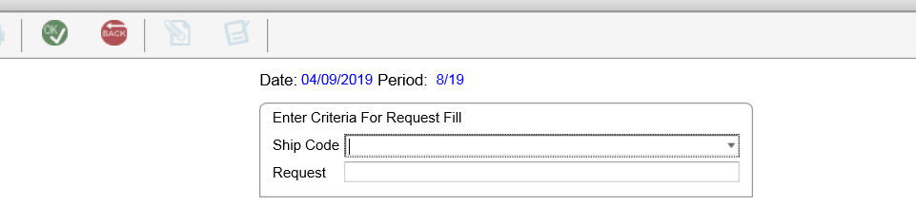
There will be three Confirmation/Questions in pop up windows:
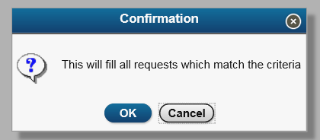
Do you want to fill requests that exceed budget for accounts set to Warning? Yes
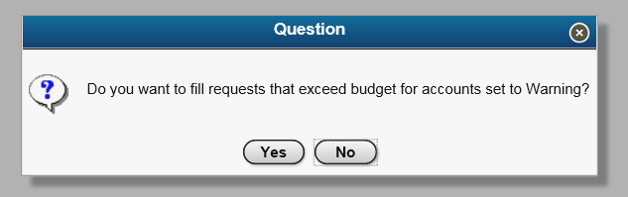

The final is the option to print the exception list - select OK if you want to see it or Back to ignore ( I have never printed this)
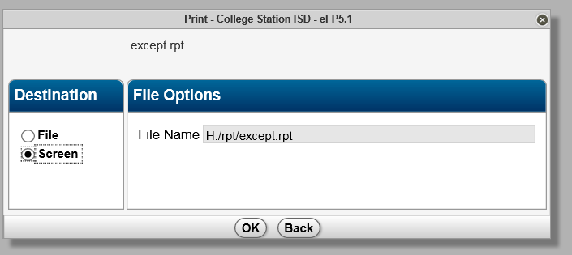
Note the Fill ID number in the red box.
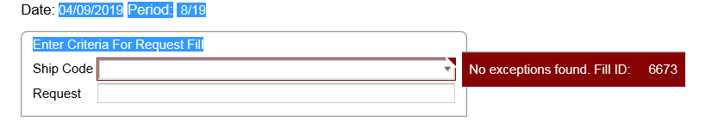
Click Back button twice to get back to Warehouse Admin page.
Click on Pick Pack List
Enter either the Fill ID Number or Request Number
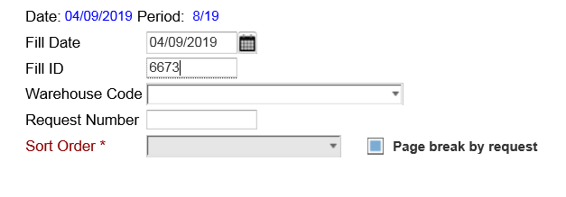
If entering the Fill ID Number : tab down to sort order
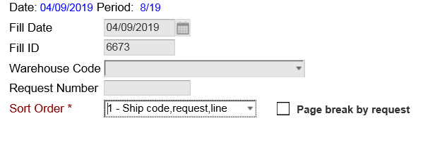 don’t change the sort order
Page break by request?
a. If you click the page break by request - all back orders will be separated from the current pick pack lists. This can cause confusion with the secretaries that are tracking the backorders. If this happens enter each request number separately and print.
b. If you do not select Page break by request and there is more than one order with the same ship code then it will put those orders on the same page. The secretaries do not like this either. If this happens enter each request number to print

Click OK -
Pop up window: Include Comments? Would you like to include Comments? YES
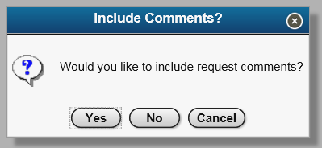
Packlist window: Click OK
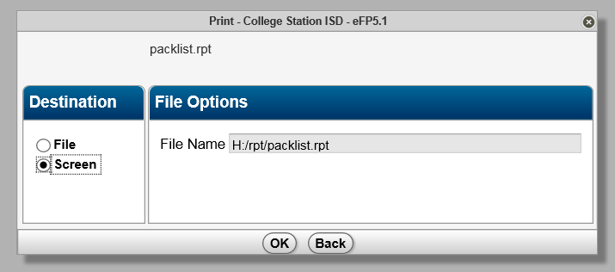
It will think a minute and then a small orange window will pop at the bottom of the screen: Do you want to open or save Packlist….from sctfinapp1.csisd.org? Click OPEN
An adobe window will open with the pick pack lists you have approved.
Look to make sure each order is on a separate page.
Click print - make sure the right printer is selected \\Print08TC\TC-HP
Change Copies to 2 - uncheck the collate box
Check to make sure you are NOT printing on both sides of the paper
Click print at bottom of page.

If any of the orders are longer than one page then it is best to print that order separately and print on both sides of the paper.

If you receive this window after clicking ok to the Packlist window
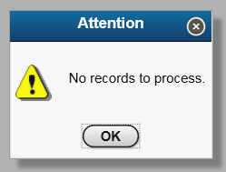 Then something has gone wrong. Double check your fill id or request number. If you are looking up a request from an earlier date then it is likely the date. Try removing the date and entering the number again.

