- Open the Requisition listing window.
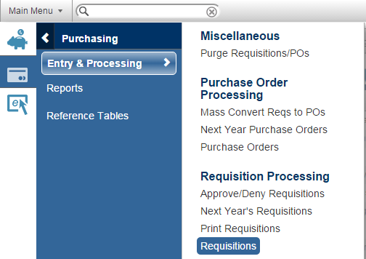
- Main Menu Purchasing Requisition Processing Requisitions (double click on Requisitions)

NOTE:
If the Requisition Listing Screen does not open, it was probably blocked. See pages at the end to allow pop ups for eFinance.

- Click the toolbar’s New button  to open the New Requisition Information window.
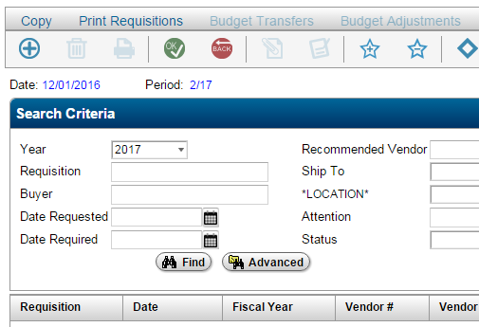

- Requisition # - Make note.
- Location – Select your location.
- Requested – Defaults to current date.
- Required –This is the date the items/service is needed by. ** Be sure to enter a date in the required field.
- Vendor – Enter Vendor number or click on magnifying glass to search for vendor name. Example: enter *wilton* and it will bring up any vendor with wilton in the name. Reminder: The vendor Must be an awarded/approved vendor on the Annual bid list or one of the Cooperatives list. If an awarded/approved vendor needs to be added please complete the new vendor request form and email to vendor@csisd.org.
- Vendor Address –Is vendor name and address correct?
- Add Attachment?-Check box if attachments will be added to the req. (quotes, cart, etc.). When the req. is saved the attachment window will automatically open.
- Freight – Leave Blank. This field defaults to F.O.B. Destination
- Comments – Required Enter the Bid or Coop and #.
  - Missing Bid or Coop # will delay the approval
- Buyer – Your name
- Attention – Who the Purchase order green/yellow will be sent to
  - Enter as “Dept/campus / Name / teacher”
- Ship To –
  - Use 923 for warehouse, or
  - Campus/Dept Location code for local orders/hand carry POs
- Ship To Address – Where items will be shipped.
- Notes –See box below
Click OK – To begin entering Line Items.

- In the Header tab complete the necessary fields.
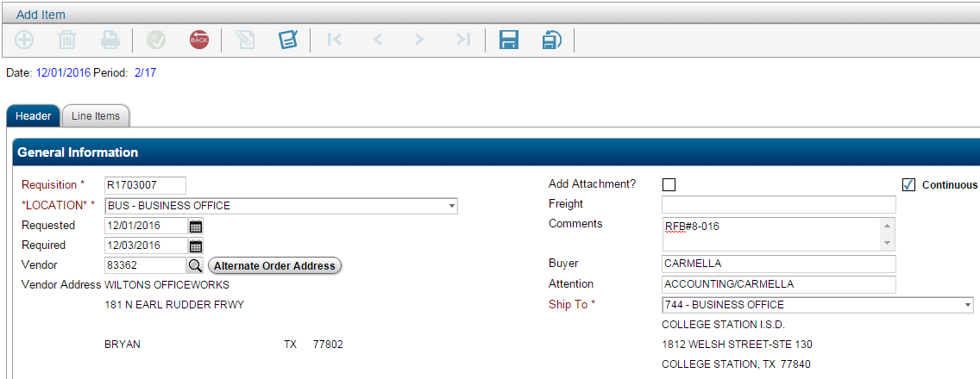

m
<- n

a
b
c
d
e
f
g
h
i
j
k
l
m

n. NOTES – Tells us where to send the purchase order to place the order.
FAX PO with/or without attach to (000-000-0000, with attachments or no/attachments. Be sure the email/fax number is correct. Remember to attach the items to be sent to the vendor.
Email PO with or without attach to (enter email address)
DO NOT ATTACH INVOICES.
IMPORTANT: IF THE NOTES DO NOT HAVE FAX, EMAIL OR OTHER INSTRUCTIONS THE PURCHASE ORDER WILL BE SENT TO THE CAMPUS/DEPT TO PLACE THE ORDER WITH THE VENDOR.

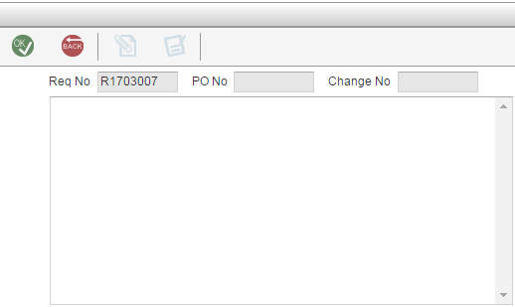
- Notes – Enter one of the 3 required options.

FAX PO WITH/WITHOUT ATTACHMENTS 000-000-0000

EMAIL PO WITH/WITHOUT ATTACHMENT (email address).

NO NOTES = WHITE COPY OF THE PO WILL BE SENT TO THE CAMPUS/DEPT TO PLACE THE ORDER WITH THE VENDOR.

Notes – One of these 3 options must be entered in the Notes field, so we know how who will place the order with the vendor.

FAX PO with/without attach to (000)-000-0000 – Use for purchase orders that need to be faxed to the vendor. Be sure the fax number is correct. Purchasing will place order with vendor.

EMAIL PO WITH/WITHOUT ATTACHMENTS to (email@xxx.com) – Use for purchase orders that are to be emailed to the vendor. Purchasing will email the vendor and copy you to place the order with vendor.
NO NOTES = Purchasing will send the white copy of the PO to the campus/dept to place the order with the vendor or hand carry to the vendor.

Be sure to attach anything needed for Purchasing to approve and place the order (ie Quotes, Attached list, Sole Source, etc.).

DO NOT ATTACH INVOICES.

IMPORTANT: IF THE NOTES DO NOT HAVE OR FAX OR OTHER INSTRUCTIONS THE PURCHASE ORDER WILL BE SENT TO THE REQUESTOR TO PLACE THE ORDER.

- In the Line Item tab complete the marked fields.
- Description – Enter Detailed Description including Part #’s even if the quote is attached.
Please note: Only the first 21 characters print on vendor check and budget reports.
- Shipping Charge –Check if there will be shipping costs.
- Continuous – Check if there are more than one-line items to be entered
- Measure – Each, Case, Dozen, Etc.
- Quantity – Number of items being ordered
- Unit Price –Enter Price
- Shipping – Enter Shipping Cost
- Budget Code – Enter Budget
  - See important note below.
- Account – Enter Account
- OK – If more line items are to be entered.
- Save – When finished entering all line items.
- Save In Progress – saves the requisition so that it can be edited or finished later. It will not show up in the approval screen until the save icon is selected once finished.

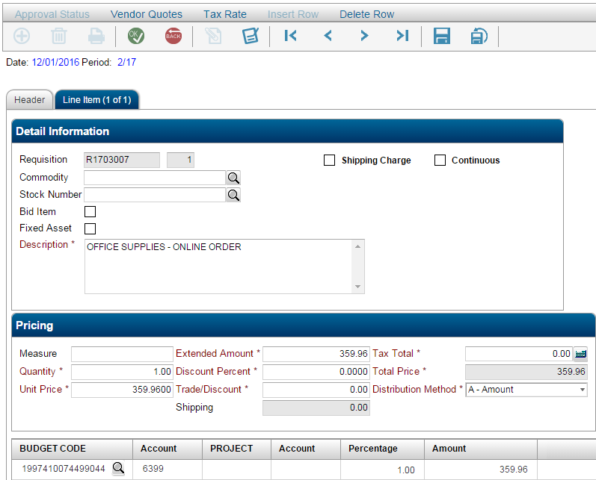

j
k

b
c

a

Enter Detailed Description including Part #’s even if the quote is attached.
Please note: Only the first 21 characters print on vendor check and budget reports.

d
e
f

g

h
i

IMPORTANT: Purchase order must be coded correctly according to TEA.
Please do not use an incorrect budget/account just because it has funds, instead prepare a budget transfer to move the funds to the correct budget/acct.
***** Using an incorrect budget/account code will delay the processing of the PO. ****

- Attachment Information Window
  - Pops up automatically when the requisition is saved if the “Add Attachment?” box was checked on the header tab.
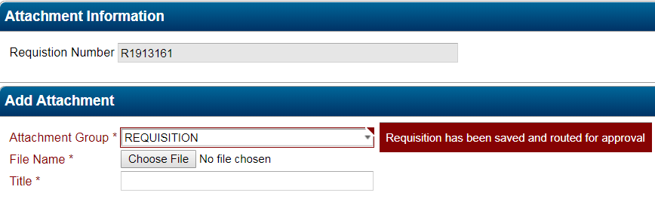

Attachment Group- Leave REQUISITION

File Name – Click Choose File to search for the file (s) to be attached.

Title = Enter the title of the document. (Quote, attachment list, registration, etc.

- Adding Attachments - After Saving if the “Add Attachment?” box was NOT checked on the header tab.

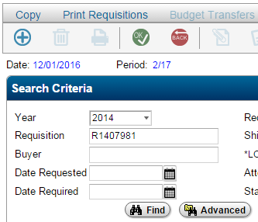
In the Requisitions Listing Window search for the Requisition that needs attachments added

Enter the Requisition Number and Click Find

IMPORTANT:

Recommendation: Create a Folder on your Desktop called Requisition Attachments to save the files to be attached to requisitions.

IMPORTANT:

Recommendation: Create a Folder on your Desktop called Requisition Attachments to save the files to be attached to requisitions.

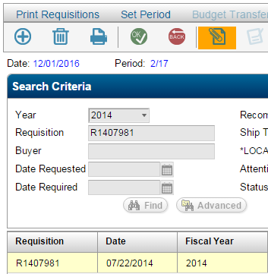

Highlight the Requisition and Click Attachments

IMPORTANT:

Recommendation: Create a Folder on your Desktop called Requisition Attachments

Save the scanned attachments as requisition number, for example “R1407981” in your Desktop Folder called Requisition Attachments.
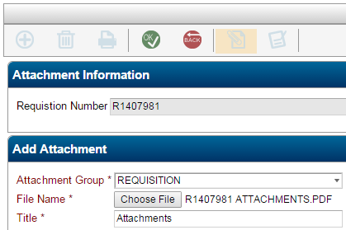
4th – Click Ok
2nd – Locate File to Attach
- Select Desktop
- Select Requisition Attachments Folder
- Select file to attach (R# Attachments)
- File name = file to be attached to the Requisition
- Click Open
1st - Click the Choose File icon to search for the saved attachments (R1407981 Attachments)

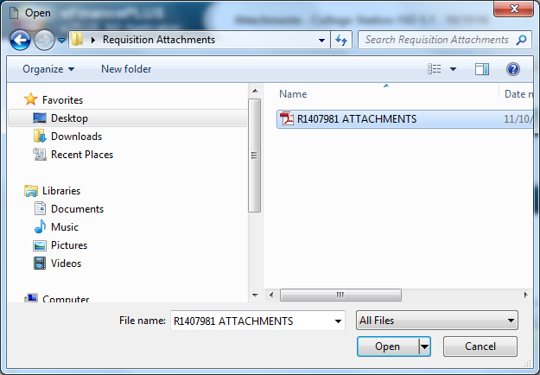
B
3rd – In the Title Box - Type “Attachments”

C
E
D
A
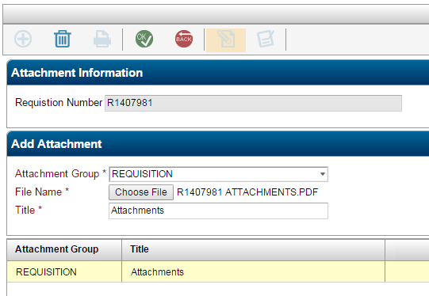

The attachment shows up in the box under Attachment Group

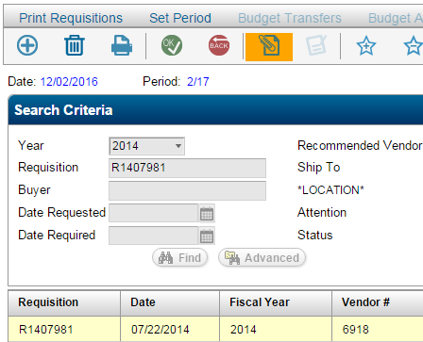
In the Requisition Listing Screen the Attachments button turns orange when the requisition has attachments.

- Approving the Requisition
Purchasing Entry & Processing Requisition Processing Approve/Deny Requisitions (double click)

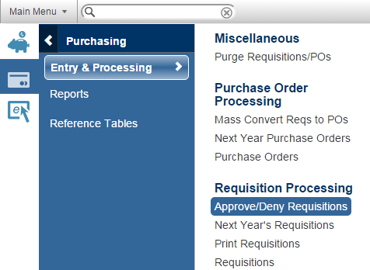

- In the Approval Criteria section,
Leave all of the fields blank and Click “OK” 2 times to pull up the requisitions to be approved.

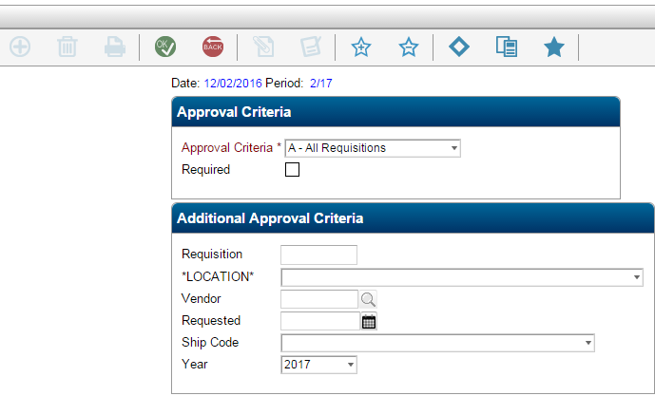

Approval
Criteria

Additional Approval Criteria

- In the Requisitions for Approval Window
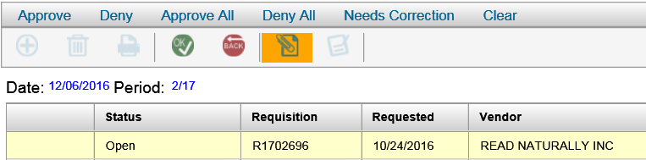
Notice the Attachments button is also orange in the Approval Screen since attachments were added to the Requisition.
Highlight the requisition(s) to be approved

Select – Approve to approve requisitions individually, or
Select – Approve All to approve all requisitions listed at one time

The Status field will change from Open to Approved.

Once all requisitions are approved select OK until print window opens.

In the print window select OK to generate the Requisition Approval/Denial Report and update the status of the requisitions.

Do not click back until report is printed!!! Otherwise the requisitions will have to be approved again.

See sample report on next page.
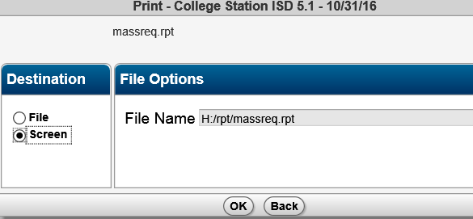

Sample Requisition Approval/Denial Report
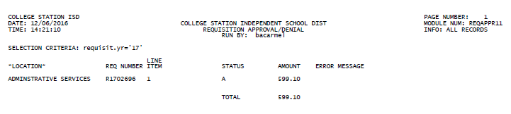

Important Items:

Pop up Blocker – Edit to allow eFinance screens to pop up

Google Chrome

If you see 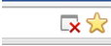 the icon next to the star with the red X then the pop up was blocked.

Click on the Red x
Check always allow pop ups from cstfinapp1.csisd.org
Click Done
Then double click on Requisitions again.

Explorer

- Launch an Internet Explorer browser window.
- In the IE navigation bar click Tools > Internet options > select the second tab, Security.
- In the Select a zone... box click the green check mark, Trusted sites and then click the button below that says Sites.
- Under Add this website to the zone: should have https://cstfinapp1.csisd.org. If not add it.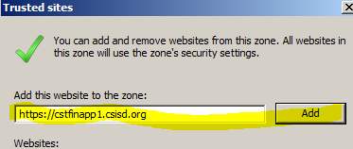
- Click the "Add" button, so that the cstfinapp1.csisd.org URL appears in the list of "Allowed sites."
- Click Close to exit the window.
- Click Ok to exit the window.

Items that were on the top are now are now at the top (see screen shot below)
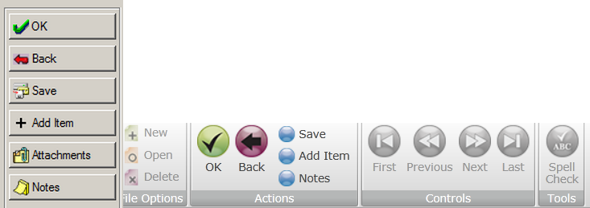
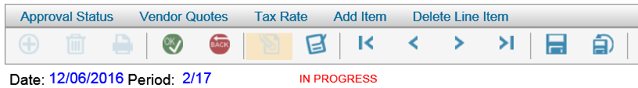

Logging Out
Use the log out button (all the way to the right) when done. 

If you don't see Log Out, make the screen bigger until you do.

