REQUISITION APPROVAL STATUS IN EFINANCE
- Open Requisition Listing—looks like this at top of page…
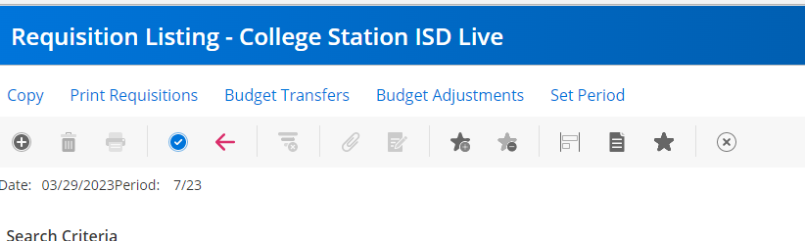

- Click blue check  and this will list all your requisitions or just enter your Req number and hit enter.
- Choose your Req from the list by double clicking to open it.
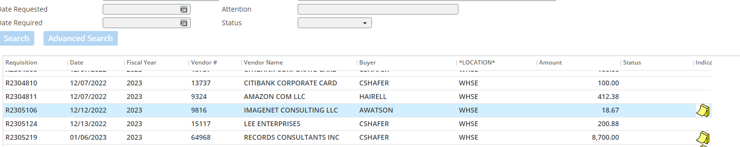
- If you see a PO number in the Status box of your line items, it has already been approved/converted/printed. No longer needing any approval.
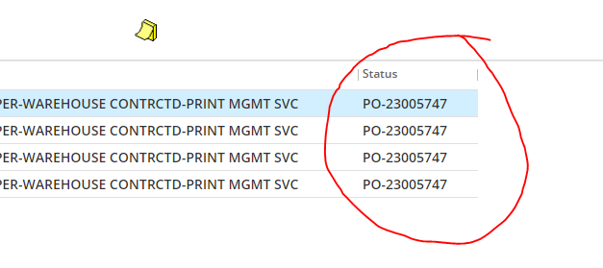
- If you see “Partly Approved” in the Status box of a line item, it is waiting on approval from someone.
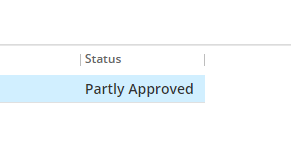
- Highlight the line item (click on it) and you will see “Approval Status” at the top of the page. Click on that.
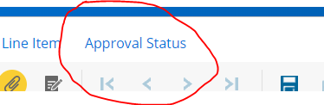
- The following box will open and you will see every person that has approved it as well as the status level that it is waiting on. (more info on the status levels below)
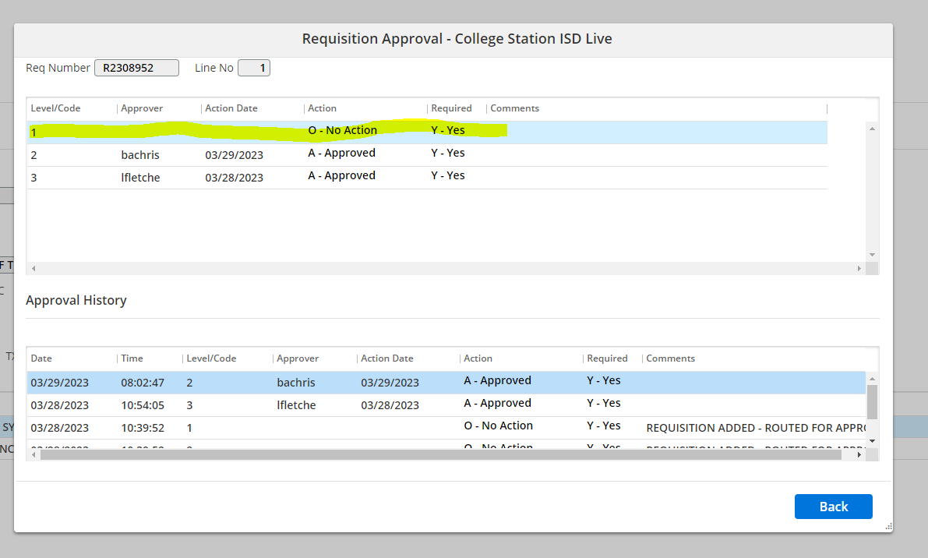

In the example above, you can see that the secretary (Level/Code 3) has approved it as well as Level/Code 2 approver and is waiting on one more approval –Level/Code 1 (highlighted). This example only has 3 levels of approval. Some campuses/departments could have up to 5 levels of approval based on what the funds are used for as well as if the purchase is over $5000, etc.

Level/Code 1 is always Purchasing—if you see that waiting, it is ready to be converted/printed
Level/Code 2 is always Chris Neely or Amy Drozd.
Level Code 3 is usually the principal/director if it is over $5000 or specific person that is designated (could also be a dept secretary in some cases)
Level/Code 4 is for a campus/department secretary who entered it or is the next approver (Most campus/dept secretaries will be at this level)
Level/Code 5 is usually the person that entered the requisition (first approver)—this code is usually only on requisitions using federal funds (i.e. Title I)

- If you have trouble figuring out who still needs to approve, if it says “0-No Action” it is waiting on someone’s approval. The codes above should give you a clue but as always, please contact purchasing and we can look it up as well.

