Common Name of Your Plant  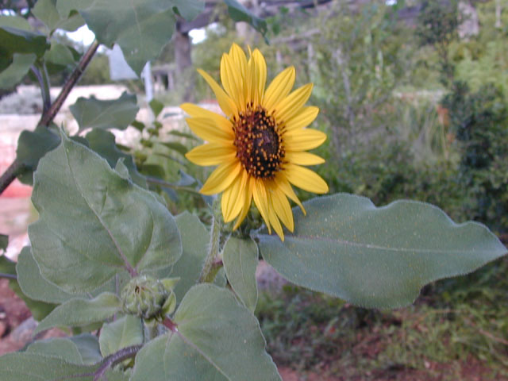  Location  Habitat  YOUR NAME HERE CLASS PERIOD HERE |  | Common Name of Your Plant (again)  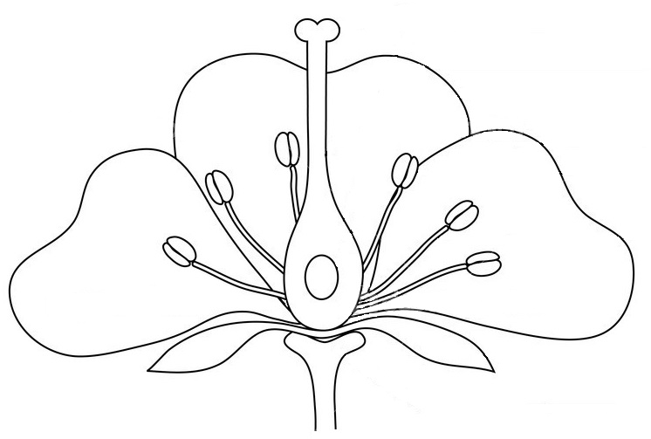  Life Cycle  Tropisms  Benefits and/or Hazards  YOUR NAME HERE CLASS PERIOD HERE
  Kingdom | Sci:  Com:
  Phylum/Division | Sci:  Com:
  Genus | Sci:  Com:
  Species | Sci:  Com:
  Scientific Name | Sci:  Com:

