Kindergarten Information Packet
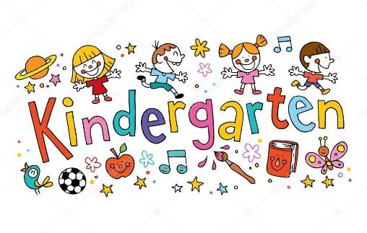
Dear Parents/Guardians,
Kindergarten is a big adjustment for students, but we will work together as partners in education to make this school year a special experience.
In this packet there is valuable information about various subject areas, guidelines, and classroom behavior. Please keep and review this packet throughout the school year. As your child's teacher, I will provide a safe, caring, and educational environment. We look forward to positive relationships with all my students and their families.
Our Schedule:
8:45-10:15 Reading
10:15-11:20 Writing
11:10-12:00 Lunch/Recess
12:00-12:40 WIN Intervention Time
12:40-2:00 Math
2:00-2:45 Specials
2:45-3:15 Science/Social Studies
3:20 Dismissal

WIN Intervention Time:

Students receive tiered instruction in the areas of math, reading or writing. This will be in addition to the instruction delivered during academic instruction. These interventions help provide additional support for struggling students and opportunities to extend learning for those that need to be challenged.

Reading and Writing:
Reading is a major focus in the life of a kindergarten student, so a great deal of the curriculum will revolve around letter identification and recognition, decoding words, and reading sight words. Phonics also plays an essential part of learning to read words that are unfamiliar to the students. Other activities include shared reading, poems, learning songs, and word families.
Our interest and goal in kindergarten is to make reading a pleasant activity for each of our students. Success in reading equals success in school!
Our writing focus will be on beginning writing skills. We will work on individual and group creative writing, as well as journals. We will also work on simple sentence structure and punctuation.

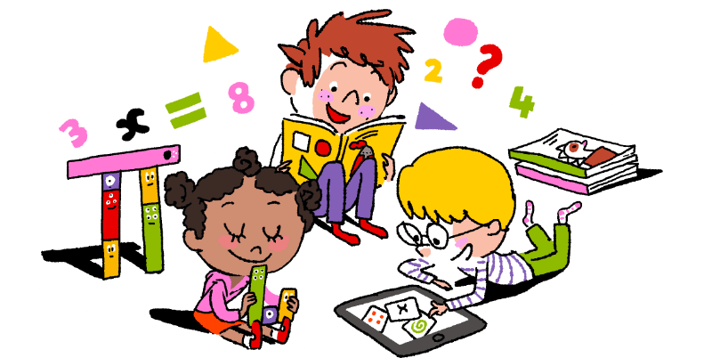
Math:
Math is also an integral part of our daily curriculum. We will use a variety of math manipulatives to introduce your child to several math concepts. Curriculum lessons will cover numbers 1 -100, counting, graphing, sorting, patterning, composing/decomposing, single digit addition, and subtraction.


Science and Social Studies:
Science and Social Studies will be taught through hands-on experiments and literature. Some of the S.S. and Science themes will include: communities, community helpers, citizens, countries, holidays, history, animals, plants, living and nonliving things.

Handwriting:
The handwriting program is developmentally based and appropriate for all children. The focus is on correct letter formation, spacing, pencil grip, and size of writing. Please note the proper letter formation when helping your child with their handwriting. Always encourage your child to start writing from top to bottom, left to right.


Homework:
Homework will consist of assignments that reinforce what has been learned in the classroom. Homework plays an important role in education. It teaches students responsibility and supports what your child is learning in school. It is also a wonderful connection between school and home. Furthermore, studies consistently demonstrate the positive impact home support has on a child’s success at school.


Assessment/Grading:
Children learn in a variety of ways, (individual, cooperative groups, exploration, etc…) and we plan to introduce them to a number of learning techniques this year. Therefore, we will be utilizing a wide variety of assessment tools to gauge their understanding. We will meet to discuss your child’s progress in October and February.
Our grades and report cards are aligned with the Arizona State Standards.


Student Behavior:
In order to provide a safe and positive learning environment, it is necessary to discuss behavior expectations. We believe that all students can behave appropriately at school and accept responsibility for their actions. All students are expected to display behaviors that reflect quality character. As a class we will discuss our classroom and school rules and what they mean starting on day 1. Each of us will communicate our classroom expectations and procedures at a later time.

Rules
- Be Kind 2) Be Safe. 3) Be Responsible

Rewards
Students who behave appropriately may be positively rewarded with:
-Verbal/Non Verbal Praise -Treasure Box -Note Home -Panther Paws

Consequences
If a student makes the decision to break a rule, the following consequences may apply:
1st Verbal Reminder 2nd Warning 3rd Time out/loss of recess 4th Contact Parent

Trustworthiness
• Be honest • Don’t deceive, cheat or steal • Be reliable - do what you say you’ll do • Build a good reputation • Be loyal • Have the courage to do the right thing •

Respect
• Treat others with respect & follow the Golden Rule • Be tolerant of differences • Use good manners, not bad language • Be considerate of the feelings of others • Don’t threaten, hit or hurt anyone • Deal peacefully with anger, insults and disagreements

Responsibility
• Do what you are supposed to do • Persevere: keep on trying! • Always do your best • Use self-control
• Be self-disciplined • Think before you act - consider the consequences • Be accountable for your choices • Return assignments on time • Seek help when necessary

Fairness
• Play by the rules • Take turns and share • Be open-minded • Listen to others •• Don’t take advantage of others

Caring
• Be kind • Be compassionate and show you care • Express gratitude • • Forgive others • Help people in need

Citizenship
• Do your share to make your school and community better • Cooperate • Get involved in community affairs • Be a good neighbor • Respect authority • Protect the environment


Newsletters:
Our newsletter, Kindergarten Kudos, will be sent home every week. The newsletter will include information about various things that are happening at school and in the classroom. Please make it a habit to review the newsletter thoroughly to stay well-informed about your child’s education.

Birthdays:
Birthdays are very special! If your child would like to bring in treats for his/her birthday, please notify your child’s teacher prior to the day you plan on bringing in treats. Our new school policy is that all treats must be individually wrapped (an example would be Rice Krispie Treats). PLEASE provide napkins and/or plates if needed. This makes distribution much easier. Please remember that the treats cannot be homemade, they must be store bought and peanut free. If your child has a summer birthday, we can celebrate it as a half-birthday. Birthday invitations may not be passed out at school. In the past this has led to hurt feelings, confusion, and tears. A class directory with contact information will be sent home. Only families who choose to be on the class directory will be included.

Share Bag:
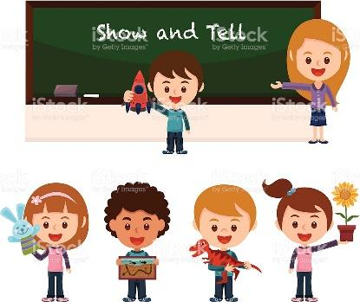
In January, we will be sending home a bag (which is the share bag) approximately once a month. Your child can bring one object from home (nothing breakable or valuable). The other children will try to guess what is in the bag. The children enjoy this activity because they get to share something special with their classmates. There will be a note in the pillow case explaining the share bag and how to write down some clues. Please do not send in toy guns, swords, or expensive items. Share bag should be the only time when toys are brought to school.
Shoes:

The kindergarten students here at Arrowhead love their playground! We have many different activities for them to do during recess. It is very important for your child’s safety that they wear appropriate shoes. For example, sneakers/tennis/gym shoes are the best choices. Flip flops, sandals, or platform shoes are dangerous. Woodchips do get stuck in the children’s feet and it hurts! In addition, since kindergarten students will have P.E. this year, they must wear appropriate shoes every day, or they will not be allowed to participate in P.E. Also, your child needs to learn how to tie their own shoes.

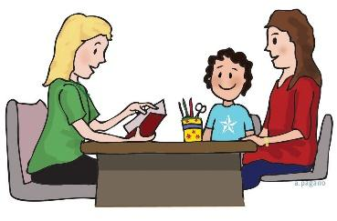
Conferences:
Conferences are required and will be held in October and February. On average, conferences usually last approximately 15-20 minutes. To ensure we are able to review all pertinent information in time, please find alternative care for your child. It is important to be punctual to respect the time of others. Parents will receive more information on sign-ups a couple weeks prior to conference week.


Volunteers:
Parent volunteers play an important role in the classroom and are greatly appreciated. Children benefit greatly by having positive role models and warm, loving adults around to provide added support. If you would like to volunteer in the classroom OR chaperone a field trip you will need to get trained immediately. Please check the Arrowhead website for the next class.
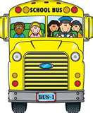
Transportation:
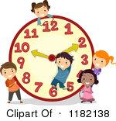
Any change in transportation must be accompanied by a email/note indicating the change, even if it is for that day only. Otherwise, your child will go home in their usual way. This is for your child’s safety! If you are late picking up your child, they will be in the front office. Your child will never be left unattended.

School Hours:
Our front office is open from 7:30 am to 4:30 pm. Deer Valley Unified School District is a closed campus district. Parents are not allowed on campus, unless they sign in at the front office, with a valid ID. Please remember that the school gates do not open until 15 minutes before school starts.

If you should have any questions or concerns, feel free to call or email your child’s teacher. We are here to help your child perform to the best of his/her ability. Do not hesitate to contact your child’s teacher about your child’s progress at any time during the school year. You do not have to wait for a formal conference time to address any needs or concerns. Kindergarten is a time of growth and we are excited to be a part of such a special time in your child’s life.
Respectfully,

The Kindergarten Team
Deborah Bondo Terri Fee Holly Flory Casandra Reaume

After signing, please detach this page and return to your child’s teacher.

___ I have read the kindergarten information packet.

Student Name _____________________________________

Parent Signature _____________________________________

Date _____________________________________

