Monday | Tuesday | Wednesday | Thursday | Friday
Name five of your favorite animals.  Describe these to a parent or friend. | Name three things you would like to do this summer. Describe your day answering, with who? What? Where? When? | Start a summer journal. Write a sentence or two about each day. | Cut out pictures  from a magazine  and think of a  word to describe  each one. | I Spy! Find 10  things that go in  your kitchen and  make a sentence  about each one.
I Spy! Find 10  things that go in  your kitchen and  make a sentence  about each one. | Play Time! Play  tic-tac-toe with  pictures and  describe each  picture on your  turn. | Play Time! Play a  memory game.  When you make a  match, use that  word in a  sentence. | Read a book with your parent. Take turns and  describe the pictures. | Name five things you  have in your fridge. Describe each one.
Spy! Find 10  things that go in  your bathroom  and make a  sentence about  each one. | Name five  foods, five animals, and  five sports. Write them  down. | Talk about the  sequence of making a  PB&J sandwich. Use first, next,  and last | Play a guessing game! use appropriate  WH questions. (where would I see it? How to use it?what is it made of? What category does it belong?) | Tell your parent  how to brush your  teeth. Use first, next,  and last.
Draw yourself engaged in your favorite activity.Write a sentence or two about your picture. | Play a guessing game! use appropriate  WH questions. (where would I see it? How to use it?what is it made of? What category does it belong?). | How are an  apple and a banana  the same? How are  they different? | Give two meanings of the word “duck” draw a picture to illustrate each meaning. | If you had one  wish, what would you  wish for? Why? Write it  down!

June

July

Monday | Tuesday | Wednesday | Thursday | Friday
Draw something you see or do at the zoo. | Tell about your five favorite sports. Describe each one. How are they different? How are they alike? | Look through a book or magazine , describe the picture to someone that can’t see it. | Give two meanings of the word “left” draw a picture to illustrate each meaning. | Tell how a cat and dog are alike? How are they different?
Name as many things as you can think of that rhyme with an object you see (i.e chair..hair, fair, bear) | Give two meanings of the word “sink” draw a picture to illustrate each meaning. | Write a letter or an email to a friend or relative. Tell them what you did last week. | Find five things in your house that have a name ending with the same sound your first name ends with. | Give two meanings of the word “duck” draw a picture to illustrate each meaning.
Write an acrostic poem using the word  S  U  M  M  E  R | Find five things outside that start with the same sound as your last name. | Have Mom or Dad name a feeling .Make a face for that feeling, Tell a situation that would make you feel that way (i.e sad, happy, disappointed, surprised) | Name 3 items in a category to a partner, have them name the category then list two more items belonging to that category | Have a partner say a “false” sentence, then you say the sentence correctly.  Partner: Grapes are always orange  You: Grapes are never orange
Put 10 different items in a bag or box, give clues so your partner knows which item to pull from the box. | Tell how a pen and pencil are alike? How are they different? | Find five things in your house that start with the same sound as your first name. | Give two meanings of the word “glass” draw a picture to illustrate each meaning. | Create an All About Me book. Draw pictures, use pictures from magazine or your own digital pictures.


August

Answer as many questions as you can for each picture:
What is it?
What does it do?
Where do you see it?
What is it made of?
What category is it in?
Name another item from that same category.

Monday | Tuesday | Wednesday | Thursday | Friday
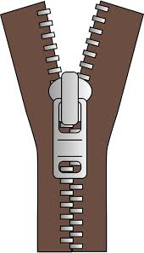 |  |  |  | 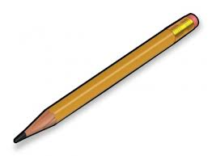
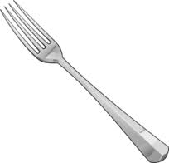 |  | 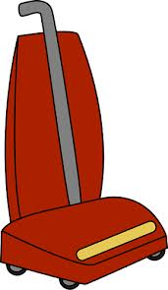 | 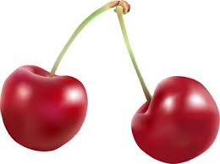 | 
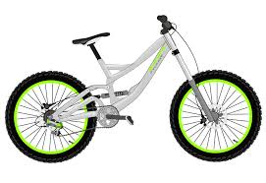 |  | 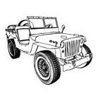 | 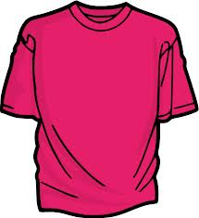 | 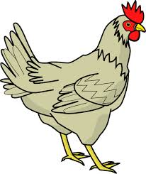
 |  |  | 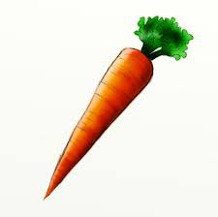 | 

