
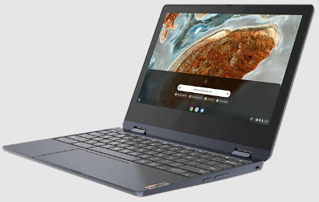
Caring for your Chromebook

Students are responsible for the general care of the district or school-owned Chromebooks they were issued.
Chromebooks that are broken or fail to work should be taken to the school's designated reporting area, typically the library/media center.
Never take your Chromebook to an outside computer service for any repair or maintenance.

Here are some tips to help keep your Chromebook in top shape

- No food or drink should be next to Chromebooks.
- Do not write or draw on, apply stickers or labels to, or otherwise mark up or deface the Chromebook.
- Do not tamper with the school tags affixed to the Chromebooks.
- Do not attempt to remove the case. The screen can be damaged if done improperly.
- Do not place anything on the keyboard before closing the lid (e.g. pens, pencils, notebooks).
- Use both hands when opening the Chromebook.
- Do not hold the Chromebook by the screen.
- Always close the Chromebook before walking with it.
- Do not place heavy objects on top of the Chromebook.
- Do not spray liquid directly on the Chromebook. Clean the screen with a soft, dry, antistatic, or microfiber cloth.
- Treat your Chromebook as valuable material, do not leave it lying around or walk away without securing it.
- Students are responsible for the cost of any damage, including cracked screens and lost power adapters.

