

… is currently reading…
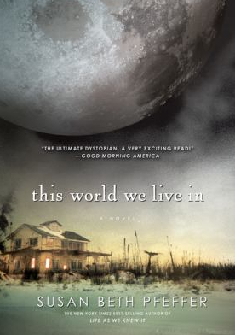

This World We Live In, by Susan Beth Pfeffer

