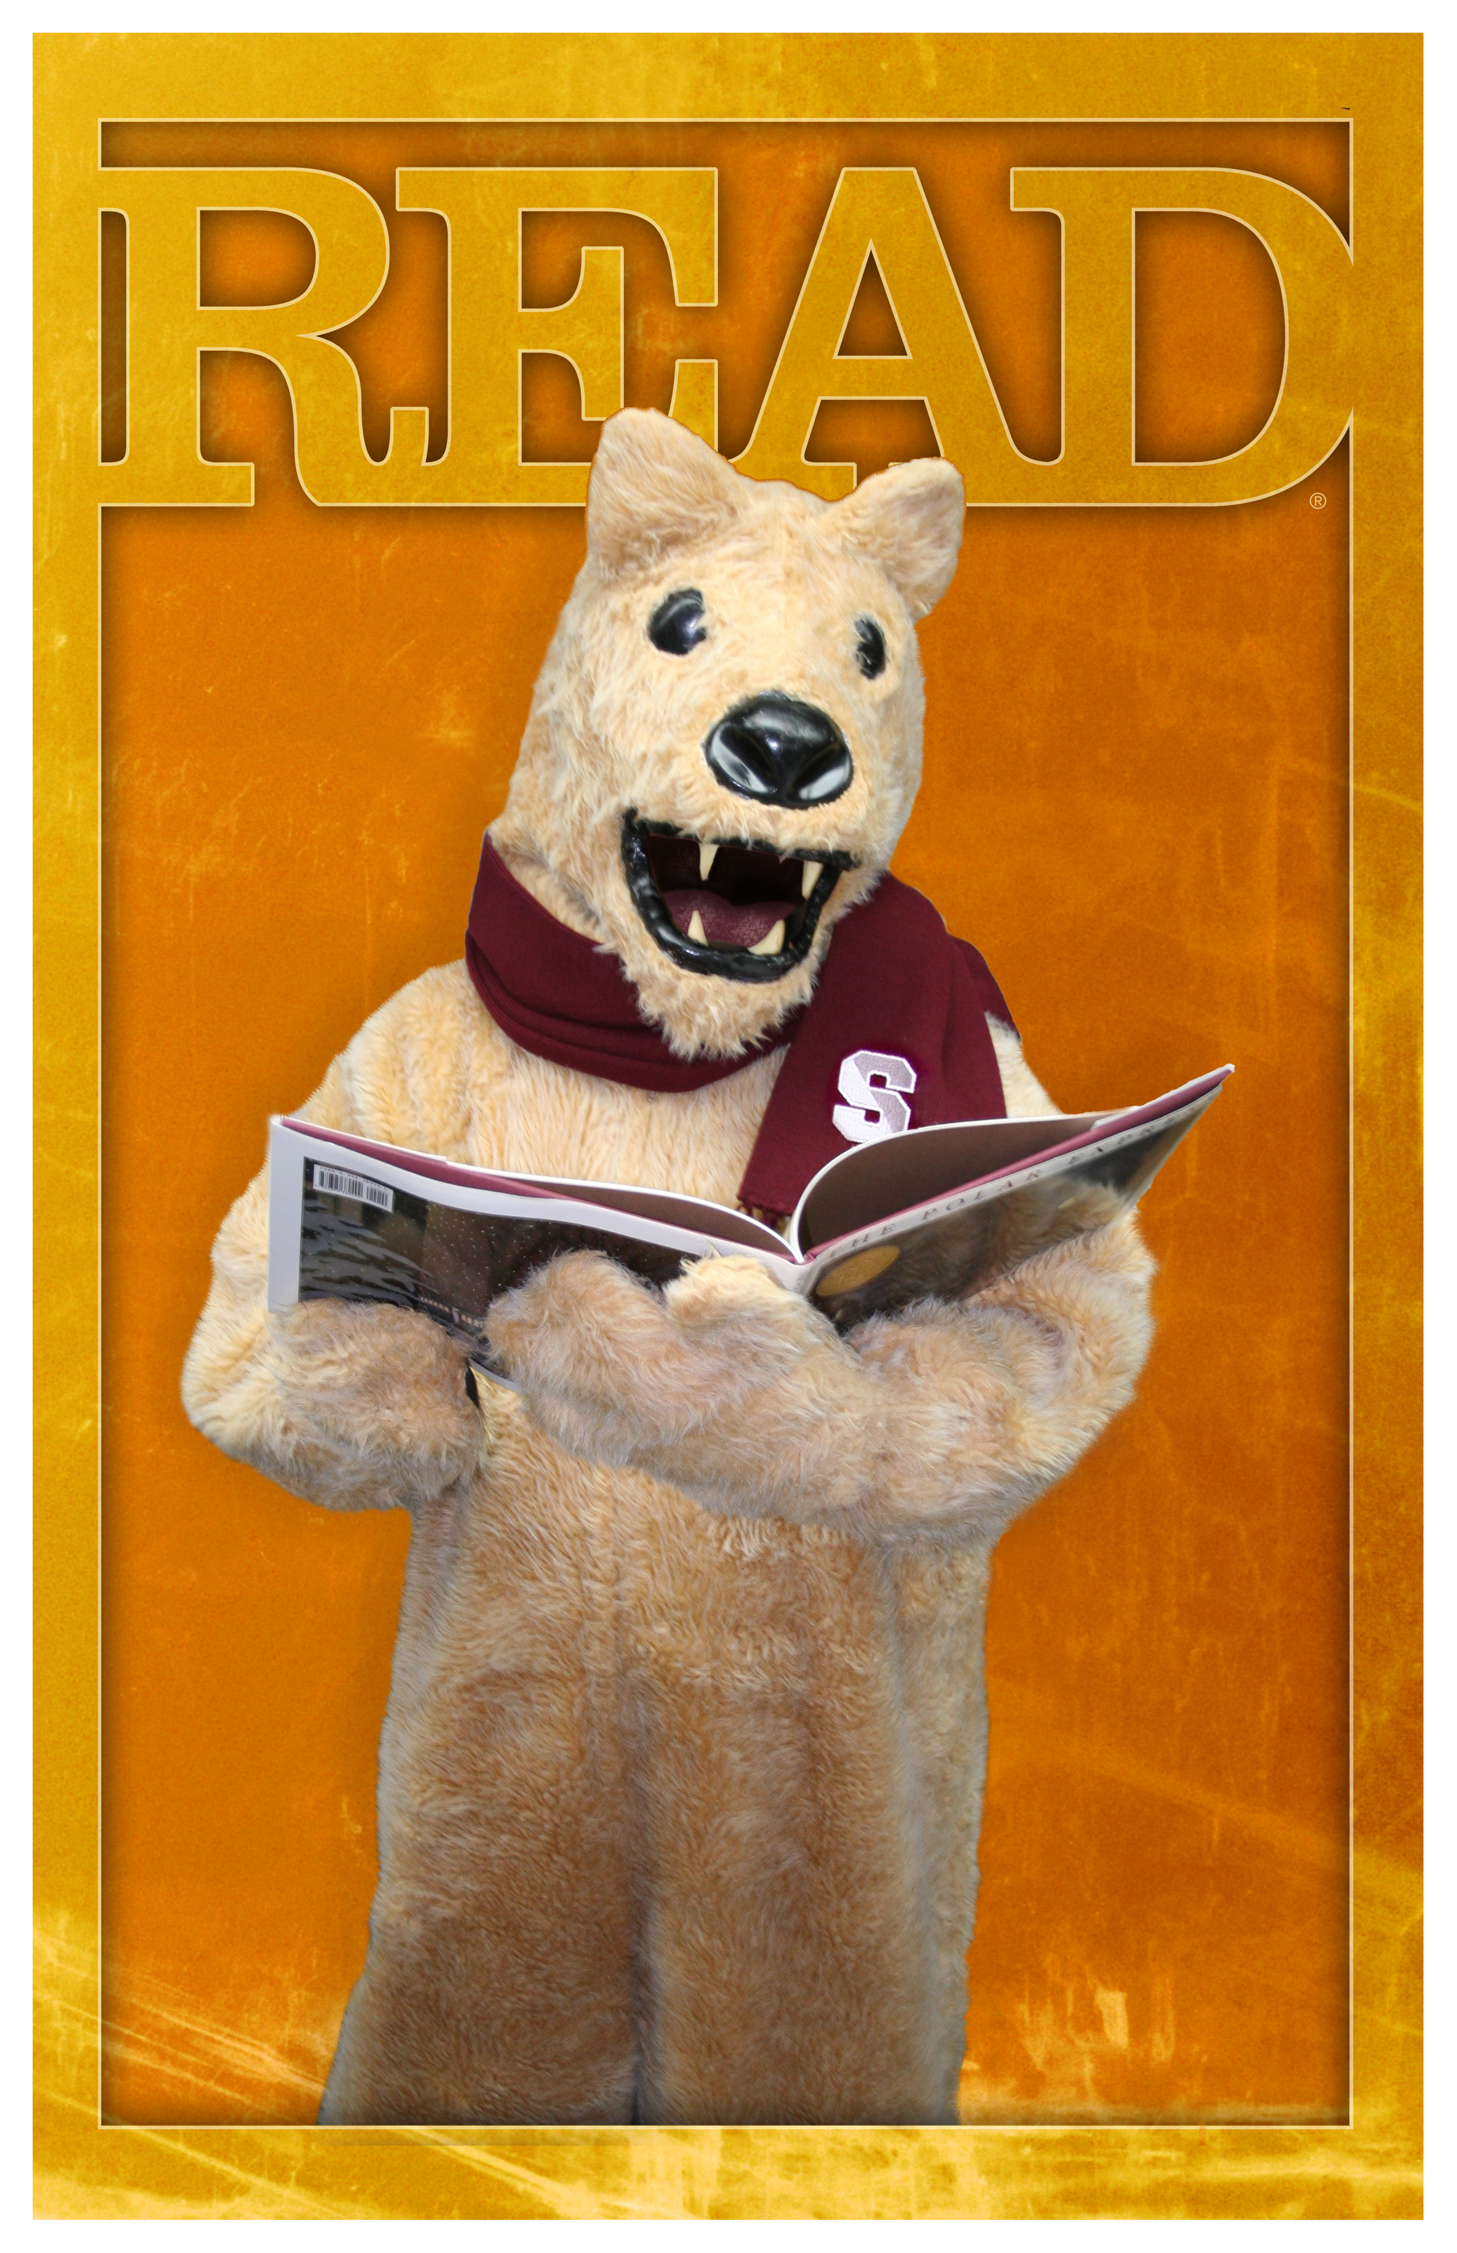

…. is currently reading…
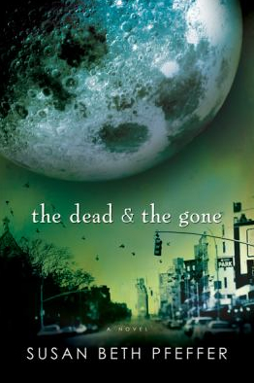

The Dead & the Gone, by Susan Beth Pfeffer

