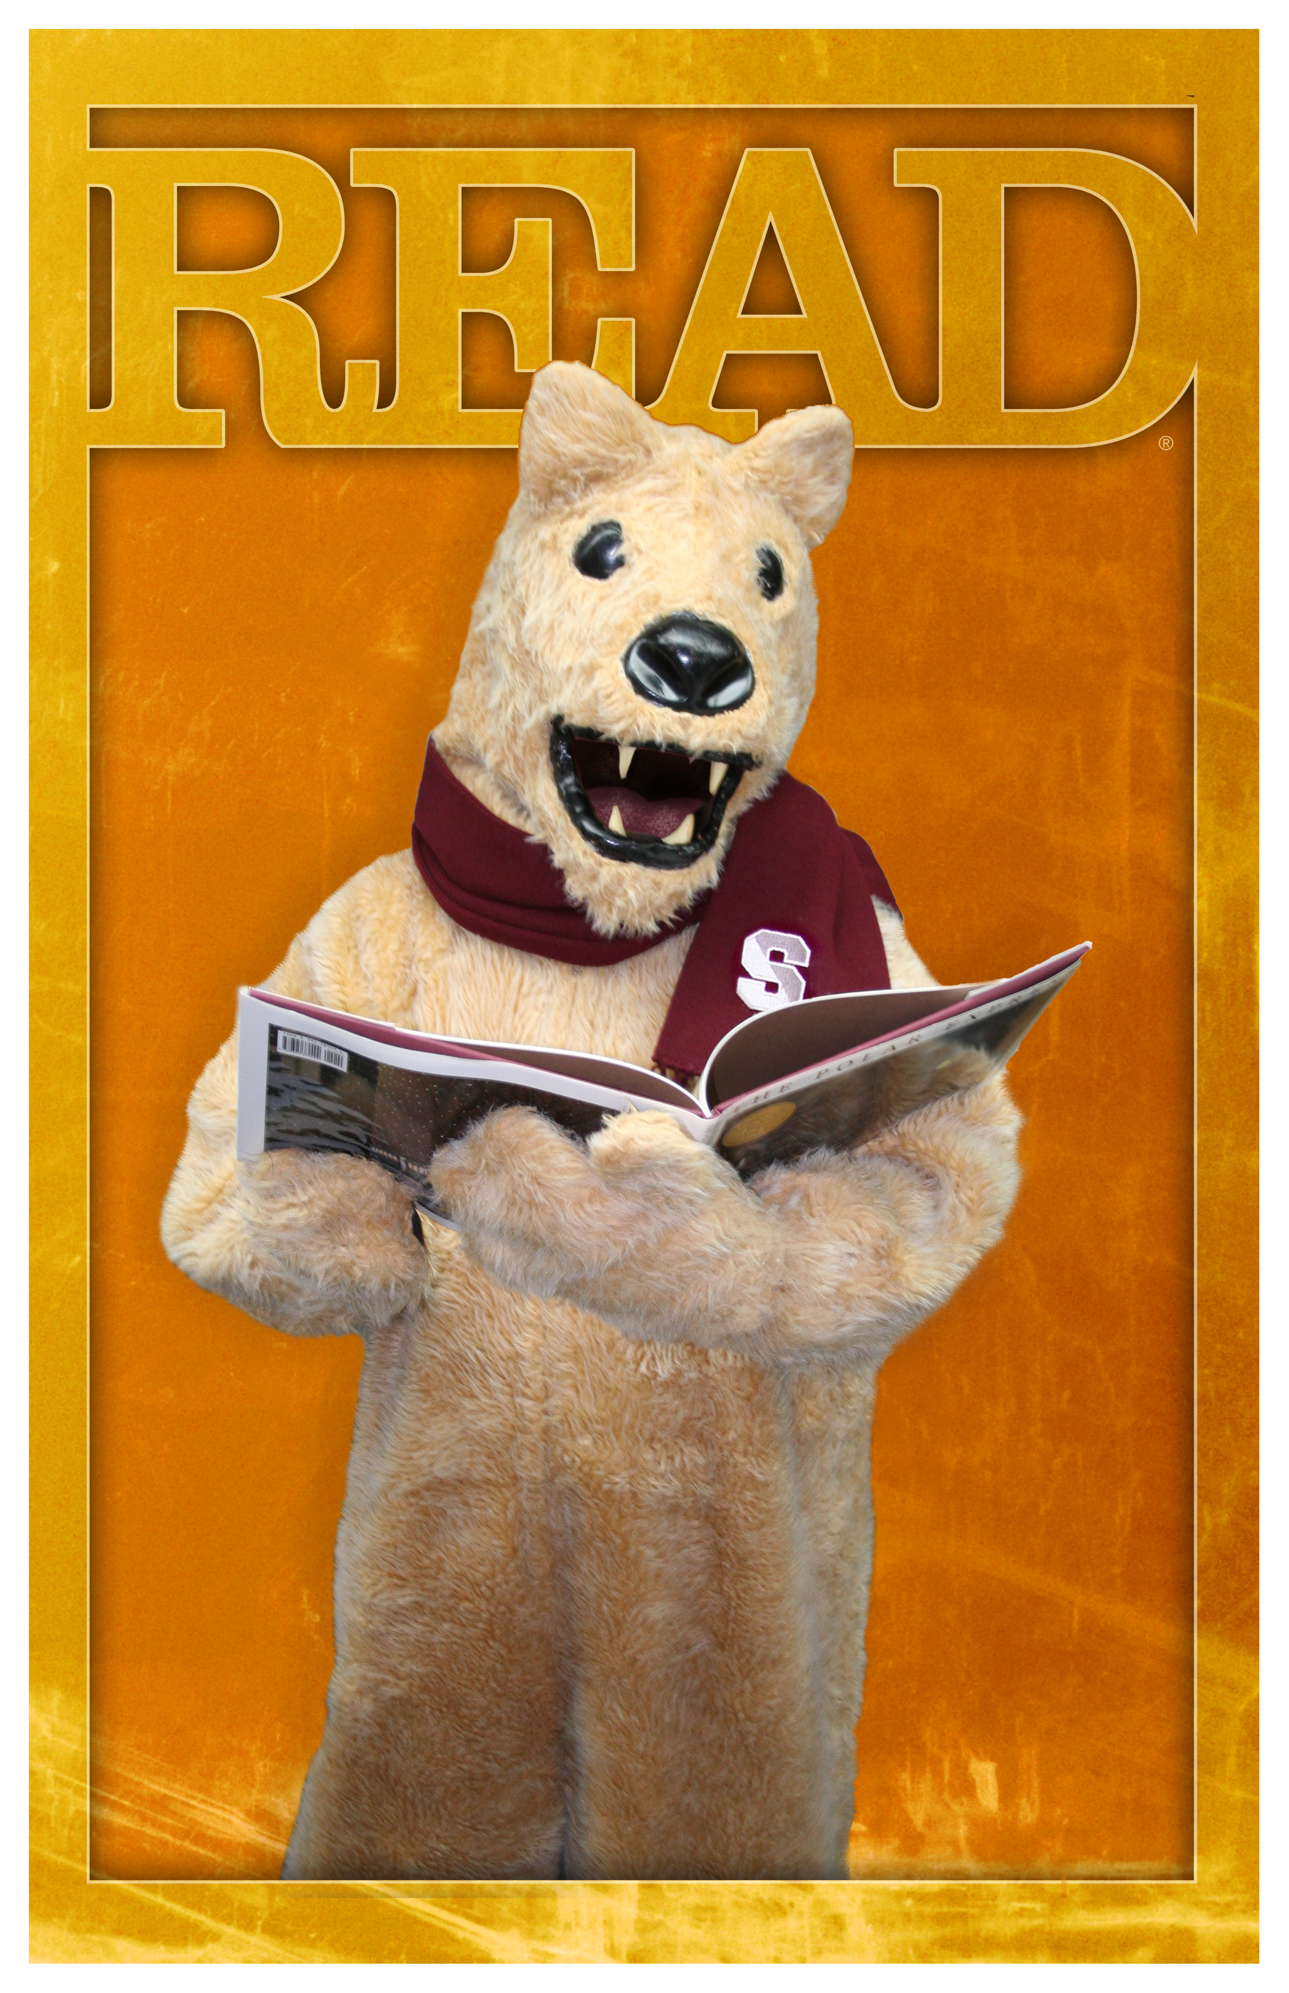

…. is currently reading…

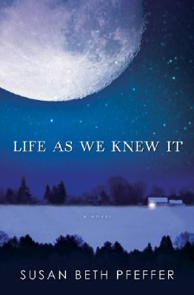

Life as We Knew It, by Susan Beth Pfeffer

