Steps to complete.
- Go to “ www.gotocollegefairs.com ”.
- Click on “Students Register Now”.
- Click on the state of “Texas”.
- Click the 2nd option “TACRA 9/17/2018 – 9/21/2018”.
- Click “Register Now”.
- Fill in ALL Require Information that has an (*)…
  - User Name
  - Password (must be at least 8 characters)
  - Re-enter Password
  - First Name – Last Name
  - Street Address
  - City; State; Zip
  - Phone
  - Email
  - Gender
  - Birth Date
  - Are you transferring from another College/University?
  - High School Name
    - Click in “Find Your School”.
    - Be sure to spell out your High School’s full name, city and state.
  - High School City
  - H.S. Graduation Year
  - When do you plan to begin college?
  - Academic Interest/Intended Major(s)
- The remaining fields are optional to complete.
- Must click the box to accept the Terms and Conditions.
- Once complete, click “Submit”.
- You will receive a “Student Barcode Pass” page; you will NEED to PRINT this page. Bring this page with you to College Night for participating Colleges/Universities to scan for convenience.
- If you need to edit your profile or re-print page, you can do so by logging into your profile at www.gotocollegefairs.com
- You will also receive an email of this information with your user ID.
College Night
September 17, 2018
6:00 pm – 8:00 pm

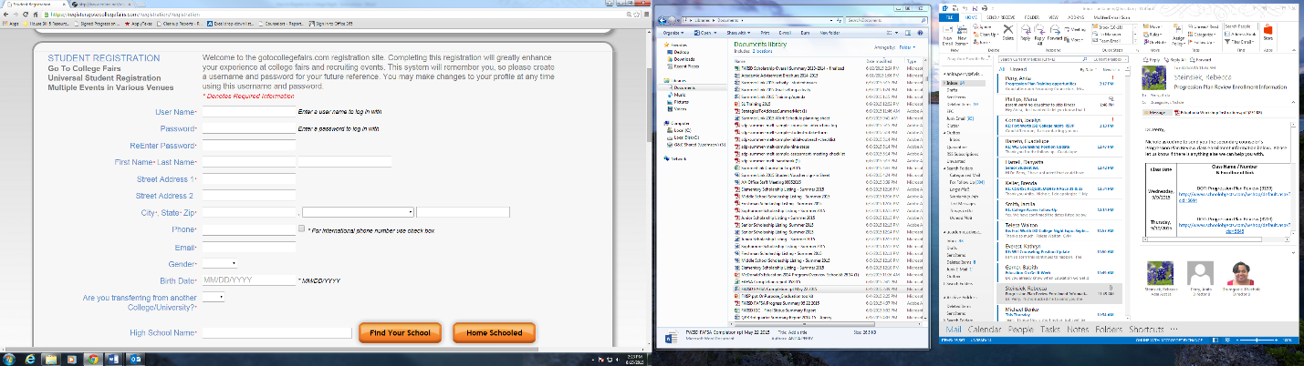
Screen shots of Registration Screens (The required fields are marked with a red star.)

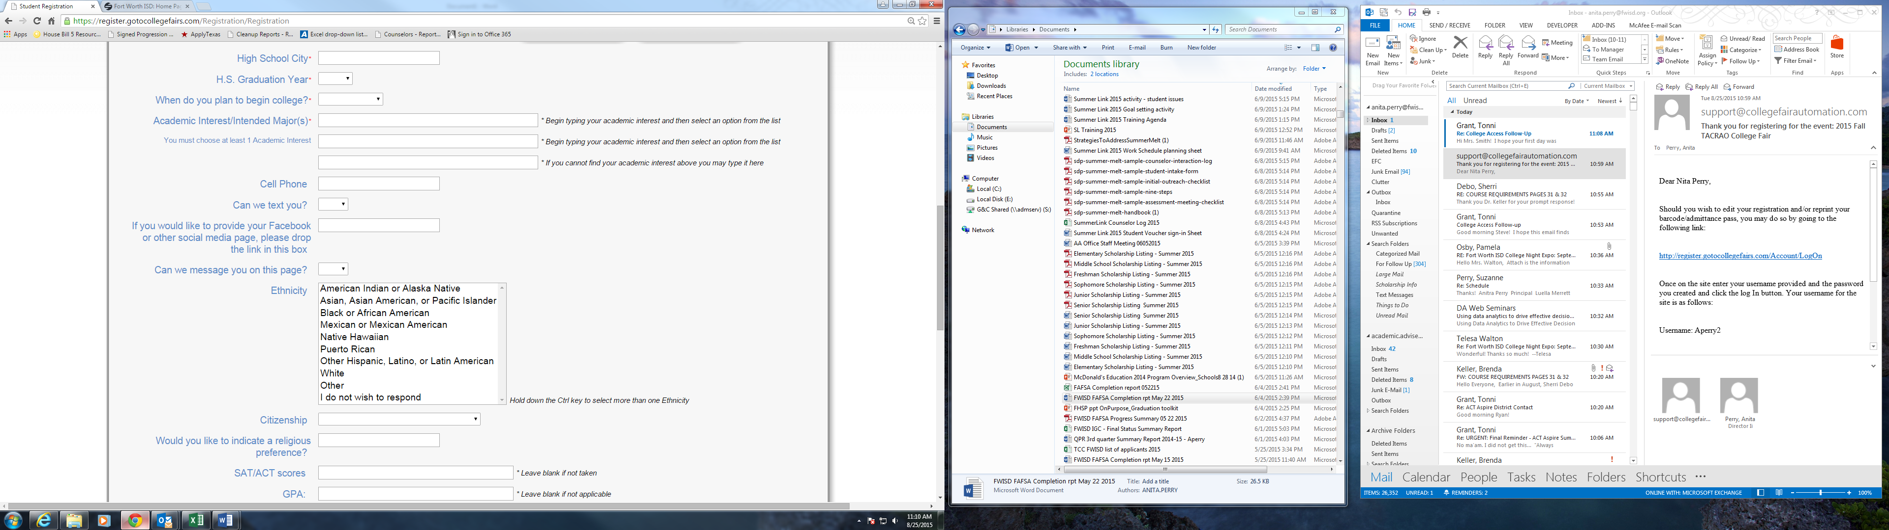
Screen shots of Registration Screens (The required fields are marked with a red star.)

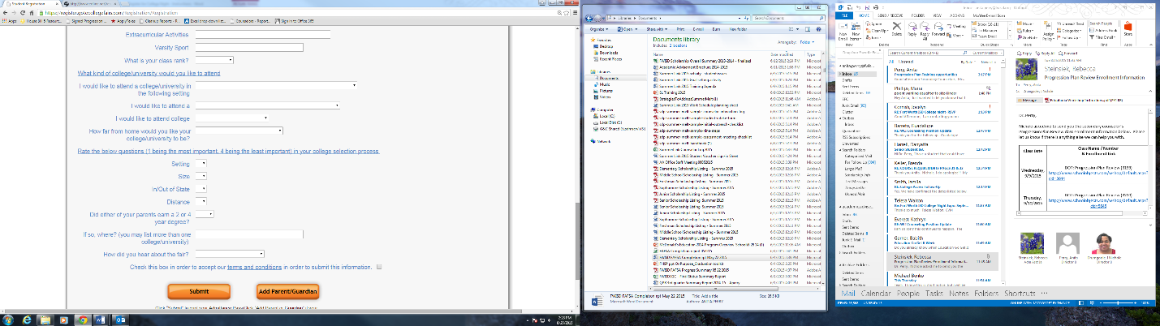
Screen shots of Registration Screens (The required fields are marked with a red star.)

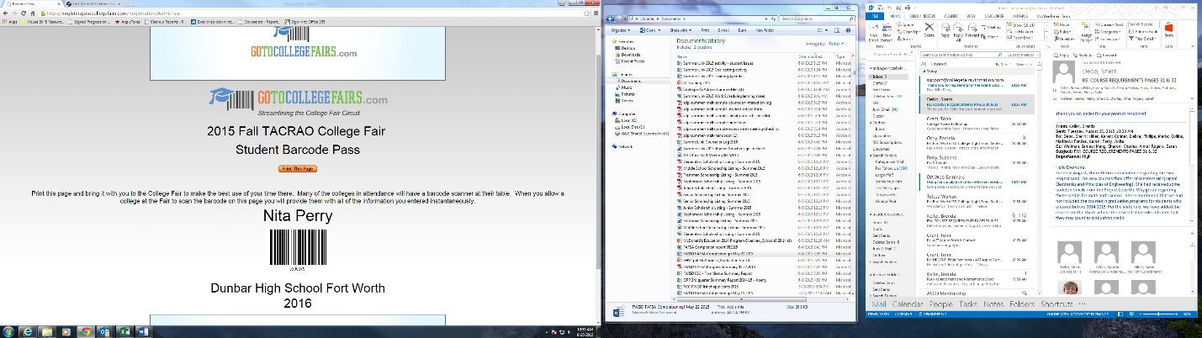
Screen shot of the completion screen after clicking on the “Submit” button.

Sample

Screen shot of the Reprint Barcode / Edit profile option which is given at the top of the Registration screen.
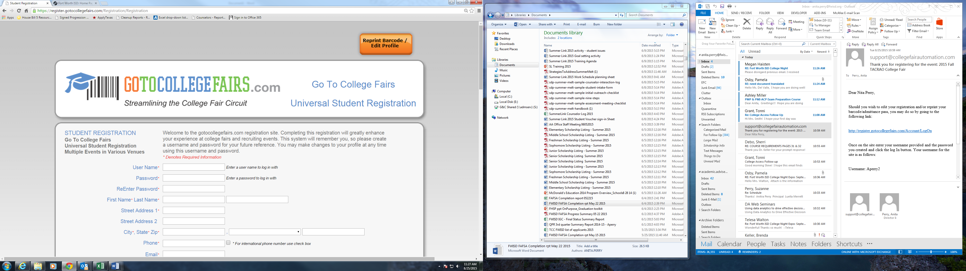

Screen shot of the email that is sent after clicking on the “Submit” button.

Dear Nita Perry,
Should you wish to edit your registration and/or reprint your barcode/admittance pass, you may do so by going to the following link:
http://register.gotocollegefairs.com/Account/LogOn
Once on the site enter your username provided and the password you created and click the log In button. Your username for the site is as follows:
Username: Aperry2
Please note passwords are case sensitive!
We trust that your barcoded registration pass will make your College Fair experience a good one.
Sample

