Home of the (Campus mascot) 1234 Main Street, Fort Worth, Texas, 76XXX
Principal: (Principal’s name) Tel: (817.814.XXXX) | Fax: (817.814.XXXX)
Article I

Name
The campus-level team shall be known as the (campus name) Site-Based Decision-Making Team.
Article II
/// NOTE: Go to Format > Styles to Style things consistently! At the bottom of the Styles panel, you can select List: “Styles in Use” to see the options.
In the bullets, level 1 is a bullet • and pressing Tab takes it to level 2, an arrow ». To revert back to a bullet from an arrow, click Shift+Tab.

Purpose
The purpose of the (campus name) Site-Based Decision-Making Team is to improve the level of student achievement for all students at (campus name).
ARTICLE III

MEMBERSHIP
- Size and Composition
The campus name SBDM team must have a core group of 14 members.

The core group shall be established annually, no later than September 1 of each school year and will consist of:
- the campus principal
- four teachers (nominated and elected by the teachers, specifically to serve on the SBDM team, with the election to be supervised by the Principal and members of the SBDM team).
These teachers will be considered for representation on the Campus Employee Relations Council (CERC).
  - From among the elected faculty, one representative will be elected by the SBDM team to serve on the District Employee Relations Council (DERC).
Teachers are professional personnel with classroom teaching responsibilities for at least four hours of the instructional day.
- one campus‐based non‐teaching professional member (nominated and elected by the campus‐based non‐teaching professional staff, with the election to be supervised by the Principal and members of the SBDM team)
  - This individual will be considered for representation on the CERC and the DERC. Campus‐based non‐ teaching professional staff members are those with a professional certificate who do not teach at least four hours a day.
- one district‐level professional staff member (nominated and elected by all professional staff, with the election to be supervised by the Principal and members of the SBDM team)
  - District‐level professional staff are those who serve multiple campuses.
- three parents (elected by parents only, with the election to be supervised by the predominant parent group)
  - Membership in the predominant parent group is not required. A parent is one who is a parent of, or one who stands in parental relation to, a student enrolled in the District. A parent representative cannot be a FWISD employee.
- two community representatives (selected by the principal and elected members)
  - Community representatives must reside in the district and must be at least 18 years of age. They must not be a parent or a District employee. They must be representative of the Community’s diversity.
- two business representatives (selected by the principal and elected members)
  - Business representatives do not have to reside in nor operate businesses within the district. They shall be representative of the community’s diversity.
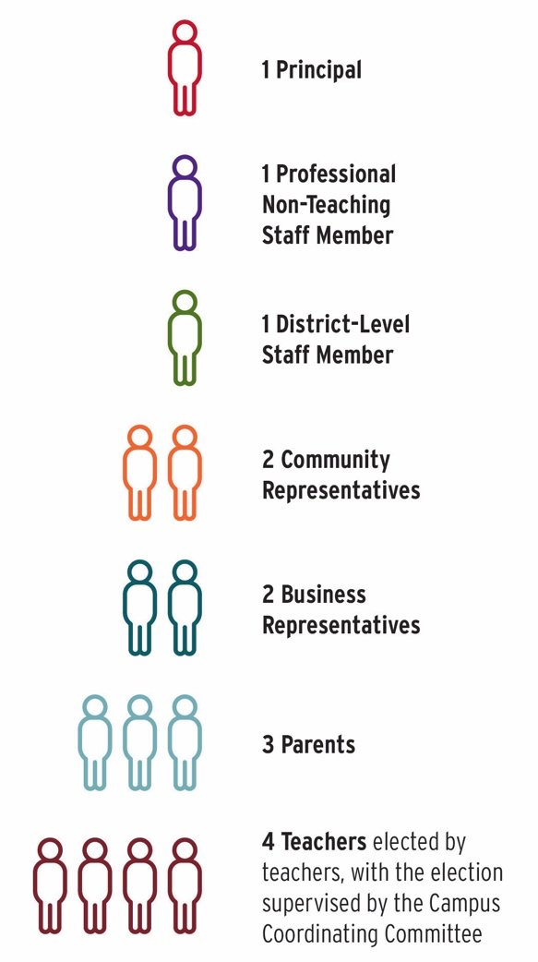
In addition, individuals as determined by the core team members may be added in order that all the school’s major constituent groups are adequately represented (i.e. classroom teachers, parents, support personnel, community and/or business representatives, and/or students); however, the overall committee shall be balanced with no one constituent group over‐represented on the committee. The core group shall ensure that racial and gender diversity is reflected on the team.
The SBDM team shall determine the size of the CERC, with a minimum of three and a maximum of six members.
At least two‐thirds of team members who represent campus‐based elected staff must be teachers (professional personnel with classroom teaching responsibilities for at least four hours of the instructional day).
All SBDM members must be elected or selected by September 1 of each school year. The principal shall furnish an up‐to‐date list of names and addresses of all members on the SBDM team to the Superintendent or designee no later than 15 working days after September 1. When team members are added or replaced during the school year, the principal is responsible within 15 working days for sending to the Superintendent or designee an updated list with the names and addresses of new members.
- Elections
- Parent Representatives
The election of parent representatives is supervised by the predominant parent group. The election occurs (date/timeframe).
Election of Parent Representatives:
- Nomination of candidates:
  - The predominant parent group can send out a request for nominations but may not select the candidates for the slate.
  - Candidates may nominate themselves.
- The Election Process:
  - The predominant parent group supervises the election.
  - The board of the predominant parent group does not select the parent representatives.
  - If the election is held at the time of a regular meeting of the predominant parent group, it must be held before or after the regular business meeting of the group. SBDM elections cannot be an item on the agenda of the business meeting of the predominant parent group.
- Use of ballots:
  - The ballot shall include the names of all parents who were nominated.
  - Ballots may be numbered but must not require a signature.
  - Ballots may be sent home through the mail or with students.
  - A minimum of three individuals should be involved in counting the ballots to ensure an accurate count. The principal should not be involved with counting ballots.
- Parents elect parents:
  - A parent candidate must not be a FWISD employee but must be a parent of, or stand in parental relation to, a student currently enrolled in the FWISD.
  - Candidates do not have to be members of the predominant parent group.
  - Parents who wish to vote do not have to be members of the predominant parent group.
  - Parents who are FWISD employees cannot vote for parent representatives at the school in which they are employed.
- Teacher Representatives, Campus‐Based Non‐teaching Professional Staff Member, District-Level Professional Staff Member, District Employee Relations Council (DERC) representative.
- The election of teacher representatives occurs (date/timeframe). Teachers vote for teachers.
  - The process for nominating and voting for teachers is (what is the process used?)
- The election of campus-based non-teaching professional staff occurs (date/timeframe). Campus-based non-teaching professional staff vote for the campus-based professional staff representative.
  - The process for nominating and voting for campus-based non-teaching professional staff is (what is the process used?)
- The election of district level professional staff occurs (date/timeframe). All professional staff vote for the district‐level professional staff member.
  - The process for nominating and voting for district-level professional staff is (what is the process used?)
The DERC representative shall be elected by the SBDM team from among the SBDM faculty member representatives.
- Terms
The terms of representatives shall begin on (date term begins) and end on (date term ends). Each term will last (number of years) years. During a representative’s term, the representative is expected to attend all SBDM meetings.
- Officers (co-chaired by the Principal)
Officers shall include (what officers, if any, will you have?)
Officers’ descriptions: (The job description for each officer should be provided.)
Officers’ selection process: (How were the officers selected?)
Officers’ term of office: (What is the length of each officer’s term?)
- Attendance
All members are expected to attend all SBDM meetings. Each member must attend (number of meetings or percentage of meetings members must attend) meetings to remain a member of the team.
- Vacancies
A vacancy in an elected position must be filled by election. A vacancy in a selected position is filled by selection of the remaining members of the team within one month after the vacancy occurs.
- Removal of Members
SBDM members may recommend removal of a member when (what is your criteria for removal, if any?).
The process for removal of member is (what is your process for removal?).
ARTICLE IV

COMMITTEES
Standing committees, subcommittees, special committees, or task forces may be established or abolished as necessary to examine issues in depth and develop recommendations to bring to the SBDM team. All committees and subcommittees shall be co‐chaired by the Principal.
ARTICLE V

MEETINGS
- Regular Meetings
At least six meetings per year outside of the school day are required by policy. The regular meetings of the team shall be held (what are the dates/times for your regular meetings?).
- Special Meetings
Special meetings may be called with (number) days’ notice.
- Submission of Items for the Meeting Agenda
The process for a person, team member, or other stakeholder to bring an issue to the team is (list your process).
(Who is responsible for preparing the agenda for each meeting?) shall prepare an agenda for each SBDM meeting.
Items placed on the agenda will be decided by (how is the decision made regarding which items/issues are placed on the meeting agenda?).
- Communication of Members with the Larger School Community
- Meeting times, agendas, and minutes
  - Team members and members of the larger school community will be informed regarding the work of the team through (what modes of communication are used to ensure stakeholders are included?).
- Annual meeting
  - A public meeting will be held once a year, after the receipt of the annual campus rating from the Texas Education Agency, to discuss the performance of the campus and the campus performance objectives.
- The Campus Employee Relations Council (CERC) is the representative body through which the faculty may bring forth questions, concerns, and recommendations for the SBDM team to consider for the benefit of the school, as a whole.
ARTICLE VI

PARTICIPATION IN DECISION-MAKING
- Defined Role in Decision Making
The principal is to consult regularly and receive input from the team in the areas of planning, budgeting, curriculum, school organization, staffing patterns and staff development. The SBDM team must approve the staff development portions of the Campus Educational Improvement Plan (CEIP).
The principal is responsible and accountable for all decisions made at the campus level. It is the principal’s responsibility to ensure that all decisions are in compliance with local and state policy. The SBDM team’s role is advisory, and its input into decision making is intended to improve the quality of decisions made by the principal.
- Methods for Reaching Agreement
- The following steps will be taken to discuss an item before a decision is made.
- (What steps/process will be used?)
- A (majority vote, consensus, etc) method(s) will be used for decision making.
ARTICLE VII

Bylaws
These bylaws may be amended at the beginning of each school year based on the needs of the campus and stakeholders.

