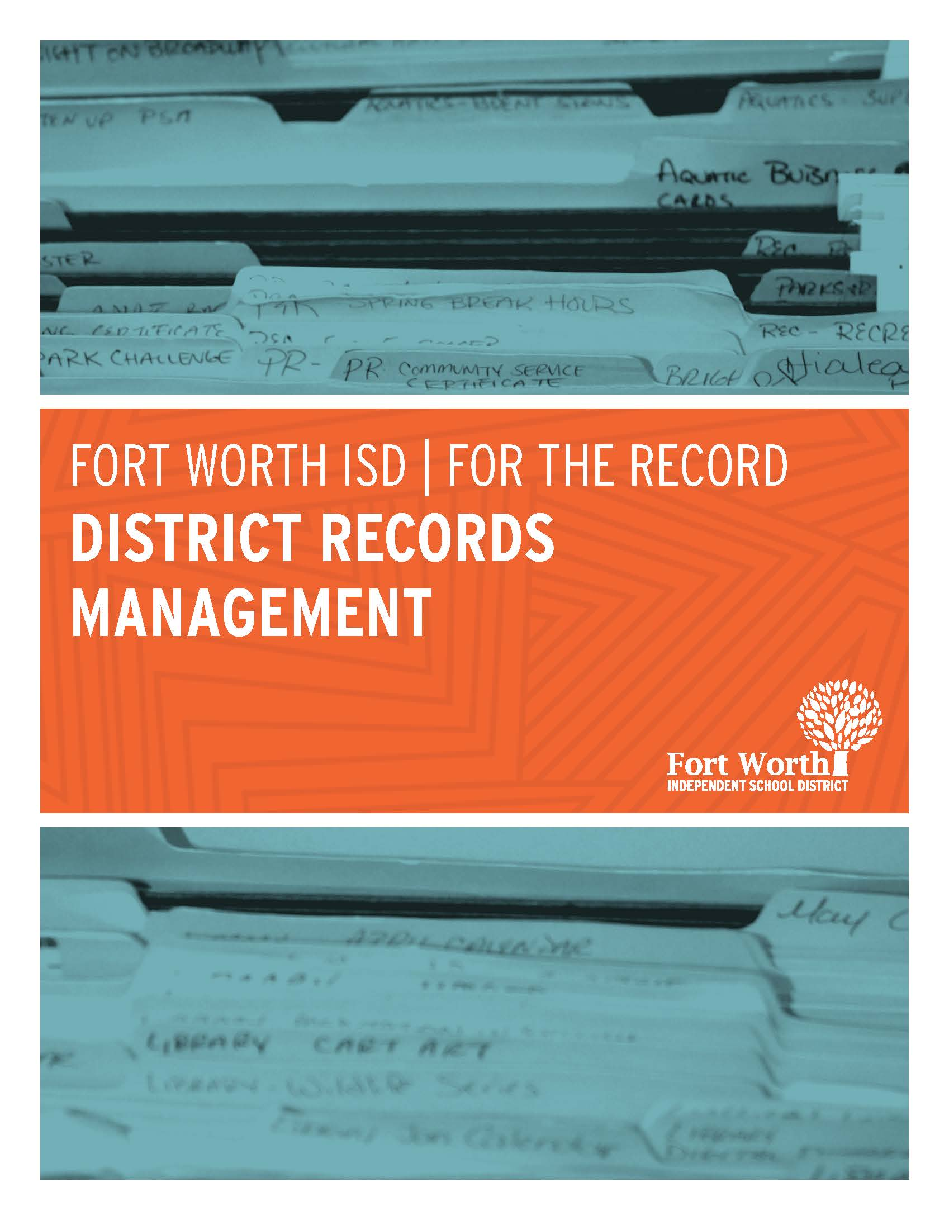
Intently Left Blank

Interim Director – Fiscal Compliance/
Records Management

Rene Moore
Rene.MooreMccauley@fwisd.org

Coordinator – District Records Management
Michelle Hernandez-Shutter
michelle.hernandez@fwisd.org

Assistant – District Records Management
Sylvia Medina
sylvia.medina@fwisd.org

100 N. University Dr. Suite SE224
Fort Worth, Texas 76107
Telephone: 817-814-2115
Fax: 817-814-2114
Office Email: recordsmanagement@fwisd.org

Table of Contents
Policy 5
Preservation of Records 9
Duties 10
Records Definition 11
Electronic Storage of Records 12
Records Management 14
Department Heads 15
Custodian of Records 16
Non-Compliance 18
Retention Definitions 19
Grants 21
Audit 22
Records Schedule 23
Destruction of Records 24
Record Destruction Year Schedule 28
Record Storage Standards 32
Records Quick Reference - SD 43
Records Quick Reference - GR 50
Appendix 61

__________________________________________________________________________________

Policy
CPC (LEGAL) DATE ISSUED: 11/20/2013 UPDATE 98 CPC (LEGAL)-P
DEFINITION
A “local government record” means any document, paper, letter, book, map, photograph, sound or video recording, microfilm, magnetic tape, electronic medium, or other information-recording medium, regardless of physical form or characteristic and regardless of whether public access to it is open or restricted under the laws of the state, created or received by the District or any of its officers or employees, pursuant to law or in the transaction of public business.
The term does not include:
- Extra identical copies of documents created only for convenience of reference or research by District officers or employees.
- Notes, journals, diaries, and similar documents created by a District officer or employee for his or her own personal convenience.
- Blank forms, stocks or publications, and library and museum materials acquired solely for the purposes of reference or display.
- Copies of documents in any media furnished to the public under the Open Records Act or other state law.
Local Gov’t Code 201.003(8)
BOARD’S RESPONSIBILITIES
In implementing the Local Government Records Act, the Board shall:
- Establish, promote, and support an active and continuing program for the efficient and economical management of all District records.
- Cause policies and procedures to be developed for the administration of the program under the direction of the records management officer.
- Facilitate the creation and maintenance of District records containing adequate and proper documentation of the organization, functions, policies, decisions, procedures, and essential transactions of the District and designed to furnish the in-formation necessary to protect the District’s legal and financial rights, the state, and persons affected by the District’s activities.
- Facilitate the identification and preservation of District records that are of permanent value.
- Facilitate the identification and protection of essential District records.
- Cooperate with the State Library and Archives Commission in its conduct of statewide records management surveys.
Local Gov’t Code 203.021
CUSTODIAN OF RECORDS
In implementing the Local Government Records Act, school personnel who are custodians of records shall:
- Cooperate with the records management officer in carrying out the policies and procedures established by the District for the efficient and economical management of records and in carrying out the requirements of the Act.
- Adequately document the transaction of District business and the services, programs, and duties for which they and their staff are responsible.
- Maintain the records in their care and carry out the preservation, microfilming, destruction, or other disposition of the records in accordance with the policies and procedures of the District’s records management program.
Local Gov’t Code 203.022
RECORDS MANAGEMENT OFFICER
In implementing the Local Government Records Act, the records management officer shall:
- Assist in establishing and developing policies and procedures for the District’s records management program.
- Administer the records management program and provide assistance to the custodians in order to reduce costs and improve record-keeping efficiency.
- In cooperation with the custodians of records, prepare and file records control schedules, amended schedules, and lists of obsolete records, as required by the Local Government Records Act.
- In cooperation with the custodians of records, prepare or direct the preparation of requests for authorization to destroy records, when such requests are required under the Local Government Records Act.
- In cooperation with the custodians of records, identify and take adequate steps to preserve District records of permanent value.
- In cooperation with the custodians of records, identify and take adequate steps to protect essential District records.
- In cooperation with the custodians of records, ensure that the maintenance, preservation, microfilming, destruction, or other disposition of records is carried out in accordance with the District’s records management program and legal requirements.

- Disseminate to the Board and custodians of records information concerning state laws, administrative rules, and government policies relating to the District’s records.
- In cooperation with the custodians of records, establish procedures to ensure that the handling of records is carried out with due regard for the duties and responsibilities of custodians that may be imposed by law and the confidentiality of information in records to which access is restricted by law.
Local Gov’t Code 203.023
RETENTION SCHEDULES
In developing the District’s records retention schedule, the records management officer shall ensure it is consistent with the applicable minimum retention schedules adopted by the State Library and Archives Commission, i.e., Local Schedule GR—Records Common to All Governments, Local Schedule EL—Records of Elections and Voter Registration, Local Schedule TX—Records of Property Taxation, and Local Schedule SD—Records for Public School Districts. 13 TAC 7.125

Preservation of Records
__________________________________________________________________________________
PRESERVATION OF RECORDS
The Board shall determine a time for which information that is not currently in use will be preserved, subject to any applicable rule or law governing the destruction and other disposition of local government records or public information. Gov’t Code 552.004 The Board shall preserve the certified agenda or recording of a closed meeting for at least two years after the date of the meeting. If an action involving the meeting is brought within that period, the certified agenda or recording shall be preserved while the action is pending. Gov’t Code 551.104(a)
MICROFILMING
District records may be maintained on microfilm in addition to or instead of paper or other media, subject to the requirements of Chapter 204 of the Local Government Code and rules adopted by the State Library and Archives Commission. Local Gov’t Code 204.002
ELECTRONIC STORAGE
District records may be stored electronically in addition to or instead of source documents in paper or other media, subject to the requirements of Chapter 205 of the Local Government Code and rules adopted by the State Library and Archives Commission.
Local Gov’t Code 205.002
FEDERAL INVESTIGATIONS AND BANKRUPTCY
Anyone who knowingly alters, destroys, mutilates, conceals, covers up, falsifies, or makes a false entry in any record, document, or tangible object with the intent to impede, obstruct, or influence the investigation or proper administration of any matter within the jurisdiction of any department or agency of the United States or any bankruptcy case, or in relation to or contemplation of any such matter or case, shall be fined, imprisoned not more than 20 years, or both. 18 U.S.C. 1519

__________________________________________________________________________________

Duties
The Records Management Department acts as a liaison between the district and the State and Local Records Management Division. This person is the representative of the agency in all issues of responsibility for records management policy and statutory compliance. The agency head determines who is most qualified to be the records management officer and how the responsibilities are to be distributed within the agency. The State and Local Records Management Division relies on the head of the agency to confirm the appointment in writing and then directs all publications and correspondence to the designated records management officer. An agency director may change the appointment at any time by writing the division and naming a new records management officer. The division maintains a file of current records management officers of all agencies. As viewed by the State and Local Records Management Division, the role of the agency records management officer is to control records activity within the agency which includes the following functions:

- Administer the records management program within the FWISD.
- Conduct or oversee the inventory of all FWISD records.
- Conduct or oversee the preparation, maintenance, and implementation of the FWISD records retention schedule.
- Protect confidential and vital records.
- Manage records within the FWISD during active use.
- Approve all documentation for transfer of records to the State Records Center.
- Approve all requests to dispose of state records.
- Attend training and information classes offered by the State and Local Records Management Division and coordinate records management training for FWISD staff, as needed.

STATE AGENCIES
- Texas Educational Agency (TEA)
- Texas State Library and Archives Commission (TSLAC)
- Texas Attorney General

REFERENCE MATERIAL
- Texas State Library and Archives Commission (TSLAC)
- Fort Worth ISD Board Policy
- Fort Worth ISD departmental website

_____________________________________________________________________________

Records Definition
RECORDS
All documents, papers, letters, books, maps, photographs, sound or video recording, microfilm, magnetic tape, electronic media, or other information recording media, regardless of physical form or characteristic and regardless of whether public access to it is open or restricted under the laws of the state, created or received by the Fort Worth Independent School District (FWISD) or any of its officers or employees pursuant to law or in transaction of public business are hereby declared to be the records of Fort Worth Independent School District (FWISD) and shall be created, maintained, and disposed of in accordance state agencies.
This definition does not include:
- Extra identical copies of documents created for convenience
- Notes, journals, dairies, and similar documents created by an officer or employee for their convenience
- Blank forms, stocks of publications, library and museum materials acquired solely for the purpose if reference or display

ESSENTIAL RECORD
Essential Record means; any record of FWISD necessary to the resumption or continuation of the operations of FWISD in an emergency or disaster, to the re-creation of the legal and financial status of FWISD, or to the protection and fulfillment of obligations to the people.
PERMANENT RECORD
Permanent record means; any record of FWISD for which the retention period on a records control schedule is given as “permanent”.
RECORDS CONTROL SCHEDULE
Records Control Schedule means; a document prepared by or under the authority of the Records Management Officer listing the records maintained by FWISD, their retention periods, and other records disposition that the records management program may require.

__________________________________________________________________________________

Electronic Storage of Records
DEFINITIONS

- “Electronic storage” means the maintenance of local government record data in the form of digital electronic signals on a computer hard disk, magnetic tape, optical disk, or similar machine-readable medium.
- “Local government record data” means the information that by law, regulation, rule of court, ordinance, or administrative procedure in a local government comprises a local government record as defined by Section 201.003.
- “Source document” means the local government record from which local government record data is obtained for electronic storage. The term does not include backup copies of the data in any media generated from electronic storage.

AUTHORIZATION

Any local government record data may be stored electronically in addition to or instead of source documents in paper or other media, subject to the requirements of this chapter and rules adopted under it.

STANDARDS AND PROCEDURES

The commission shall adopt rules establishing standards and procedures for the electronic storage of any local government record data of permanent value and may adopt rules establishing standards and procedures for the electronic storage of any local government record data whose retention period is at least 10 years on a records retention schedule issued by the commission. The rules must be approved as required by Section 441.165, Government Code.

With regard to the types of local government record data covered by Subsection (a), the rules may require or prescribe:

- Standards and procedures for the generation of backup or preservation copies of the local government record data on paper, microfilm, electronic, or other approved media;

- Standards and procedures for the recopying or duplication of the magnetic tape, optical disk, or similar machine-readable medium on which the local government record data are stored;

- Standards and procedures for the physical storage and maintenance of magnetic tapes, optical disks, or similar machine-readable media;

- Standards and procedures for providing access by members of the public to electronically stored local government record data to which they are entitled under law; and other standards and procedures that the commission considers necessary to ensure the availability, readability, or integrity of the local government record data.

- Other standards and procedures that the commission considers necessary to ensure the availability, readability, or integrity of the local government record data.

Records Management
__________________________________________________________________________________
RECORDS MANAGEMENT
Records Management means; the application of management techniques to the creation, use, maintenance, retention, preservation, and disposal of records for the purposes of reducing the costs and improving the efficiency of recordkeeping. The term includes the development of the records control schedules, the management of filing and information retrieval systems, the protection of essential and permanent records. The economical and space-effective storage of inactive records, control over the creation and distribution of forms, reports, and correspondence, and the management of micrographics, electronic, copier devices and other records storage systems.
RECORDS PROPERTY
All records of FWISD by definition are declared to be the property of the Fort Worth Independent School District. No FWISD official or employee has, by virtue of his or her position, any personal or property right to such records even though he or she may have developed or compiled said records. The unauthorized destruction, removal from files, or use of such records is prohibited. Once an official or employee vacates position, all records will remain in said office, department, and school.

__________________________________________________________________________________

Department Heads
DEPARTMENT HEAD DEFINITION:
“Department Head” means the principals, directors, administrators and other officers who by ordinance, order or administrative policy is in charge of an office of the Fort Worth ISD that creates or receive records.
DEPARTMENT HEADS SHALL:
- Cooperate with the Records Management Officer in carrying out the policies and procedures established in the Fort Worth Independent School District for the efficient and economical management of records and in carrying out the requirements of this order;

- Adequately document the transaction of government business and the services, programs, and duties for which the department head/principal and his or her staff are responsible; and

- Maintain the records in his or her care and carry out their preservation, microfilming, destruction, or other disposition only in accordance with the policies and procedures of the records management program of the Fort Worth Independent School District.

__________________________________________________________________________________

Custodian of Records
IN IMPLEMENTING THE LOCAL GOVERNMENT RECORDS ACT, DISTRICT PERSONNEL WHO ARE CUSTODIANS OF RECORDS SHALL:

School district personnel who are Custodians of Records have the responsibility of cooperating with the Records Management Department in carrying out the policies and procedures established by the District for the efficient and economical management of records and in carrying out the requirements of the Act.

Adequately document the transaction of District business and the services, programs, and duties for which they and their staff are responsible. Maintain the records in their care and carry out the preservation, microfilming, destruction, or other disposition of the records in accordance with the policies and procedures of the District’s Records Management Program.
Each department head/principal shall designate a member of his or her staff to serve as Custodian of Records for the implementation of the records management program in the department/school. If the Records Management Officer determines that in the best interests of the records management program more than one Custodian of Records should be designated for a department/school, the department head/principal shall designate the number of Custodian of Records specified by the Records Management Officer. Persons designated as Custodian of Records shall be thoroughly familiar with all the records created and maintained by the department/school and shall have full access to all records of the Fort Worth Independent School District maintained by the department/school. In the event of the resignation, retirement, dismissal, or removal by action of the department head/principal of a person designated as a Custodian of Records, the department head/principal shall promptly designate another person to fill the vacancy. A department head/principal may serve as Custodian of Records for his or her department/school.

DUTIES:
- Conduct or supervise the conduct of inventories of the records of the department in preparation for the development of records control schedules;

- In cooperation with the Records Management Officer coordinate and implement the policies and procedures of the records management program in their departments/schools; and

- Disseminate information to department/school staff concerning the records management program.

The Custodian of Record duties identified by the District Records Management department are:
- complete all District Records Management trainings
- participate in a records storage audit if scheduled
- communicate District Records Management regulations with location data owners
- maintain the location’s storage area in an organized manner and ensure that all location data owners follow the district storage procedures

__________________________________________________________________________________

Non-Compliance
RETENTION SCHEDULE FOR RECORDS OF PUBLIC SCHOOL DISTRICTS

This schedule establishes mandatory minimum retention periods for records that are associated with Public School Districts. No local government office may dispose of a record listed in this schedule prior to the expiration of its retention period. A records control schedule of a local government may not set a retention period that is less than that established for the record in this schedule. Original paper records may be disposed of prior to the expiration of their minimum retention periods if they have been microfilmed or electronically stored pursuant to the provisions of the Local Government Code, Chapter 204 or Chapter 205, as applicable, and rules of the Texas State Library and Archives Commission adopted under those chapters. Actual disposal of such records by a local government is subject to the policies and procedures of its records management program.
“Destruction of local government records contrary to the provisions of the Local Government Records Act of 1989 and administrative rules adopted under it, including this schedule, is a Class A misdemeanor and, under certain circumstances, a third degree felony (Penal Code, Section 37.10). Anyone destroying local government records without legal authorization may also be subject to criminal penalties and fines under the Public Information Act (Government Code, Chapter 552).”

__________________________________________________________________________________

Retention Definitions
TOTAL RETENTION DEFINITIONS
- After Close (or terminated, completed, expired, or settled): The record is related to a function or activity with a finite closure date.

- Administratively Valuable: The immediate purpose for which the record was created has been fulfilled and subsequent need for the record to conduct the operations of the agency, if any has been satisfied.

- Calendar Year End: December 31

- Fiscal Year End: August 31

- School Year End: June 31

- PERMANENT: A record that possesses enduring legal, fiscal, or administrative value and must be preserved permanently by the agency.

- Until Superseded: The record is replaced by an updated version. If a record subject to this retention period is discontinued or is no longer required by law, the date of the supersession is the date the decision to discontinue the record is made or the law takes effect. If the record related to an employee, the date of supersession is the date of termination or the last date the record is needed with reference to the employee, as applicable. For example, an authorization for direct deposit would be superseded on the date of the last deposit is made under the authorization.

- Record Copy: The document which is kept on file as an original or official record for the total retention period. It is distinct from a “working” or convenience” copy, which is a duplicate used for reference purposes.
- Caution: Care must be taken by records management officers in determining if duplicate records are, indeed, convenience copies or if two or more copies of the same document must be considered record copies. It is very possible for the same document to be present in two or more units of a state agency and be the record copy in each unit if it serves a different function in of those units.

- Record Series: A group of identical or related records with the same function and the same retention period that is evaluated as a unit for retention scheduling purposes.

- Retention Period: The amount of time a records series must be retained before destruction or archival preservation.

- Retention Notes: OTHER SCHEDULES – This schedule should be used by public school districts, regional educational service centers, and other local education agencies (as defined on page 2) in conjunction with Local Schedule GR (Records Common to All Governments) and Local Schedule TX (Records of Property Taxation). In particular, many records maintained by public school districts are includable among the general administrative, financial, and personnel record series in Local Schedule GR, especially those relating to grant allocations, funding, and reporting. In any instances of conflict between retention periods established in this schedule and in Local Schedules GR or TX, the retention periods in this schedule shall prevail.

__________________________________________________________________________________

Grants

GRANT RECORDS – The 5-year retention period frequently established for records of school districts in this schedule and Local Schedule GR derives from federal requirements in 34 CFR 80.42(a)(1) and (c), which declares the following: “Starting date of retention period—(1) General. When grant support is continued or renewed at annual or other intervals, the retention period for the records of each funding period starts on the day the grantee or sub grantee submits to the awarding agency it’s single or last expenditure report for that period. However, if grant support is continued or renewed quarterly, the retention period for each year’s records starts on the day the grantee submits its expenditure report for the last quarter of the Federal fiscal year. In all other cases, the retention period starts on the day the grantee submits its final expenditure report. If an expenditure report has been waived, the retention period starts on the day the report would have been due.” These requirements involve the retention of financial and programmatic records, including supporting documents, statistical reports, and other records pertinent to program regulations or the grant agreement relating to projects or programs funded by the U.S. Department of Education through sub grants using federal funds from the Texas Education Agency.

These federal regulations require that all records of the types mentioned must be available for audit for 3 years after the date of submission of the single or last expenditure report by the Texas Education Agency as sub grantor, not by the school district. Because final expenditure reports are submitted by the Texas Education Agency after all reports from districts are received, a 5-year retention period for many records of school districts is necessary to satisfy this requirement adequately.

If an audit is pending in which expenditure or the eligibility of a student to participate in a federal program is questioned, then all records affecting the outcome of the audit must be retained until the audit is settled.

Copies of reports or records submitted to the Texas Education Agency must be retained by school districts in accordance with this schedule.

__________________________________________________________________________________

Audit
SITE AUDITS
The District Records Department will be conducting site visits to departments and schools to review their records storage. Below are the areas of review:
Storage Room Condition
- Room is clean and free of trash
- Storage area is adequate for amount of records being stored
- Room is not used to house anything other than records
- Storage room is accessible
- Storage room is secured

Storage Room Safety

- Any free standing shelves are secured for stability
- Heavy items are stored at a suitable height
- Records are stored within shelves with no overhang
- Storage room has adequate lighting
- Fire detection system present

Storage Boxes

- Banker boxes are used to store records
  - No signs of damage to storage boxes such as water, rodent, or broken down boxes)
  - Records are not exposed to direct sunlight, fire, steam, structural collapse or theft
- Records and/or storage boxes are not in contact with the floor
- No boxes past retention time present

Recommended Actions

- Use and complete information on the district approved record label
- Use banker boxes for record storage
- Replace worn and/or damaged boxes
- Organize record storage room by shred date
- Increase storage room safety and security
- Seek more appropriate storage options
- Organize box contents and remove clips, binders, etc.
- Replace or repair unsafe shelving
- Remove and shred boxes past retention time

An audit report will be emailed to the location department head and the custodian of record following the audit. The site can request an onsite storage assistance and training.
__________________________________________________________________________________

Records Schedule
Below are the header definitions of the District Records Schedule:
- Office/Dept.: The Department in which Records Management has determined the specific records should be maintained.

- Record Series #: Records series item numbers are assigned by the State and Local Records Management Division of the Texas State Library and Archives Commission.

- Record Series Title: The most general titles possible have been chosen.

- Subtitle: Explanations are provided for those titles which are not self-explanatory.

- Vital Records: Vital records are those that are essential to resume business or continue an organization, to recreate an agency’s financial or legal position, or to preserve the rights of employees and citizens. Records series commonly regarded as vital have been so designated.

- Total Retention: Retention is expressed in the years unless otherwise noted.

- Authority/Comments: This column contains citations to applicable federal or state laws or regulations or other information regarding records retention requirements.

__________________________________________________________________________________

Destruction of Records
DESTRUCTION OF RECORDS
A District record may be intentionally destroyed under any of the following conditions:
- The record is listed on a records control schedule filed with the State Library and Archives Commission and either its retention period has expired or it has been microfilmed or electronically stored in accordance with legal standards.
- The record appears on a list of obsolete records approved by the State Library and Archives Commission.
- A destruction request is filed with and approved by the State Library and Archives Commission for a record not listed on an approved control schedule.
- The district court issues an expunction order for the destruction or obliteration of the records, pursuant to state law.
- The records are defined as exempt from scheduling or filing requirements or listed as exempt in a records retention schedule issued by the State Library and Archives Commission.
Local Gov’t Code 202.001
EXCEPTIONS: A District record the subject matter of which is known by the custodian to be the subject of litigation shall not be destroyed until the litigation is settled. A District record that is subject to a request under Chapter 552, Government Code, shall not be destroyed until the request is resolved.
Local Gov’t Code 202.002
METHOD OF DESTRUCTION
Fort Worth ISD approved method of destruction is by cross cut shredding or pulping.
PERSONAL LIABILITY
A custodian of local government records, records management officer, or other officer or employee of a local government may not be held personally liable for the destruction of a local government record if the destruction is in compliance with this subtitle and rules adopted under it.

Instructions for using the On-site Document Destruction/Shredding Contract may be found on the Purchasing website. http://www.fwisd.org/

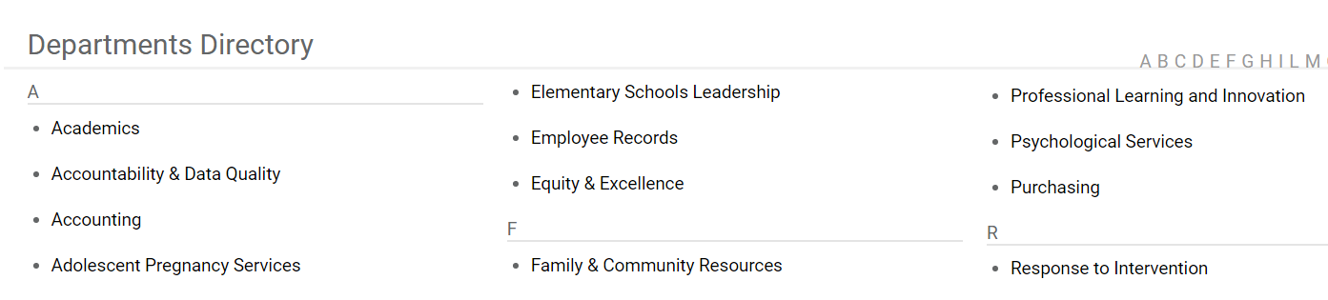

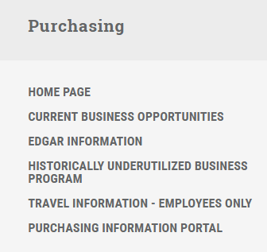
3
2
1
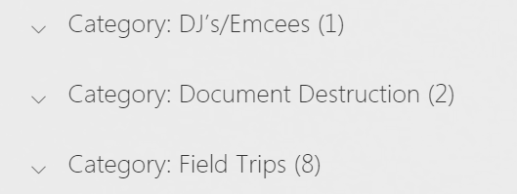
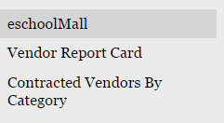

Select the two documents for the explanation of services and ordering instructions for Expanco.

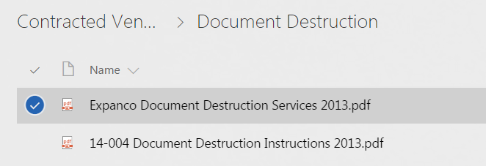
4

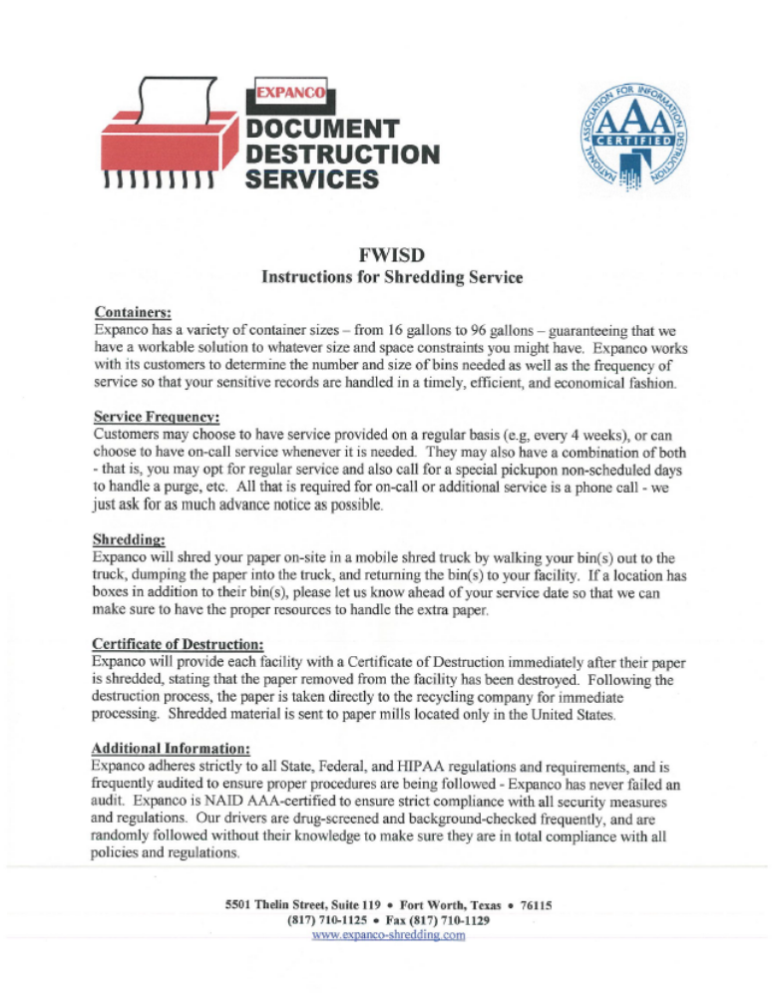

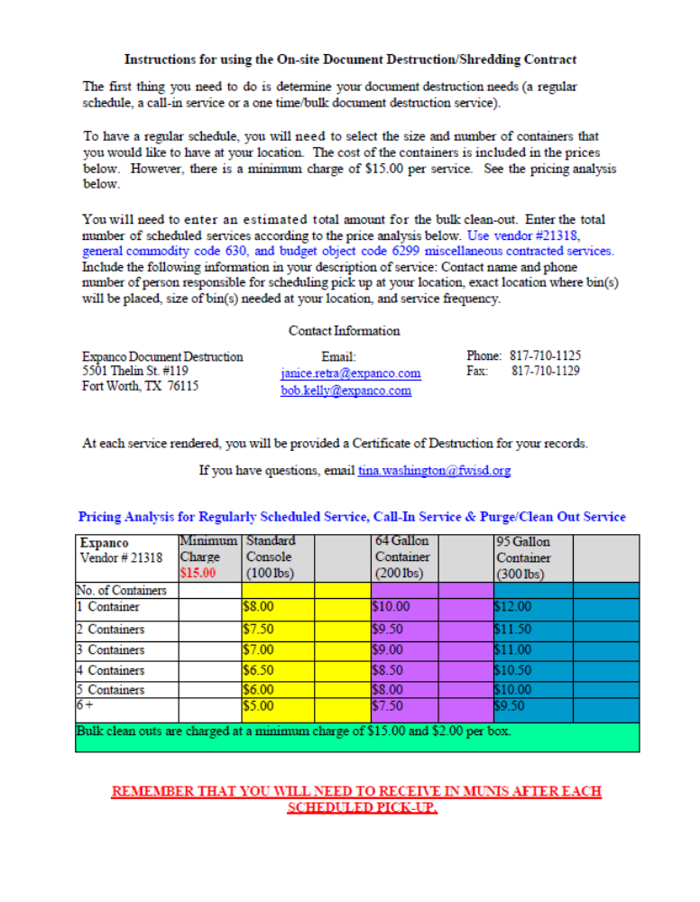

__________________________________________________________________________________

Record Destruction Year Schedule

S

Two (2) Year Schedule

Year End Date  Is on or before  June 31st of: | The Destruction date to be written on the box form is July 1:
2006-2007 | 2009
2007-2008 | 2010
2008-2009 | 2011
2009-2010 | 2012
2010-2011 | 2013
2011-2012 | 2014
2012-2013 | 2015
2013-2014 | 2016
2014-2015 | 2017
2015-2016 | 2018
2016-2017 | 2019
2017-2018 | 2020
2018-2019 | 2021
2019-2020 | 2022

Three (3) Year Schedule

Year End Date  is on or before  June 31st of: | The Destruction date to be written on the box form is July 1:
2006-2007 | 2010
2007-2008 | 2011
2008-2009 | 2012
2009-2010 | 2013
2010-2011 | 2014
2011-2012 | 2015
2012-2013 | 2016
2013-2014 | 2017
2014-2015 | 2018
2015-2016 | 2019
2016-2017 | 2020
2017-2018 | 2021
2018-2019 | 2022
2019-2020 | 2023

Five (5) Year Schedule

Year End Date  is on or before  June 31st of: | The Destruction date to be written on the box form is July 1:
2006-2007 | 2012
2007-2008 | 2013
2008-2009 | 2014
2009-2010 | 2015
2010-2011 | 2016
2011-2012 | 2017
2012-2013 | 2018
2013-2014 | 2019
2014-2015 | 2020
2015-2016 | 2021
2016-2017 | 2022
2017-2018 | 2023
2018-2019 | 2024
2019-2020 | 2025

Seven (7) Year Schedule

Year End Date  is on or before  June 31 of: | The Destruction date to be written on the box form is July 1:
2006-2007 | 2014
2007-2008 | 2015
2008-2009 | 2016
2009-2010 | 2017
2010-2011 | 2018
2011-2012 | 2019
2012-2013 | 2020
2013-2014 | 2021
2014-2015 | 2022
2015-2016 | 2023
2016-2017 | 2024
2017-2018 | 2025
2018-2019 | 2026
2019-2020 | 2027

__________________________________________________________________________________

Record Storage Standards
Local Government Code Title 6, Subtitle C Section 203.048
Care of Records of Permanent Value

The Fort Worth ISD shall adopt rules establishing standards for the proper care and storage of local government records of permanent and non-permanent value.
RECORDS SHALL BE STORED IN A MANNER THAT COMPLIES WITH THE FOLLOWING:
Offers protection from fire, water, steam, structural collapse, unauthorized access, theft, and other similar hazards; and
- Does not expose records to direct sunlight.
- Records or storage boxes shall not be stored in contact with the floor.
- Records stored in a building or storage area shall be protected by an operational fire detection system or the facility must be in compliance with local fire codes.
- Records will be stored in district approved boxes.
- Records will be organized, packed, and labeled in district approved method.
RECORDS STORAGE BOX REQUIREMENTS:
Standard letter/legal size records storage box specifications are as follows:
- Order from the FWISD Warehouse – Stock Catalog
- Oder number: 60-1530
- Unit of Measure: EA
- Description: BOX, STORAGE (PRE-LABELED) (FITS LEGAL/LTR. SIZE FILES) with Lid
- Unit Cost: 1.93
- Can be ordered in a 25 unit bundle
RECORDS STORAGE BOX LABEL REQUIREMENTS:
Standard labeling of records storage box specifications are as follows:
- Order from the FWISD Print Shop
- Form number: 800
- Unit of Measure: 1 sheet (4 labels per sheet)
- Description: BOX, STORAGE (PRE-LABELED) (FITS LEGAL/LTR. SIZE FILES) with Lid
- Unit Cost: $1.50
- Request to be cut
- Can be ordered based on the amount needed.
1 sheet (4 labels) $1.50 - 10 sheets (40 labels) $15.00 or 15 sheets (60 labels) $22.50
PACKING RECORDS:
- Pack only one record series for one year in each box. Records in the same records series, covering the same period, may be added to the box during the year.
  - When removing records from file cabinets, keep them in order.
  - If filed in numerical order – place lower number to the front of each box.
  - If filed in alphabetical order – begin with “A” in the first box.
- If records in the file cabinets are not arranged in a logical order that can be used for retrieving files, they must be put in order before packing boxes. Staff must be able to quickly and easily locate a file with a box.
- Place letter and legal size records upright in the box, as they would normally be arranged in a file drawer.
  - Place letter size records in the box facing the front, toward the label.
  - Place legal size records in the box lengthwise, facing the left-handed side of the box if viewed from front end the bottom of the page should be toward the label.
- Storing binders and ledgers in records boxes is not recommended. However, if they are necessary to manage the records efficiently, stack the binders and ledgers on their sides or backs facing the lid of the box. Do not stack above the hand holes.
- Plastic folders, hanging files, and/or other costly filing supplies must be removed prior to storage.

LABEL SAMPLE:
Labels are to be ordered from the FWISD print shop.

Destruction Year (DRM Use Only)
Storage Box Label

Department/School #: _______________ School Year: ____________ Box Number: ________ of ________
Department/School Name: _________________________________________________________________
Record Series: SD GR PW TX AR Record Series #: ____________________________
Record Series Title: ________________________________________________________________________
Range: _____________________________________________ Alpha Numeric Date Other
Total Retention: 2 Years 5 Years 7 Years Permanent Other: _____________________
Packing Date: _________________________ Destroy Month: ____________Year: ____________________
Description of Contents: ___________________________________________________________________
________________________________________________________________________________________
________________________________________________________________________________________

FWISD STORAGE BOX LABEL:
Use a “black” permanent marker to print the required information on the district standard storage box labels. Do not use red, purple, or other bright colors, as they have tendency to fade over time.
RECORDS STORAGE BOX LABEL REQUIREMENTS:
Standard labeling of records storage box specifications are as follows:
- Order from the FWISD Print Shop
- Form number: 800
- Unit of Measure: 1 sheet (4 labels per sheet)
- Description: BOX, STORAGE (PRE-LABELED) (FITS LEGAL/LTR. SIZE FILES) with Lid
- Unit Cost: $1.50
- Request to be cut
- Can be ordered based on the amount needed.
1 sheet (4 labels) $1.50 - 10 sheets (40 labels) $15.00 or 15 sheets (60 labels) $22.50
Instructions for completing each field on the FWISD record storage box label are described as follows:
- Department/School #: enter your department/school number
Example: Department – DRMO = 411 or Carter-Riverside = 001
- School Year: enter the year the records were produced
Example: 2014/2015
- Box Number: the box number indicates the number of boxes in a consecutive series
Example: Box Number: 1 of 5
- Department/School Name: enter the full department/school name
Example: District Records Management Office / Carter-Riverside
- Record Series: select the record series SD, GR, PW, TX, AR – The record series number is the same information as the records series number in the FWISD Records Control Schedule.
- Records Series Number: write the records series number that corresponds to your records. If you have problems locating the record series number on the FWISD Records Control Schedule contact District Records Management Office.
Example: SD3275-01a
- Record Series Tile: Example: Attendance Control Documentation

- Range: additional information to describe the contents of the box in more detail. A range can be alpha, numerical, date, grade level, etc.
Example:
Alphabetical | Numerical | Date | Other
A-K | 1782-2912 | Oct – Dec | 1st – 3rd six weeks
L-Z | 1st – 4th | 02/2007 – 04/2007 | 1st period – 6th period
ACK-ZUN | 400-600 | 03/01/2004 - 03/31/2004 | 6th grade – 8th grade

- Range Selection: select Alpha (Alphabetical), Numeric (Numerical), Date, Other
- Total Retention: select the required retention years.
- Packing Date: date the box was packed with records.
Example: September, 2015 - 10/17/2015 - May 23, 2016
- Destroy Month: the month to dispose of the records. (This field may be left blank)
- Destroy Year: the year to dispose of the records. Calculate based on the date of the records and the requirements according to the records control schedule or governing authority such as state or federal regulations. Refer to pages 24-27 for year destruction calculation.
Example: 2007, 2012, 2023 or PERMANENT
- Description of Contents: a good description should sufficiently identify the contents of the box without opening the container.
Example:
Good Description: Daily Registers of Pupil Attendance
Parent/Doctor Notes for Attendance
Administrator Notes for Attendance

Poor Description: Student Records
Lucille McGillicuddy files
Office Files

DO NOT store the following: Remove all documents from binders, remove binder clips, rubber bands, and hanging file folders.
Department/School #: _______________ School Year: ______/________ Drawer #: ________ of ________
Department/School Name: _________________________________________________________________
Record Series: EL GR PW TX SD Record Series #: ____________________________
Record Series Title: ________________________________________________________________________
Range: _____________________________________________ Alpha Numeric Date Other
Total Retention: 2 Years 5 Years 7 Years Permanent Other: _____________________
Packing Date: _________________________ Destroy Month: ____________Year: ____________________
Description of Contents: ___________________________________________________________________
________________________________________________________________________________________
________________________________________________________________________________________
Storage File Cabinet Label

FWISD STORAGE FILE CABINET LABEL:
Use a “black” permanent marker to print the required information on the district standard STORAGE FILE CABINET labels. Do not use red, purple, or other bright colors, as they have tendency to fade over time.
RECORDS STORAGE FILE CABINET LABEL REQUIREMENTS:
Standard labeling of records STORAGE FILE CABINET specifications are as follows:
- Order from the FWISD Print Shop
- Form number: 801
- Unit of Measure: 1 sheet (4 labels per sheet)
- Description: STORAGE FILE CABINET LABELS
- Unit Cost: $1.50
- Request to be cut
- Can be ordered based on the amount needed:
1 sheet (4 labels) $1.50 - 10 sheets (40 labels) $15.00 or 15 sheets (60 labels) $22.50
Instructions for completing each field on the FWISD record storage box label are described as follows:
- Department/School #: enter your department/school number
Example: Department – DRMO = 411 or Carter-Riverside = 001
- School Year: enter the year the records were produced
Example: 2014/2015
- Drawer Number: the drawer number indicates the number of drawers in a consecutive series.
Example: Drawer Number: 1 of 5
- Department/School Name: enter the full department/school name
Example: District Records Management Office / Carter-Riverside
- Record Series: select the record series EL, SD, GR, PW, TX – The record series number is the same information as the records series number in the FWISD Records Control Schedule.
- Records Series Number: write the records series number that corresponds to your records. If you have problems locating the record series number on the FWISD Records Control Schedule contact District Records Management Office.
Example: SD3275-01a
- Record Series Tile: Example: Attendance Control Documentation

- Range: additional information to describe the contents of the box in more detail. A range can be alpha, numerical, date, grade level, etc.

Example:
Alphabetical | Numerical | Date | Other
A-K | 1782-2912 | Oct – Dec | 1st – 3rd six weeks
L-Z | 1st – 4th | 02/2007 – 04/2007 | 1st period – 6th period
ACK-ZUN | 400-600 | 03/01/2004 - 03/31/2004 | 6th grade – 8th grade

- Range Selection: select Alpha (Alphabetical), Numeric (Numerical), Date, Other
- Total Retention: select the required retention years.
- Packing Date: date the records were filed in the cabinet.
Example: September, 2015 - 10/17/2015 - May 23, 2016

- Destroy Month: the month to dispose of the records. (This field may be left blank)
- Destroy Year: the year to dispose of the records. Calculate based on the date of the records and the requirements according to the records control schedule or governing authority such as state or federal regulations. Refer to pages 24-27 for year destruction calculation.
Example: 2007, 2012, 2023 or PERMANENT
- Description of Contents: a good description should sufficiently identify the contents of the box without opening the container.
Example:
Good Description: Daily Registers of Pupil Attendance
Parent/Doctor Notes for Attendance
Administrator Notes for Attendance

Poor Description: Records
Rob Van Winkle files
Office Files

DO NOT store the following: Remove all documents from binders, remove binder clips, rubber bands, and hanging file folders.

FWISD FILE CABINET “DON’TS”

NO BINDERS 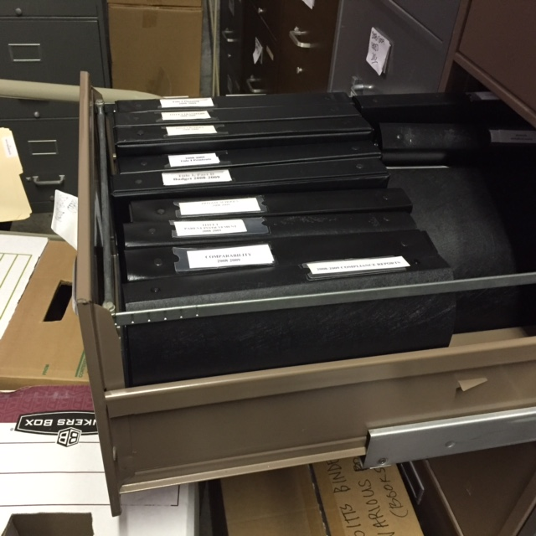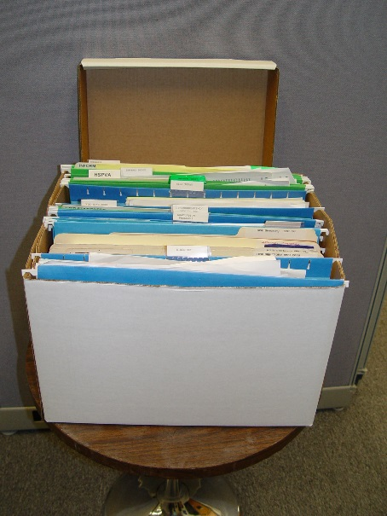
NO BINDERS 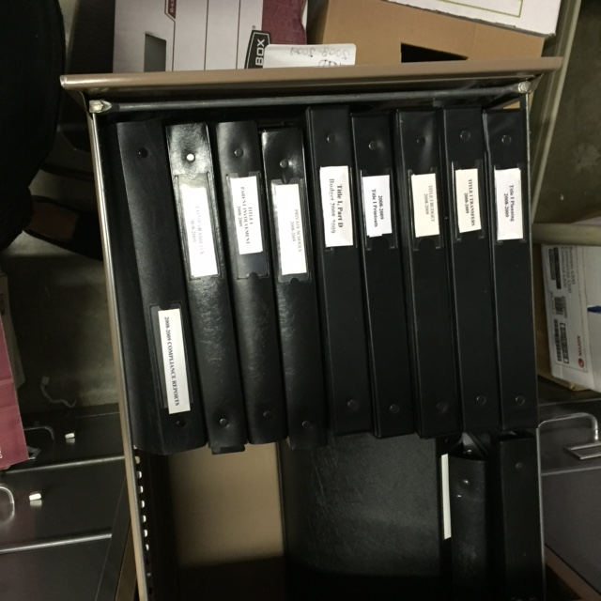

NO BINDER CLIPS
NO PLASTIC FILE FOLDERS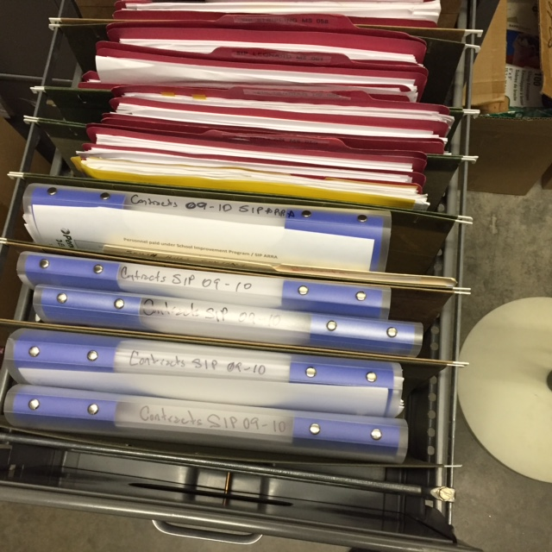
FWISD STORAGE BOX “DON’TS”

NO UNAUTHORIZED STORAGE BOXES
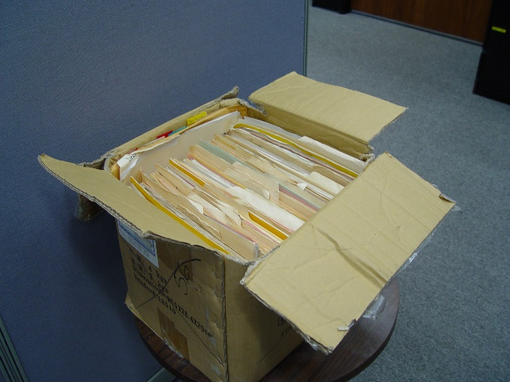
DO NOT OVER-PACK BOXES
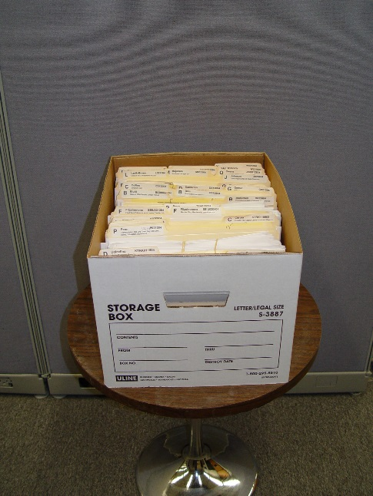
NO BINDERS
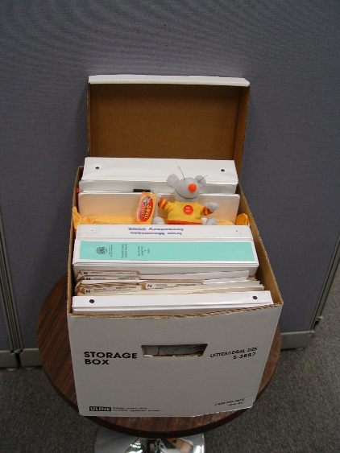
NO HANGING FILES
NON-RECORD MATERIALS
Note: Non-record materials should not be mixed with “official” records.
The following items (but not limited to) generally are NOT records.

- Stocks of publications and printed brochures that are not originals.

- Library material acquired and preserved for reference including textbooks, periodicals, and other technical reference materials.

- Unsolicited announcements, invitations or other materials that are not filed as evidence of business activity or production operations.

- Preliminary drafts, worksheets, memoranda, and informal notes which do not represent significant steps in the preparation of record documents.

- Routing slips that contain no pertinent information or approvals used to direct the distribution of papers and correspondence.

- Personal property such as employee’s own copies of personnel file, certificates, training documentation, etc.

- Extra copies of records in addition to “official” records contained elsewhere. Duplicate copies of records maintained as reading, convenience, tickler, and identical copies maintained with the “official” records are non-records if they are maintained only for reference and convenience and do not contain additional information.

- Blank forms, file and office supplies, or other items that can be found in the store’s warehouse.

- Papers belonging to another office or file station — they should be routed appropriately.

- Junk mail.

__________________________________________________________________________________

Records Quick Reference - SD
SD – “School District” Records
Record Series | Record Title
SD3200 | PART 1: STUDENT ACADEMIC RECORDS
SD3225 | PART 2: FAMILY EDUCATIONAL RIGHTS AND PRIVACY ACT RECORDS
SD3250 | PART 3: RECORDS OF SPECIAL POPULATIONS AND SERVICES
SD3275 | PART 4: ATTENDANCE RECORDS
SD3300 | PART 5: STUDENT HEALTH RECORDS
SD3325 | PART 6: INSTRUCTION AND GRADE REPORTING
SD3350 | PART 7: DISCIPLINE AND COUNSELING RECORDS
SD3375 | PART 8: ADULT AND VOCATIONAL EDUCATION RECORDS
SD3400 | PART 9: DRIVERS EDUCATION RECORDS
SD3425 | PART 10: ACCREDITATION RECORDS
SD3450 | PART 11: FOOD SERVICE RECORDS
SD3475 | PART 12: TEXTBOOK RECORDS
SD3500 | PART 13: SCHOOL TRANSPORTATION RECORDS
SD3525 | PART 14: SCHOOL SAFETY RECORDS
SD3550 | PART 15: FINANCIAL RECORDS
SD3575 | PART 16: PERSONNEL AND STAFFING RECORDS
SD3600 | PART 17: MISCELLANEOUS REPORTS AND SURVEYS
SD3625 | PART 18: MISCELLANEOUS RECORDS
SD3650 | PART 19: LIBRARY RECORDS

PART 1: STUDENT ACADEMIC RECORDS
Retention Notes: Any records in this part (e.g., enrollment cards) created for students who enroll or register in a school district, but who do not subsequently attend classes need to be retained only as long as administratively valuable.
SD3200-01a | Academic Records |  | SD3200-01b | Academic Records
SD3200-02 | Birth Date Documentation |  | SD3200-03 | Custody Documents
SD3200-04 | Enrollment or Registration Forms |  | SD3200-05 | Home Language Surveys
SD3200-06 | Missing Child Prevention and Identification Program Records |  | SD3200-06a | Missing Child Prevention and Identification Program Records
SD3200-06b | Missing Child Prevention and Identification Program Records |  | SD3200-06c | Missing Child Prevention and Identification Program Records
SD3200-07 | Parental Permission Records |  | SD3200-08 | Student Withdrawal/Record Transfer Form
SD3200-09a | Test and Academic Measurement Reports |  | SD3200-09b | Test and Academic Measurement Reports
SD3200-09c | Test and Academic Measurement Reports |  | SD3200-10 | Ethnicity Forms
SD3200-11 | Statement of Assurance for Students who are Victims of a Violent Criminal Act

PART 2: FAMILY EDUCATIONAL RIGHTS AND PRIVACY ACT RECORDS
SD3225-01 | Access Policies |  | SD3225-02 | Access to Information,  Records Of
SD3225-02a | Access to Information,  Records Of |  | SD3225-02b | Access to Information,  Records Of
SD3225-02C | Access to Information,  Records Of |  | SD3225-02d | Access to Information,  Records Of
SD3225-03 | Protest of Record Statements |  | SD3225-04 | Record Amendments Requests & Related Documentation

PART 3: RECORDS OF SPECIAL POPULATIONS AND SERVICES
Retention Notes: The term “cessation of services” used in the retention periods set in sections 3-1 through 3-5 with reference to records created on students who are referred to but not subsequently enrolled in the special program described, means the date determination against enrollment is made.
Section 3-1: Special Education Program Records
SD3250-01 | Special Education - Enrollment Lists and Rosters |  | SD3250-02 | Special Education Student Records

Section 3-2: Bilingual and Special Language Program Records
SD3250-08 | Bilingual and Special Language Program Records

Section 3-3: Gifted/Talented Program Records
SD3250-16 | Gifted/Talented Program Records

Section 3-4: Section 504 Program Records
SD3250-20 | Section 504 Program Records

Section 3-5: Dyslexia Program Records
SD3250-26 | Enrollment List and Rosters |  | SD3250-27 | Dyslexia Program Records

Section 3-6: Migrant Student Record Transfer System (MSRTS) Records
SD3250-33 | Migrant Student Record Transfer System (MSRTS) Records |  | SD3250-34 | Migrant Student Record Transfer System (MSRTS) Records
SD3250-35 | Migrant Student Record Transfer System (MSRTS) Records - Monitoring Documentation |  | SD3250-36 | Migrant Student Record Transfer System (MSRTS) Records - Recruiting Records
SD3250-37a | Migrant Student Record Transfer System (MSRTS) Records |  | SD3250-37b | Migrant Student Record Transfer System (MSRTS) Records
SD3250-37c | Migrant Student Record Transfer System (MSRTS) Records

Section 3-7: Other Special Populations Records
SD3250-43 | Federal Impact Aid Survey Forms |  | SD3250-43a | Federal Impact Aid Survey Forms
SD3250-43b | Federal Impact Aid Survey Forms |  | SD3250-44 | McKinney Homeless Assistance Act Student Record

PART 4: ATTENDANCE RECORDS
SD3275-01a | Attendance Control Documentation |  | SD3275-01b | Attendance Control Documentation
SD3275-01c | Attendance Control Documentation |  | SD3275-01d | Attendance Control Documentation
SD3275-02a | Attendance Reports |  | SD3275-02b | Attendance Reports
SD3275-03 | Scholastic Census Record |  | SD3275-04 | Transfer, Applications for, and Associated Reports

PART 5: STUDENT HEALTH RECORDS
SD3300-01 | Student Health Records - Accident Reports |  | SD3300-02 | Student Health Records - Activity and Statistical Reports
SD3300-03 | Student Health Records |  | SD3300-04 | Student Health Records
SD3300-05 | Student Health Records |  | SD3300-06 | Student Health Records - Exclusion & Verification
SD3300-06a | Student Health Records - Exclusion & Verification |  | SD3300-06b | Student Health Records - Exclusion & Verification
SD3300-06c | Student Health Records - Exclusion & Verification |  | SD3300-07a | Health Screening Documentation
SD3300-07b | Health Screening Documentation |  | SD3300-08a | Immunization Records
SD3300-08b | Immunization Records |  | SD3300-09 | Student Health Records
SD3300-10 | Reports to Enforcement Agencies |  | SD3300-11a | Special Health Care Records
SD3300-11b | Special Health Care Records

PART 6: INSTRUCTION AND GRADE REPORTING
SD3325-01 | Curriculum Guides |  | SD3325-02 | Grade Books
SD3325-02 | Grade Books |  | SD3325-03 | Grade Reports
SD3325-04 | Lesson Plans |  | SD3325-05 | Report Cards

PART 7: DISCIPLINE AND COUNSELING RECORDS
SD3350-01 | Discipline Records |  | SD3350-01a | Discipline Records
SD3350-01b | Discipline Records |  | SD3350-03 | Law Enforcement Notifications
SD3350-02 | Student Guidance and Counseling Files

PART 8: ADULT AND VOCATIONAL EDUCATION RECORDS
SD3375-01 | Class Organization Reports and Rosters |  | SD3375-02 | Curriculum Planning Documentation
SD3375-03 | Follow-Up Reports |  | SD3375-04 | Student Records

PART 9: DRIVERS EDUCATION RECORDS
SD3400-01 | Drivers Education Records - Student Records |  | SD3400-01 | Drivers Education Records - Student Records
SD3400-02 | Drivers Education Records - Student Rosters |  | SD3400-03 | Drivers Education Records - Instructional Checklist
SD3400-04 | Drivers Education Records - Licensing and Completion Forms |  | SD3400-05 | Drivers Education Records

PART 10: ACCREDITATION RECORDS
SD3425-01a | Accreditation Reports |  | SD3425-01b | Accreditation Reports
SD3425-02 | Accreditation Reports - Planning Records

PART 11: FOOD SERVICE RECORDS
SD3450-01 | Certificates of Authority |  | SD3450-02 | Daily Food Service Records
SD3450-03 | Food & Food Inventory Records |  | SD3450-04a | Free or Reduced-Price Meal Records
SD3450-04b | Free or Reduced-Price Meal Records |  | SD3450-04c | Free or Reduced-Price Meal Records
SD3450-05 | Health Inspection Reports |  | SD3450-06a | Menu Records
SD3450-06b | Menu Records

PART 12: TEXTBOOK RECORDS
SD3475-01 | Textbook Records |  | SD3475-02 | Textbook Records
SD3475-03 | Textbook Records |  | SD3475-04a | Textbook Records
SD3475-04b | Textbook Records |  | SD3475-04c | Textbook Records
SD3475-04d | Textbook Records |  | SD3475-05a | Textbook Procurement Records
SD3475-05b | Textbook Procurement Records |  | SD3475-05c | Textbook Procurement Records
SD3475-06a | Textbook Sales and Disposition Records |  | SD3475-06b | Textbook Sales and Disposition Records

PART 13: SCHOOL TRANSPORTATION RECORDS
SD3500-01 | School Transportation Records |  | SD3500-02 | School Transportation Records
SD3500-03 | Drivers Records |  | SD3500-03a | Drivers Records
SD3500-03b | Drivers Records |  | SD3500-03c | Drivers Records
SD3500-04 | Eligible Rider Documentation |  | SD3500-05 | Pupil Transportation Reports
SD3500-06 | Route Descriptions |  | SD3500-07a | School Transportation Cost and Maintenance Records
SD3500-07b | School Transportation Cost and Maintenance Records |  | SD3500-07c | School Transportation Cost and Maintenance Records
SD3500-07d | School Transportation Cost and Maintenance Records |  | SD3500-07e | School Transportation Cost and Maintenance Records
SD3500-08 | School Transportation Cost and Maintenance Records |  | SD3500-09a | School Bus Surveillance Video (no incident)
SD3500-09b | School Bus Surveillance Video (incident)

PART 14: SCHOOL SAFETY RECORDS
SD3525-01 | School Safety Records |  | SD3525-02 | Fire Drill Records
SD3525-03 | Fire Safety Inspection Reports

PART 15: FINANCIAL RECORDS
Retention Notes: This part supplements and should be used in conjunction with Part 2 of Local Schedule GR.
SD3550-01 | Agency Fund Records |  | SD3550-02 | County Available Reports
SD3550-03 | School Bonds, Applications for Guaranty

PART 16: PERSONNEL AND STAFFING RECORDS
Retention Notes: a) This part supplements and should be used in conjunction with Part 3 of Local Schedule GR. b) If the retention period for a period for a record in this part is given as US or as US+ a specific number of years and the person to whom the record related ceases employment before supersession occurs, the date of separation shall also be considered the date of supersession for records retention purposes.

Section 16-1: Individual Employee Records
SD3575-01 | Personnel and Staffing Records |  | SD3575-02 | Applications and Recommendations for Professional or Paraprofessional Certificates or Permits, Copies of
SD3575-02a | Applications and Recommendations for Professional or Paraprofessional Certificates or Permits, Copies of |  | SD3575-02b | Applications and Recommendations for Professional or Paraprofessional Certificates or Permits, Copies of
SD3575-03 | Audit Verification Cards |  | SD3575-04 | Deficiency Plan
SD3575-05 | Performance Appraisal Records (Career Ladder System) |  | SD3575-05a | Performance Appraisal Records (Career Ladder System)
SD3575-05b | Performance Appraisal Records (Career Ladder System) |  | SD3575-05c | Performance Appraisal Records (Career Ladder System)
SD3575-05d | Performance Appraisal Records (Career Ladder System) |  | SD3575-05e | Performance Appraisal Records (Career Ladder System)
SD3575-05f | Performance Appraisal Records (Career Ladder System) |  | SD3575-06 | Service Record Affidavits
SD3575-07 | Statements of Commitments |  | SD3575-08 | Statements of Intention to Become US Citizen
SD3575-09 | Teacher Certificate Registers |  | SD3575-10 | Tuberculosis Certificates
SD3575-11 | Criminal History Checks

Section 16-2: Staffing Records
SD3575-16 | Personnel Rosters |  | SD3575-17 | Personnel Unit Requirement Calculation Worksheets
SD3575-18 | Substitute Teaching Rosters

PART 17: MISCELLANEOUS REPORTS AND SURVEYS
SD3600-01-1 | PEIMS Data Submission |  | SD3600-02 | Data Verification Reports
SD3600-03 | Surveys

PART 18: MISCELLANEOUS RECORDS
SD3625-01 | Program Approval Applications |  | SD3625-01a | Program Approval Applications
SD3625-01b | Program Approval Applications |  | SD3625-02 | Requests for Waiver of TEA Policies and Rules
SD3625-02a | Requests for Waiver of TEA Policies and Rules |  | SD3625-02b | Requests for Waiver of TEA Policies and Rules
SD3625-03 | School Calendar |  | SD3625-04 | UIL Records
SD3625-05 | Extracurricular Activity Records |  | SD3625-06a | Student Drug/Alcohol Test
SD3625-06b | Student Drug/Alcohol Test |  | SD3625-07 | Visitor Logs
SD3625-08 | Parking Decal/Permit Records

PART 19: LIBRARY RECORDS
SD3650-01 | Accession/Deaccession Records |  | SD3650-02 | Borrower Registration Records
SD3650-03 | Circulation Records |  | SD3650-04 | Interlibrary Loan Records
SD3650-05 | Inventory Records |  | SD3650-06 | Library Catalogs

__________________________________________________________________________________

Records Quick Reference - GR
GR – “Government” Records

Record Series | Record Title
GR1000 | PART 1: ADMINISTRATIVE RECORDS
GR1025 | PART 2: FINANCIAL RECORDS
GR1050 | PART 3: PERSONNEL AND PAYROLL RECORDS
GR1075 | PART 4: SUPPORT SERVICES RECORDS
GR5750 | Section 4-4: Workplace Safety Records
GR5800 | PART 5: INFORMATION TECHNOLOGY RECORDS
GR5825 | Section 5-2: Computer Operation and Technical Support Records

PART 1: ADMINISTRATIVE RECORDS
Retention Note: SCOPE OF SECTION - The retention periods established in this section also apply to the records of subsidiary boards, bureaus, commissions, or committees established by the governing body of a local government that have rulemaking or quasi-judicial authority over any activity or program of the government or that were established by ordinance, order, or resolution for the purposes of advising the governing body or a subsidiary body on policy. Consequently, the use of the term “governing body” in a records description includes the corresponding records of those subsidiary bodies.
Section 1-1: Records of Governing Bodies
GR1000-01a | Agendas |  | GR1000-01b | Agendas
GR1000-02 | Dedications |  | GR1000-03 | Minutes
GR1000-03a | Minutes |  | GR1000-03b | Minutes
GR1000-03c | Minutes |  | GR1000-03d | Minutes
GR1000-03e | Minutes |  | GR1000-03f | Minutes
R1000-03g | Minutes |  | GR1000-04 | Open Meeting Notices
GR1000-05 | Official Orders, Resolutions, or Proclamations |  | GR1000-06 | Petitions
GR1000-07 | Proclamations |  | GR1000-08 | Speeches, Papers, and Presentations

Section 1-2: General Records
GR1000-20 | Accident Reports |  | GR1000-20a | Accident Reports
GR1000-20b | Accident Reports |  | GR1000-21a | Affidavits of Publication
GR1000-21b | Affidavits of Publication |  | GR1000-21c | Affidavits of Publication
GR1000-22 | Annexation, Dis-annexation, Abolition, and Other Jurisdictional Records |  | GR1000-23 | Charters
GR1000-24 | Complaints |  | GR1000-25 | Contracts, Leases, and Agreements
GR1000-26 | Correspondence, Internal Memoranda, and Subject Files |  | GR1000-26a | Correspondence, Internal Memoranda, and Subject Files
GR1000-26b | Correspondence, Internal Memoranda, and Subject Files |  | GR1000-26c | Correspondence, Internal Memoranda, and Subject Files
GR1000-27 | Deeds |  | GR1000-28 | Easements
GR1000-29 | Insurance Policies |  | GR1000-30 | Legal Opinions
GR1000-31 | Litigation Case Files |  | GR1000-32 | Minutes (STAFF)
GR1000-33 | Public Relations Records |  | GR1000-34 | Public Information Act Requests
GR1000-34a | Public Information Act Requests |  | GR1000-34b | Public Information Act Requests
GR1000-35 | Organizational Charts |  | GR1000-36 | Permits and Licenses
GR1000-37 | Photographs, Recordings, and other Non-Textual Media |  | GR1000-38 | Policy and Procedure Documentation
GR1000-39 | Publications |  | GR1000-40a | Records Management Records
GR1000-40b | Records Management Records |  | GR1000-40c | Records Management Records
GR1000-40d | Records Management Records |  | GR1000-41a | Reports and Studies (Non-Fiscal)
GR1000-41b | Reports and Studies (Non-Fiscal) |  | GR1000-42 | Waivers of Liability
GR1000-43 | Conflicts Disclosure Statements and Conflict of Interest Questionnaires |  | GR1000-44 | Local Government Officer,  Lists of:
GR1000-45 | Calendars, Appointment and Itinerary Records |  | GR1000-46 | Insurance Claims
GR1000-47 | Customer Surveys |  | GR1000-50 | Transitory Information

PART 2: FINANCIAL RECORDS
Retention Notes: AUDIT REQUIREMENTS - Most local governments are required by state law to conduct annual or biennial audits of their records and accounts. These audit requirements were taken into account in setting the retention periods in this schedule. The following retention rules also apply:
1) In any local government for which there is no statutory audit requirement and audits are conducted irregularly or in a local government in which a statutorily required audit is delayed, any record in this schedule whose retention period dates from the end of a fiscal year (FE) must be retained for the retention period stated or one year after audit, whichever later.
2) With regard to any special fund of a local government or elective county office for which there is no statutory audit requirement and the fund is not audited, any records listed under item numbers GR1025-26, GR1025-27, GR1025-28, and GR1025-30 associated with receipts and disbursements from or to the fund must be retained for FE + 10 years.

Section 2-1: Fiscal Administration and Reporting Records
GR1025-01a | Fiscal Audit Records (by both internal and external auditors) |  | GR1025-01b | Fiscal Audit Records (by both internal and external auditors)
GR1025-01c | Fiscal Audit Records (by both internal and external auditors) |  | GR1025-01d | Fiscal Audit Records (by both internal and external auditors)
GR1025-01e | Fiscal Audit Records (by both internal and external auditors) |  | GR1025-02 | Bank Security Records
GR1025-03 | Bond Records |  | GR1025-03a | Bond Records
GR1025-03b | Bond Records |  | GR1025-03c | Bond Records
GR1025-03d | Bond Records |  | GR1025-04a | Budgets and Budget Documentation
GR1025-04b | Budgets and Budget Documentation |  | GR1025-04c | Budgets and Budget Documentation
GR1025-04d | Budgets and Budget Documentation |  | GR1025-04e | Budgets and Budget Documentation
GR1025-05 | Capital Assets Records |  | GR1025-05a | Capital Assets Records
GR1025-05b | Capital Assets Records |  | GR1025-05c | Capital Assets Records
GR1025-05d | Capital Assets Records |  | GR1025-06 | Federal Revenue Sharing Records
GR1025-07 | Financial Reports |  | GR1025-07a | Financial Reports
GR1025-07b | Financial Reports |  | GR1025-07c | Financial Reports
GR1025-07d | Financial Reports |  | GR1025-08 | Grant Development and Administrative Records
GR1025-08a | Grant Development and Administrative Records |  | GR1025-08b | Grant Development and Administrative Records
GR1025-08c | Grant Development and Administrative Records |  | GR1025-08d | Grant Development and Administrative Records
GR1025-09a | Investment Transaction Records |  | GR1025-09b | Investment Transaction Records
GR1025-10 | Charge Schedules and Price Lists

Section 2-2: Accounting Records
Retention Notes: a) ACCOUNTING RECORDS OF MOTOR VEHICLE AND BOAT LICENSING AND REGISTRATION - For accounting and banking records relating to motor vehicle licensing not noted in this part, use Part 3 of Local Schedule TX.
GR1025-25 | Accounting Policies and Procedures Documentation |  | GR1025-26a | Accounts Payable and Disbursement Records
GR1025-26b | Accounts Payable and Disbursement Records |  | GR1025-26c | Accounts Payable and Disbursement Records
GR1025-26d | Accounts Payable and Disbursement Records |  | GR1025-27 | Accounts Receivable Records
GR1025-27a | Accounts Receivable Records |  | GR1025-27b | Accounts Receivable Records
GR1025-27c | Accounts Receivable Records |  | GR1025-27d | Accounts Receivable Records
GR1025-27e | Accounts Receivable Records |  | GR1025-29 | Cost Allocation and Distribution Records
GR1025-28 | Banking Records

GR1025-30 | Ledgers, Journals, and Entry Documentation |  | GR1025-30a | Ledgers, Journals, and Entry Documentation
GR1025-30b | Ledgers, Journals, and Entry Documentation |  | GR1025-30c | Ledgers, Journals, and Entry Documentation
GR1025-30d | Ledgers, Journals, and Entry Documentation |  | GR1025-31 | Transaction Summaries
GR1025-31b | Transaction Summaries |  | GR1025-31c | Transaction Summaries
GR1025-31d | Transaction Summaries |  | GR1025-32 | Unclaimed Property Documentation

PART 3: PERSONNEL AND PAYROLL RECORDS
Retention Notes: a) FEDERAL RETENTION REQUIREMENTS - Federal retention periods for personnel and payroll records arise principally from the administration of the Civil Rights Act of 1964, Title VII; the Age Discrimination and Employment Act of 1967; the Equal Pay Act; the Fair Labor Standards Act; the Federal Insurance Contribution Act; and the Federal Unemployment Tax Act. Various federal agencies or departments of agencies administer these acts and, because retention periods are set to enable each agency to carry out its particular oversight authority, different retention periods are often established for the same record. In compiling Schedule GR, the longest applicable federal retention period is cited as authority for the retention period indicated. A federal regulation is not cited if a state law or regulation requires a longer retention period. A federal retention period is also not cited if a Texas statute of limitations makes a longer retention period advisable. For example, the federal retention requirement for employment contracts [see item number GR1050-15(a)] is given as 3 years from the last effective date of the contract in 26 CFR 516.5, but suits in Texas may be brought by either party to such a contract within four years of the occurrence of an alleged breach; therefore a retention period of 4 years from the last effective date of the contract is set in this schedule. All retention periods in this part apply, by authority of this schedule, to all local governments, although some of them may be otherwise exempt from the federal requirement cited. This provision does not require the creation by exempted local governments of any special documentation demonstrating compliance with federal regulations that may be required of non-exempted governments.
b) PERSONNEL FILES - The individual employee personnel file is not scheduled as a unit in this section; documents normally placed in such files are scheduled separately.
c) TERMINATED EMPLOYEES - Notwithstanding any retention periods in this part, all personnel records existing on the date of termination of an involuntarily terminated employee must be retained for 2 years from the date of termination [29 CFR 1602.31, 1602.40, and 1602.49].
d) JTPA AND CETA EMPLOYEES - Any records maintained on applicants for or holders of positions paid in whole or in part from Comprehensive Employees’ Training Act (CETA) funds or affirmative action apprenticeship program funds administered by the U. S. Department of Labor must be retained for 5 years from the date of enrollment in the program. [29 CFR 30.8(e)]. This 5-year retention period is extended by authority of this schedule to comparable records on applicants for or holders of positions paid in whole or in part from Job Training Partnership Act (JTPA) funds.
e) DEFINITION OF EMPLOYEE - For the purposes of this part, the term “employee” also includes elected or appointed officials of a local government who are paid wages or a salary from any funds of the local government and anyone voluntarily working or not receiving payment or compensation for working.
Section 3-1: Personnel Records
GR1050-01a | Affirmative Action Plans |  | GR1050-01b | Affirmative Action Plans
GR1050-02 | Aptitude and Skills Test Records |  | GR1050-02a | Aptitude and Skills Test Records
GR1050-02b | Aptitude and Skills Test Records |  | GR1050-02c | Aptitude and Skills Test Records
GR1050-02d | Aptitude and Skills Test Records |  | GR1050-03 | Awards and Commendations
GR1050-04 | Certificates and Licenses |  | GR1050-05 | Conflict of Interest Affidavits
GR1050-06a | Counseling Program Records |  | GR1050-06b | Counseling Program Records
GR1050-07 | Disciplinary and Adverse Action Records |  | GR1050-08 | Employee Pension and Benefits Records
GR1050-08a | Employee Pension and Benefits Records |  | GR1050-08b | Employee Pension and Benefits Records
GR1050-08c | Employee Pension and Benefits Records |  | GR1050-09 | Employee Recognition Records
GR1050-10a | Employee Security Records |  | GR1050-10b | Employee Security Records
GR1050-11 | Employee Selection Records |  | GR1050-12 | Employee Service Record
GR1050-13 | Employment Advertisements or Announcements |  | GR1050-14 | Employment Applications
GR1050-14a | Employment Applications |  | GR1050-14b | Employment Applications
GR1050-15a | Employment Contract/Collective Bargaining Records |  | GR1050-15b | Employment Contract/Collective Bargaining Records
GR1050-16a | Equal Employment Opportunity Records and Reports |  | GR1050-16b | Equal Employment Opportunity Records and Reports
GR1050-16c | Equal Employment Opportunity Records and Reports |  | GR1050-17 | Equal Pay Records
GR1050-18 | Fidelity Bonds |  | GR1050-19 | Fingerprint Cards
GR1050-20 | Grievance Records |  | GR1050-21 | Job Evaluations  (Performance Appraisals)
GR1050-22a | Medical and Exposure Reports |  | GR1050-22b | Medical and Exposure Reports - Periodic

GR1050-22c | Medical and Exposure Reports |  | GR1050-22d | Medical and Exposure Reports - Periodic
GR1050-23 | Oaths of Office |  | GR1050-24 | Personnel Action or Information Notices
GR1050-25 | Personnel Studies and Surveys |  | GR1050-26a | Position Description, Classification, and Staff Monitoring Records
GR1050-26b | Position Description, Classification, and Staff Monitoring Records |  | GR1050-26c | Position Description, Classification, and Staff Monitoring Records
GR1050-27 | Reduction in Force Plans (including any related implementation documentation) |  | GR1050-28 | Training and Educational Achievement Records
GR1050-28a | Training and Educational Achievement Records |  | GR1050-28b | Training and Educational Achievement Records
GR1050-28c | Training and Educational Achievement Records |  | GR1050-28d | Training and Educational Achievement Records
GR1050-29 | Unemployment Compensation Claims Records |  | GR1050-30 | Verification of Employment Eligibility (INS Form I-9)
GR1050-31 | Work Schedules |  | GR1050-32 | Workers Compensation Claim Records
GR1050-33 | Financial Disclosure Statements |  | GR1050-34 | Public Access Option Forms
GR1050-35 | Employee Exit Interviews |  | GR1050-36 | Criminal History Checks
GR1050-37 | Employee Acknowledgement Forms |  | GR1050-38 | Unsolicited Resumes
GR1050-39 | Volunteer Service Files

Section 3-2: Payroll Records
Retention Note: OTHER ACCOUNTING RECORDS - This section supplements Section 2-2 and schedules financial and accounting records found in most local governments specific to the disbursement of payroll. If a payroll-related record is not scheduled in this section, use Section 2-2 for the comparable record; e.g., payroll fund reconciliations should be retained for FE + 5 years under the retention for Banking Records (see item number GR1025-28).
GR1050-50 | Deduction Authorizations |  | GR1050-51 | Direct Deposit Applications/ Authorizations
GR1050-52a | Earnings and Deduction Records |  | GR1050-52b | Earnings and Deduction Records
GR1050-52c | Earnings and Deduction Records |  | GR1050-52d | Earnings and Deduction Records
GR1050-52e | Earnings and Deduction Records |  | GR1050-52f | Earnings and Deduction Records
GR1050-53a | Federal and State Tax Forms and Reports |  | GR1050-53b | Federal and State Tax Forms and Reports
GR1050-54a | Leave Records |  | GR1050-54b | Leave Records
GR1050-54c | Leave Records |  | GR1050-54d | Leave Records

GR1050-55 | Payroll Action or Information Notices |  | GR1050-55a | Payroll Action or Information Notices
GR1050-55b | Payroll Action or Information Notices |  | GR1050-56 | Time and Attendance Reports
GR1050-57 | Time Change Records |  | GR1050-58 | Requests and Authorizations to Engage in Reimbursable Activities
GR1050-59a | Wage and Salary Tables |  | GR1050-59b | Wage and Salary Tables

PART 4: SUPPORT SERVICES RECORDS
Section 4-1: Purchasing Records
Retention Notes: RELATIONSHIP WITH ACCOUNTS PAYABLE RECORDS - In a local government in which purchasing and accounts payable records (see item number 1025-26) are maintained by the same individual or department, duplicate copies of a record need not be created and/or retained to satisfy the retention requirements of this section if the record is used in documenting both the ordering and procurement of and payment for goods and services. In such instances, retention requirements for accounts payable records prevail over those noted in this section.

GR1075-01a | Bids and Bid Documentation |  | GR1075-01b | Bids and Bid Documentation
GR1075-01c | Bids and Bid Documentation |  | GR1075-01d | Bids and Bid Documentation
GR1075-02 | Inventory Records (Parts and Supplies) |  | GR1075-03a | Purchase Order and Receipt Records
GR1075-03b | Purchase Order and Receipt Records |  | GR1075-03c | Purchase Order and Receipt Records
GR1075-03d | Purchase Order and Receipt Records

Section 4-2: Facility, Vehicle, and Equipment Management Records
GR1075-15 | Accident and Damage Reports (Property) |  | GR1075-16a | Construction Project Records
GR1075-16b | Construction Project Records |  | GR1075-16c | Construction Project Records
GR1075-18 | Maintenance, Repair, and Inspection Records |  | GR1075-18a | Maintenance, Repair, and Inspection Records
GR1075-18b | Maintenance, Repair, and Inspection Records |  | GR1075-19 | Service Requests/Work Orders (for repairs and maintenance to facilities, vehicles, or equipment)
GR1075-20 | Usage Reports |  | GR1075-20a | Usage Reports - Reports of usage of facilities, vehicles, and equipment

GR1075-20b | Usage Reports - Reports of usage of facilities, vehicles, and equipment |  | GR1075-20c | Usage Reports - Reports of usage of facilities, vehicles, and equipment
GR1075-21 | Vehicle or Equipment Assignment Records |  | GR1075-22 | Visitor Control Registers
GR1075-23 | Warranties (for vehicles and equipment) |  | GR1075-24 | Vehicle Titles and Registration
GR1075-25 | Surveillance Videos

Section 4-3: Communications Records
GR1075-40a | Postal and Delivery Service Records |  | GR1075-40b | Postal and Delivery Service Records
GR1075-41 | Telephone Logs or Activity Reports |  | GR1075-41a | Telephone Logs or Activity Reports
GR1075-41b | Telephone Logs or Activity Reports |  | GR1075-41c | Telephone Logs or Activity Reports
GR1075-42 | E-Rate Records

Section 4-4: Workplace Safety Records
GR5750-01 | Blood borne Pathogen Training Records |  | GR5750-02 | Facility Chemical Lists
GR5750-04 | Hazardous Materials Training Records |  | GR5750-05 | Material Safety Data Sheets (MSDS)
GR5750-06 | Workplace Chemical Lists

PART 5: INFORMATION TECHNOLOGY RECORDS
Retention Notes: (a) This part establishes retention periods for records essential to the creation, maintenance, and use of electronic records (information recorded in a form for computer processing including data, graphics, digital images, multi-media records, etc.) and records related to computer operations/technical support not covered elsewhere in this schedule. Records in this part may be maintained on whatever medium is appropriate including electronic (on-line, magnetic tape, optical disk, CD-ROM, etc.), paper, and microform.
(b) Other types of records may be maintained electronically that are listed elsewhere in this schedule, such as administrative, fiscal, personnel, and support services records, or in other specialized schedules adopted by the Texas State Library and Archives Commission, such as Local Schedule PS (Records of Public Safety Agencies), Local Schedule HR (Records of Public Health Agencies), etc. The retention period for those electronic records will be as specified under the appropriate records series item number according to the function of the information. For example, if an electronic system were used to maintain encumbrance and expenditure reports, the retention period for these electronic records would be 2 years as specified in item number 1025-04(d). Retention requirements apply to records maintained on all types of electronic systems including mainframe, minicomputer, microcomputer, local-area-network based systems, etc.
(c) Administrative rules of the Texas State Library and Archives Commission (13 TAC 7.71-7.79) require that retention procedures for electronic records with an approved retention of 10 years or more must include provisions for scheduling the disposition of the electronic records as well as related software, documentation, and indexes; and for regular recopying, reformatting, and other necessary maintenance or conversion activities to ensure the retention and stability of electronic records until the expiration of their retention periods.
(d) If automated information is copied to paper or microform to create the official record, the electronic files do not have to be maintained for the full retention period of the record. The added value of electronic files for facilitating retrieval, making queries, providing for automated audit trails, etc., should be carefully reviewed prior to destruction of the electronic files even though there is an official record in another medium.

Section 5-1: Records of Automated Applications
GR5800-01 | Audit Trail Records |  | GR5800-02 | Finding Aids, Indexes, and Tracking Systems
GR5800-03 | Hardware Documentation |  | GR5800-04 | Master File Records
GR5800-05 | Processing Records |  | GR5800-06 | Software Programs
GR5800-08 | Technical Documentation

Section 5-2: Computer Operation and Technical Support Records
GR5825-01 | Access Security Records |  | GR5825-02 | Batch Data Entry Control Records
GR5825-03 | Chargeback Records to Data Processing Services Users |  | GR5825-04 | Computer Job Schedules and Reports
GR5825-05 | Data Processing Policies and Procedures |  | GR5825-06 | Data Processing Planning Records
GR5825-07 | Network Systems Disaster Preparedness and Recovery Plans |  | GR5825-08 | Electronic Media Library System Records
GR5825-09 | Input Documents |  | GR5825-10 | Network Circuits Inventories
GR5825-11 | Network Implementation Records |  | GR5825-12 | Operating System and Hardware Conversion Plans
GR5825-13 | Output Records for Computer Production |  | GR5825-14 | Quality Assurance Records
GR5825-15 | Project Records |  | GR5825-15a | Project Records
GR5825-15b | Project Records |  | GR5825-16 | System Activity Monitoring Records
GR5825-17 | Electronic Records Training Records |  | GR5825-18 | Internet Cookies
GR5825-19 | History Files - Web Sites |  | GR5825-20 | Software Registrations, Warranties, and License Agreements

__________________________________________________________________________________

Appendix

SAMPLE FORM - Destruction of Records
I certify these records have met all retention requirements and there is no pending litigation or open records requests.

Custodian of Records Authorization:
Signature: ___________________________

Printed Name: ________________________

Date: ________ School/Dept. #: _________
Name: ______________________________
School/Dept.: ________________________
Telephone#: _________________________

Record  Series # | Description of Records | School Year Produced | Number of Boxes
Total Number of Boxes
Page ____ of ____

Records Management Department Use Only
Documents must be destroyed within 5 business days of receipt of approval.

Destruction Approval: Approved Denied
RDA#: __________________
D Signature: _____________________________________ Date: _________________________
Reason for Denial:

Instructions for Completion of Records Destruction Authorization Form

The Destruction Authorization form should be completed and two copies are to be made. Submit the original copy to the District Records Management Department (DRM) and retain the second copy for your school/department file. Each request is numerically identified and will be processed, once the Records Management Department reviews it.

- Contact Information -- Complete the name of the person preparing form, as well as the date, school/department number, name, school/department name and telephone number.

- Retention Schedule # -- You must provide the DRM with a retention schedule number for all documents to be destroyed. It is the school/department’s responsibility to assure that all records have met the retention period required by state law. The retention schedules (Records Management Plan for Schools and Records Management for Administrative Departments) can be viewed at the District Records Management Portal Web site. Administrative Departments will need to request a copy of the retention schedule that relates to their department from the Records Management Department because the copy on the Web site does not contain the retention schedule numbers that are needed.

- Record Description -- A specific detailed description must be given for all records that are requested for destruction. No general description is accepted. *For example: Financial Records would be considered as general. A correct description is as follows: Financial Records -- Payroll Checks.

- Date Range -- A specific date range must be given for all records. It will determine whether or not records have met their retention period.

- Number of Boxes -- Specify the number of boxes you have for that category of records and the grand total of boxes to be destroyed

- Authorization -- Please allow your school/department assigned Custodian of Records to review and sign the authorization signature located at the top right portion of the form.

The Records Management Department will not schedule
or destroy any records without the authorization signature.

Records Management Use Only -- The bottom portion of the form is for Records Management use only. Once the documents have been destroyed our staff will sign off as destroyed, and a copy will be sent back to your school/department for your records.

Once your form is completed you can email or fax to Records Management. Fax #: 817-814-2114 or email to recordsmanagement@fwisd.org. Records Management will then review the request for compliance. If clarification or corrections are not needed, your request will be approved for destruction.
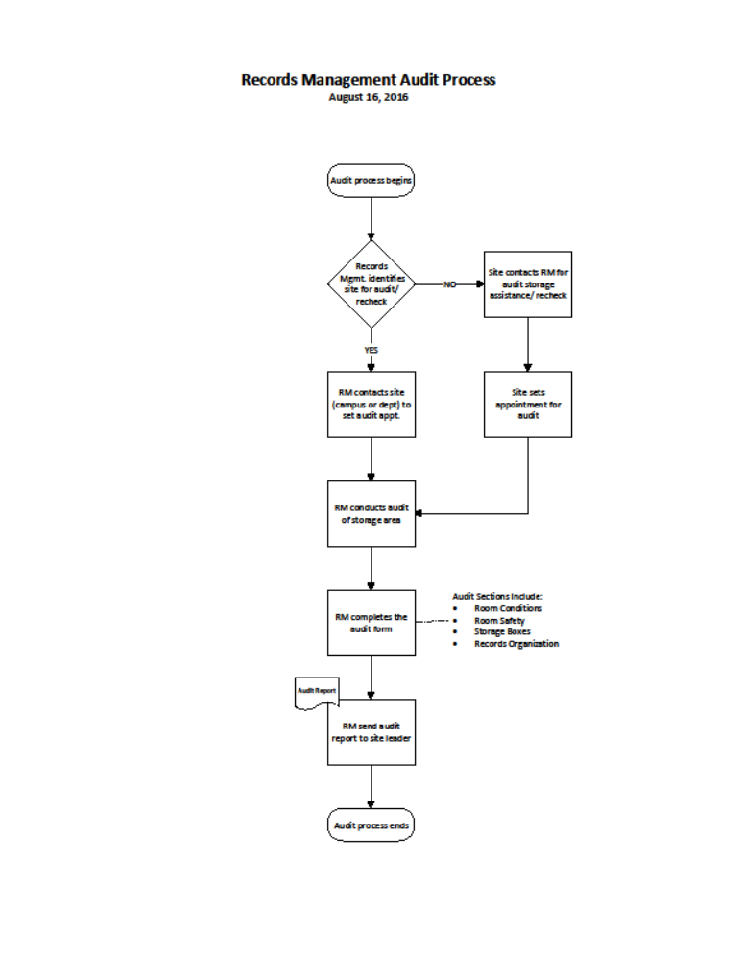

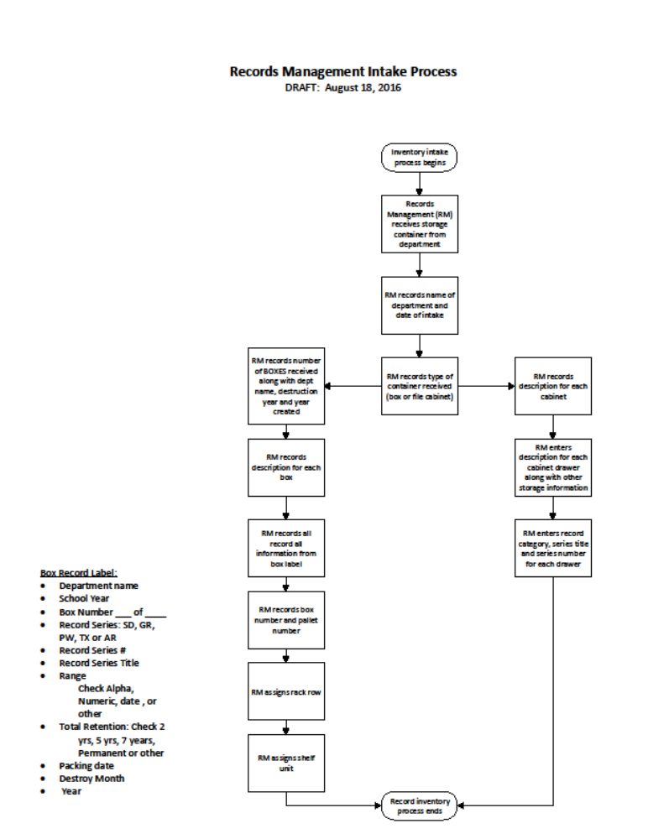

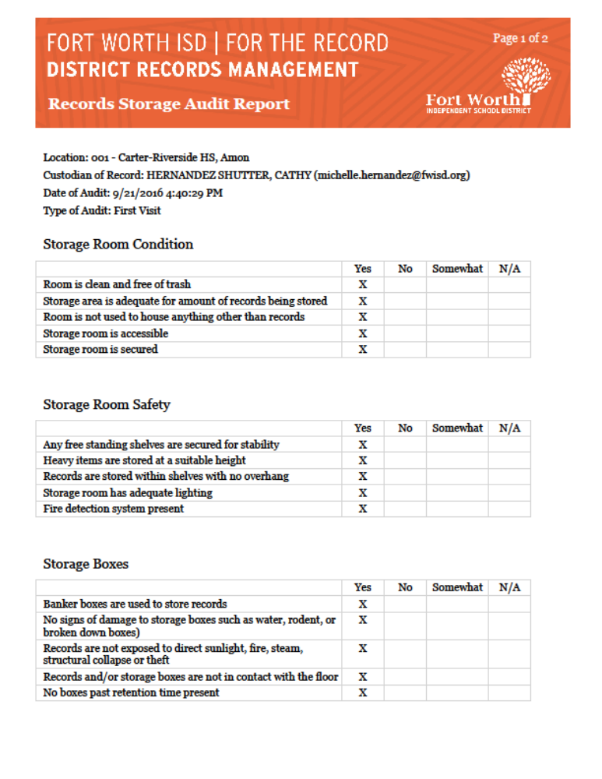



Creation Date: January, 2015
Revised: August, 2016

This training material was developed by the
Fort Worth Independent School District,
District Records Management Department for use by the District

