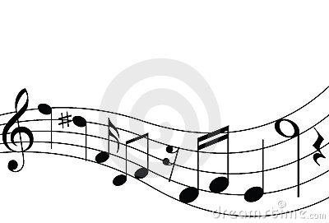
-Can choose to audition the following year-

* THESE CLASSES ARE AUDITION BASED

Chorus (9^{th)} and Chorale (10th-12th) :
The choirs work on elements of singing such as proper breathing, achieving a supported sound, vocal harmony with other voice parts and a full understanding of the concepts of written music. Each of these is achieved through daily sight singing activities, vocal warm-up exercises and thorough preparation of the chosen repertoire. The choirs also present two concerts during the school year in the winter and spring.

Girls Ensemble*
Full-year choir geared for the more musically confident student. It is made up of 10^{th,} 11th and 12th grade girls and requires an audition as a prerequisite. The choir works on elements of singing such as proper breathing, achieving a supported sound, vocal harmony with other voice parts and a full understanding of the concepts of written music. Each of these is achieved through daily sight singing activities, vocal warm-up exercises and thorough preparation of the chosen repertoire. SSA and SSAA repertoire of all styles and periods will be performed. The choir also presents two concerts during the school year in the winter and spring as well as multiple performances throughout the community.

Concert Choir*
Concert Choir is a full-year choir geared for the most musically confident student. It is made up of both male and female singer in 10th, 11th and 12th grade and requires an audition as a prerequisite. The choir works on elements of singing such as proper breathing, achieving a supported sound, vocal harmony with other voice parts and a full understanding of the concepts of written music. Each of these is achieved through daily sight singing activities, vocal warm-up exercises and thorough preparation of the chosen repertoire. SATB repertoire of all styles will be performed. The choir also presents two concerts during the school year in the winter and spring as well as multiple performances throughout the community.
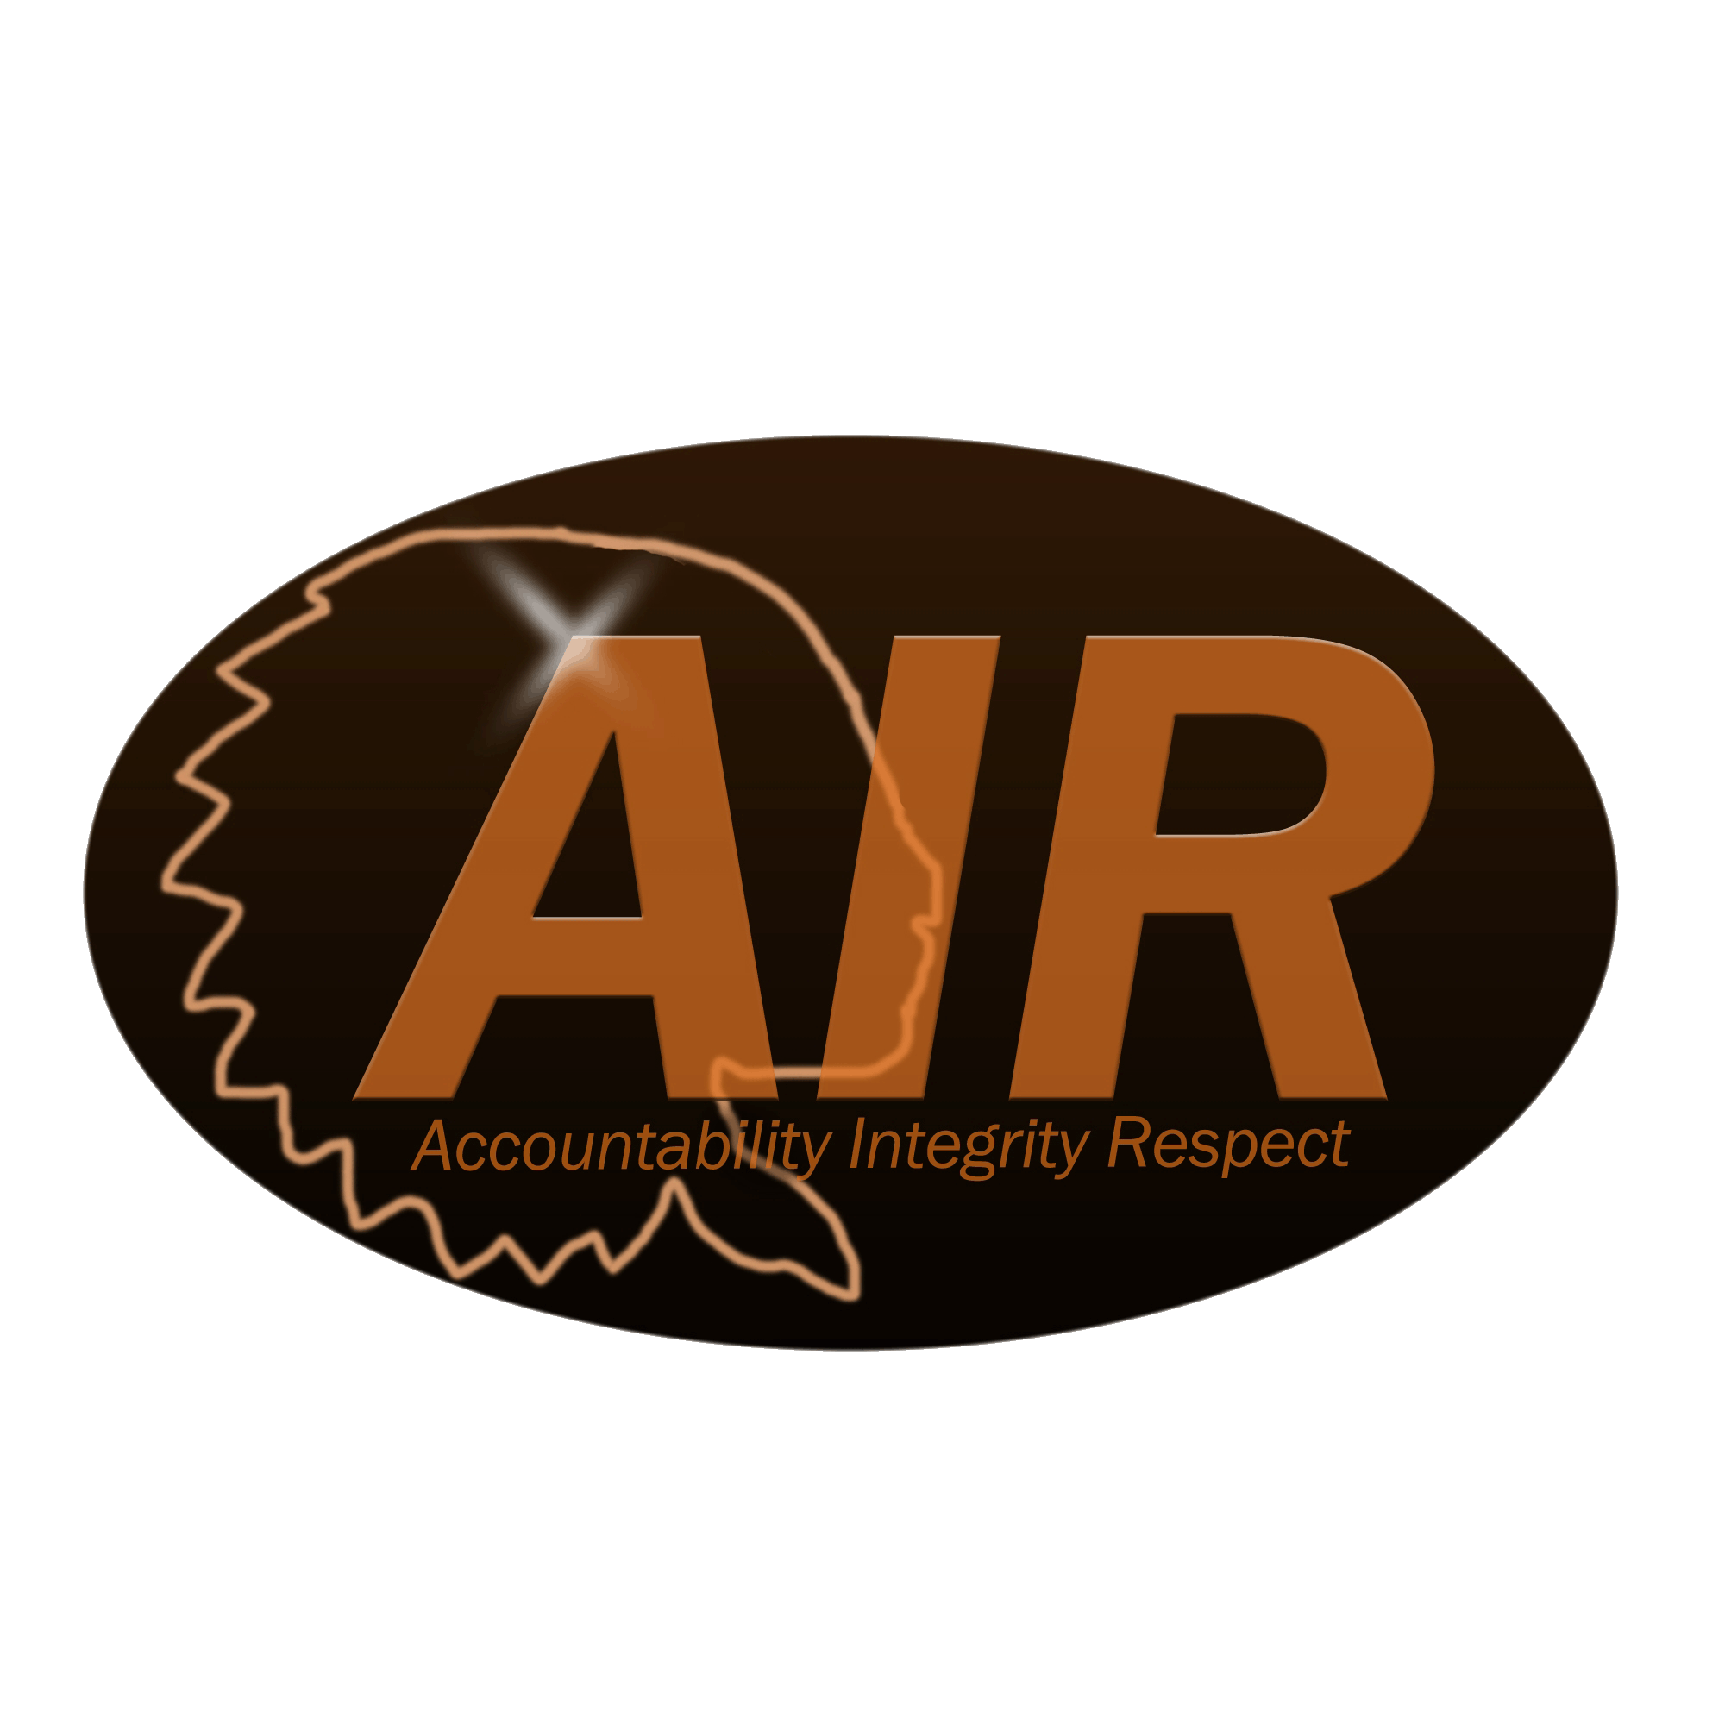
OTHER MUSIC ELECTIVES

Music Appreciation
A survey of music from its origins to contemporary compositions. Requires much listening in music in class with subsequent discussion and analysis. Students will study the basic elements and the history of music.

Tech in Music I and II
Provides an overview of and hands-on experience with a number of commercially available music-related hardware and software. Extensive class time is devoted to gaining practical understanding of the Musical Instrument Digital Interface (MIDI) and applying it effectively in the areas of composition, orchestration, recording, performance, and education.

Music Theory I and Advanced Placement Music Theory
Provides training in reading, writing, analyzing, and performing music. Prior experience in reading music suggested. AP Music Theory is for the accelerated music student pursuing a career in music. Basic musical skills and knowledge learned in Music Theory I, such as clefs, rhythms, and notation, will be refined and enhanced. Students will spend the majority of their time working on developing their ability to aurally identify intervals, chord qualities, and dictate melodies. Students taking this class are eligible to take the Advanced Placement examination in Music Theory

Piano Lab
Designed for the student who has very little or no piano experience. In this course, the student will learn to read and write music; perform on the piano; compose and improvise music; and incorporate music history, music of different cultures, and music of modern society in the assigned pieces of music.

