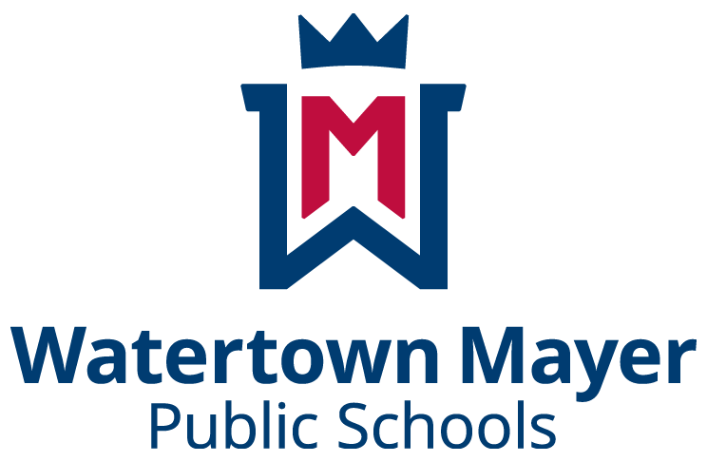

School Wellness Policy #533

Annual Action Plan Update

December 1, 2023

In compliance with the Healthy, Hunger-Free Kids Act of 2010 and our School District's Wellness Policy #533 our District's Wellness Committee will promote and monitor student wellness. Our committee currently consists of staff and parents. Our committee consists of district parents and staff. Our first triennial report will be presented to the school board at the end of the 2024-2025 School year. This report is from the 2022-2023 data gathering year.
Completed by: District Student Wellness Committee Members 22-23:
Nikki Magee, RN, LSN Erica Bossert, Beth Bottenfield, Holly Hokenson,
Watertown Mayer Public Schools Nichole Hunkins, Rachel Muchow, Jenna Olson,
ISD #111 Abbey Schuette
District Wellness Coordinator

December 1st, 2023
End of the Year Report WM District Wellness Goals 2022-2023
See attached Action Plan Chart.
Goal 1. Eat the Rainbow Everyday
A variety of foods are offered at all meals at each of our school buildings. Our schools have made progress towards our goal, specifically at the Elementary School who successfully reintroduced sweet potatoes into the menu sporadically.
Goal 2: Promoting Kids In the Kitchen
Two high school foods experience to broaden meal plan ideas and abilities through a visit from a Japanese chef, and a high school global foods field trip. This goal was met by student engagement.
Goal 3: Delta Dental - Students in first grade received a free bag and pack of oral hygiene kits. Included was a presentation provided by Delta Dental to school each of their students the importance of oral hygiene starting at a young age!
Goal 4: Healthy Snack Drive - Students with food insecurities or those who have no snack with them should be able to have access to free healthy snack options during the school day. We received a 3 month supply of snacks through Carver County. We then set up an Amazon WishList with Smart Snack compliant products and sent this list to families of our district starting in April 2023 - we successfully collected/were donated >3 month supply of snacks for our students.
Goal 5: Physical Activity inside and outside of classroom - Goal Met but we can continue to grow in opportunity to provide to out students more frequent options to participate in. Stride for Students had an increase in participants and donations from years prior and ES Track and Field day was completed.
Goal 6: Move Mindfully - Completed. Of 3 classrooms each saw improvement in classroom energy after the 6 week residency of the Move Mindfully outside instruction.
Goal 7: Foods courses will continue to follow state and national curriculum standards. - goal met
Goal 8: HS Physical Activity opportunities - room for more opportunity in the future. Goal met with Staff vs. Senior Student Volleyball game and HS Pep RAlly.
Goal 9: Shared Table - goal not met. Will try again next year while following State and National rules and regulations.
22-23 Program Activities
Mental Health Awareness Week - NHS
Unity Day Oct 19, 2022
Student to Staff Connections Survey
Stride for Students (Elementary School)
MS Medallion Hunt
Track and Field Day (Elementary School)

School Wellness Policy

Action Plan
School Name: Watertown-Mayer Public Schools Date: School Year 2022-2023
Goal  What do we want to accomplish? | Action Steps  What activities need to happen? | Timeline  Start dates | Measurement  How is progress measured? | Lead Person | Stakeholders  Who will be involved and/or impacted? | Complete?
Example:  Food and beverages will not be used as a reward for students. | - Provide teachers with list of non-food reward examples.  - Discuss changes at back-to-school staff training.  - Follow-up mid-year to discuss challenges and determine additional communication needed. | Before the beginning of next school year. | - Verbal check-ins with staff to ensure compliance.  - Teacher survey at end of school year. | Principal | Teachers, staff, students | Yes
- Eat the Rainbow Everyday | 1a. Offer a colorful variety of healthy foods at each meal.  1b.Safely reintroduce Sweet Potatoes into the menu at the Elementary School.  1c.Monthly menu posted on school website | 2023 | - Menu planning & verbal check-in with each Food Service Lead Cook to determine compliance.  - Nursing staff consulted at the District and ES level  - Last minute menu changes emailed to nurses and secretarial staff | Beth Bottenfield, Food Services Director | Students & Staff | WMES - successfully reintroduced sweet potatoes into the meal plans, at least one time in 22-23 school year.
- Kids In the Kitchen | 2a. Middle School Japanese Chef  2b. High School Global Foods Field Trip | 2023 | Student engagement | Beth Bottenfield & Holly Hokenson | Students | May 2023- completed
- Delta Dental program to promote effective oral hygiene at an early age - 1st graders. | 3a.Kits ordered through Smiles for Schools  3b. Classroom participation  3c. Classroom distribution | 2023 | - Classroom participation  - All 1st grade students received. | Rachel Muchow, Elementary Building Nurse | Students, Staff, & Teachers | This goal was fully met. All 1st grade students received their kits March 1st, 2023.
- Healthy Snack Drive - Obtain a 3 month supply of snacks for our students within our district each quarter. | 4a. Snack collection (Drop off middle school office)  4b. Amazon Online Order Wish list  4c. SHIP Healthy Eating  4d.Smart Snacks | 2023-ongoing | - Number of donations (received in person or via via Amazon WishList)  - 3 month supply at each level  - donations received | Erica Bossert and Abbey Schuette, and | -Community Members  -Staff  -Students  - | Online Amazon account went live in late April 2023.  Ongoing - the 1st 3 month supply of snacks have been received in a short period of time.
5. Physical activity inside and outside of the classroom | 5a. Strides for Students - Spring Run - Elementary School  5b. Field Day - ES & MS  5c. Yoga Kindergarten & SPED | 2023 | - Participation | Nikki Hunkins along with PTO | -Community Members  -Staff  -Students | -Completed, Stride for Students run 5/6/23.  -Field day 5/18/23.
6. Move Mindfully/Play works | 6a. Move Mindfully - 6 week residency | 2023 | - Classroom activity  - Survey results | Middle School Staff & Teachers  -Jenna Olson | -Students  -Teachers | Completed,January 2023  Of three classrooms - each saw improvement in classroom energy and a decrease in classroom disruptions.
7. Foods Courses | 7a. 7th grader - MyPlate Fundamentals  7b. Food Labels | Ongoing | - Follow State/National Curriculum Standards  - Test Scores | Holly Hokenson | -Students | Ongoing yearly.
8.High School Physical Activity | 8a. Homecoming Volleyball vs. Staff | Fall 2023 |  |  |  | Ongoing yearly.
9. Share Table | 8a. Share Table Guidance for Schools MDH |  |  | Holly Hokenson | -Students and Food Service Staff | Not complete - will continue to try to reach goals.

