7th Grade Language Arts 2022-23
Mrs. Fancher
G.W. Bush Middle School
Dear Parents and/or Guardians,

Hello and welcome back to school! My name is Mrs. Fancher, and I am delighted to be your child’s English Language Arts teacher for this school year. We will work on reading, writing, language, speaking, listening, and research in class. Our studies will be linked to the Common Core State Standards. For a full breakdown of Common Core Standards, please visit English Language Arts Standards | Common Core State Standards Initiative.

What curriculum will be used?
In class, we will use myPerspectives: English Language Arts by Pearson Publishing. This curriculum is organized around an essential question listed within each unit. All students will start with the same text selections. During this course, students will have writing and presenting opportunities. In addition, students will be assigned specific novels which tie into the units. We will also add other materials and resources to our studies.

The entire textbook of myPerspectives: English Language Arts by Pearson Publishing is online. You will be able to view the table of contents for all selected titles as soon as the students are online. Some novels included with our curriculum are The Outsiders, James and the Giant Peach, My Side of the Mountain, Hatchet, and Hoot.

First Semester:
- Our Focus Question will be, “What can one generation learn from another?”
- For writing, we will work on Expository/Informative Writing.
- Novel: The Outsiders

Second Semester:
- Our Focus Question will be, “Should we make a home in space?”
- For writing, we will work on an Argumentative Essay.
- Novel: James and the Giant Peach

Homework Expectations:
  - Daily: Independent reading (at least 20 minutes per day which will be assessed in various formats four times a year)
  - Weekly: MobyMax online grammar practice (60 problems per week)
  - When Assigned: Curriculum Reading
  - When Needed: Classwork / Project completion

Prepared-for-Class Expectations:
  - Arrive with charged Chromebook EVERY DAY!
  - Pencil, composition notebook, and MyPerspectives reader!
  - In your SEAT when the schedule says class begins!
  - Homework complete!
  - Cell phones off and away!

How will students be graded?

A = 90-100% | Wow! Your work exceeds the expectations! You show that you could probably teach this standard to other people.
B = 80-89% | Excellent! Your work has **reached standard**! You show that you understand this concept at grade level.
C = 70-79% | Your work is close to standard! However, if this is your overall grade for the class, and you have been reaching standard on your completed work, you may have missing assignments.
D = 50-69% | Your work is below standard on most assignments, or you may have missing assignments.
IE = 0-49% | Your work is below standard, you have missing assignments, and for those reasons, there is Insufficient Evidence for a letter grade.

Academic and Non-Academic Grades:
- Non-Academic Grades:
  - Work Completion: Did your student participate? Did your student complete their work? Was the work on time? Did your student ROCK?
- Academic Grade:
  - By the following Categories and Weighted 90/10 according to District Policy:

Tests and Quizzes--90%
- Essays
- Quizzes & Tests
- Book Projects/Comp Qś for Books
- Vocabulary Tests
Daily Work--10%
- Vocabulary Lessons
- Classwork
- Standards (Moby Max, IReady, etc.)
Viewing Grades and Assignments:
- Check Skyward. Grades will be updated weekly or as soon as humanly possible.
- Check Google Classroom for assignments.
- Check Message Center on Skyward for assignments and info.

Other Communications from Mrs. Fancher:
- Download the Skyward App to receive a notification straight to your phone (go to the App Store, get the Skyward App 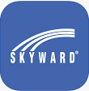, click yes for Notifications).
- Message Center on Skyward--check your email or Skyward.


What are the Behavior Expectations?
- Everyone will be treated with respect.
- Put-downs and inappropriate language (or actions) will not be tolerated. Words can hurt.
- No one will be allowed to disrupt the learning process of anyone else.
- Come prepared every day with a pencil, a charged Chromebook, your composition book, and myPerspectives book.
- Students will sit in assigned seats, ready to learn at the time class is scheduled to begin.
- Cell phones are OFF and AWAY!

I consider it a privilege to work with your child, and I look forward to meeting you at Conferences on November 1st thru 4th, or sooner. Visit me before or after school, or let’s set up a time for you to visit or help in the classroom.

Please do not hesitate to contact me! The best way is by email at: andrea.fancher@tumwater.k12.wa.us .

Sincerely,


Andrea Fancher
7th Grade ELA Teacher
G.W. Bush Middle School
andrea.fancher@tumwater.k12.wa.us
(360) 709-7468

Please sign and return the next page.

Please return this portion signed.
- I am interested in Volunteering!
- I am interested in volunteering with students. Here is my availability:______________
- I am interested in grading papers. Here is my availability:_______________________
- I would love to chaperone a field trip this year!
- I have an expertise in_______________________ that I would love to share or teach
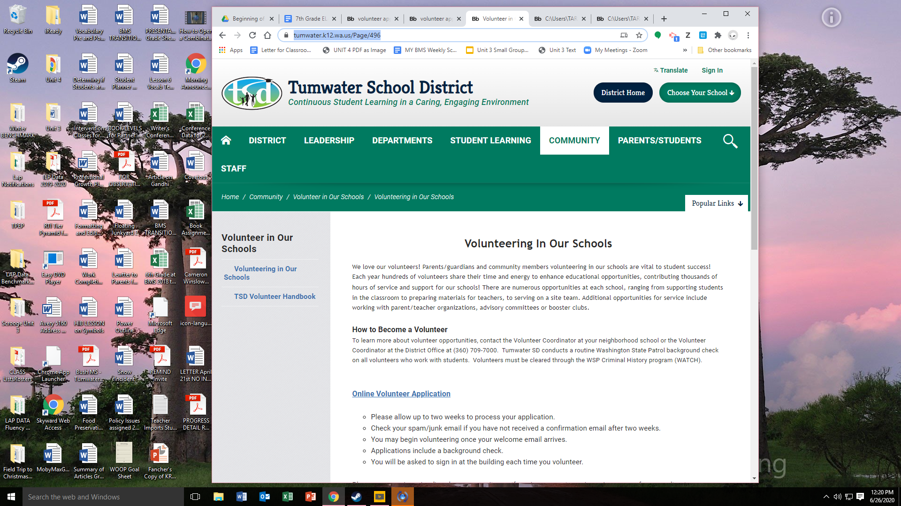
the class.
*****If you would like to volunteer, please fill out the online volunteer application by going to: https://www.tumwater.k12.wa.us/Page/496
You can also find this volunteer form by going to the Tumwater School District website, clicking on the Community tab, and proceeding to the Volunteer in Our Schools link.

I have read the syllabus and class expectations for Mrs. Fancher’s ELA Class.
- I have filled out the Online Volunteer Application
- I cannot help at this time.

Student Name (PRINT):
Student Signature:

Parent/Guardian Signature:

If you have anything I should know about your child (impressive or otherwise), please tell me about it in the box below or in an email at andrea.fancher@tumwater.k12.wa.us. Thank you.

