Mental Math Strategies Presented in Dimensions

Our Dimensions math trainer, Cassy Turner, has created a parent video that is an overview of Dimensions math. The video is located on the TCA website: http://tcatitans.org/parents__students/elementary_parent_resources

For an overview of the progression of number sense and mental math strategies, check out the segment that starts at 11 minutes and 30 seconds and continues through 22 minutes and 55 seconds.

Mental math refers to mental strategies that leverage number sense. It is a way to make difficult computation easier. Below is a more detailed progression of mental math strategies introduced in first and second grade and applied in the following grades. Mastery of these foundational skills will support algebraic thinking and the standard addition algorithm with regrouping (which you may know as “carrying”).

Make a 10 - Students will use number bonds to decompose, or split, addends into easier combinations to find the total. Make a 10 is a powerful strategy that supports the concept of place value and the concept of equality.
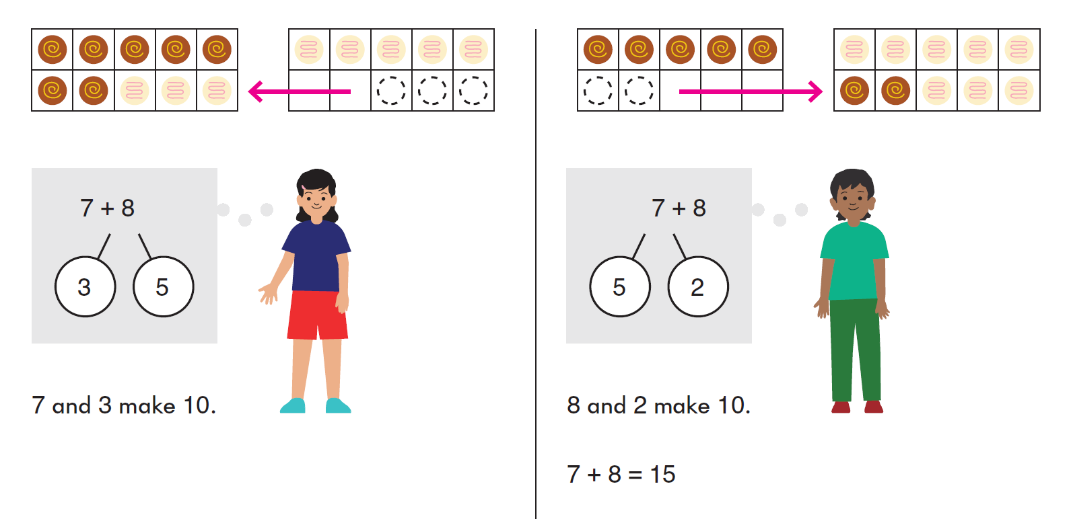
Subtract from a 10 - Students will learn to split a teen number into a ten and ones and then subtract from the ten. They add that answer to the remaining one. For example, 13-9 is the same as 10 minus 9 plus 3.
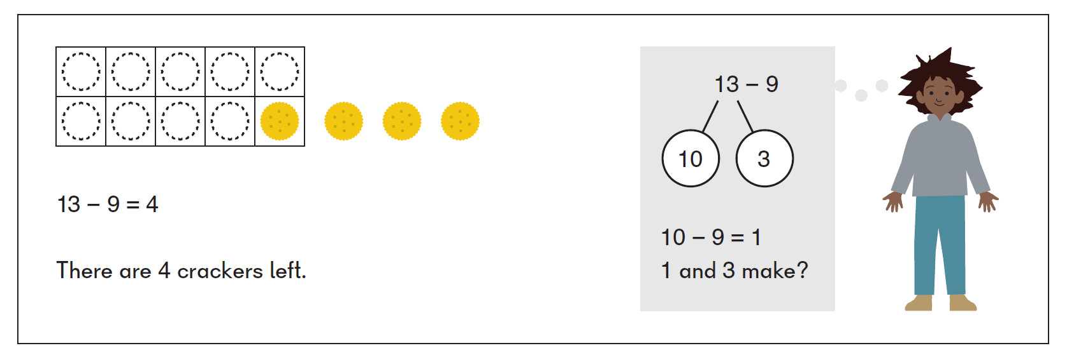
Subtract Twice - Students will learn to split the number being subtracted into 2 parts to make an easier problem.
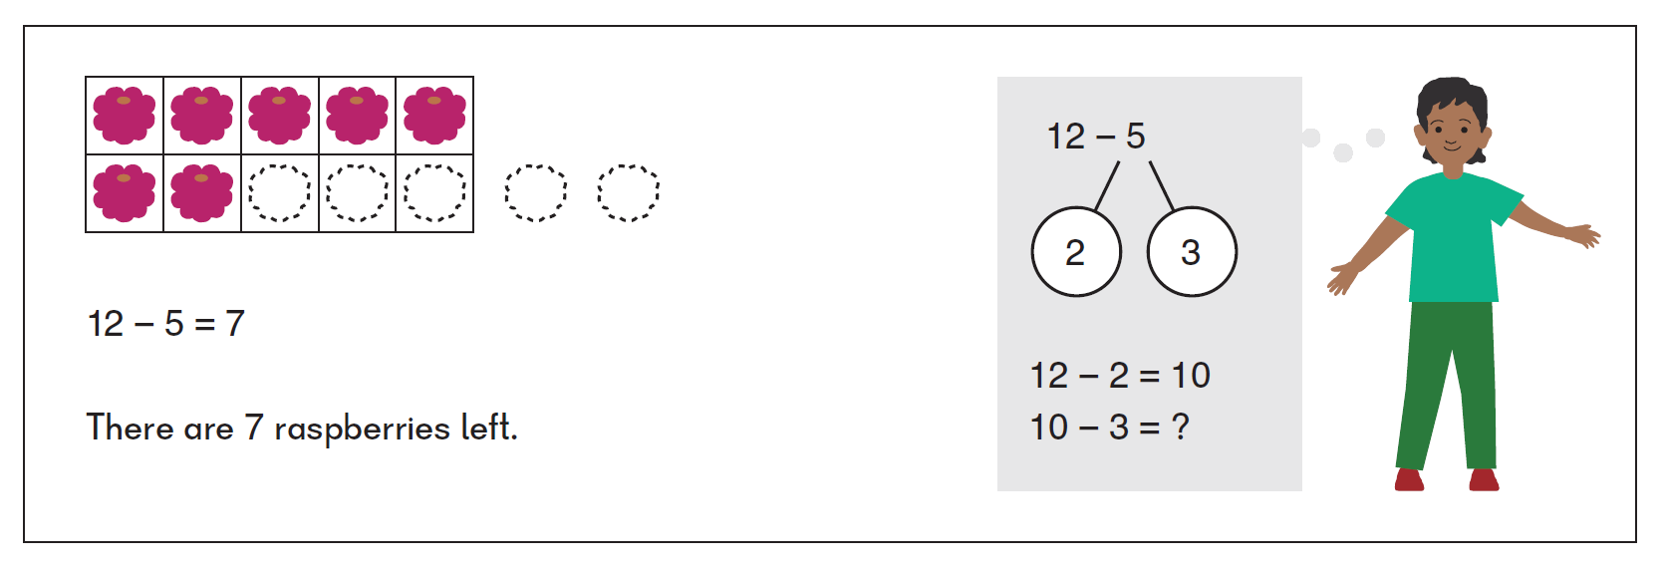

Add and subtract the ones – Students will learn to split the number into tens and ones and then add or subtract the ones.
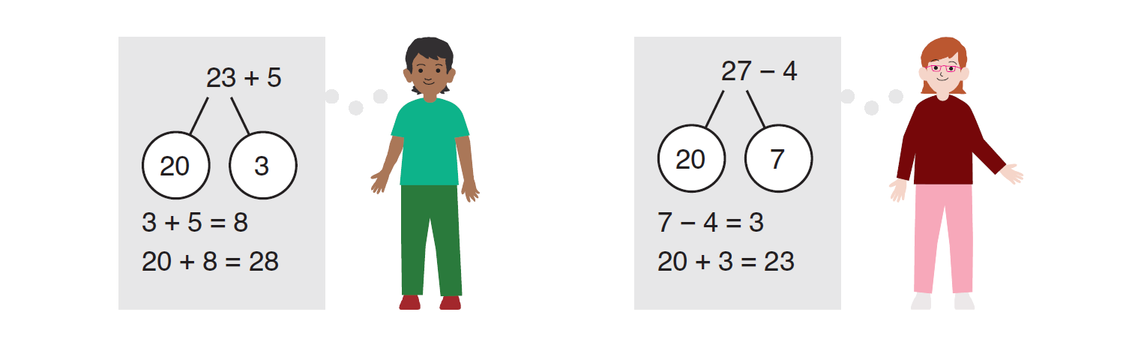

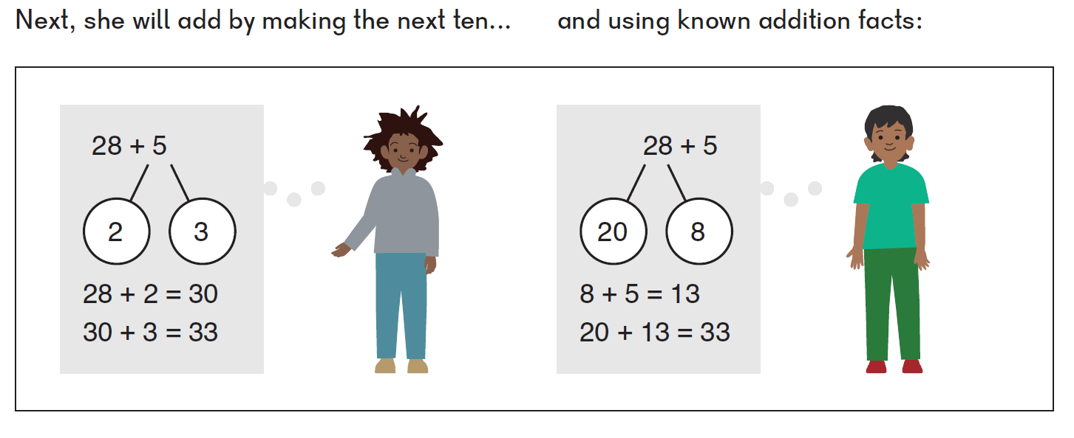
Make the Next 10 – Similar to Make a 10,
the students will use number bonds to
decompose, or split, addends into easier
combinations to find the total.

Add Using a Known Fact – Student will
use number bonds to decompose or
split addends to make a fact they
have memorized.

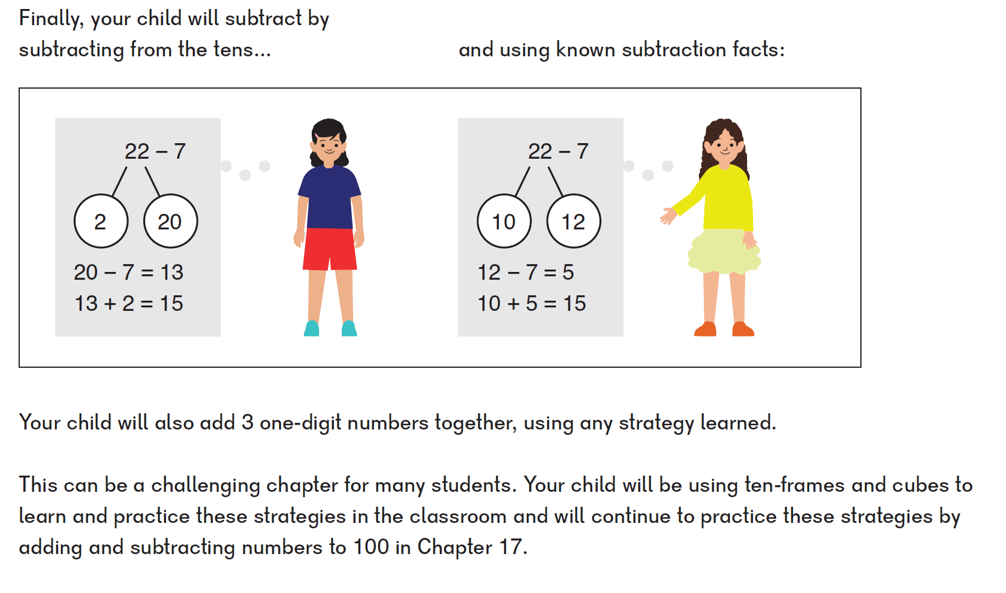
Subtracting from the tens – Similar to
Subtract from a 10, students will learn
to split a number into the tens and ones
and then subtract from the tens. Then
add that answer to the remaining ones.

Subtract Using a Known Facts - Students
will use number bonds to decompose
or split addends to make a fact they
have memorized.

Add Tens and Then Add Ones (with 2-digit numbers) - Students will learn to split the number into tens and ones and add the tens then the ones.
Add tens: Add tens then add ones:
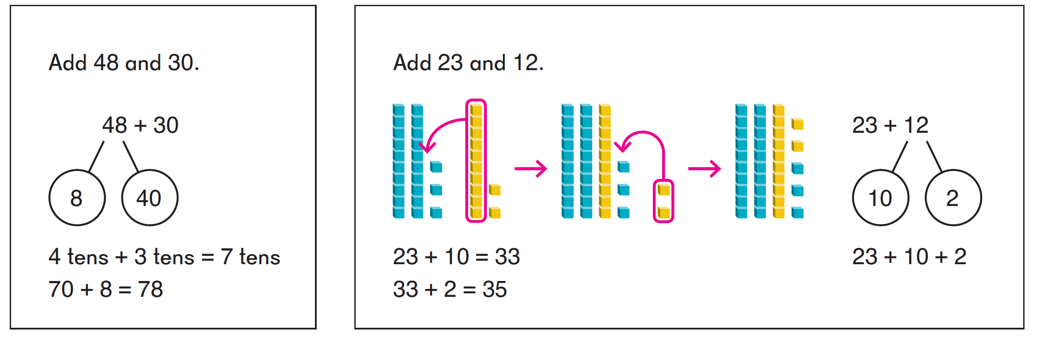

Add Tens and Then Add Ones (with regrouping)
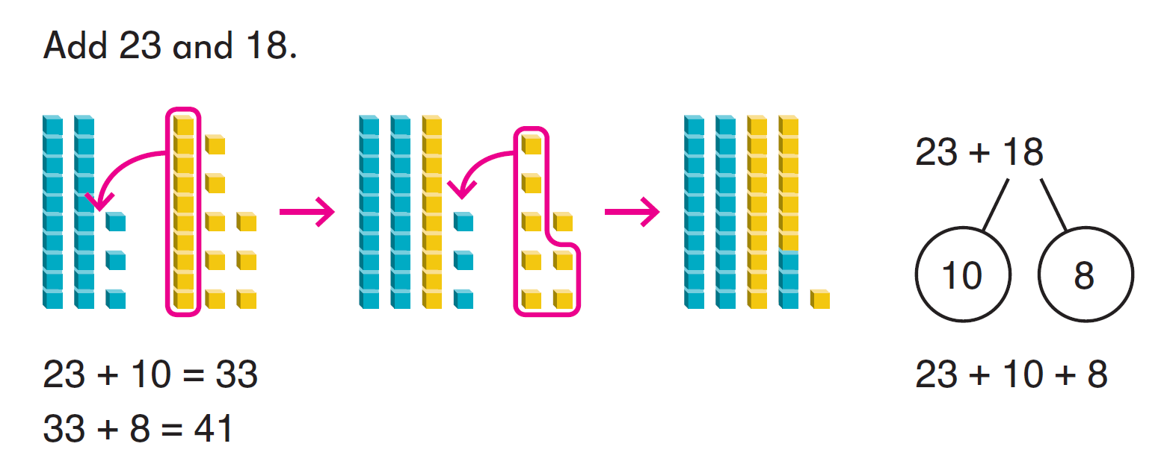
Subtract Tens and Then Ones (with 2-digit numbers) - Students will learn to split the number into tens and ones and subtract the tens then the ones.
Subtract tens: Subtract tens and then subtract ones:
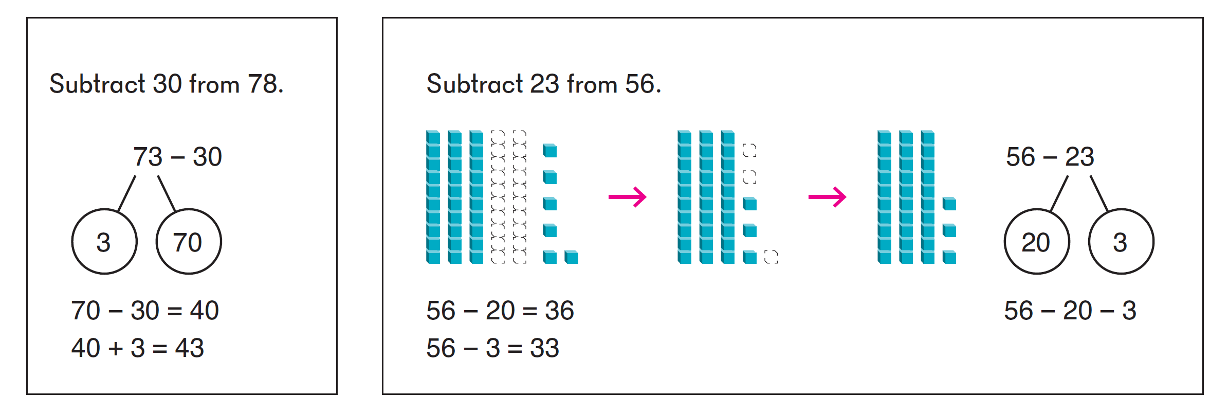

Subtract Tens and Then Subtract Ones (with regrouping)
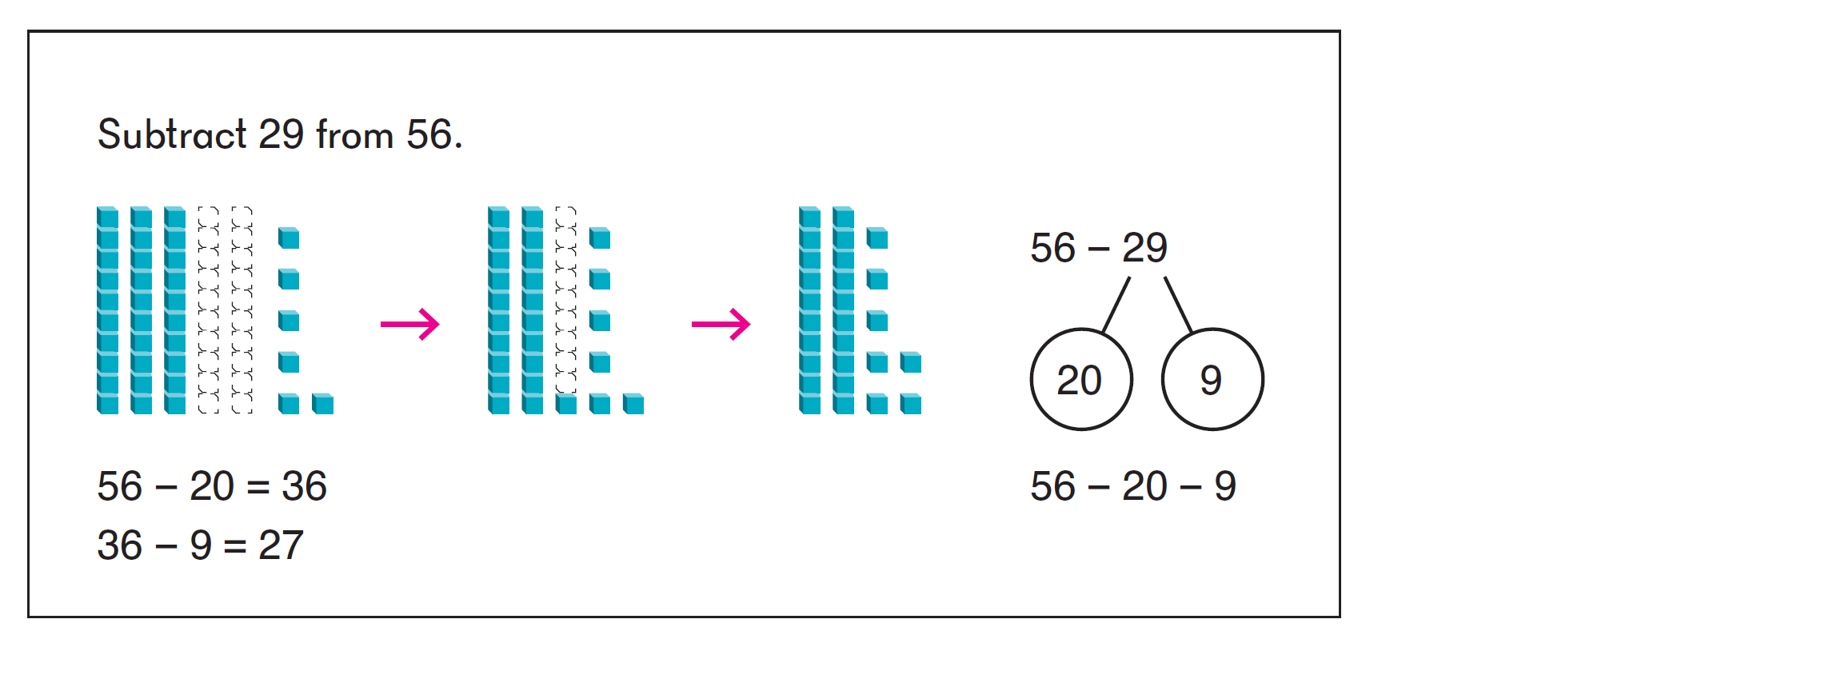
Then in second grade, after a strong foundation of place value and number sense, students will line the two numbers up and use a traditional vertical algorithm.

Adding 97, 98 or 99 (to a two-digit or three-digit number)
Making the next 100: Over adding:
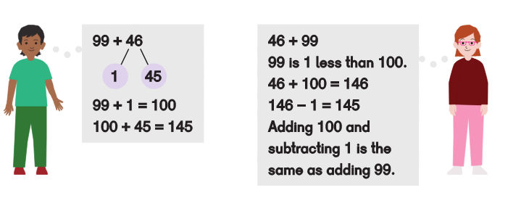

Subtracting 97, 98 or 99 (from a two-digit or three-digit number)
Making the next 100: Over Subtracting:
