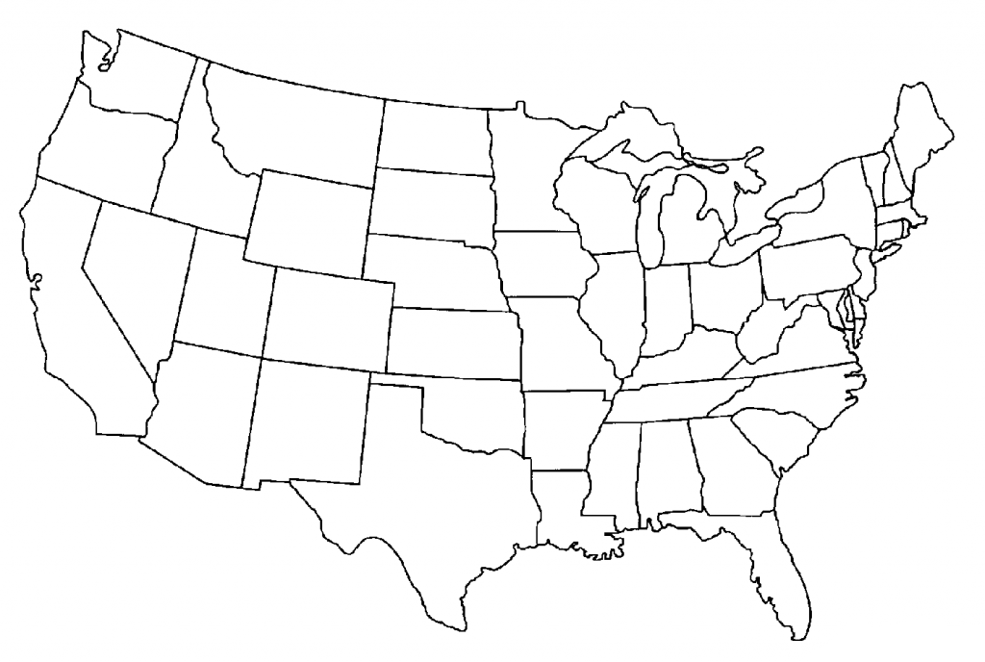
United states western Region
Study Guide
11
12

10
9
8

5
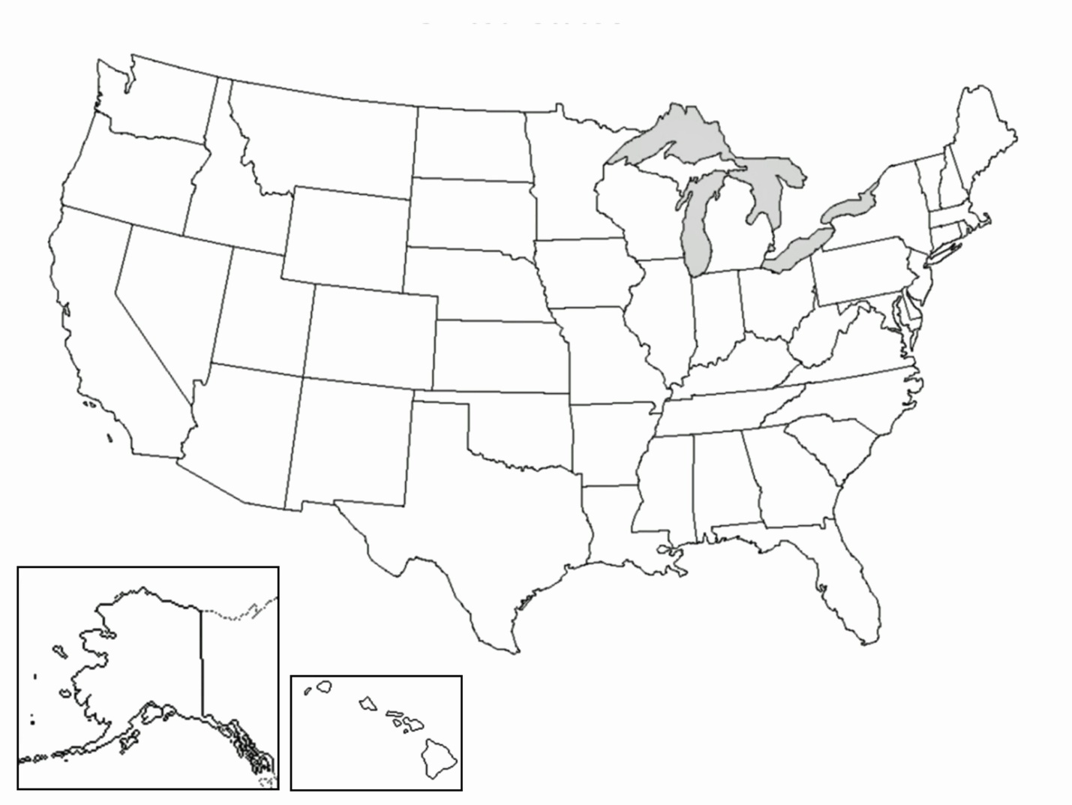
7
6

4

3
14
2

1
1. | 8.
2.  2. | 9.
3 | 10.
4. | 11.
5. | 12.
6. | 13.
7. | 14.
13

