Midwestern United States
Study Guide
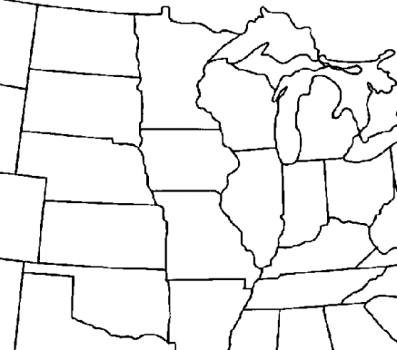
12

13

11
8
7

9
10
6
4
5

3
2

1. | 8.
2. | 9.
3 | 10.
4. | 11.
5. | 12.
6. | 13.
7.
1

