Southeastern United States
Study Guide

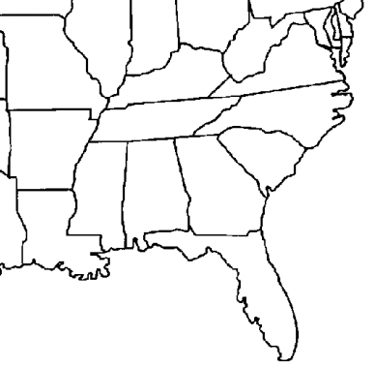

6
5

7

8
4

12
3

10
9
2

11
1. | 7.
2. | 8.
3 | 9.
4. | 10.
5. | 11.
6. | 12.

1

