Northeastern United States
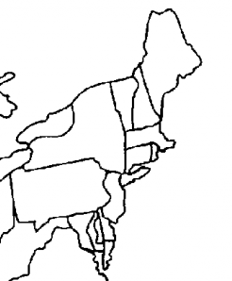
Study Guide

7

8
6

9
5
3

4
1. | 7.
2. | 8.
3 | 9.
4. | 10.
5. | 11.
6.

1
11
2
10

