
World Literature
The Classical Academy 2020-21 blos@asd20.org
Mr. Los Room 3435
Free Period: 3

Course Objectives:

Students will study the philosophical questions posed by this year’s reading curriculum from a variety of perspectives. These questions might include: What is the meaning of life? How can humanity be happy? How should humans act? Do humans have “free will”? If so, what are the consequences? What is Art? Truth? Knowledge? Goodness? Evil? Justice? Mercy? Students will engage in dialogue in which they form their own opinions on such philosophical questions. In addition to articulating their own positions, students will learn generosity and thoughtfulness towards the authors of the past, using close analysis of the text and careful classroom conversation. We will look not only at the “what” (authors, plots, characters) but deeply and frequently discuss the “how” (technique) and the “why” (purpose, application, virtuous lesson and motivation) of literature.

Syllabus of Major Works (order and details subject to change):

Semester One: “My Last Duchess,” Robert Browning
The Inferno, Dante
1984, Orwell

Semester Two: The Brothers Karamazov, Dostoyevsky
Hamlet, Shakespeare
Selected Poems

What am I graded on in this class?
- Preparation for discussion, including consistency in bringing books, annotating or other assigned notes and evidence of completion of expected reading prior to class.
- Participation in analytical conversation and activities, including engaging with other students and the instructor politely, positively and academically.
- Potential reading quizzes, in-class writing or other accountability for reading.
- Tests/Exams/Final Exam – approximately one for each unit/novel, which will explore the student’s knowledge of the text as well as key notes, terms and ideas discussed in class.
- Essays and short papers in MLA format, providing detailed, skilled analysis.
- Senior Thesis Paper: a 10-page capstone essay that involves independent research, worth approximately 30% of the semester grade.

What are my class materials that I should have at the ready?
- YOUR BOOK(s)! Every day unless stated otherwise you MUST bring your book.
- Writing implements of your choice for taking notes and annotating the texts.
- A notebook or 3-ring binder with lined paper for in-class writing assignments
- A folder or your binder in which you can store hand-outs and returned assignments.
- A set of 100 notecards (for Inferno)
- Highly recommended: A personal copy of your independent reading book of choice for the Senior thesis project (list of authors/options to be distributed.)
- Digital: An operational PPLD library card and an operational JSTOR account for research on the thesis paper and other assignments
- Digital: Your Turnitin.com password and log-in information for writing assignments

What's the late policy for this class?
- Assignments turned in late will receive a flat 20% deduction.
- After a unit ends, assignments for that unit cannot be turned in anymore. A short grace period may be allowed for assignments due on the very last day of a unit.
- Major essays and projects receive the 20% deduction for the first three days that it is late. After three days, the late policy indicates that I can no longer receive it for any credit.
- Please talk to me or e-mail me as early as possible if you find yourself in circumstances that prohibit you from completing an assignment on time.

Common Problems with Turnitin.com:
- Keep your password written down at home so you don’t forget how to log in.
- Check your e-mail to ensure you received a receipt for your submission.
- If your assignment is unexpectedly marked in IC as “missing,” take a screenshot of your Turnitin e-mail receipt and e-mail it to me.
- If Turnitin.com is truly down, please e-mail me your assignment to prove that you completed it on time. Submit your assignment to Turnitin.com after it becomes available again.
- Be proactive about communicating your tech issues to me, rather than waiting until after I discover that your assignment is missing. Thank you!

Weighted Grades:

Participation – 20% Classwork & Quizzes – 20% Essays & Tests – 30% Final – 30%

(These percentages may change if administration gives us a directive regarding how finals will work this year.)
Plagiarism Policy: 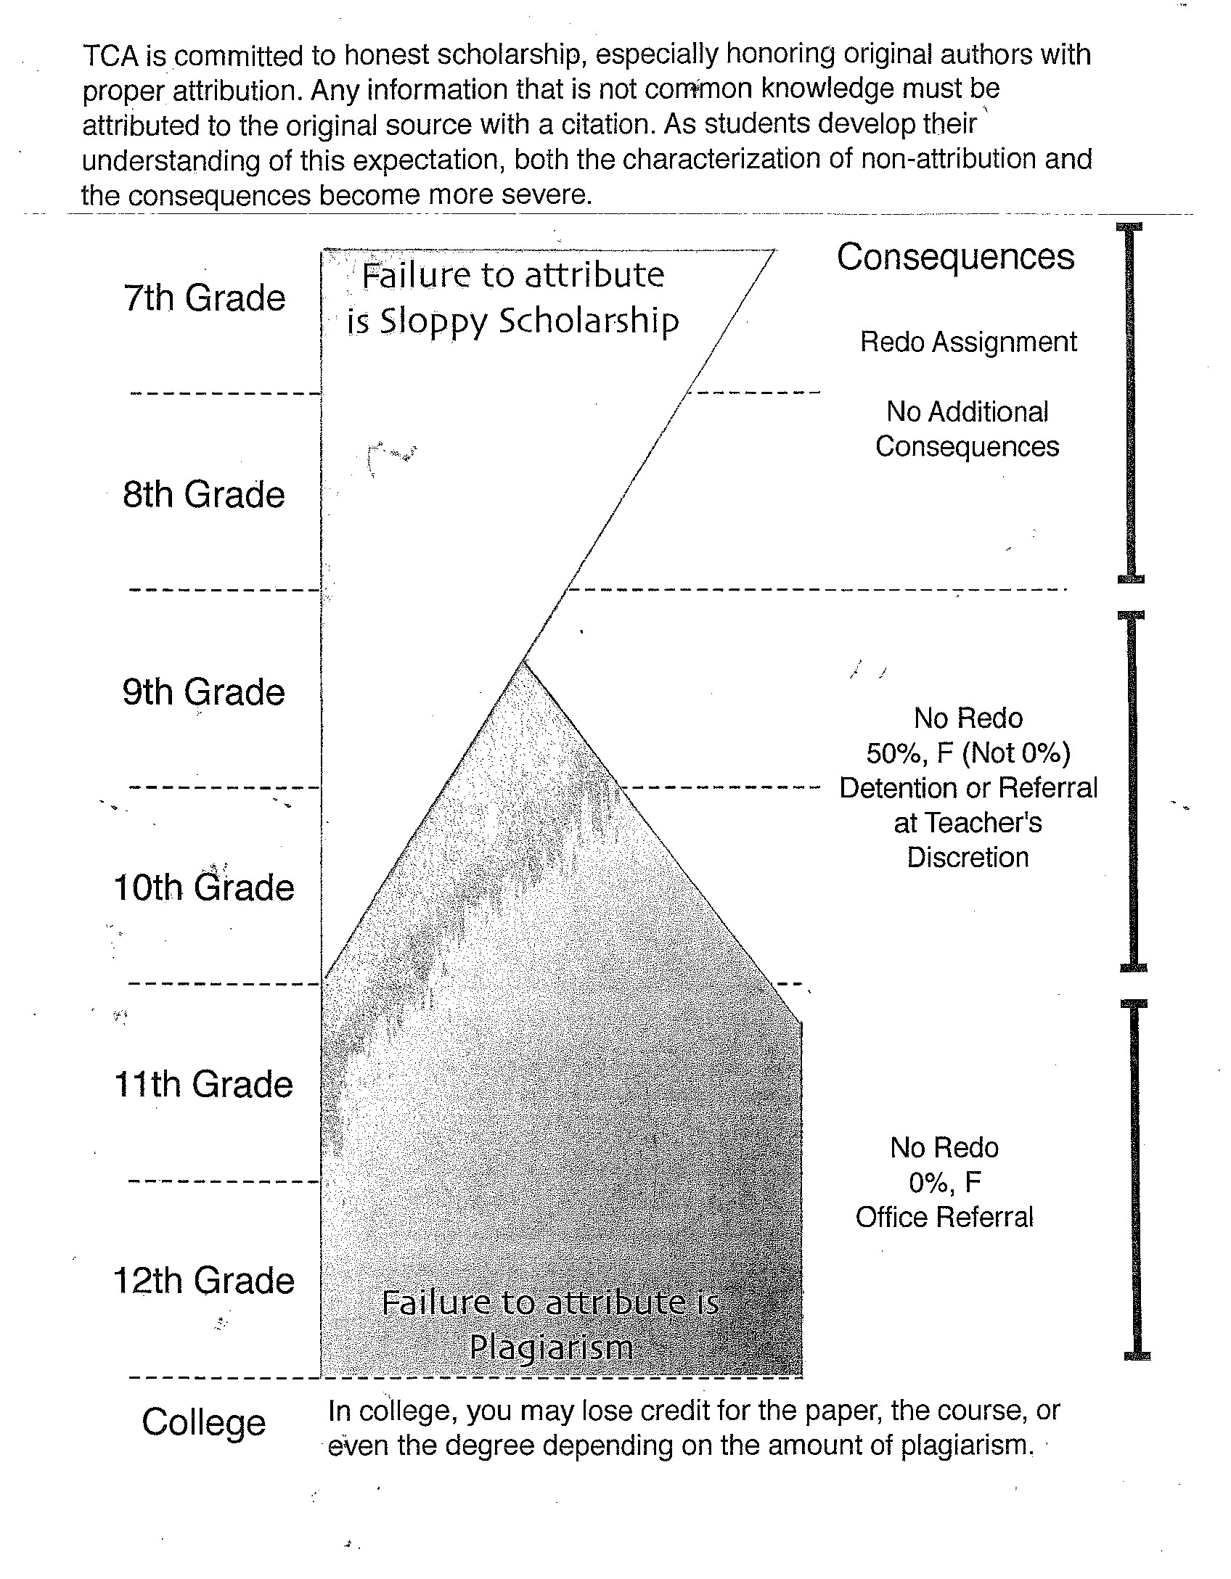

Remove this page and turn it in separately.

Your signature indicates that you are familiar with the class expectations of World Literature and Composition for the 2020/21 school year.

Student name:

____________________________________ __________________________________
(print) (sign)

Parent/guardian name:

____________________________________ __________________________________
(print) (sign)

Date:

____________________________________

