MSBSD Online Library APP

Mat Su has a new audio and e-book library! It is FREE to all students and staff in the district.

STEP ONE: Download the SORA by OverDrive APP

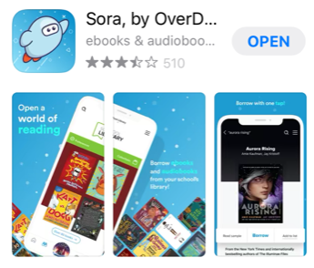
STEP TWO: Search for Matanuska Susitna Borough School District
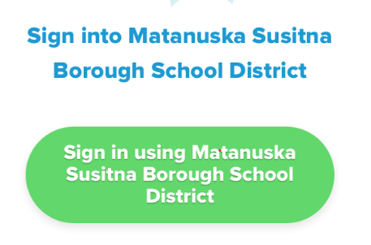
STEP Three: Login with your active directory

Login: Student ID + @ad.matsuk12.us
(example: ab12345@ad.matsuk12.us)
Password = Chromebook password

STEP FOUR: Start searching for books! Happy Reading!
MSBSD Online Library APP
MSBSD Online Library APP

Mat Su has a new audio and e-book library! It is FREE to all students and staff in the district.

STEP ONE: Download the SORA by OverDrive APP

STEP TWO: Search for Matanuska Susitna Borough School District
STEP Three: Login with your active directory
Login: Student ID + @ad.matsuk12.us
(example: ab12345@ad.matsuk12.us)
Password = Chromebook password

STEP FOUR: Start searching for books! Happy Reading!

