
Mt. Diablo High School
2450 Grant St.
Concord, CA 94520
Phone: (925) 682-4030
Fax: (925) 687-9658
https://mdhs.mdusd.org/

Dear Parents and Guardians,

Starting this summer, and continuing into the 2024-2025 school year, we will be making our school a phone-free space to improve teaching and learning using a system called Yondr. Yondr has been implemented in over 2,000 schools across 16 countries to facilitate an engaged learning environment.

We believe that phones have great utility. We have also found that learning and social behavior improve drastically when students are fully engaged with their teachers and classmates.

The Yondr Program utilizes a simple, secure pouch that stores a phone. Every student will secure their phone in a personally assigned Yondr pouch when they arrive at school. Students will maintain possession of their phones and will not use them until their pouches are opened at the end of the school day. Students are required to bring their Yondr pouch to and from school each day and are responsible for their pouch at all times.

Yondr received responses to their annual surveys from over 1,200 school partners, and after implementing the Yondr Education Program:

- 84% saw a change in student engagement
- 72% saw a positive change in student behavior
- 68% saw a positive change in academic performance

The most recent impact survey of over 370 of our school partners:
- 86% saw a positive impact in student safety and wellness

If there is an emergency and you would like to get in contact with your child, please do not hesitate to contact the school directly at 925-682-4030.

In an effort to best serve your child, we appreciate your full support in adoption of the Yondr Program at our school.

Thank you,

Dr. Markell McCain

How Yondr Works
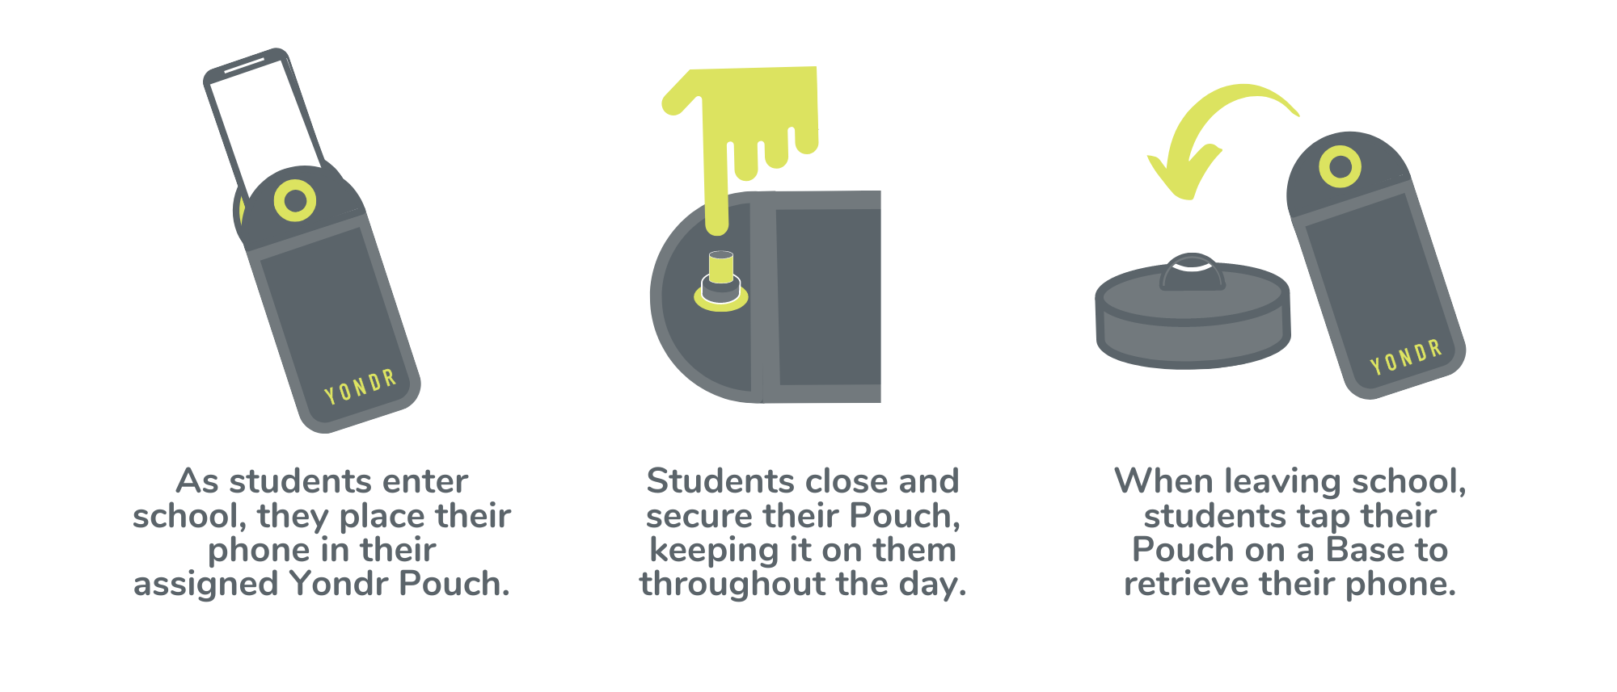
Frequently Asked Questions
What if I want to reach my child during the school day?
We want our students to be engaged in their learning. If you need to contact your child during the school day, contact the main office at (925) 682-4030.

What if there is a school emergency?
In case of a school emergency, we direct our students to safety first, following our school emergency preparedness protocol.

Will my student’s phone be safe?
Students are in possession of their phone - in their Yondr pouch - for the entire school day. We will advise students to store the pouch in their backpacks where it is completely safe.

What if the Yondr pouch gets damaged or a student is caught on their phone?
The Yondr pouch is property of Mt. Diablo High School. If a student damages their Pouch or is caught on their phone, Administration will collect the phone/Pouch and call home:

- If a student damages their Pouch or is caught on their phone, Administration will collect the phone/Pouch and a parent/guardian will be required to come to school and pick it up.
- Repeated offenses will require a parent/guardian pickup and detention or In-School Suspension.
- Lost or damaged pouches will result in a replacement fee of $50.

Note: Damage consists of any signs that the physical integrity of the pouch has been compromised, whether intentional or unintentional, as determined by the school or Yondr staff.

