
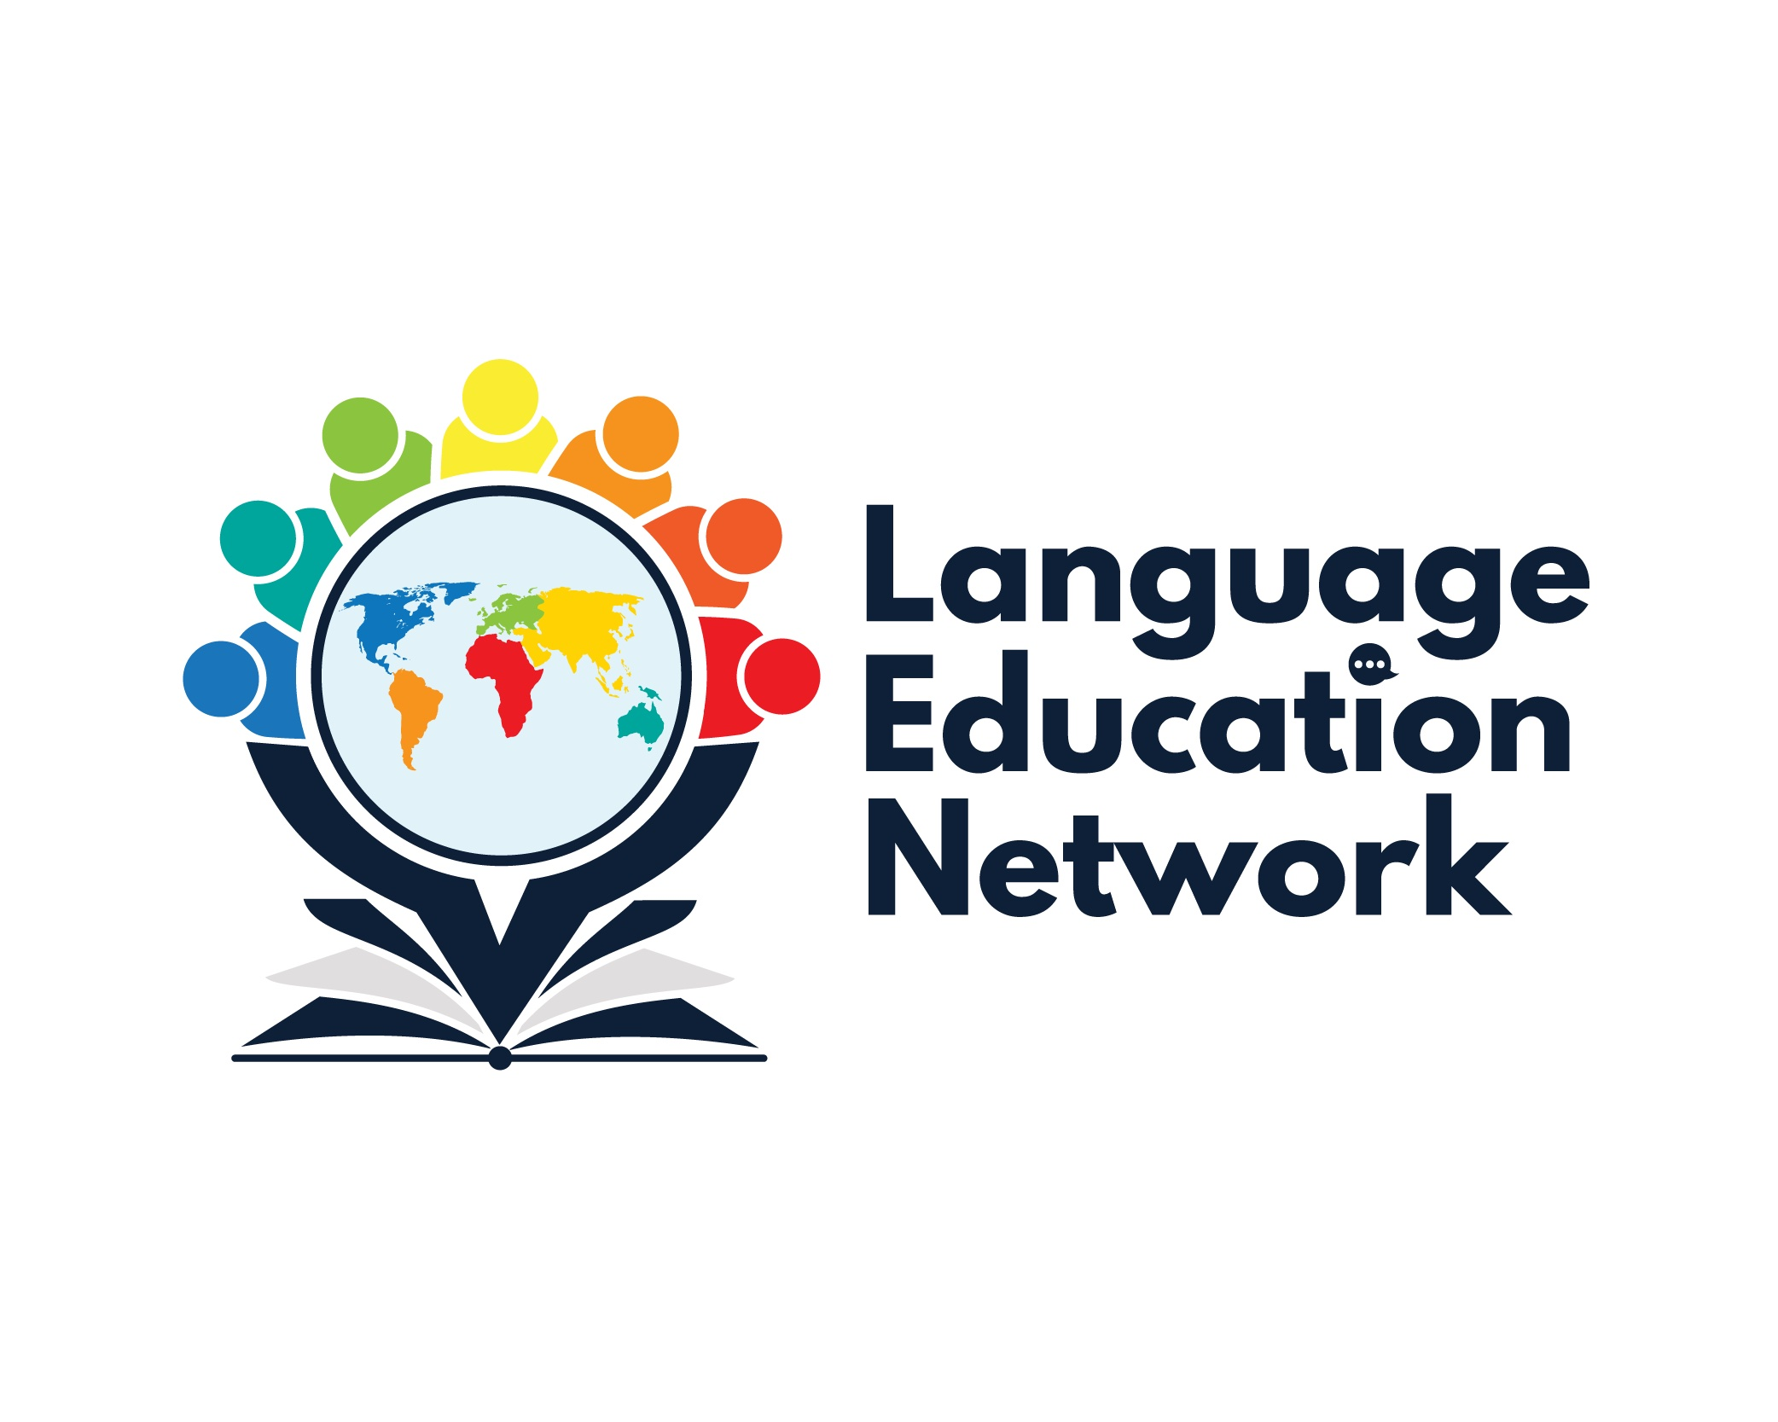
May 17, 2024
1:00 – 2:30 PM
AGENDA

Purpose: The purpose of our network is to come together to align current research and policy with the work that is required to prepare our English learners for college and career.
ZOOM LINK  Passcode: LEN | Facilitators:  Carlos Pagán: cpagan@sbceo.org  Melissa Garcia: mgarcia@sbceo.org

2023-2024 Meeting Dates
(1:00-2:30PM)
- September 8, 2023  - October 26, 2023 (World Languages Day, 8:30-3:30, in-person)  - December 15, 2023  - March 1, 2024  - May 17, 2024 | WELCOME!  ¡BIENVENIDOS!

TOPIC |  | NOTES/LINKS
PROFESSIONAL LEARNING OPPORTUNITIES (Summer-Fall 2024)
EWIG-EPiCC Zone C  - Project GLAD – (June & July) Santa Barbara County (full)  - Spanish Literacy – Dr. Jiménez Jiménez  September 26th (4th & 5th) Santa Barbara County  October 10th (6th-8th) Ventura County | SBCEO Professional Learning Opportunities Webpage  EPiCC Professional Opportunities Statewide HUB
BILINGUAL COORDINATORS NETWORK (BCN) REPORTS & UPDATES
- Bilingual Teacher Professional Development Program Grant  - Newcomer Students Webpage Updates  - State Seal of Biliteracy  - ELPAC Updates (Melissa Garcia)  - BATALLA DE LOS LIBROS – May 21, 2024 |  | SBCEO Batalla de los libros webpage
UPDATES & ANNOUNCEMENTS
Bilingual Authorization Program  - Begins July 8, 2024  - Information Session Data |  | SBCEO BAP WEBPAGE
INSTRUCTIONAL RESOURCES & PROFESSIONAL LEARNING OPPORTUNITIES

INSTRUCTIONAL RESOURCES:
- EL Toolkit of Strategies
- Designated & Integrated English Language Development Videos
- California ELD Standards
PROFESSIONAL LEARNING OPPORTUNITIES:
2024-2025:
- Project GLAD (Spanish)
- Spanish Literacy – Dr. Jiménez Jiménez
September 26th (4th & 5th) Santa Barbara County
October 10th (6th-8th) Ventura County
- Dr. Gabriela Bell Jiménez & Silvia Dorta Duque de Reyes – Spanish Assessments & Screeners, Spanish Writing
- Via Educational Consulting – Spanish Writing

