What is FERPA?
The Family Educational Rights and Privacy Act (FERPA) is a Federal law that protects personally identifiable information (PII) in students’ education records from unauthorized disclosure. It affords parents the right to have access to their children's education records, the right to seek to have the records amended, and the right for parents and eligible students to have some control over the disclosure of PII from education records.
FERPA includes provisions allowing students’ PII from education records to be disclosed without the prior written consent of parents, if the disclosure meets the criteria for one of the permitted consent exceptions.
The school official exception allows educational agencies to share PII from education records without consent with contractors, consultants, volunteers, or other parties to whom an agency or institution has outsourced institutional services or functions, as long as certain additional requirements are met.
The FERPA statute is codified at 20 U.S.C. § 1232g, and the FERPA regulations are found at 34 CFR Part 99.
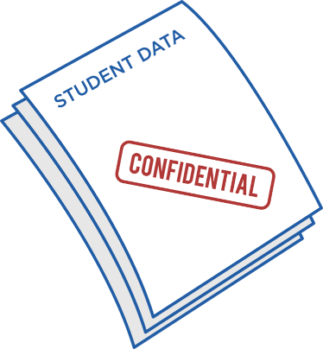

What are my responsibilities under Kentucky Family Education Rights and Privacy Act?
(1) Education records of students in the public educational institutions in this state are deemed confidential and shall not be disclosed, or the contents released, except under the circumstances described in KRS 160.720.

(2) School officials shall take precautions to protect and preserve all education records, including records generated and stored in the education technology system. School officials shall:
(a) Retain for a minimum period of one (1) week a master copy of any digital, video, or audio recordings of school activities without editing, altering, or destroying any portion of the recordings, although secondary copies of the master copy may be edited; and
(b) Retain for a minimum of one (1) month in an appropriate format, a master copy of any digital, video, or audio recordings of activities that include, or allegedly include, injury to students or school employees without editing, altering, or destroying any portion of the recordings.

(3) Recordings of school activities shall be subject to privacy and confidentiality requirements as provided in this chapter.

KRS 160.705

Who can I contact for more information?
Christel Nall 270-653-2341


Acknowledgement of Volunteer Responsibilities under the Family Educational Rights and Privacy Act (FERPA)

and

Kentucky Family Education Rights and Privacy Act

This document is intended for Local Education Agencies (LEAs) and schools to give to their volunteers to inform them about their responsibilities to protect students’ personally identifiable information from education records acquired under FERPA’s school official exception. For more information about FERPA, please visit https://studentprivacy.ed.gov.

Introduction
You have volunteered for Hickman County Schools to perform services that require you to access and use personally identifiable information (PII) from students’ education records. Your access and use of the PII is governed by the Family Educational Rights and Privacy Act (FERPA).
FERPA requires the school or school district to maintain “direct control” over your use and maintenance of students’ education records and to use reasonable methods to ensure that you obtain access to only those education records in which you have an educational interest.
If you have any questions about information in this document, they should be directed to Christel Nall.



What should I do to protect student PII from education records under FERPA?
It’s important that you take the following steps to protect student privacy:

- Do not disclose the PII to another party (except back to the School or District). The PII must not be shared with unauthorized users, and it must be protected from inadvertent disclosure due to careless handling.

- Do not use the PII for other purposes. The PII has been provided only for you to perform the volunteer service for which the school provided you the information. It should not be used for other purposes.

- Do not keep the PII after you complete your volunteer service. Destroy or return the PII to the school or district after completion of the service that you provided.

The undersigned acknowledges that he or she has read, understands, and will uphold all responsibilities as outlined in Acknowledgement of Volunteer Responsibilities under FERPA.

_______________________________
(Print name)

_______________________________
(Name of school or school district)

_______________________________
(Signature)

_______________________________
(Date)

