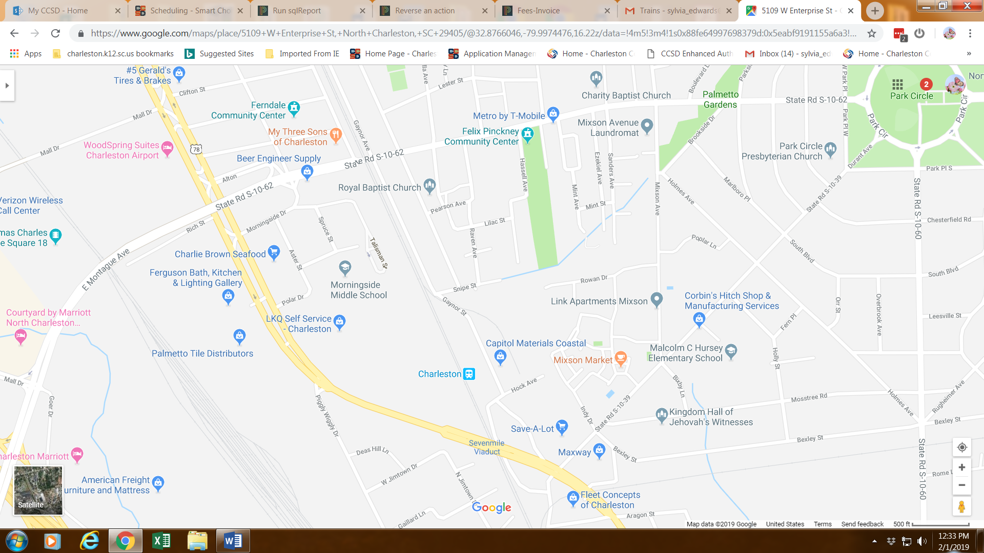

Turn around and take Rivers Avenue as if you were going towards downtown Charleston. You will take a left onto Durant Avenue. Then you will take another left onto Mixon Avenue. This will lead you back to Montague Avenue.

