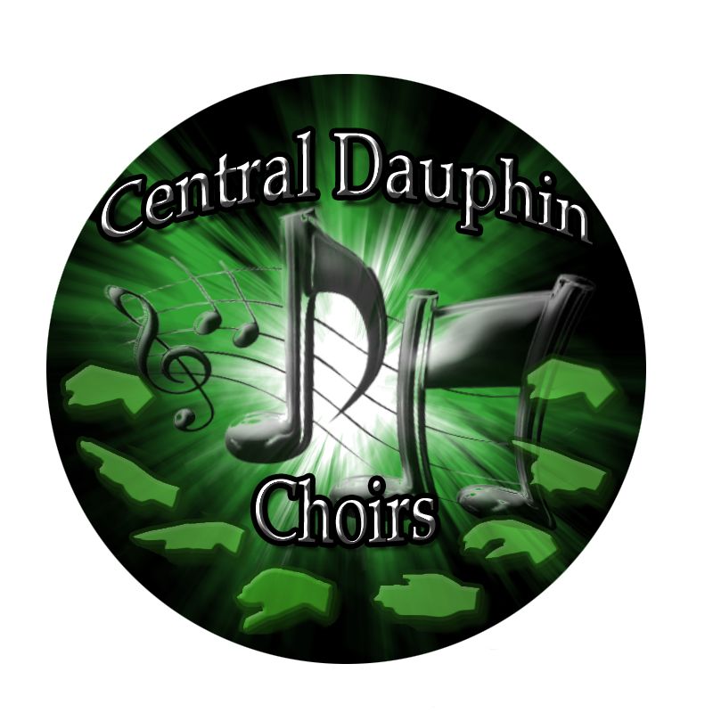

Teaching Values, Building Community, and Inspiring Joy through Vocal Music Excellence

CHOIR HANDBOOK
2023-2024

Central Dauphin High School
437 Piketown Road
Harrisburg, PA 17112
717-703-5360

Welcome!
Welcome to the 2023-2024 academic year for the Central Dauphin High School Choir Program. Our program is rooted in a tradition of excellence, and we have continued to set the stage for the amazing events yet to come this school year. All members are called to strive for their personal best in and out of the choir room. We are so glad you decided to join us this year!

Contact Mr. John Madas, Director of Choirs
Email: jharchakmadas@cdschools.org
Phone: 717-340-0759
Mail: Central Dauphin High School
Attn: Mr. John Madas-Vocal Music
437 Piketown Road
Harrisburg, PA 17112

Welcome CD Choir Parents!
Welcome to all parents of the Central Dauphin Choirs! We have a very exciting year ahead of us, ultimately wanting the very best experiences for all of our CD Choir students. You are warmly invited to join the choir parents as we plan, organize, dream-big, and support the efforts of all vocal music activities at CDHS. Please review the meeting schedule located on the back of this handbook; Our first meeting is Tuesday, September 19th at 6:30pm in the choir room. We hope to see you there. Come to say hello and see what’s going on behind the scenes with the CDHS choirs.
Thanks!- Mrs. Kristi Sims, President

Choir Parent Officers 2023-2024
President – Mrs. Kristi Sims
Vice President –Mrs. Danielle Denne
Financial Secretary – Renee Strange
Treasurer – Mrs. Danica Storry
Secretary – Mrs. Jeri Bowden

Contact the CDCPA President:
Kristi Sims Email: ksims79@hotmail.com

Join CD Choirs Remind!  Get text notifications regarding choir events, performances, and deadlines!  Text the number 81010 with your choir’s code:  CD Singers: @cdcsingers  Chanson: @cdcchanson  Men’s Chorale: @cdcmens  Women’s Chorale: @cdcwomens  CD Choir Parents: @cdcpa2024 | Follow CD Choirs on Social Media!  Facebook: http://www.facebook.com/CentralDauphinChoirs/  Instagram:  http://www.instagram.com/cdchoir  Twitter:  http://twitter.com/ChoirsCD

Student Choir Officers 2023-2024
President – Riley Storry  Treasurer – Tessa Bowden  Secretary (Singers)– Julia Denne  Secretary (Chanson) – Elizabeth Wise  Secretary (Women’s Chorale) –  Secretary (Men’s Chorale) – Aiden Hartly  Men's Chorale Intern - Tyler Strange | Vice President – Lillian Mbuu  Public Relations – Sara Yesalavage & Lizzie Camilli  Librarian (Singers) – Cadence Sims  Librarian (Chanson) – Blessing Nwokeji  Librarian (Women's Chorale)-  Librarian (Men’s Chorale) – Neetash Dhimal

Student Choir Officer Positions

Choir officer applications are accepted in early June of each academic year. In addition to strong personal leadership traits, choir officers assume the following roles:

President:
· Assist and advise Mr. Madas, on a daily basis, with communication, clerical, student, and related music items
· Plan, communicate, and lead choir officer meetings
· Write thank you notes to those who help the choir throughout the year
· Lead other choir officers in making sure their duties are carried out
· Assemble and supervise committees for special projects
· Assist the upkeep of the choir room
· Design and plan choir social events, including the end-of-year banquet
· Promote and represent CD Choirs throughout the school and community
· Middle school and elementary liaison: periodically make contact with CD middle and elementary schools, inviting
them to all choir functions

Vice President:
· Oversee the preparation and teardown of choir activities and performances
· Organize robe racks and stoles
· Work/communicate with the president on the design and organization of projects
· Post accomplishments and special announcements on the choir board
· Maintain the cleanliness of the choir room, and assist in the organization and cleanup
· Assist in maintaining the cleanliness of the back room and concert attire storage room
· Promote and represent CD Choirs throughout the school and community
· Assemble and supervise committees for special projects
· Assist and advise with clerical and related music items
· Attend all choir officer meetings

Public Relations Officer:
· Take pictures at all choir events
· Write choir announcements, communicate with PennLive and other local news media
· Update choir bulletin board with announcements, handouts, pictures, and decorations
· Design, collect, and organize a slideshow for the end-of-year banquet
· Produce publicity and communications for choral events: make signs/posters for choral events as it is relevant to
each activity.
· Attend all choir officer meetings

Treasurer:
· Assist and advise Mr. Madas, on a daily basis, regarding fundraising, financial, and permission slip items
· Collect payments and permission slips from the choir mailbox
· Prepare deposits: photocopy, stamp, calculate, and record all checks/payments
· Assign, communicate, and collect choir student obligations
· Communicate with choir parent fundraising chairs and trip coordinators for appropriate procedures regarding each
individual fundraising and trip situation
· Attend all choir officer meetings

Secretary:
· Communicates effortlessly with all members of their specific choir
· Coordinates and delivers announcements when needed during the choir period
· Takes minutes at choir officer meetings; posts minutes on choir board
· Take attendance at choir officer meetings, attend all meetings
· Assign, record, and post music folder numbers- done with the librarian
· Assist organizing, record, and post robe numbers and help with general attire needs

Librarian:
· Process and file of all new music: stamp, number, record, organize, and file
· Process and file currently used repertoire
· Maintain Excel choir library database
· Maintain a backup file folder of all current repertoire
· Assign, record, and post music folder numbers (work with choir secretaries)
· Assign and submit obligations for missing choir music/folders
· Repair damaged music
· Assist with concert program name checklist/cross reference
· Maintain physical appearance and cleanliness of music library
· Attend all choir officer meetings

Choir Interns:
· Lead a mini-rehearsal with the choir with which you are assigned
· Serve as a positive and affirming rehearsal leader
· Maintain control of a rehearsal to ensure maximum learning of content
· Display strong personal musicianship
· Boost morale and positive spirit within the choir
· Attend all choir officer meetings

Section Leaders:
· Lead a mini-rehearsal with your specific voice section
· Serve as a positive and affirming rehearsal leader
· Effortlessly know your own voice part for each piece of repertoire
· Be able to lead a successful sectional
· Display strong personal musicianship
· Communicate with Mr. Madas, daily, regarding the ensemble’s repertoire needs, concerns, and understanding
· Boost morale and positive spirit within the section
· Invited to attend all choir officer meetings

The Choir officers are ultimately here to help choir students and be their liaisons to the director.
Please contact them if you have comments or concerns regarding choir.
You can reach them by emailing: cdchoirofficers@gmail.com
Ensembles


Class ID Number: 64031-1
The Central Dauphin Women’s Chorale is an outstanding performance ensemble comprised of freshman through senior women. There are typically 75-85 young women in the ensemble. This one credit class meets everyday of the school year during period five, for 41 minutes. This class may be scheduled as a music lunch if the student’s schedule is already full. Students in Women’s Chorale learn a wide variety of repertoire ranging from a cappella Renaissance to accompanied 20th century scores. Members of the ensemble learn basic note reading, solfege-hand sign skills, rhythm identification, vowel production technique, music theory elements, and foreign language pronunciation skills. Women’s Chorale performs at least four times during the academic year, including the Fall, Holiday, Midwinter, and Spring concerts. This choir is a non-auditioned vocal ensemble, open to all freshman, sophomore, junior, and senior women.


Class ID Number: 64009-1
The Central Dauphin Men’s Chorale (aka “Boyz Noyz”) is an all-male ensemble providing a unique opportunity to foster strong vocal performance through men-specific repertoire. There are typically 30-40 young men in the ensemble. This one credit class meets everyday of the school year during period six, for 41 minutes. This class may be scheduled as a music lunch if the student’s schedule is already full. Students in Men’s Chorale learn a wide variety of repertoire ranging from a cappella Renaissance to accompanied 20th century scores. Members of the ensemble learn basic note reading, solfege-hand sign skills, rhythm identification, vowel production technique, music theory elements, and foreign language pronunciation skills. Men’s Chorale performs at least four times during the academic year, including the Fall, Holiday, Midwinter, and Spring Concerts. Men’s Chorale is a non-auditioned vocal ensemble, open to all freshmen, sophomore, junior, and senior men.


Class ID Number: 64028-1
CD Chanson is the premier SSAA Women’s Choir at Central Dauphin High School. There are typically 40-45 young women in the ensemble. This one credit class meets everyday of the school year during period one, for 41 minutes. The ladies of CD Chanson learn challenging traditional and contemporary choral compositions, spanning all compositional time periods. Members of CD Chanson are expected to give extra time in order to contribute to the ensemble’s artistic success. CD Chanson is a traveling choir, with the members performing at competitions and festivals, in addition to the four main choir performances of Fall, Holiday, Midwinter, and Spring. Additionally, members of CD Chanson perform as part of the annual CDSD District Honor Choir Festival. CD Chanson members learn advanced notation comprehension, score analysis, advanced solfege-hand sign command, rhythmic identification, advanced music theory elements, and foreign language pronunciation skills. Members of CD Chanson are examples of the choir philosophy: Artistry and Leadership Through Vocal Music Excellence. CD Chanson is an auditioned ensemble, open to sophomore, junior, and senior women. An audition packet will be made available in April with additional information, including audition details.



Class ID Number: 64038-1
The CD Singers of Central Dauphin High School serve as the premier SATB vocal ensemble at Central Dauphin High School. There are typically 40 members in CD Singers. This one credit class meets everyday of the school year during period three, for 41 minutes. The CD Singers learn challenging traditional and contemporary choral compositions, spanning all compositional time periods. Repertoire performed by the CD Singers parallels most college level vocal ensembles. Although not officially titled, the CD Singers could be easily categorized as an AP level course, given the numerous similarities found at colleges across America. Members of CD Singers are expected to give extensive energy during and outside of the rehearsal setting. Daily practice of the repertoire is mandatory. This ensemble develops the highest level of vocal education, musicianship, and artistry. All members can be relied on as leaders, musically and personally. The CD Singers are a tour ensemble, performing at community events, off-site concerts, collaborations with other choirs, and competitive festivals in addition to the four CDHS-school concerts and the CDSD District Honors Festival. Members of CD Singers learn advanced notation comprehension, score analysis, advanced solfege-hand sign command, rhythmic identification, advanced music theory elements, and foreign language pronunciation skills. The CD Singers are living examples of the choir philosophy: Artistry and Leadership Through Vocal Music Excellence. This ensemble is an auditioned ensemble, open to sophomore, junior, and senior women and men. Please see the Choir Interview Packet for audition details. An audition packet will be made available in April with additional information, including audition details.


Spring Musical
The Central Dauphin Choral and Instrumental Department produces a Broadway-level musical each Spring. The musical is a multifaceted artistic event that involves over 150 CDHS students as cast members, tech crew, and pit orchestra. Additionally, the students are working one-on-one with artistic professionals through choreography, costumes, programs, ticket sales, concessions, advertising, set construction, and other musical theater elements. Auditions are held in the Fall and are open to all Central Dauphin High School students in good academic standing. Rehearsals begin in early December and culminate in a performance run of four shows. With the Central Dauphin Choral Program at its core, the Spring Musical provides many opportunities in music leadership and excellence.

Auditioned Honor Choirs

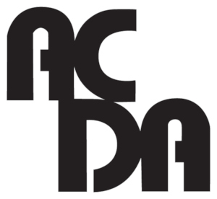
ACDA: American Choral Directors Association
Founded in 1959, the American Choral Directors Association (ACDA) is a nonprofit music education organization whose central purpose is to promote excellence in choral music through performance, composition, publication, research, and teaching. ACDA strives, through arts advocacy, to elevate choral music’s position in American society.
Students at CDHS are able to compete, through a certified audition process, for placement in State, Eastern Division, and National Honor Choirs. ACDA Honor Choirs represent the highest level of vocal achievement. Selected honor choir students will be under the direction of the most respected choral directors in the world, in addition to refining vocal, interdependent, social, and leadership skills through the lens of vocal music education.
CDHS choir students have had the opportunity to participate in past honor choirs including: State Men’s and Women’s, State Student-Director, State Junior High, Eastern Division High School, Eastern Division Junior High, Eastern Division Gospel, Eastern Division Men’s, Eastern Division Women’s, National High School, and National Multicultural Honor Choirs.
PMEA: Pennsylvania Music Educator’s Association
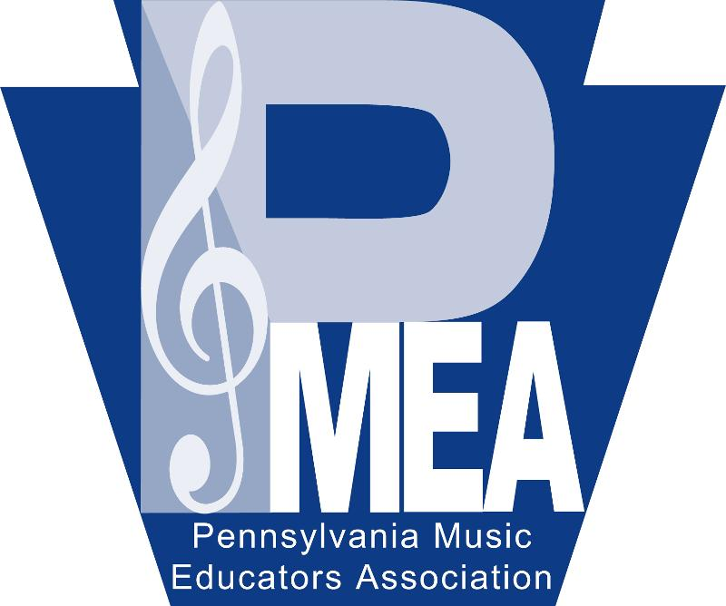
PMEA is the state level operation of NAfME: National Association for Music Education. Through NAfME/PMEA, student at Central Dauphin High School are offered competitive musical settings that enhance vocal performance, group/team/skills, hard work, musical development, and personal/ethical growth. Through a highly organized and tiered audition process, students are able to strive for District, Regional, and State Chorus. Additionally, students can audition for Vocal Jazz at the District and State levels.
District Choir: CDHS is located in PMEA District 7. This district is comprised of eight surrounding counties. Students who audition for district choir must master two pieces of choral repertoire and then perform them in a blind audition in the Fall. The top 20 students from each voice part are then invited to participate in the District Choir Festival, typically held in January of the New Year.
Regional Choir: All students who are selected for District choir have the opportunity to audition for Regional Choir. During the District choir festival, students audition for placement in Regional Choir. The audition is comprised of repertoire from the District festival. The top 12 scoring students from each voice part will continue to the Regional level.
All-State Choir: All students selected for Regional Choir will have the opportunity to audition for All-State Choir. The audition is similar to acceptance for the Regional festival. Here though, the top six students from each voice part will be invited to be part of the All-State Choir.

Concert Attire
Each choir has different concert attire requirements for different events. You will be informed of your concert attire requirements prior to your performance. The following is a general guideline of what each group will be wearing:
- CD Singers and Chanson: You will be wearing tuxes and gowns for a majority of your performances. During CD Honors Choir and those selected for PMEA Festival Choirs, you will be wearing green and white robes. Some less formal performances will require you to wear your CD Choirs Polo – see below for more information on what to wear with your polo.
- Women’s Chorale: You will be wearing green and white robes for almost all performances. Some less formal performances will require you to wear your CD Choirs Polo – see below for more information on what to wear with your polo and robe.
- Men’s Chorale: You will be wearing a black button down shirt, black pants, black shoes, black socks, and a solid green tie. The tie will be provided for you before concerts and will be returned the following day in order to receive concert credit. Some less formal performances will require you to wear your CD Choirs Polo – see below for more information on what to wear with your polo.

Choir Polo
All CDHS Choir students will need to purchase an official CD Choir Polo. These polos are custom made, featuring the CD Choir crest, and are worn as performance attire. CD Choir Polo orders are taken at the beginning of the year and the cost is typically $22.00 per shirt. Polo sizes must fit loosely; all inappropriate fitting polos will be replaced with a properly fitted size. The following requirements are established for all CDHS choir members:
- Polos must be worn with black pants, black socks, black dress shoes, and if applicable, black undershirt (unless otherwise specified).
- Polo must be tucked-in and black belt should hold your pants up.
- No sneakers, boots, leggings, multicolored socks, or different colored belts.
- Easy rule: before leaving home, ask yourself: “Is everything I have on black?” If not, then fix it so you can answer “yes” to that question.

Hair
Women: Hair must be out of your face/eyes for all performances. Use a bobby pin to pull the
hair off to one or both sides of your face.
Men: Please wash your hair and comb/style it. If you have long bangs/hair, use a bobby pin or
hair product to keep the hair out of your eyes. If you are at a loss, shave your head.

Additional Concert Attire Rules
The following general guidelines are established for concert attire:
- Students are not permitted to sit on the floor while wearing concert attire.
- When wearing robes: black pants, black socks, black choir polo, and black dress shoes must be worn underneath robes. Students are responsible for returning their assigned robe to the matching hanger, zipping up the entire zipper, and then hanging the robe back on its assigned rack.
- Students must avoid heavy make-up/foundation around the neck area as this leaves a permanent stain on our concert attire.
- All jewelry must be removed or hidden during performances. Bracelets, chokers, nose rings, and necklaces that hang out of the performance attire are not permitted. Stud earrings are the only exception.
- Students should be showered and deodorized before putting on concert attire in order to ensure longevity of the garment.
- Water ONLY. No food, drinks, or candy while wearing your concert attire!
If you are wearing the incorrect attire for a particular performance, you may be asked not to travel or perform that day. ALWAYS err on the side of caution with your concert attire!

Cell Phones
Cell phones are great communication tools, but during performances and rehearsals, they turn into the ultimate distraction. Here are some general rules about cell phones in choir:
- When warming up, rehearsing, or performing, or sitting in the audience at a CDHS choir event, your phone is to be turned off and put away! Cell phones should not be charged in the choir room at any time – period.
- If this rule is ignored, you will be asked to put your phone in a location away from your person in order to maintain your focus on the task or activity at hand. You will also be written up.
- There may be some classes where you are asked to use your cell phone as an educational tool. If it is found that you are not using your cell phone for the correct purpose during these times, you will get a zero on the assignment.

Assessment
Students in the Central Dauphin Choir Program not only experience a high standard in artistic performance, but are also authentically assessed using reliable criteria. All CDHS choir students are ultimately expected to or are prepared to:
- Sing with a rich, warm, dark tone color.
- Commit to Energy, Placement, and Beauty in all music activities.
- Perform the choir music at hand, observing all score markings and director markings.
- Analyze and Discuss a score using musical terms.
- Read sight-singing examples.
- Reflect and Write expressively about music, as well as their personal growth through music, and the music making process.
- Prepare and practice assigned music in order to be a contributing member of the ensemble.
- Have black folder including all ensemble repertoire at every rehearsal.
- Have a working pencil in hand or in a folder pocket during every rehearsal.
- Follow deadlines (Late assignments are subject to a 10% penalty per day).

Percentages

Every CDHS choir student will be authentically assessed using the following grade breakdown:
- Preparation/Daily Participation-----------------------30%
- Classwork/Writing/Homework-----------------------30%
- Concert Performances/Tests---------------------------40%

Folders

All CDHS Choir Students are required to maintain a choir folder during the course of the year. This is equivalent to your textbook in other classes. The following guidelines should be observed regarding folders:
- Folders are brought to every rehearsal. Rehearsing without a folder will result in a student being marked unprepared for class. (30% of your grade.) You will continue to lose these participation points until your folder is found, or you pay a replacement fee to receive new music.
- Folders are to be extremely cared for. They should never be dropped, which results in a loud bang, torn music, and strewn contents.
- Folders are expensive. Music can cost between $25-$50+ per person when the entire collection of repertoire is added up. If you lose your folder, it is your number one objective to find it. If this happens to you, act concerned!!!...and then find it.
- Folders should ALWAYS have a pencil clipped on or in the inside pocket.
- Folders should always go home with you at night. Students should review the literature at hand on a daily basis as part of one’s homework habits.

Musical Expectations:
The Central Dauphin High School Choral Department holds the highest expectations regarding vocal music development. Students will be guided in an active process of vocal music comprehension, through vocal performance preparation.
Primary Skills are based on:
- Energy, Placement, and Beauty: These standards are addressed and taught EVERY DAY as part of the blueprint of vocal music excellence.

- Life, Vibrancy, Excitement, Positive Spirit, Vigor, and Soul drives every sound that is produced. This must happen at all times; energy drives rehearsals, individual practice, and performance. (Energy)

- Warm, Rich, Dark, Resonant, and Healthy Tone. (Placement)

- Artistic Singing: (Beauty) Fundamental vocal technique that includes posture, breath control, vocal freedom, resonance, articulation, intonation, vocal flexibility, and range.

- Comprehension: Written notation and effect of music.

- Solfege: Students will be able to comprehend notation and transfer into solfege performance.

- Understanding and Meaning: Students practice/develop critical listening skills relative to structure, interpretation, and performance quality. Students work at gaining an understanding of the cultural and historical perspective of works being performed. Students strive to understand and create personal connections to text and its relationship to the musical score.

- Leadership: Students consistently strive for self-respect, peer respect, and ethical conduct.

- Taste: Students develop positive attitudes and values toward a wide spectrum of music styles and cultures.

Attitude and Behavioral Expectations

The CDHS choral program is based on strong relationships. The important relationship between students, directors, parents, administration, community, and alumni, is a well-balanced environment with musical excellence at the core. It is important that all choral family members understand that they must put personal agendas aside and focus on what they can do to foster a premier ensemble. It is asked that all members of our choir team follow two simple guidelines: 1) Honor those who are not present and 2) Give everyone the benefit of the doubt.

Respect
Behavior and Discipline become unimportant when all attitudes, decisions, and actions are based on respect. As a CDHS Choir Member, you are to practice respect.
*Respect for your school and the choral program. Students conduct themselves with pride and
continually reach for excellence.
*Respect for the music you are rehearsing and performing. You will have the opportunity to
perform exciting pieces, perhaps in styles you may never have tried before. To excel, you will
need to place your personal concerns on hold while working hard at the unfamiliar work at hand. Ultimately, know that you will never be asked to attain something that is not possible.
*Respect for your teachers and instructors. They will work harder, care more, and give more
knowing you have regard for them.
*Respect for all peers/other members of the choral program. You are part of a whole. In order for
the whole to achieve new heights, you must encourage each other to succeed.
*Respect for yourself, which is the most important of all! Set your goals high and know that you will
be able to achieve them. If you possess the pride and work ethic to be all that you can be, the
results will be greater than you could have ever imagined.

Rules of the Choir Room - 910
- The Choir Room is a community space, warm and welcoming to all students. If anything disturbs the welcoming nature of the room, including gossiping, cliques, loud obnoxious noises, pungent odors, yelling, and screaming, those participating individuals will be asked to leave the room immediately.
- Chewing Gum is not permitted in room 910, EVER! Upon entering, all chewing gum is to be placed in a large trash can, located at the entrance of the room. You will be written up if you chew gum in class.
- Bathroom visits must be anticipated/planned so that the rehearsal is not interrupted. Bathroom use, during rehearsals, is to be kept to extreme and emergency situations. If you have medical-related bathroom needs, please discuss this with the nurse or Mr. Madas.
- Warm-ups are sung immediately as you enter the room. While you are getting organized with your folder and pencil, the singing of warm ups during this time will maximize your music potential for the rest of the rehearsal. Get organized quickly and quietly before immediately reporting to the risers.
- Pencils are used to mark your music score. All rehearsal markings and score suggestions, given by Mr. Madas, are to be marked in pencil immediately. Do NOT use a pen EVER to mark your music! Sometimes, you will be marking your music even if you are not asked to. Be proactive and write something in your score every 1-2 minutes during rehearsal whether it was something you realized or something you were told to write.
- The Copier is not to be used by students unless arrangements have been made with Mr. Madas.
- Cleanliness of the Choir Room is mandatory. The floor must remain free of all trash, empty water bottles, and other scrap material.
- The Wenger 4-step Choir Risers are the best choir risers in the world, and we are grateful to have 8 sections for our use. Please keep the carpeted risers as clean as possible in order to impact longevity of their use. Obviously, no food, gum, or pen markings ever touch the risers.
- The Choir Library is off limits to all students except Choir Librarians and assisting officers. It is not permitted for students to “browse” through the stacks. With permission, students may search the digital database for octavos.
- Honor Deadlines: All CDHS choir students will honor deadlines.
- Officer Work Areas must be kept free of backpacks and books. All officer chromebooks and electronic devices are for choir related use only, including printing of documents and web browsing. All stationary items are property of CD Choirs and are to be used only by officers who are completing choir tasks.
- THE BOX: All signed forms, payments, correspondences, etc. must be placed in the box. This special mailbox is gray in color and is located on the wall directly below the glass window, outside of Mr. Madas’s office in 910.
  - Envelopes must be used when placing an item in THE BOX. Please write in detail on the outside of the envelope in order to help out the choir officers. Envelopes are provided for free and can be found in a stack on top of THE BOX.
- Tardiness: is not accepted in the CDHS Choral Department. Get to daily rehearsal before the bell rings - period. Show up early to dress rehearsals and related events - period. Be proactive and make sure that you arrive early, which establishes reliability. Tardy slips will be enforced as needed.

Attendance and Accountability
Each CDHS vocal department member needs to understand that the success of all performing teams depends upon each and every member being in attendance! The choral team cannot have members absent or being tardy while expecting to be successful at the same time. Each present individual makes the ensemble stronger; one missing person makes the ensemble weaker. For each ensemble there are different requirements, however attendance at all rehearsals, dress rehearsals, and performances is mandatory. An unexcused absence will result in the lowering of the final grade and in some cases, expulsion from the group.

Absence Procedure for a Rehearsal or Concert
Sudden Unanticipated Absence (Extreme illness or family emergency):
1. Contact the choir director at jmadas@cdschools.org OR 717-340-0759.
2. Send/leave an email/message stating your name and reason for absence. Then…
3. Place a note in THE BOX, signed by a parent/guardian, explaining the absence.

Anticipated Absence:
Submit a signed Absence Request Form two (2) weeks in advance of the absence. Absence Request Forms are available for download from the choir website or are in hardcopy format in the choir room.

Please note:
- Requests for absences will not be excused if they occur inside the two-week window prior to a performance. Please plan ahead.
- Do not tell someone else to tell Mr. Madas or other staff members about an absence; you must directly correspond with Mr. Madas regarding your absence.
- Failure to give proper notice will result in the lowering of your grade.
- Although there is no possible way to “make-up” a missed performance, an excused absence from a performance will require make-up work, which will be determined by the choir director.
Examples of EXCUSED Absence/Tardy:
- Extreme/Sudden Illness (Student should not be in school the day after a performance if suddenly ill)
- Sudden Emergency
- Religious Observance
- Death in the family
- Other unforeseen event (These will be dealt with on an individual basis.)

Examples of UNEXCUSED Absence/Tardy:
- “I have to work.” Or “My boss scheduled me and I have no control over it.”
- Non-emergency doctor/dentist appointments
- Hair appointments or Shopping
- Lack of Transportation
- Beauty contest/talent show outside of school
- Dance rehearsal
- Recreational games/tournaments
- Other school/after-school activities (unless arrangements have been planned for and discussed between Mr. Madas and the sponsor of the other activity)

**Ultimately: Always be upfront about upcoming/possible conflicts**

Travel
Performances and travel opportunities outside of the Central Dauphin Community serve as an integral component of the CDHS Choral Program. Every year, students will have the opportunity to participate in a choir travel-performance experience. Travel possibilities range from local mall holiday performances to out of town adjudication festivals. Extra-curricular tours are funded through the individual choir student; the CDCPA also contributes to help offset the cost of travel. To be eligible for performance travel, choir members must have:
- No unexcused concert or dress rehearsals during the year.
- No misconduct write-ups or disciplinary referrals.
- Passing grades in all major classes

Travel Guidelines
The following policies are in addition to the course of actions set forth by the Central Dauphin School District and Central Dauphin High School. When traveling, choir members must:
- Be on time.
- Conduct themselves in a manner that reflects the best of Central Dauphin Choirs.
- Carefully follow the instructions of the choir directors, staff, bus drivers, and parent chaperones at all times.
- Be responsible for seeing that all performance items have been properly packed.
- Travel in small groups, no duets or solos.
- Ride the same bus for the entire trip.
- Be sensitive to those around them. Don’t let your good time ruin someone else’s good time.
Note:
- Students can only be released to parents/legal guardians. A signed permission note must be presented to the director, prior to departure, stating that the student is to be released from travel.
- For the safety and security of all traveling participants, the director reserves the right to check luggage prior to departing for travel.
- Drug, Alcohol, and Tobacco policies parallel CDSD in-school policies. Please refer to the code of conduct for further details.

Schedule - see back page

Once again, welcome to the 2023-2024 academic year for the Central Dauphin High School Choirs! Please review the calendar, located on the back page, and highlight all dates that pertain to your particular choir. Thank you for being proactive by marking the dates on your home calendars.

* Every effort has been made to ensure all dates are readily available. Special events and performances are intermittently added throughout the year. Students will have as much prior notification as possible. Any arising conflicts/concerns will be addressed on an individual basis. If there are any concerns, please correspond with Mr. Madas by email: jharchakmadas@cdschools.org or call: 717-340-0759.

Audience Concert Etiquette

A friendly reminder for all audience members attending a formal choir or band concert…

Please remain seated until the end of the program. Entering or leaving the auditorium during the performance should occur only in an emergency, and is best done during applause, or when the performers are changing positions.

Please remain quiet during the performance. Things like talking, whispering, and making noise with wrappers is very distracting to the performers and other audience members.

Young children are expected to be stationary and quiet, and must be under the constant supervision of an adult. If a baby or young child is crying, please quietly exit the auditorium.

Above all, turn off all cell phones, ipods, and other similar devices and put them away for the duration of the performance as a courtesy to the performers and other audience members. Please abstain from flash photography as it is distracting to the performers. Due to copyright laws, recording devices of any kind are prohibited.

Remember… the musicians have worked very hard to prepare the music you are listening to this evening. We want to make sure that we show you our very best work. The audience members can help make that happen by following these few rules of concert etiquette.

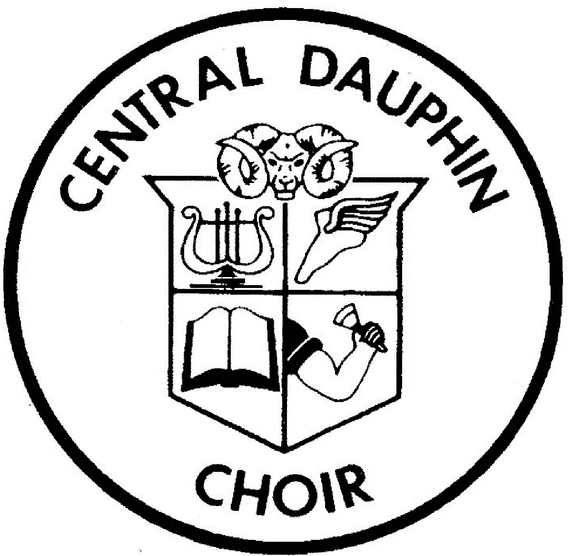

CD Choirs 2023-2024
Day Date Group Event Place Time
Tuesday | Sep. 5 | Choir Families | Choir Back to School Night | Zoom | 6:30 PM
Friday | Sep. 8 | Student Officers | Meeting | Choir Room-910 | 2:45 PM
Thursday | Sep. 14 | Student Officers | Back to School Night | Café | 6:00 PM
Tuesday | Sep. 19 | Choir Parents | Meeting | CDHS/Zoom | 6:30 PM
Friday | Oct. 6 | Student Officers | Meeting | Choir Room-910 | 2:45 PM
Tuesday | Oct. 10 | Choir Parents | Meeting | CDHS/Zoom | 6:30 PM
Saturday | Oct. 21 | Men’s Chorale | In Low Voice | Penn State Univer. | 7:00AM-8PM
Saturday | Oct. 28 | PMEA Districts | PMEA District Choir Auditions | Central York HS | 6:30AM-4PM
Monday | Oct. 30 | All Choirs | Fall Concert | Auditorium | 7:00 PM
Wed.-Thurs. | Nov. 1-2 | Musical Students | Musical Auditions | Room 910/Aud. | 6PM-9PM
Friday | Nov. 3 | Student Officers | Sweet Soundsations | Auditorium | 8:00AM-3PM
Friday | Nov. 3 | Student Officers | Meeting | Choir Room-910 | 2:45 PM
Tuesday | Nov. 14 | Choir Parents | Meeting | CDHS/Zoom | 6:30 PM
Friday | Dec. 1 | Student Officers | Meeting | Choir Room-910 | 2:45 PM
Tuesday | Dec. 12 | Choir Parents | Meeting | CDHS/Zoom | 6:30 PM
Sunday | Dec. 17 | Mens/Womens Choir | Holiday Concert | Auditorium | 2:00 PM
Sunday | Dec. 17 | Singers/Chanson | Holiday Concert | Auditorium | 4:30 PM
Friday | Jan. 5 | Student Officers | Meeting | Choir Room-910 | 2:45 PM
Tuesday | Jan. 9 | Choir Parents | Meeting | CDHS/Zoom | 6:30 PM
Fri.-Sat. | Jan. 26-27 | PMEA District Choir | PMEA District 7 Choir Festival | ELCO High School | All Day
Friday | Feb. 2 | Student Officers | Meeting | Choir Room-910 | 2:45 PM
Fri.-Sat | Feb. 9-10 | CD Singers/Chanson | CDSD Honors Choir Festival | CD Middle | All Day
Tuesday | Feb. 13 | Choir Parents | Meeting | CDHS/Zoom | 6:30 PM
Thursday | Feb. 22 | Musical Students | Musical Preview/Senior Show | Auditorium | 10AM-6PM
Fri.-Sun. | Feb. 23-25 | Musical Students | Musical Performances | Auditorium | 7:00 PM
Wed.-Sat. | Feb. 28-Mar. 2 | ACDA Eastern Choir | ACDA Eastern Conference | Providence, RI | All Day
Thursday | Mar. 7 | Student Officers | Meeting | Choir Room-910 | 2:45 PM
Fri.-Sat. | Mar. 8-9 | PMEA Region Choir | PMEA Region V Choir Festival | TBD | All Day
Tuesday | Mar. 12 | Choir Parents | Meeting | CDHS/Zoom | 6:30 PM
Fri.-Sat. | Mar. 15-16 | District Jazz | PMEA District 7 Jazz Festival | CDHS | All Day
Saturday | Mar. 23 | Chanson | Roxbury Invitational | Roxbury HS | All Day
Friday | Apr. 5 | Student Officers | Meeting | Choir Room-910 | 2:45 PM
Tuesday | Apr. 9 | Choir Parents | Meeting | CDHS/Zoom | 6:30 PM
Fri.-Sat. | Apr. 12-13 | DCMEA Choir | DCMEA County Choir Festival | Susquehanna HS/ Forum Auditorium | All Day
Wed.-Sat. | Apr. 17-20 | PMEA All-State | PMEA State Convention | Erie, PA | All Day
Wednesday | May 1 | All Choirs | Spring Concert | Auditorium | 7:00 PM
Thursday | May 2 | Student Officers | Meeting: Final Banquet Prep | Choir Room-910 | 2:45 PM
Mon.-Fri. | May 6-10 | All Choirs | Choir Auditions 2024-2025 | Choir Room-910 | All Day
Thursday | May 9 | All Choirs | Banquet | TBD | 6:00 PM
Tuesday | May 14 | Choir Parents | Meeting | CDHS/Zoom | 6:30 PM
Wednesday | May 29 | All Choirs | B-way Showstoppers 2024 | Auditorium | 7:00 PM
Tuesday | June 4 | Choir Parents | Meeting | CDHS/Zoom | 6:30 PM
Wednesday | June 5 | Seniors | Graduation | Landis Field | 6:30 PM

