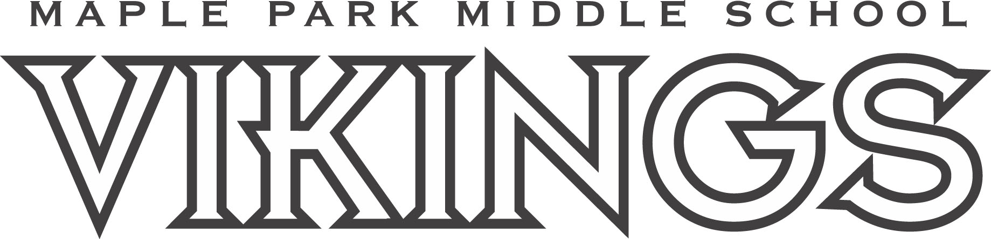

CROSS COUNTRY INFORMATION
School Year 2024-2025

Do you like being outdoors with your friends? Are you looking for a way to get involved at Maple Park? If so, Cross Country is the perfect sport for you!

You don’t have to have any running experience to join! We will work with you to improve your running stamina and skills no matter what your running experience is. During practice we will work on running drills and you will spend time running at your level.

Cross Country meets are a fun chance for you to show your improvement competing against other middle schools in the area. Our goal is always to do better than you did the time before, to show good sportsmanship, represent Maple Park positively and to have fun!

Practices start August 19 from 2:30-3:30pm and after school until 4:00pm starting August 20. From August 20 on, students needing to ride the activity bus home can stay at school, supervised, until the buses leave around 4:45pm.

Students need to wear shoes and clothing that are easy to run in and MUST bring a water bottle.

If you are interested, please email Coach Peterson to get added to the contact list.

Coach Peterson: charissa.peterson@nkcschools.org
Coach Abbott: anthony.abbott@nkcschools.org

