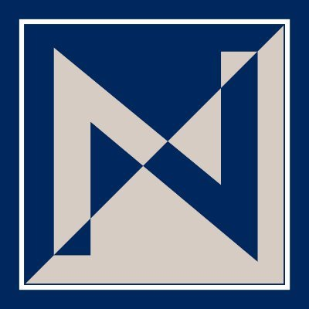
NKCSD Middle School Swim Team 2024

Who: Any NKCSD 7th or 8th Grade Middle School Athlete

When: After School from 3:00 – 4:30 p.m. Monday – Friday; Practice starts Monday, March 3rd.

Where: Gladstone Community Center

Physicals: Swimmers will need to complete a physical form and have it on file at their middle school.

Activity Fee: Swimmers will need to pay the yearly activity fee to their middle school by February 24th. This fee should be paid online through MyPaymentsPlus. If you participated in a previous sport this year, you do not have to pay this fee again.

Transportation: Busses will take athletes from their middle school to the community center. Parents MUST pick their athlete up by 4:30 p.m. There are NO RETURN BUSSES available.

Supplies: Each swimmer will need to provide their own SWIMSUIT (this needs to be a competitive racing suit, no tie-back suits or Tech suits for meets), GOGGLES, WATER BOTTLE, WORK OUT CLOTHES and TENNIS SHOES for dryland. Caps are optional as you will receive one after 14 practices. If you have long hair, you may want one for the time being.
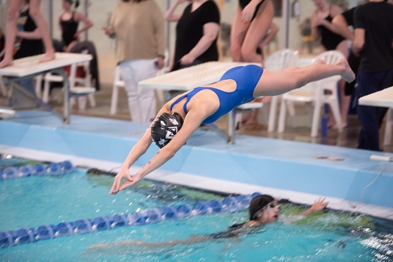
Parent Meeting: A parent meeting is planned for the first day of practice. Parents can come in to the community center when they arrive for pick up for a short meeting with the coaches.

Questions: Contact Riley Byrne
riley.byrne@nkcschools.org

