World History
Section II
Total Time--1 hour, 40 minutes

Question 1 (Document-Based Question)
Suggested reading and writing time: 60 minutes

It is suggested that you spend 15 minutes reading the documents and 40 minutes writing your response. Note: You may begin writing your response before the reading period is over.

Directions: Question 1 is based on the accompanying documents. The documents have been edited for the purpose of this exercise.

In your response you should do the following.
- Respond to the prompt with a historically defensible thesis or claim that establishes a line of reasoning
- Describe a broader historical context relevant to the prompt
- Support an argument in response to the prompt using at least six documents
- Use at least one additional piece of specific historical evidence (beyond that found in the documents) relevant to an argument about the prompt
- For at least three documents explain how or why the document’s point of view, purpose, historical situation, and/or audience is relevant to an argument
- Use evidence to corroborate, qualify, or modify an argument that addresses the prompt

- Using specific examples, analyze the extent to which the Moroccan Constitution of 2011 has achieved its stated goals regarding equal inclusion of the various cultural identities within Morocco.

Background: A Brief History of Morocco
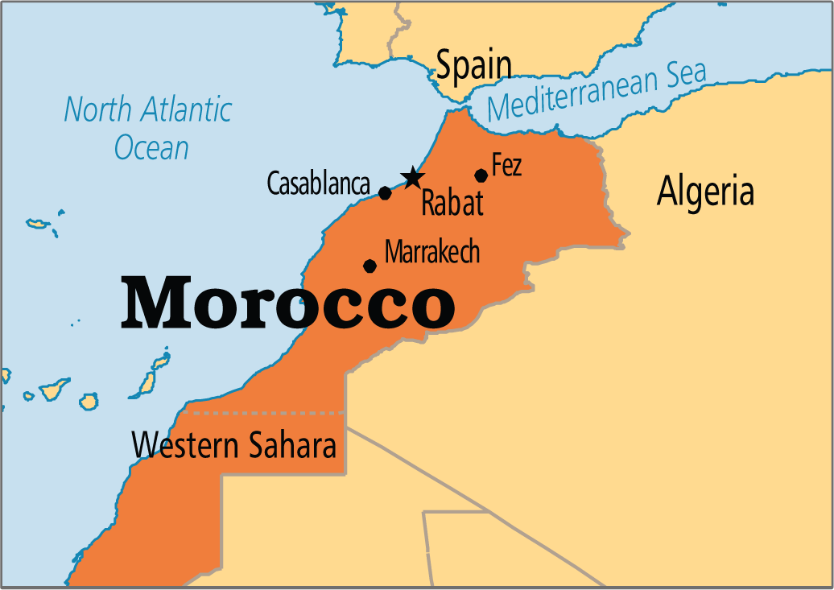
MOROCCO’S FOUNDATION (1)
The Kingdom of Morocco is the most westerly of the North African countries known collectively as the Maghreb--The “Arab West.” It has Atlantic and Mediterranean coastlines, a rugged mountain interior, and a history of independence not shared by its neighbors. Its rich culture is a blend of Arab, Berber, Hebrew, European and African influences and the area has been continuously settled for several millennia.
The indigenous people of the region are known as Berbers, though many prefer the name Amazigh, and are documented to have lived in the region as early as 3000 BCE, ruling through small, kin-based clan networks. Beginning with Phoenician colonization in the 8th and 6th centuries BCE, Morocco became increasingly more diverse and cosmopolitan. Morocco became part of some of the infamous empires of antiquity--Carthage and Rome--and was exposed to Christianity, Judaism, and massive trade networks. Morocco even boasted one of the largest population of Jews in Africa prior to the creation of the state of Israel. After Roman rule, the country was conquered by Arabs in the late 7th century and was ruled by a series of kingdoms after that. Morocco was at its height during the 11th through the 16th centuries with a series of powerful Berber dynasties. It was a popular trade hub of the Trans-Saharan network with Marrakech serving as an output for caravanserais on their way to the coasts, involved in a lucrative trade of a variety of goods from all over the region, most notably spices, carpets, jewelry, and leather products. However, beginning with the Saadi dynasty, the successive rule of the indigenous Berbers was over and since then, Arab dynasties with alleged ties to Muhammad have reigned.

FRENCH & SPANISH COLONIALISM IN MOROCCO (2)
Despite strong European influence after the mid-1800s from Portugal, the Ottoman empire, Spain, and France, Morocco was able to thwart attempts at Turkish and European control until the country became a French protectorate in 1912. While the Portuguese control of the coasts did not threaten interior Morocco, other forces, such as the French did. There was more wealth in this part of the Maghreb and Morocco’s location was both strategically and economically important to those who sought to imperialize this portion of Africa. As internal instability increased in the late 19th century, France positioned themselves for influence over interests in the region. Since the French were already in Algeria, annexing portions of the kingdom of Morocco was relatively simple.
The Moroccan Crises were two international conflicts that arose before Morocco was imperialized by Spain and France from 1905 to 1911. While most countries in Africa were being colonized, Morocco was still independent; however, numerous European nations sought control over Morocco. The Treaty of Fez in 1912 officially made Morocco a protectorate of France, while Spain was granted special zones of influence. The far north of Morocco was under control of the Spanish Protectorate, including its enclaves in Melilla and Ceuta. Also, Spain had control over Ifni in the South. The capital of the Spanish Protectorate was Tetouan. The French Protectorate consisted of a majority, about nine-tenths, of Morocco. France controlled the Moroccan land to the south of the Spanish Protectorate. The capital city of the French Protectorate was Rabat. The French government imperialism focused on the exploitation of Morocco's mineral wealth, the creation of a modern transportation system, and the development of a modern agricultural sector geared to the French market. Tens of thousands of colonists entered Morocco and acquired large tracts of the rich agricultural land. Additionally, the French set up schools and worked on their “civilizing” mission, teaching natives French.

MOROCCAN NATIONALISM & INDEPENDENCE (3)
Beginning in the year of 1920, nationalism began to spread among the people of Morocco. While Morocco was under control of France and Spain, nationalists made several attempts to get independence for their country. The rebellions of the people of the Rif Mountains were ultimately unsuccessful. After defeating Abd-el-Krim, the French and Spanish were able to control the nationalists for a couple of decades until independent movements began again. In the year 1944, toward the end of WWII, nationalists formed an independence party called the Istiqlals, which challenged colonialism. The Istiqlals issues a manifesto, which was a public declaration of their intentions and opinions. In response, the French, who were unhappy with the Istiqlal Party, arrested all of the leaders of the group and accused them of working with the Germans. Also, the French fired on people gathered in Fez in peaceful protest. Later, in December of 1952 there were riots in the city of Casablanca. The riots caused the resident general to ban the Istiqlal and the Moroccan Communist Party.
A year later, the French made a big mistake by exiling then-leader Sultan Mohammed V to Madagascar. In the Sultan's place Mohammed Ben Aarafa took over. Mohammed Ben Aarafa was not well-liked by the Moroccans. Nationalists who liked Mohammed V and saw him as a religious leader were angered by France's actions. This led to revolts and opposition from the Moroccan citizens in the form of terrorist acts and armed movements against the French. Finally, in 1955 the French government were expelled from Morocco. The Sultan was able to return from his exile on November 16, 1955. Then, on March 2, 1956, Morocco officially became independent. After the French left Morocco, the Spanish did the same. In April, the region of Morocco under the Spanish protectorate was freed. Also, Tangier, which was given international status, became a part of Morocco again in October. After 44 years of colonization Morocco was finally an independent country again.
Although Morocco gained its independence in 1956, Spain still colonizes two parts of Morocco to this day. The cities of Ceuta and Melilla and a small chain of islands of the coast in the Atlantic ocean are still under the control of Spain. The Spanish had taken over Melilla in 1497 and got Ceuta in 1580. When Spain gave up the protectorate in Morocco, they did not give up these parts of Morocco. Ceuta and Melilla are two cities in dispute between Spain and Morocco. Moroccans consider the cities to be apart of Morocco while the Spanish say that it is Spain's property and Spanish people already settled there before the Moroccans did. The legacy of colonialism exists to this day.

DEVELOPMENT OF GOVERNMENT AND RULE (4)
Upon gaining independence, Sultan Mohammed V was dedicated to building a modern government structure for the kingdom. Morocco is a constitutional monarchy with a capital in Rabat. The monarch, who serves as head of state, appoints the prime minister, who serves as head of government. The country has a bicameral parliament with indirectly elected members. The king chairs the Supreme Council of the Judiciary, the National Security Council, and the Council of Ministers, which must approve all legislations. He is also the commander of the faithful, adding religious authority to his political and security ones. Muhammad V ruled until he was succeeded in 1961 by his son, Hassan II, who ruled for 38 years and played a prominent role in the search for peace in the Middle East. He also ruthlessly suppressed domestic opposition.
Groomed for "kingship", as his late father King Hassan II referred to his upbringing, Mohammed VI became monarch in 1999. He initiated political and economic changes and an investigation into human rights abuses during his father's rule. A key reform was the Mudawana, a law which grants more rights to women. The king has said it is in line with Koranic principles, but religious conservatives have opposed it. According to some Moroccans, they cannot see how their country would function without their king and put great faith in him. Most are happy with his rule but say that other parts of government have become corrupt. Today, there are tensions in the northern Rif region of the country with regards to respecting Berber rights and the Amazigh movement for greater recognition of indigenous heritage and language.
In the past, the Moroccan government pursued privatization and economic reform since the 1980s, and now has an open, diverse market economy. Key sectors of the economy include agriculture, aerospace, phosphates, textiles and apparel. The tourism and telecommunications sectors are becoming increasingly important. Media is mostly controlled by the state or reflect the official line. Recently, the private press has succeeded in breaking taboos over some sensitive topics, including allegations of high-level corruption. However, Morocco’s Press Law provides for prison terms. The editor of Al-Massae daily was jailed for one year in 2011 for stories he had written about corruption and the activities of the security services. Paris-based Reporters Without Borders notes that "religion, the king and the monarchy in general, the country and territorial integrity cannot be questioned." Bloggers generally avoid sensitive topics, such as Western Sahara and the royal family.

ARABIZATION OF MOROCCO (5)
In 1956, with the end of French colonial rule, Morocco implemented a national policy known as Arabization. The main goal of this program actively sought to replace French, the official language used during the period of colonization, with Arabic. In an era of newfound independence, French was now seen as the “language of the colonizer”, whereas the implementation of Arabic as the standard, monolinguistic, national dialect, was an assertion of Morocco’s of its Arab-Islamic historical roots and a statement of its cultural, political and economic independence from Western imperialist influence.
Another objective of the policy of Arabization was to unify the new nation by fostering a greater sense of “Moroccan” identity. Arabic, as the national, monolingual language, would, as it was conceived, bring Moroccan citizens together with a common belief and shared experience in recently acquired independence and self-sufficiency and through the assertion of commonality of religious faith as a Muslim. Arabic, as the Quranic language of Divine Revelation, was believed to promote not only the agenda of a more unified Moroccan state and national identity but also to connect Moroccan Muslims with the world population of Muslims within the Dar al-Islam. However, while the policy of Arabization sought to affirm nationalism with the promotion of a single language and an Arab-Islamic cultural identity, the program marginalized other traditional languages, such as Tamazight (Berber), and the role of minority religions, such as Judaism and Christianity, within Moroccan history
In the late 80s, the objectives and the goals of the policy of Arabization were re-evaluated. Consequently, in 2000, with the Charter for Educational Reform, the Moroccan government adopted a significant change in policy towards language instruction and towards broader education reform in general. There was an acknowledgement that the goal of pursuing a policy of promoting Arabic as the single, official language had placed Moroccan students at a severe learning disadvantage. Two issues arose: first, in the fields of science and technology (which had been taught since colonization in French and English ) and second, the fact that a significant percentage of Moroccans, with a mother tongue of Tamazight, and are non-Arabic speakers.

ARAB SPRING & ITS INFLUENCE ON MOROCCO (6)
The Arab Spring is a term used in the media for the revolutionary wave of demonstrations and protests (both nonviolent and violent), riots, and civil wars in the Arab world that began on December 18, 2010. Rulers were forced from power in Tunisia, Egypt (twice), Libya and Yemen. Civil uprisings occurred in Bahrain and Syria. Major protests occurred in Algeria, Iraq, Jordan, Kuwait, Morocco and Sudan. Minor protests occurred in Mauritania, Oman, Saudi Arabia, Djibouti, Western Sahara and Palestine. There were minor protests in countries that are not part of the Arab World, such as Iran and Israel. Many Arab Spring demonstrations were met with violent responses from authorities, as well as from pro-government militias and counter-demonstrators. These attacks were answered with violence from protesters in some cases.
The protests in Morocco shared some techniques of the other Arab Spring protests in civil resistance in sustained campaigns involving strikes, demonstrations, marches, and rallies, as well as the effective use of social media to organize, communicate, and raise awareness in the face of state attempts at repression and Internet censorship. Following pressure for reform inspired by these Arab Spring protests, a new constitution was proposed in 2011 in Morocco, expanding the powers of parliament and the prime minister but leaving the king with broad authority over all branches of government.

A NEW CONSTITUTION: ELECTION 2011 (7)
In 2011, the King announced a new constitution was being drafted. The constitution, like all preceding ones, was written by a commission of experts appointed by the king, rather than by an elected constituent assembly or another representative body. Once the submissions were made, however, there was no follow up or debate. The organizations were not shown a draft of the new constitution until weeks later and even then they were not shown a written document but only able to listen to an oral presentation.
The two most controversial issues to surface during the debate over the constitution were related to the definition of the identity of the Moroccan state: whether Morocco should be defined as an Islamic state, and whether Morocco should recognize Amazigh, the language spoken by the Berber minority, as an official language. Whether this is just a short-lived victory in the first skirmish of a long battle or a turning point on the road to transforming Morocco into the Arab world’s first constitutional monarchy will depend not only on how the king acts in the coming months, but also on the capacity and willingness of Moroccan political organizations to build on the opportunities the constitution offers them.
In the end, the constitution defines Morocco as a Muslim state in the preamble, and states that Islam is the state religion in Article 3, which also guarantees freedom of religious practices to all faiths. Compared to the text of most Arab constitutions—which proclaim sharia as one of the sources, if not the source of law—the new Moroccan constitution, like the previous one, is quite liberal. It should also be noted that in Morocco religion is an integral part of the king’s power: as the officially recognized “commander of the faithful” the king would see his position somewhat diminished if Morocco was not defined as an Islamic state.
The new constitution also recognizes Amazigh as an official language, despite the objections by conservative elements and by those who thought such recognition would dilute Morocco’s Arab identity. It also contains a reference to the plurality of influences on the Moroccan culture, including Andalusia, more broadly the Mediterranean culture, the people in the Sahara, Christianity, and Judaism. The compromise in this case appears to be language that makes it clear that the official status of the Amazigh language will be implemented slowly. How far the king’s top-down reform will go may well depend on the strength of a bottom-up push by political parties and protesters.

THE CURRENT STATE OF MOROCCO (8)
Morocco today is a vibrant and diverse country, just about the same size as the state of California, boasting a population of 35 million people. Life expectancy for males is 74 and for women is 77 years of age, numbers strongly above the international average of 68 and 72, respectively. According to 2016 data from Al-Jazeera, a state-funded news agency out of Qatar, 70% of Moroccans self-identify as Arab, 29% Berber, and 1% Other. Morocco is a 90% Muslim country, while 10% of the people identify as either Christian or Jewish. The official languages of Morocco are Arabic and Berber, while other popular languages spoken are French and Spanish. English in becoming increasingly used in the bigger cities.
Due to the stability of the government of Morocco, the country has remained one of the top destinations for travelers in North Africa. Morocco is known for its rich history and has millions of tourists visit each year, specifically to see UNESCO World Heritage Sites and the notable cities such as Marrakech, Casablanca, Fez, Essaouira, and Rabat, as well as trek in the Sahara Desert of Atlas Mountains, or enjoy the beaches along the Atlantic or Mediterranean coasts. In 2016, the United Nations held its premier climate change conference in Marrakech, bringing much international media attention to Morocco, showcasing the country’s progress since its independence in 1956.
Despite its many attributes, there continues to be consistent concern from human rights activists groups who cite a corrupt justice system, rampant domestic violence, silenced dissidents, censorship and lack of public expression, as some of the issues plaguing today’s Morocco. One of the examples of this tension can be seen in the riots in northern Morocco’s Rif region as the Amazigh movement of the country’s indigenous peoples persist against the dominant Arab majority and call for greater pluralism and inclusion in politics and society.

Document 1

Source: Constitution of Morocco, Preamble, May 11, 2011.
English Translation © 2012 by William S. Hein & Co., Inc. All rights reserved. Translated by Jefri J. Ruchti Prepared for distribution on constituteproject.org with content generously provided by Hein Online. This document has been recompiled and reformatted using texts collected in Hein Online’s World Constitution’s Illustrated.

With fidelity to its irreversible choice to construct a democratic State of Law, the Kingdom of Morocco resolutely pursues the process of consolidation and of reinforcement of the institutions of a modern State, having as its bases the principles of participation, of pluralism and of good governance. It develops a society of solidarity where all enjoy security, liberty, equality of opportunities, of respect for their dignity and for social justice, within the framework of the principle of correlation between the rights and the duties of the citizenry.

A sovereign Muslim State, attached to its national unity and to its territorial integrity, the Kingdom of Morocco intends to preserve, in its plentitude and its diversity, its one and indivisible national identity. Its unity is forged by the convergence of its Arab-Islamist, Berber [amazighe] and Saharan-Hassanic [Saharo-Hassanie] components, nourished and enriched by its African, Andalusian, Hebraic and Mediterranean influences [affluents]. The preeminence accorded to the Muslim religion in the national reference is consistent with [va de pair] the attachment of the Moroccan people to the values of openness, of moderation, of tolerance and of dialog for mutual understanding between all the cultures and the civilizations of the world. […]

Founded on these values and these immutable principles, and strong in its firm will to reaffirm the bonds of fraternity, or cooperation, or solidarity and of constructive partnership with all other States, and to work for common progress, the Kingdom of Morocco, [a] united State, totally sovereign, belonging the Grand Maghreb, reaffirms that which follows and commits itself:

- To work for the construction of the Union of the Maghreb, as [a] strategic option;
- To deepen the bonds of togetherness with the Arab and Islamist Ummah [Oumma], and to reinforce the bonds of fraternity and of solidarity with its brother peoples; […]
- To protect and to promote the mechanisms [dispositifs] of the Rights of Man and of international humanitarian law and to contribute to their development within their indivisibility and their universality;
- To ban and combat all discrimination whenever it encounters it, for reason of sex, or color, of beliefs, of culture, of social or regional origin, of language, of handicap or whatever personal circumstance that may be; […]

Document 2

Source: Personal photos taken in Morocco on a Fulbright-Hays Group Project Abroad, July 2017 documenting various examples of the imprint of Arab/Muslim hegemony on the cultural landscape.
Photo A
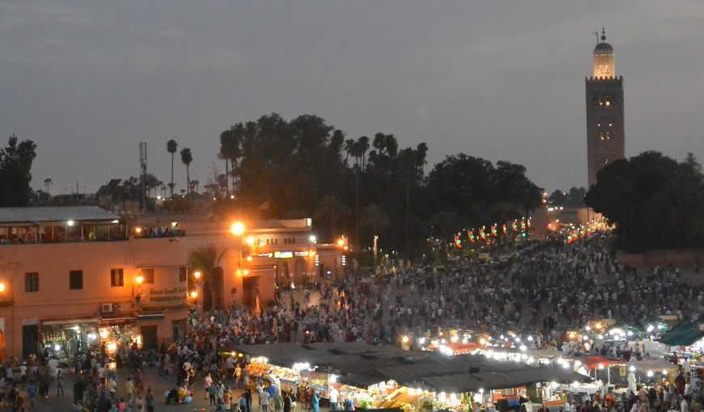

Picture at left:
Jemaa el-Fnaa, the main marketplace and square in Marrakech, established over 1000 years ago. The Koutoubia mosque can be seen looming high in the background. The building of the mosque was completed at the end of the 12th century. (Photo by Suzanne Anderson).

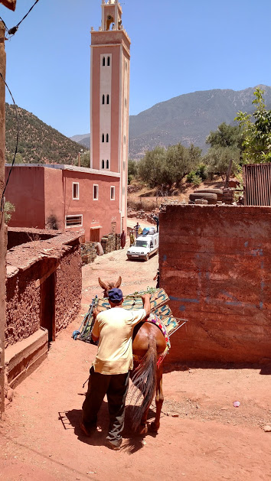

Photo B

Picture at right: In the High Atlas mountains, outside of Ouirgane, a local Berber villager is shown with his animal transporting goods. There is limited access in these areas to major roads and most transportation is done on foot or on animals, though some small vehicles have access. In the background, one of many mosques scattered throughout the area. (Photo by Tasha Bergson-Michelson).

Document 3

Source: July 28, 2014 article The Amazigh Movement and Democratic Reform: A Look at Morocco and Algeria, by Anna Jacobs for Muftah, a news outlet dedicated to producing original content from diverse individuals about global events. https://muftah.org/amazigh-movement-democratic-reform-look-morocco-algeria/#.WlfxOdWnHrd

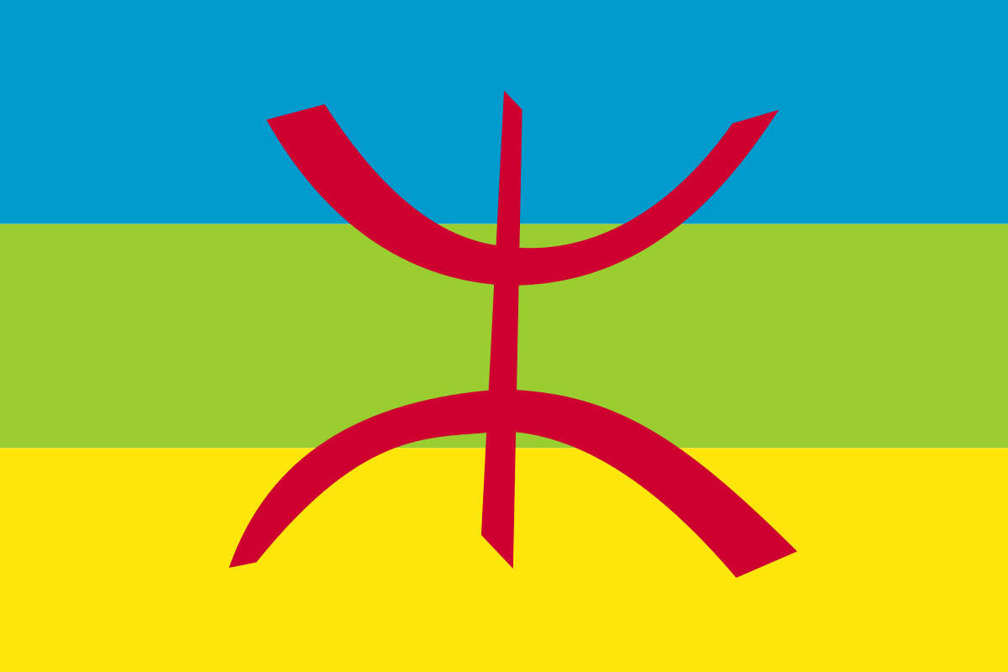
Note: The image to the right represents the Berber flag of the Amazigh movement. Each color corresponds to an aspect of Tamazgha, the territory inhabited by Berbers (Amazigh) in North Africa: blue represents the Mediterranean Sea and the Atlantic Ocean; green represents nature and the green mountains; and yellow represents the sands of the Sahara Desert. The yaz (letter) symbolizes the "free man", which is the meaning of the Berber word amazigh, the Berbers' own name for themselves. The symbol is in red, the colour of life, and also the color of resistance. The Berber flag thus symbolizes the entire Amazigh people, living in harmony with their land.

The Berbers, or Imazighen (plural of Amazigh), represent the indigenous population of the North African region, where they have resided for over 4000 years, well before the Arab conquest. The group currently represents between 40 and 50 percent of Morocco’s population. Berber communities exist across the region, with small minorities stretching from Mali to Egypt. The Berbers are a significant part of Maghrebi culture and society, and they are fighting for a greater presence in the national narrative. Throughout the post-independence era, and in particular the last thirty years, Berbers have voiced cultural and political demands through an increasingly vocal Pan-Amazigh movement, which calls for greater political pluralism and respect for Amazigh history and culture, like making official recognition of Tamazight languages their key demand. More widely, these Pan-Amazigh political movements have become integral elements in holding leaders accountable for their promises of reform in various North African states.

Morocco’s Berber community has a long history of resistance, including participating in the revolt against Spanish rule under the revolutionary Moroccan leader Al-Khattabi and establishing the Rif Republic of 1921-1926. Berbers played an important role in the Moroccan Liberation Army, which fought the French. After independence in 1956, small Berber associations developed in the country, but were not allowed to include the term “Berber” in their names. The Berber community felt increasingly under threat in the 1970s because of the proliferation of Arabization programs in public schools. The politicization of Berber communities in Morocco began to develop in 1980. The dominant narrative about peaceful Arab conquest of North Africa also began to be challenged. In these and other ways, the Berber community began to assert its unique cultural identity while also challenging the discursive status-quo about the spread of Islam in the region.

The Amazigh Cultural Movement was established in 1994 with a national committee to effectively communicate its platform. Throughout the decade, King Hassan II made promises to increase the presence of Tamazight (and its dialects) in the national media and schools. With the arrival of the ostensibly forward- thinking King Mohammed VI in 1999, expectations for reform were very high. Rather than address the fundamental demands of the Amazigh community, that is, diversity and representation in Moroccan culture, Mohammed VI co-opted the reform process. Using a strategy that has now become commonplace, the king monopolized the issue and set about addressing the movement’s concerns on palace terms. This included creating the Royal Institute of Amazigh Culture in June 2001. Many Amazigh saw this as an utterly shallow attempt to appease the movement, which led to further radicalization.

Many Moroccan activists see the Amazigh movement as the heart and soul of current demands for greater political pluralism and real democratic reform. King Mohammed VI has been very cognizant of this threat, especially after segments of the Rif and the Souss Valley began calling for autonomy in 2008. This is especially true in the wake of Morocco’s recognition of Tamazight as an official language, the increasing dissemination of the Tamazight dialects on national media, development projects that have been channeled to dissident regions, media restrictions, and continued repression of political opposition in regions like the Rif.
Document 4

Source: Morocco: Victims of Attack Jailed for “Homosexual Acts”, April 8, 2016 (Human Rights Watch article). https://www.hrw.org/news/2016/04/08/morocco-victims-attack-jailed-homosexual-acts

(Tunis) – A Moroccan court has convicted one man and is trying a second for homosexual acts, after a group of youths attacked and brutalized them on the night of March 9, 2016. The youths broke into the home of one of the men in the city of Beni Mellal, beat them, and dragged them naked onto the streets. The case attracted international attention when a video clip appeared online on March 25, showing two men cowering naked, one of them covered in blood, being beaten, kicked, and dragged outside, while anti-gay slurs and “Call the authorities!” – apparently uttered by the assailants – can be heard on the soundtrack.

On March 15, the Beni Mellal Court of First Instance convicted one of the victims for “acts of sexual deviancy with a person of the same sex,” under penal code article 489, and “public drunkenness.” The defendant, who according to his police statement had waived his right to legal counsel, was sentenced to four months in prison and a 500 dirham (US $52) fine and remains in prison. The same court that day convicted two of the attackers for assault and sentenced them to suspended two-month sentences.

“Beaten, bloodied, and pushed naked into the street, and then sent to prison for your private life,” said Sarah Leah Whitson, Human Rights Watch Middle East and North Africa director. “This verdict will discourage victims from seeking justice and increase the likelihood of homophobic crimes.” The prosecution shows the determination of Moroccan authorities to enforce anti-homosexuality laws, even when the acts in question allegedly took place in a private residence between consenting adults, and after neighbors assaulted them for their supposed sexual orientation, Human Rights Watch said.

Moroccan law does not penalize “being homosexual;” rather, it prohibits same-sex sexual acts. Laws that criminalize consensual same-sex conduct violate rights protected by the International Covenant on Civil and Political Rights (ICCPR), to which Morocco is a state party, including the right to privacy and the right to nondiscrimination. The United Nations Working Group on Arbitrary Detention has ruled that arrests for consensual same-sex conduct are, by definition, arbitrary.

Though the judiciary does not provide statistics, Morocco frequently imprisons men under penal code article 489, which provides for terms of up to three years and fines of up to 1000 dirhams (US$104). The draft revisions to the penal code that the Justice Ministry introduced in 2015 maintain this offense and the applicable prison terms, while increasing the fines. Human Rights Watch urged the authorities to abolish article 489 and all laws penalizing consensual sexual acts among adults. Morocco’s 2011 constitution states, in article 24, “All persons have the right to protection of their private life.” In response to the Beni Mellal case, at least 20 non-governmental organizations in Morocco have called for the repeal of penal code article 489. “Repealing the ban on same-sex acts among consenting adults would both affirm Moroccans’ right to privacy and help to protect people from hate crimes,” Whitson said.

Document 5

Source: “About” Section for Association Mimouna: http://www.associationmimouna.org

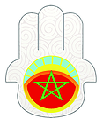

Association Mimouna Logo

Traditionally celebrated at the end of Passover, “Mimouna” is a unique Moroccan Jewish celebration of liberty and community. Moroccan Jews would often invite their Muslim neighbors to join in the festivities associated with returning to eating leavened food once Passover ended.

We are a group of Moroccan Muslim students striving to preserve and promote the history of Morocco’s ancient Jewish community. Founded in 2007 at Al Akhawayn University in Ifrane (AUI), the MIMOUNA takes its name from the original “Mimouna,” a symbol of the heritage shared by all Moroccans. We seek to educate the Moroccan people about the Jewish culture that used to flourish in the country, and encourage harmony between Jews and Muslims. MIMOUNA members study Hebrew and Jewish history, as well as organize cultural events. Thousands of people have attended our annual “Moroccan Jewish Days” and recently launched "Moroccan Jewish Caravan."

In September 2011, MIMOUNA organized a conference commemorating Jewish victims of the Nazi Holocaust and honoring King Mohammed V for his refusal to assent to the persecution of Jews during the Vichy occupation. The conference was recognized in the New York Times as “the first of its kind in an Arab or Muslim nation and a sign of historical truth triumphing over conspiracy theories and anti-Semitic dogma.” MIMOUNA members have continued their activities despite criticism, refusing to give in to ignorance and intolerance, and in fact work to counter both through their activism.

MIMOUNA has recently expanded to include new chapters at university in Fez, Rabat, and Marrakesh. In August 2012, these chapters formed the Association MIMOUNA, a Moroccan non-profit umbrella organization.

Document 6

Source: Moroccan Cultural Preservation and the Jewish Experience, by Dr. Yousef Ben-Meir for TransConflict, June 22, 2017. http://www.transconflict.com/2017/06/moroccan-cultural-preservation-and-the-jewish-experience-226/

King Muhammad VI launched a national project in 2012 to rehabilitate the Jewish cemeteries. There are approximately 600 Hebrew “saints” that are buried in all parts of the kingdom. Many have laid in rest a millennium or more, and 167 of the sites have been part of the national preservation effort. Additionally, the rehabilitation of the mellah, the Jewish quarter which historians suggest first appeared in Marrakech during the second half of the 16th century, has begun. The Jewish experience in Marrakech has been incredibly rich, complex, nonlinear, hopeful, painful, continuous, and ongoing to this very moment. Therefore, the initiative to preserve this living and evolving social artifact is exceptionally worthy, and an action fully consistent with the Moroccan national identity and Constitution.

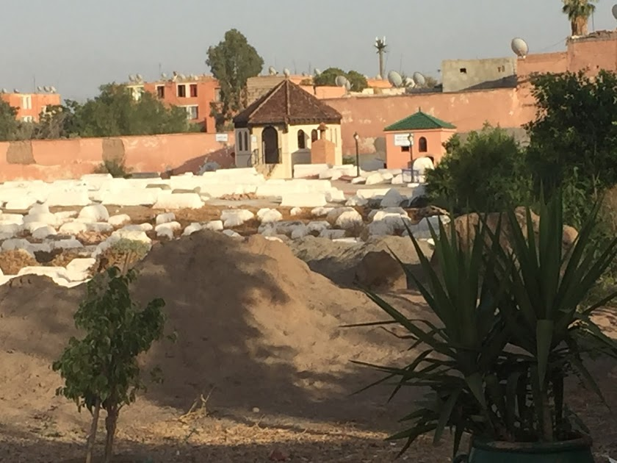
Pictured above: Jewish cemetery in mellah of Marrakech. Older tombs are being cleaned and new buildings erected to honor the Jewish saints buried here. (Photo by Bonnie Sussman).

Document 7

Source: “Language Attitudes in Morocco Following Recent Changes in Language Policy”
by Dawn Marley from Language Policy, March 2004, Vol. 3, Issue 1, pgs. 25-46

Students were asked to say if they agreed or disagreed with a series of statements relating to the languages in Morocco, with the following results. The categories were complete agreement = 1, slight agreement = 2, slight disagreement = 3, complete disagreement = 4, do not know = 5.
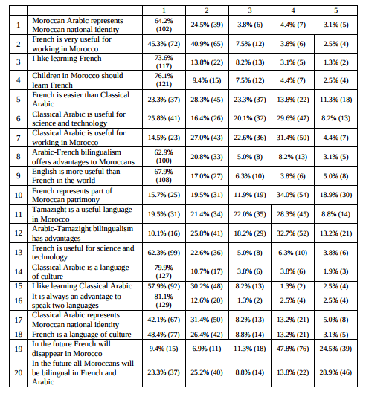

These survey responses suggest that young people are very conscious of the different values assigned to different languages present in their society. Although Classical Arabic is the national language, and has been the primary medium of instruction throughout their education, they are firmly in favour of French- Arabic bilingualism and believe that French is far more useful than Arabic in working life in Morocco. Given that the study took place in a non-Tamazight speaking region, it is perhaps not surprising that so few should have felt that Tamazight was useful. Nevertheless, their response here is in direct contradiction to the overwhelming majority who believe that ‘speaking two languages is always an advantage’! It implies that they do not really consider Tamazight to be a language on par with French or Arabic.
Document 8

Source: Personal photos taken by Andrea Milius and Heather Merovich in Morocco on a Fulbright-Hays Group Project Abroad, July 2017.
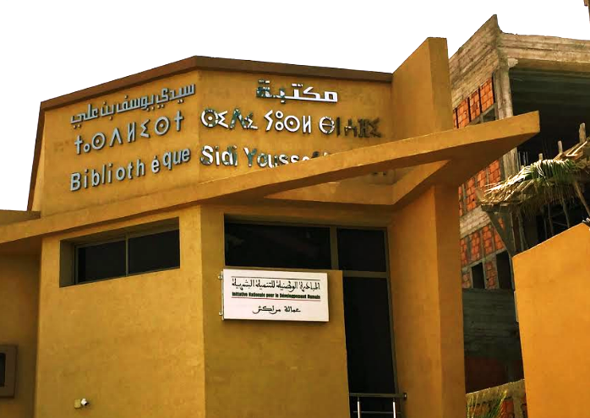

Above: A library in Marrakech features signage with translations in three languages: Arabic, Tamazigh, and French. All new government or public buildings now show signs in multiple languages. (Photo by Andrea Milius)

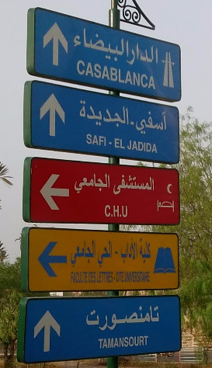

At right: A roadside sign just outside of Marrakech featuring two languages: Arabic and English. Many signs such as this could be
seen with two visible languages, one of them often being English.
(Photo by Heather Merovich)

l

END OF DOCUMENTS FOR QUESTION 1

