Evaluate the factors that enabled rulers of land-based empires in the early modern era (1450-1750) to establish or maintain their authority.

Document 1
Source: German depiction of Ottoman Janissaries.
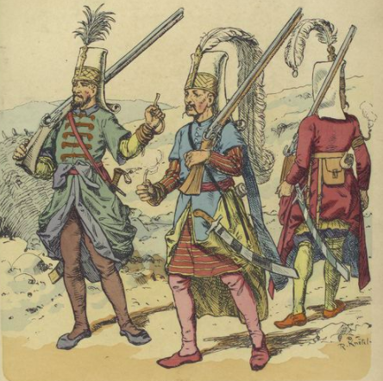

Document 2
Source: The Memoirs of the Emperor Jahangir, an account of his reign of the Mughal Empire depicting major political and cultural events in his life, 1605-1627.

[H]aving on one occasion asked my father [Akbar] the reason why he had forbidden anyone to prevent or interfere with the building of these haunts of idolatry [Hindu temples], his reply was in the following terms: “...Ill should I discharge the duties of my exalted station, were I to withhold my compassion and indulgence from any of those entrusted to my charge. With all of the human race, with all of God’s creatures, I am at peace; why then should I permit myself, under any consideration, to be the cause of molestation or aggression to anyone? Besides, are not five parts in six of mankind either Hindus or aliens to the faith; and were I to be governed by motives of the kind suggested by your inquiry, what alternative can I have but to put them all to death! I have thought it therefore my wisest plan to let these men alone”

Document 3
Source: Imperial edict of Hongwu, the first emperor of the Ming Dynasty
To all civil and military officials:

I have told you to refrain from evil. Doing so would enable you to bring glory to your ancestors, your wives, your children, and yourselves. With your virtue, you then could assist me in my endeavors to bring good fortune and prosperity to the people. You would establish names for yourselves in Heaven and on earth, and for thousands and thousands of years, you would be praised as worthy men.
However, after assuming your posts, how many of you really followed my instructions? Those of you in charge of money and grain have stolen them yourselves; those of you in charge of criminal laws and punishments have neglected the regulations. In this way, grievances are not redressed and false charges are ignored. Those with genuine complaints, their words never reach the higher officials. Occasionally these unjust matters come to my attention. After I discover the truth, I capture and imprison the corrupt, villainous, and oppressive officials involved. I punish them with the death penalty or forced labor or have them flogged with bamboo sticks in order to make manifest the consequences of good or evil actions...

Document 4
Source: Aurangzeb Muhi-ud-Din Muhammad, the sixth Mughal emperor, excerpt from a statement to his tutor, c. 1635.

Answer me, sycophant! Ought you not to have instructed me on one point at least, so essential to be known by a king; namely, on the also to have foreseen that I might, at some future period, be compelled to contend with my brothers, sword in hand, for the crown, and for my very existence? Such, as you must well know, has been the fate of the children of almost every king of Hindustan.
Did you ever instruct me in the art of war, how to besiege a town, or draw up an army in battle array? Happy for me that I consulted wiser heads than thine on these subjects! Go! Withdraw to thy village. Henceforth let no person know either who thou art, or what is become of thee.

Document 5
Source: Edicts of Russian Emperor Peter I (the Great), 1702 & 1714
Decree on the Invitation of Foreigners and on Promotion to Officer’s Rank

Since our accession to the throne, all our efforts and intentions have tended to govern this realm in such a way that all of our subjects should...become more and more prosperous. For this end, we have always tried...in every possible way to improve and extend trade. With this purpose, we have been compelled to make some necessary and salutary changes in the administration, in order that our subjects might more easily gain a knowledge of matters of which they were before ignorant, and become more skillful in their commercial relations. We have therefore given orders...and founded institutions indispensable for increasing our trade with foreigners, and shall do the same in the future...
Since there are so many who promote to officer rank their relatives and friends—young men who do not know the fundamentals of soldiering, not having served in the lower ranks...therefore, let a decree be promulgated that henceforth there shall be no promotion [to officer rank] of men of noble extraction or of any others who have not first served as privates in the Guards...

