WHAP Exam Review
Unit 3-4 (1450-1750CE)

Reference Dates!
These are good to use as reference points when you see documents or are writing about Causation.
You don’t need to memorize them, but it might be helpful. :)

1440 - Gutenberg invents the printing press
1453 - Constantinople (Byzantine capital) conquered by Ottomans
1492 - Columbus’s voyage; end of the Spanish Reconquista (reconquering Spain from Muslims) and Spanish Inquisition (Jews expelled)
1514 - King Afonso of the Kongo writes to King of Portugal asking him to slow the slave trade
1517 - Martin Luther begins the Protestant Reformation
1521 - Spanish conquest of Aztec Empire
1526 - Mughal Empire established in India
1571 - Ottomans defeated by Europeans at the Battle of Lepanto (Mediterranean Sea)
1603 - Tokugawa Shogunate established in Japan
1607 - Jamestown colony established in Virginia
1626 - Ana Nzinga’s war against the Portuguese begins
1631 - King Louis XIV builds Palace at Versailles
1636 - Manchu conquer China and establish Qing Dynasty
1675 - Metacom (King Philip)’s War against New Englanders begins
1687 - Isaac Newton publishes his work on gravity and the laws of motion
1689 - England establishes a constitutional monarchy with a Bill of Rights
1690 - John Locke publishes his Two Treatises on Government (beginning of Enlightenment)

SPICE-T Chart (Units 3-4)

You should be able to:
Compare the methods by which various empires increased their influence from 1450 to 1750

Instructions: Fill out the chart below as completely as you can. Use examples from ANY of the states listed in the region (you don’t have to pick just tone) and put key terms in bold.
(Try to find something to put in each box even if it’s general.)

*Focus on ways states maintained power and influence.
 | Europe/Americas/W. Africa  (England, France, Portugal, Spain, Dutch + American colonies + African slave trade) | E. Africa/Middle East/India  (Ottoman, Safavid, Mughal, Swahili Coast) | E/SE Asia  (Ming, Qing, Tokugawa, Indian Ocean trading states)
Society
How did states use social class/relationships to maintain power and influence?
Politics
How did states arrange their government and rule effectively?
Interaction w/ Environment
How did states use/control their environment to establish power and influence?
Culture
How did states use cultural practices to maintain power and influence?
Economy
How did states maintain and establish economic power?
Technology
How did states use technology (either existing tech or innovating new tech) to maintain power and influence?

Part 2. Outside Evidence

Instructions: PICK FOUR+ QUESTIONS. Identify and explain ONE piece of specific evidence that could address each of the following…
(This is NOT a full SAQ. Just identify the evidence and include enough information to make it clear to me that you know what you’re talking about. This could be complete sentences or detailed bullet points.)

Example:: Identify and explain religion influencing state formation between 1200-1450.
“In northern India, various Hindu clans united loosely under Rajput Kingdoms until they were conquered by Islamic invaders who set up the Delhi Sultanate.”
OR

“Abbasid Dynasty - claimed Islamic “caliphate” - opened Islam to non-Arabs - treated Jews and Christians well”

- Identify and explain one way that states used art/architecture to legitimize their rule between 1450-1750.

- Identify and explain one example of various religions interacting in new ways between 1450-1750.
- Identify and explain one way the interconnection of Eastern and Western Hemispheres transformed social structures.
- Identify and explain one example of states taking an active role in the economic development of their states between 1450-1750.

- Identify and explain one consequence of the Columbian Exchange on Afro-Eurasia between 1450-1750.
- Identify and explain one example of a non-European trading state that continued to flourish in the Indian Ocean between 1450-1750.
- Identify and explain one example of coerced labor (besides African slavery) that benefited states between 1450-1750.
- Identify and explain one example of indigenous resistance to state expansion into new territory between 1450-1750.

Part 3. HIPP
Instructions: Evaluate the Historical context, Intended audience, Purpose, OR Point of View of each document. Make sure to include how that HIPP impacts our understanding of the document. (Is part of the document now problematic? Is there a part of the document that might be exaggerating or downplaying some historical development? Is there information that’s intentionally left out or given prominence?)

Example:

Christopher Columbus, describing his first encounter with the indigenous Arawak people in his captain’s log  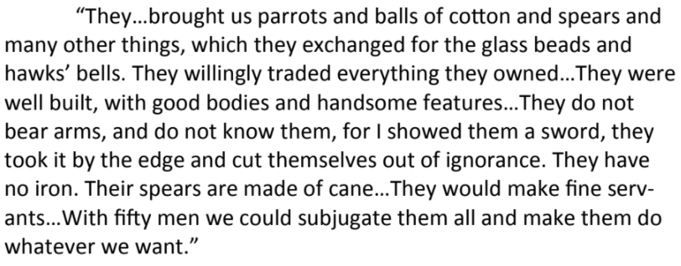 | Columbus’s log was intended to document his first journey to the Americas. Although it was a private document, it could be used as evidence to convince the Spanish Crown to fund more expeditions. Because of that, Columbus emphasized the natives’ “willingness” and “ignorance” to show the king that his investment would bring an easy conquest and a lot of material rewards.

Doc. A

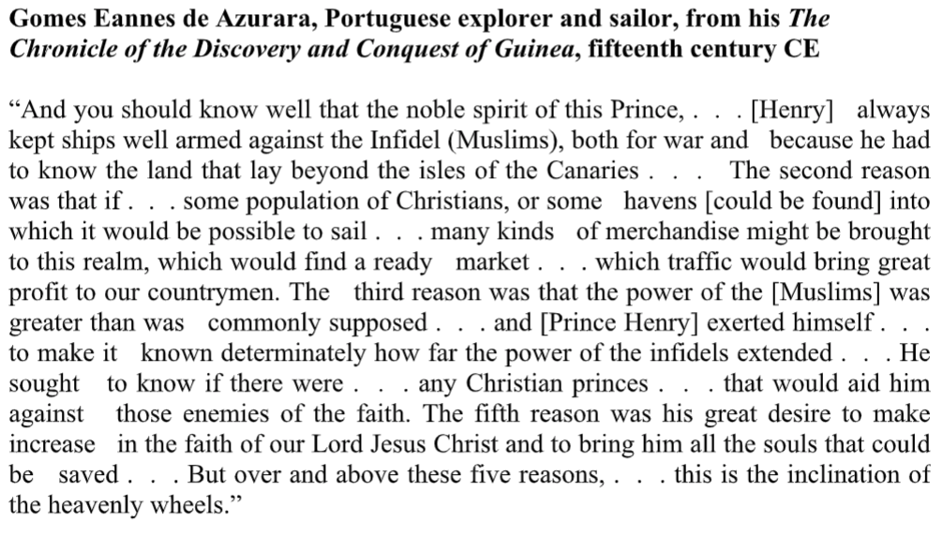

Doc. B

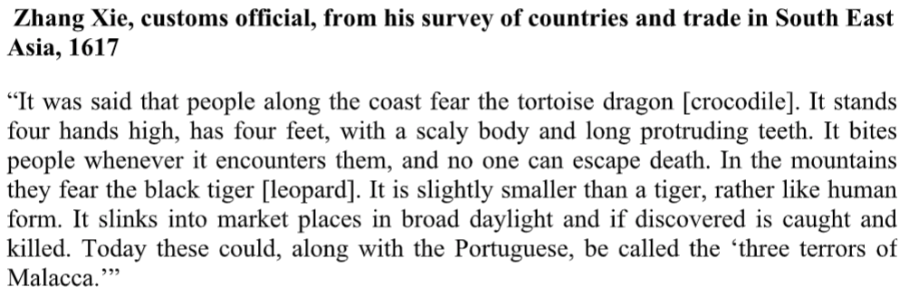

Doc. C

