Evaluate the extent to which railroads affected the process of empire-building in Afro-Eurasia between 1860 and 1901

Document 1

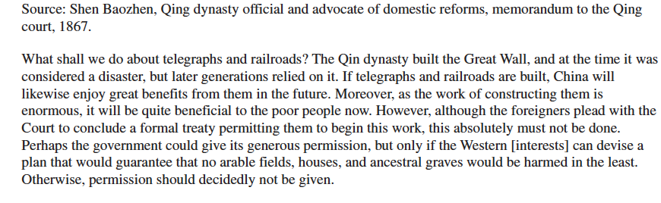

Document 2
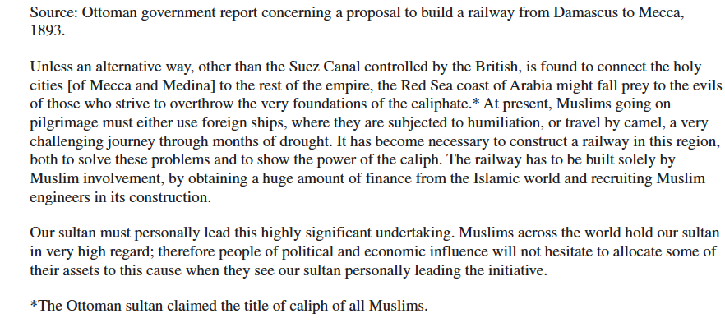

Document 3

Document 3
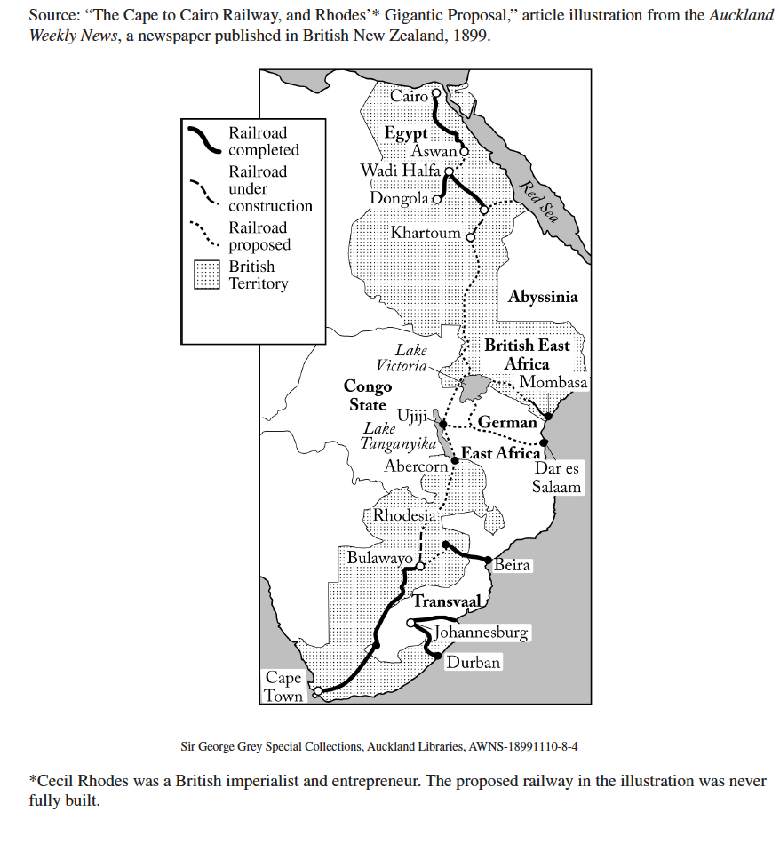

Document 4

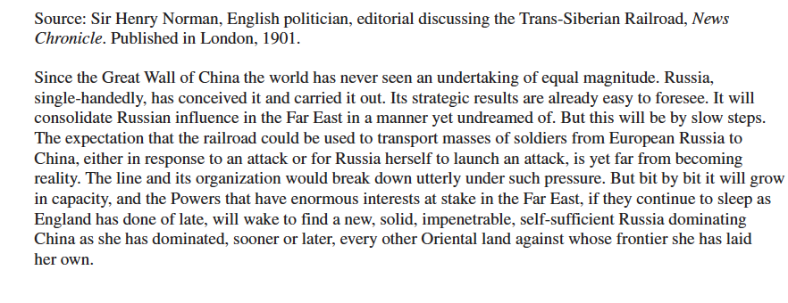

Document 5

