1. Evaluate the extent to which global migrations changed societies across the world from the nineteenth to early twentieth centuries.

Document 1

Source: From Henry Grimm, The Chinese Must Go: A Farce in Four Acts. San Francisco: Bancroft and Co., 1879
THE CHINESE MUST GO"
ACT I.
SCENE--A Kitchen; Sam Gin woshing dishes; Ah Coy smoking his opium pipe.
Ah Coy. I telly ^{you,} white man big fools; eaty too muchee, drinky too muchee, and talkee too muchee.
Sam Gin. white man catchee plenty money; chinaman catchee little money.
^{Ah Coy.} By and by white man catchee no money; Chinaman catchee heap money; Chinaman workee cheap, plenty work; white man workee dear, no work-sabee?
Sam Gin. He heep sabee.
Ah Coy. Chinaman plenty work, plenty money, plenty to eat. White man no work, no money, _{die-sabee?}
Sam Gin. Me heep sabee.
Ah Coy. White man damn fools; keep wifee and children--cost plenty money; Chinaman no wife, no children, save ^{plenty} money. By and by, no more white workingman in California; all Chinaman--sabee? (Enter Frank Blaine.)
Frank B. Damn such luck; can't borrow a cent to save my life. Money is getting as scarce as flies about ^{Christmas.} I must have some. Losing three games of billiards, one after the other, with this flat-footed Jack Flint is a shame. (To Ah Coy.) Why don't you work? Ah Coy. Your mother no payee me last month; no payee, no workee--sabee?
Frank B. How much does she owe you? Ah Coy. Six dollars. Frank B. All right, John; I get it for you. (Aside.) lf I squeeze the six dollars out _{of the old man that} Chinaman has to pay me commission, that's business (pulling Som Gin by the queue). Exit. Sam Gin. Damn hoodlum. What for you foolee me all the time?

Document 2
Source: Campaign speech by Alfred Deakin in 1903 (Deakin went on to become Australias second prime minister following the 1903 election)
In this theatre, two and-a half years ago, I laid special stress upon the white Australia policy of the Government. (Applause) After that there was a fierce conflict in Parliament as to whether the means we proposed to exclude the undesirable and colored aliens would suffice. There were those who wished that on the face of the statute the prohibition against them should appear in so many words.
We believed that we studied Australian interests, and also lessened the difficulties of the mother country, if, instead of saying in so many words they should be excluded, we placed in the hands of the Government an educational test which could be applied so as to shut out all undesirables. We have had two years’ experience of the working of our test, and it has worked well. You have seen from time to time how few have managed to survive it. The returns for the last nine months show that 31,000 persons entered Australia from over sea, 28,000 being Europeans. Of the remainder, many of the colored persons came to Australia to engage on pearling vessels. The arrangement we have made is that they land only to sign their articles. A guarantee is taken from those who bring them that, when their time is up, they shall leave the country. By this means they never really enter Australia. They merely fish in our waters or just outside them.

Document 3
Source: Doyers Street in New York City Chinatown, 1909.
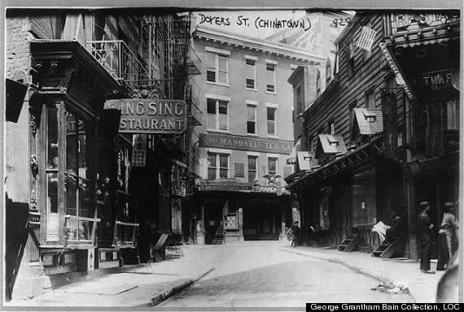

Document 4
Source: Pierre Denis, Italian Laborers on a Coffee Plantation in Brazil, 1911

The Italian element was increasing with such rapidity that they despaired of ever assimilating it. On various occasions the Government has attempted to limit, in the contracts signed with immigration agents, the proportion of immigrants of Italian blood. But these fears had no foundation. As far as I could discover there is no “Italian peril” in San Paolo. I cannot remember to have remarked, in any Italian established in San Paolo, the slightest tendency to resist assimilation, or the least conscious animosity against Brazil as a nation. All those who are not swallowed up by the plantations, but who settle in the towns, become quickly nationalized, overpowered by an atmosphere in which the Brazilian is naturally dominant. Even those who work on the fazendas learn Portuguese rapidly and willingly.

Document 5
Source: A Syrian bazar (marketplace or shopping quarter) in Sao Paulo, bears the multi-ethnic name Sarruf and Stephano, Ltd.

