Evaluate the extent to which the methods used by rulers to legitimize their authority were similar in the period 1450-1750 CE.

Document 1

Source: Reports from Venetian merchants from the Safavid Empire during the early reign of Shah Ismail, c1502 CE

“…after Ismail’s first victory, the members of his sect flocked to join him because in their books they found it foretold that a prophet of their religion would come and they must support and exalt him…everyone and particularly his soldiers consider [Ismail] immortal,…[and that he is seen] as the holy of holies, full of divinatory power, for he takes counsel from no one…his every act is divine-inspired.”

Document 2

Source: Drawing titled “Panorama of Constantinople (Sheet 8, 1559)” by Danish artist Melchior Lorck, during his travel around the Ottoman Empire from 1555 to 1559

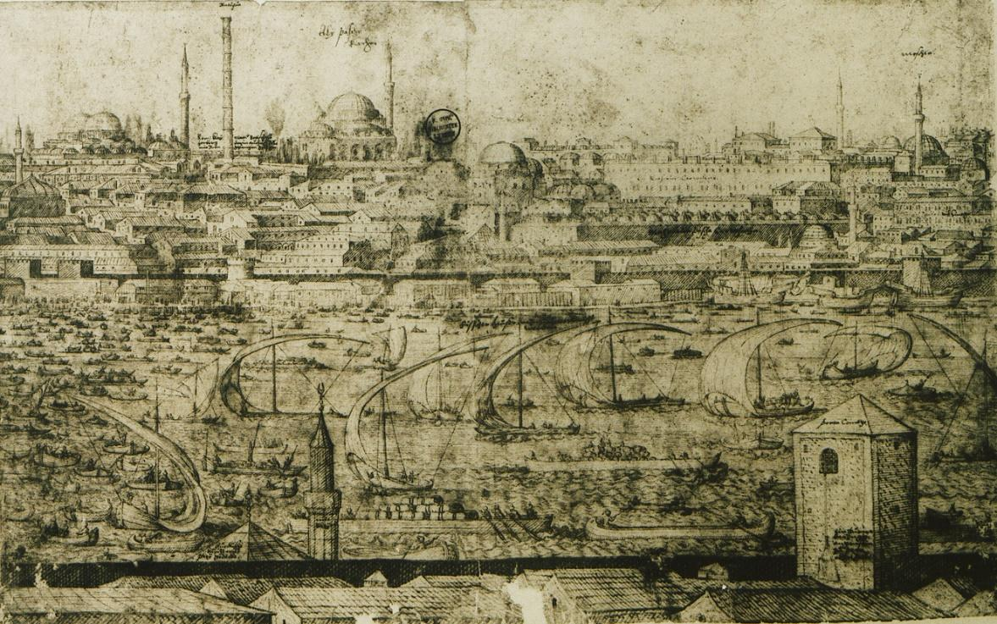

Document 3

Source: James I (of Scotland) and IV (of England) in a speech to the English Parliament c1610 CE

. . .The state of monarchy is the supremest thing upon earth, for kings are not only God's lieutenants upon earth and sit upon God's throne, but even by God himself they are called gods. There be three principal [comparisons] that illustrate the state of monarchy: one taken out of the word of God, and the two other out of the grounds of policy and philosophy. In the Scriptures kings are called gods, and so their power after a certain relation compared to the Divine power. Kings are also compared to fathers of families; for a king is truly parens patriae [parent of the country], the politic father of his people. And lastly, kings are compared to the head of this microcosm of the body of man . . .
I conclude then this point touching the power of kings with this axiom of divinity, that as to dispute what God may do is blasphemy . . . so is it sedition in subjects to dispute what a king may do in the height of his power. But just kings will ever be willing to declare what they will do, if they will not incur the curse of God. I will not be content that my power be disputed upon, but I shall ever be willing to make the reason appear of all my doings, and rule my actions according to my laws . . .

Document 4

Source: Reception of Le Grande Condé by Louis XIV at Versailles in 1674, a painting by Jean-Léon Gérôme, 19th century painter, depicting the French nobility made to reside at the Palace of Versailles during the reign of Louis XIV (1643-1715 CE).
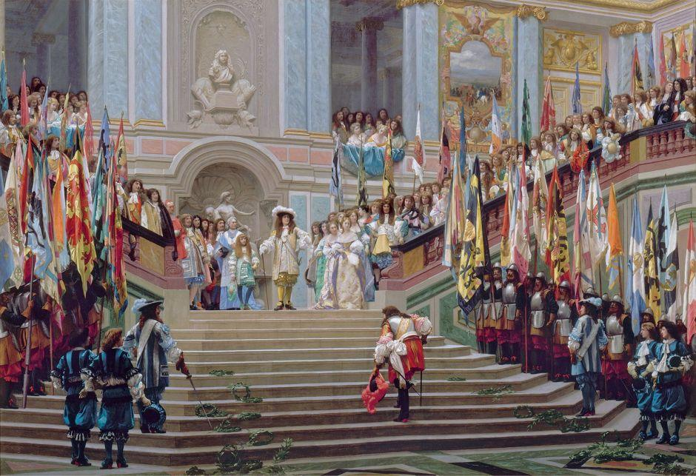

Document 5

Source: Emperor Kangxi (r. 1661 to 1722), the second Qing emperor, “On Ruling”, part of Kangxi’s autobiographical reflections on leadership.

Talent does not depend of geographical location. Even in the mountain wilderness how can there be no one with ability? Have the talented ever chosen where they were to be born? … When a person is truly good, then one should use him and promote him … regardless of whether he has advanced degrees….

The Doctrine of the Mean says: “The superior man does what is proper to the station in which he is; he does not go beyond this. In a high situation, he does not treat with contempt his inferiors. In a low situation, he does not court the favor of his superiors. He rectifies himself, and seeks for nothing from others, so that he has no dissatisfaction. He does not murmur against Heaven nor grumble against man. Thus it is that the superior man is quiet and calm, waiting for the appointments of Heaven, while the mean man walks in dangerous paths, looking for lucky occurrences.”

