Below is a list of the members of Biden’s Cabinet. For each person in the position, provide a brief summary of the job that office is responsible for. Also explain the person’s background, and your opinion on weather or not this individual is qualified to do this job.

Your paper should look something like this
- Office, and name of cabinet member
- Summary of what goes on there:
- Why does this person have this position?
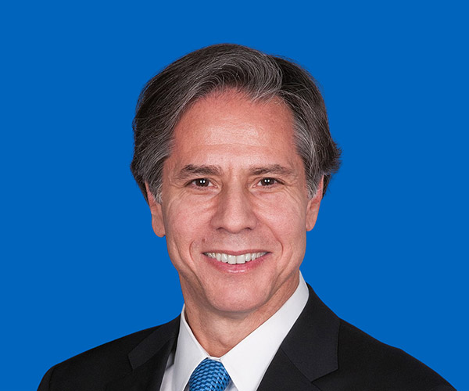

Antony Blinken

SECRETARY OF STATE


Dr. Janet Yellen

SECRETARY OF THE TREASURY
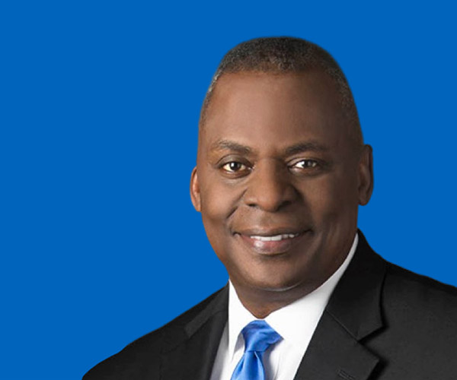

Lloyd Austin

SECRETARY OF DEFENSE
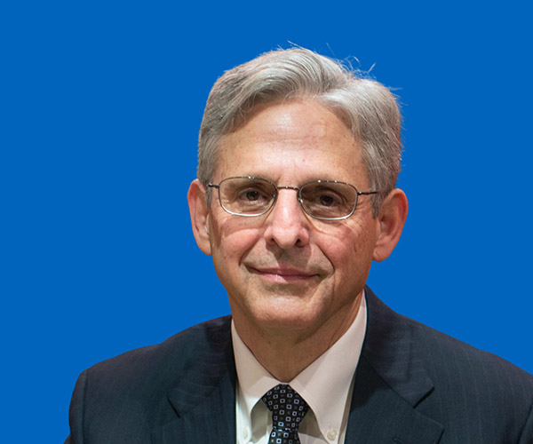

Merrick Garland

ATTORNEY GENERAL
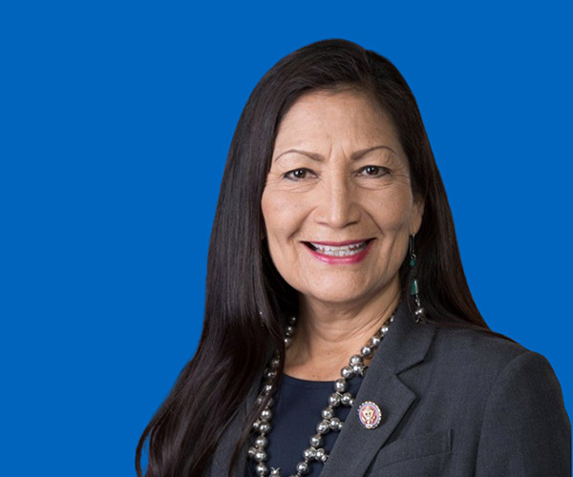

Deb Haaland

SECRETARY OF THE INTERIOR
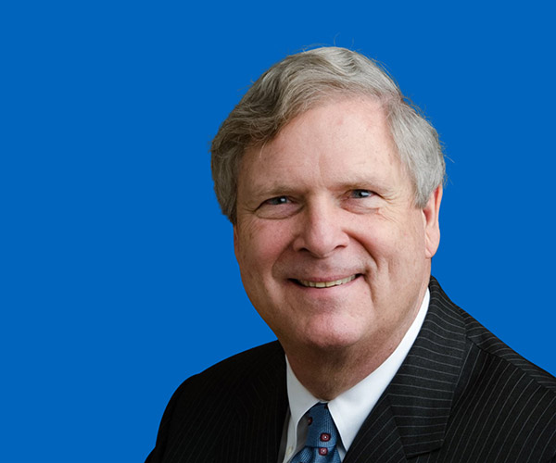

Tom Vilsack

SECRETARY OF AGRICULTURE
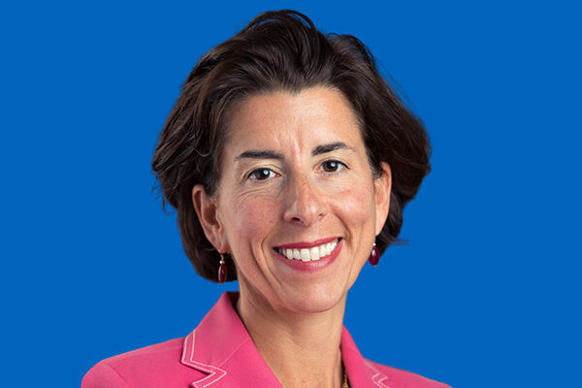

Gina Raimondo

SECRETARY OF COMMERCE
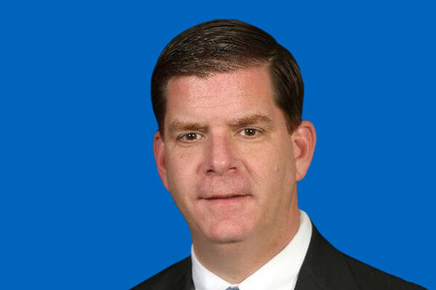

Marty Walsh

SECRETARY OF LABOR
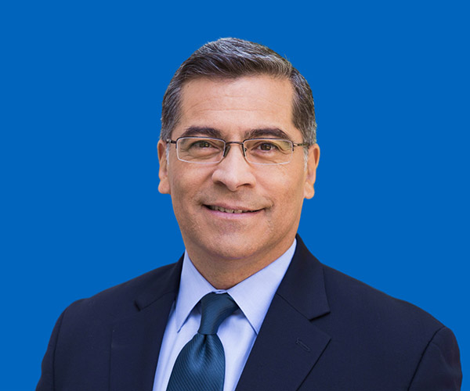

Xavier Becerra

SECRETARY OF HEALTH AND HUMAN SERVICES
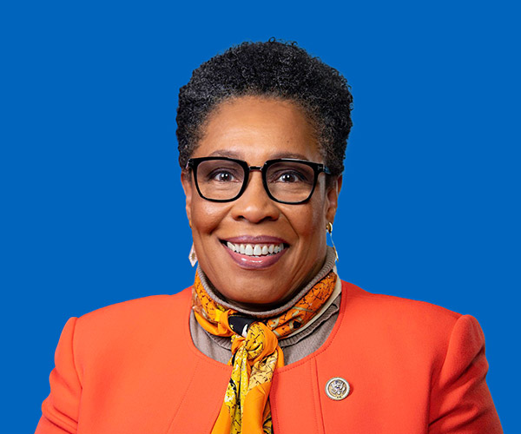

Marcia Fudge

SECRETARY OF HOUSING AND URBAN DEVELOPMENT
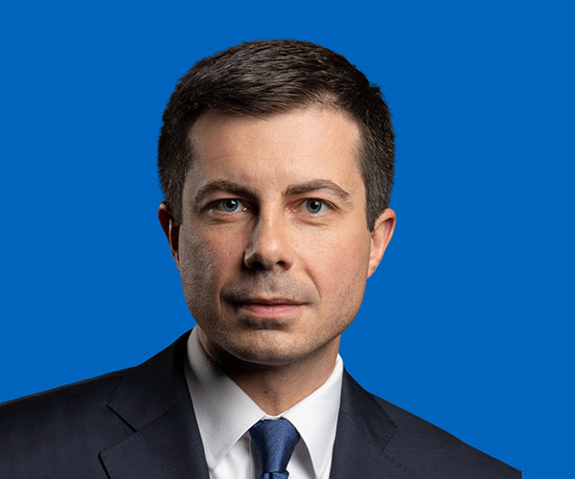

Pete Buttigieg

SECRETARY OF TRANSPORTATION
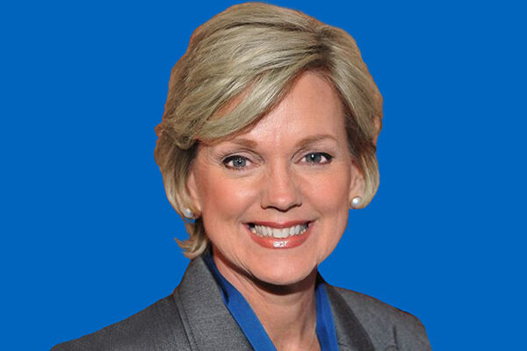

Jennifer Granholm

SECRETARY OF ENERGY
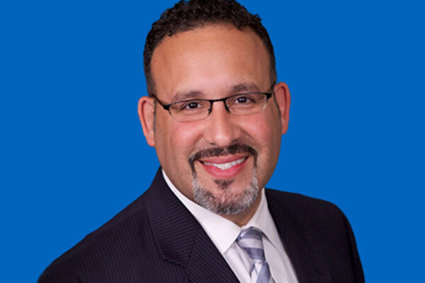

Dr. Miguel Cardona

SECRETARY OF EDUCATION
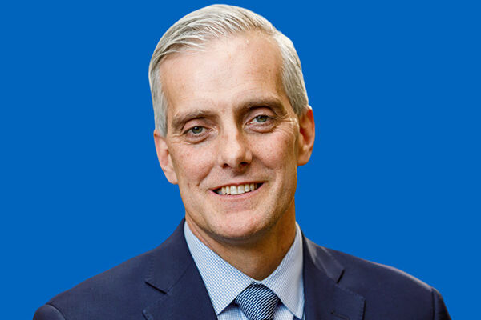

Denis McDonough

SECRETARY OF VETERANS AFFAIRS
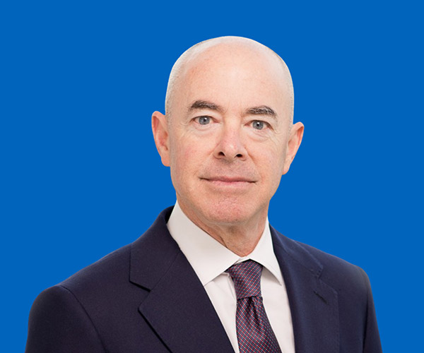

Alejandro Mayorkas

SECRETARY OF HOMELAND SECURITY
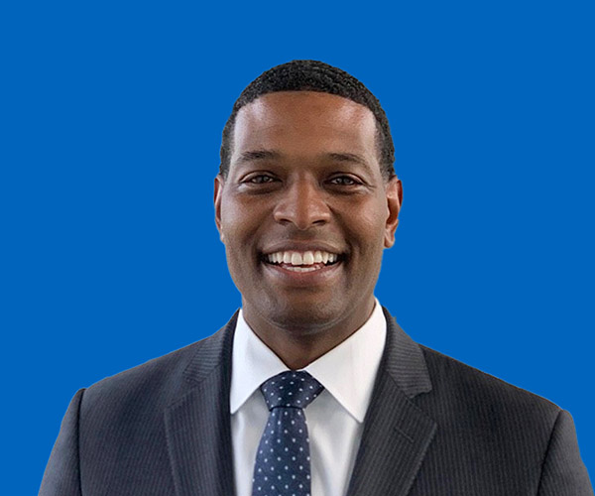

Michael Regan

ADMINISTRATOR OF THE ENVIRONMENTAL PROTECTION AGENCY
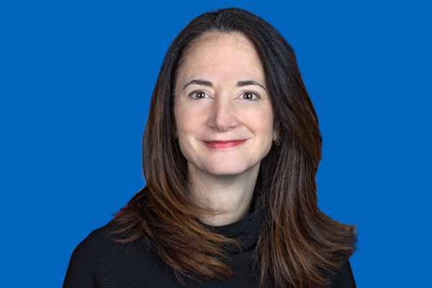

Avril Haines

DIRECTOR OF NATIONAL INTELLIGENCE
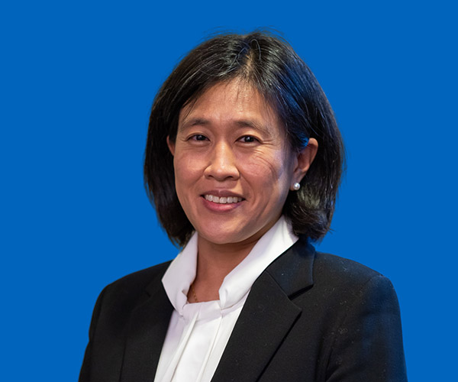

Katherine Tai

UNITED STATES TRADE REPRESENTATIVE
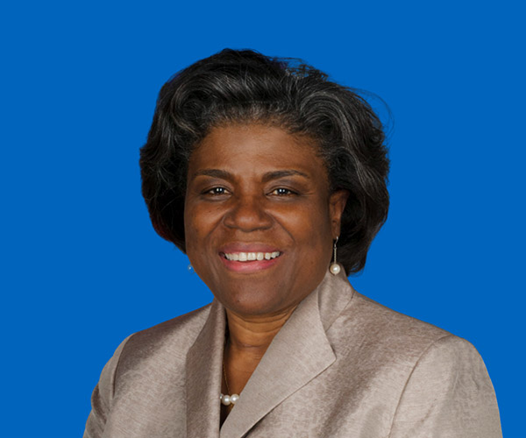

Linda Thomas-Greenfield

UNITED STATES AMBASSADOR TO THE UNITED NATIONS
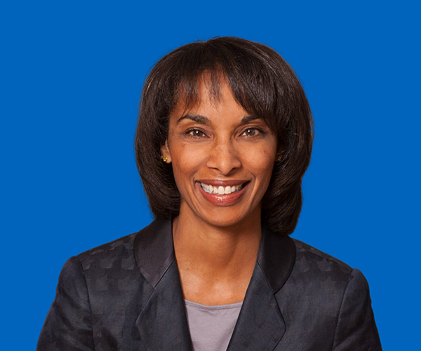

Dr. Cecilia Rouse

CHAIR OF THE COUNCIL OF ECONOMIC ADVISERS
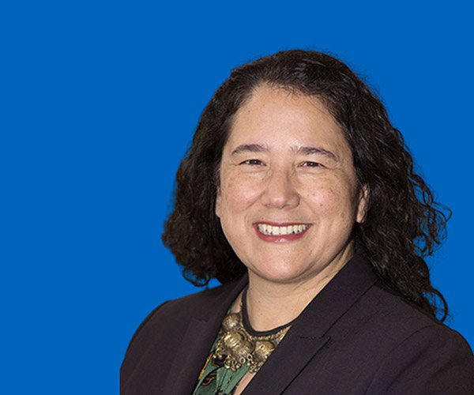

Isabel Guzman

ADMINISTRATOR OF THE SMALL BUSINESS ADMINISTRATION


Dr. Eric Lander

PRESIDENTIAL SCIENCE ADVISOR AND DIRECTOR OF THE OFFICE OF SCIENCE AND TECHNOLOGY POLICY
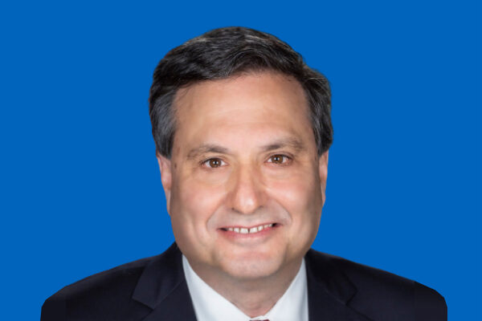

Ron Klain

CHIEF OF STAFF

