CLASSIFICATION & DICHOTOMOUS KEY ACTIVITY

Background
You constantly use systems of classification in everyday life. For example, you are classified by year in school, your age, and city. Articles of clothing or products in grocery stores are examples of items that are classified for ease in handling.

Taxonomy is the area of biology dealing with classification of different organisms. The value of a classification system to science is threefold. First, it shows relationships among organisms by grouping together living things that have similar characteristics. Second, the last two divisions of the classification system give the scientific name for each organism. Third, the two-word name of an organism in the classification system is the same worldwide.

Group names have been established to simplify the complex process of classifying living things. For example, the largest group is referred to as a domain. Each domain is divided into smaller groups called kingdoms. Each kingdom is divided into several smaller groups called phyla (singular - phylum). After successive divisions into smaller and smaller groups, the genus and species are reached. Each living thing is named by its genus and species (scientific name).

Classification of organisms helps biologists identify and understand the organisms on the earth. However, the information must be organized for easy use if it is to be of any value. Can you imagine trying to use a dictionary in which the words are not listed in alphabetical order?

In biology, we frequently want to know what kind of organism we have found. Among the best classification aids are dichotomous keys. This key is a listing of specific characteristics, such as structure and behavior, in such a way that an organism can be identified. Perhaps you have used a field guide to identify birds or flowers. A beginner may just flip through the key, randomly looking at the pictures. Many birds and flowers have been successfully identified in this manner. However, there is a high risk of error. You certainly would not want to use the random hit-or-miss method to identify poisonous plants! This method is not accurate enough to detect certain details, which may be important in distinguishing between similar species, so the dichotomous key is used.

A phylogenetic tree is a diagram that represents evolutionary relationships among organisms. The branching pattern in a phylogenetic tree reflects how species or other groups evolved from a series of common ancestors. Two species are more related if they have a more recent common ancestor (branch point) and less related if they have a less recent common ancestor branch point).

Purpose
In this investigation you will:

Part A • prepare a classification key for some common objects • place these objects into domains, kingdoms, phyla and classes • give names to each domain, kingdom, phylum and class

Part B • use a dichotomous (taxonomic) key to identify fish
Part C • explore how to read a cladogram

Materials
Part A: comb / crayon / drinking straw / greeting card / paper clip / pencil /
penny / push pin / refrigerator magnet / ribbon / rubber band / ruler /
scissors / scrunchie / sewing needle / spool of thread / sticky note (Post-it)
tissue (Kleenex) / tooth pick / tweezers
Part B: https://fergusonfoundation.org/btw-students/fish-identification/
Part C: https://learn.genetics.utah.edu/content/evolution/diagrams
https://learn.genetics.utah.edu/content/evolution/evidence/

Safety Cautions WASH YOUR HANDS!

Procedure Part A (THIS ACTIVITY IS OPTIONAL)
• Look around your house and gather everything listed in Part A Materials. If you do not have the object, choose something else to replace it. Be certain you have 20 objects. Call this entire group “House” Domain.
• Place all the objects into two groups. You decide which characteristic to use as a basis for separating your two groups. To begin, call them Group 1 and Group 2. Equal numbers of objects do not have to be in each group.
• On your answer sheet answer the following questions:
1) List the objects that you placed into Group 1. List the objects that you placed into Group 2.
2) What characteristic did you use as basis for placing objects in Groups 1 & 2?
3) Using the characteristics you chose, decide on an appropriate but brief name for Group 1 and Group 2. The name should describe the trait you used (examples – Red Group / Blue Group, or Hard Group / Soft Group).
• If these had been living things, you would place them into groups called kingdoms. Many biologists group living things into kingdoms such as - Protists, Fungi, Plants and Animals.
• Return to objects that belong in Group 1. Divide these objects again into two new groups based on certain characteristics. Equal numbers of objects do not have to be in each group. Refer to these two new groups as Group 1A and Group 1B.
• On your answer sheet answer the following questions:
4) List the objects placed into Group 1A. List the objects placed into Group 1B.
5) What characteristic did you use as a basis for placing objects in each group?
6) Decide on an appropriate name for Group 1A and Group 1B.
• If these were living things, they would be placed into groups called phyla (singular - phylum). Your answers to question 6 are phylum names. There can be many phyla in each kingdom.

• Take the objects of Group 2 and divide them again into three separate phyla. You decide what to use as a basis for separating the three groups. Equal numbers of objects do not have to be in each group. Refer to these groups as Group 2A, Group 2B, and Group 2C.
• Decide on appropriate names that describe each of the three groups.
• On your answer sheet answer the following questions:
7) List the objects placed into Group 2A. List the objects placed into Group 2B. List the objects placed into Group 2C.
8) What characteristic did you use as a basis for placing objects in each group?
9) Decide on an appropriate name for Group 2A, Group 2B and Group 2C.

• Objects in each phylum can be separated further into groups called classes. Each phylum may have several classes.
• Finally, take each of the phyla you created for both Group 1 and Group 2 and further divide each phyla into classes. You decide how many classes for each phyla and what characteristics to use as a basis for separating the phyla. Decide on appropriate names that describe each of the new groups you created.
• Answer the following questions on your answer sheet:
10) List the objects placed into your new groups (classes).
11) What characteristic did you use as a basis for placing objects in each class?
12) Decide on an appropriate name for your new classes.

• On your answer sheet, construct a tree diagram of your classification system.
DO NOT WRITE NAMES OF OBJECTS YET. Begin like this:

House Domain

Group 1 (Kingdom) Group 2 (Kingdom)

Gr.1A Gr.1B Gr.2A Gr.2B Gr.2C

Now add the names of each class under your group names.
THEN LIST OBJECTS UNDER THE CLASS NAMES.
• If you were to continue classifying the objects, new group names would appear. For example, classes are broken down into orders, orders into families, families into genus, and genus into species. Thus, the classification of living things is domain, kingdom, phylum, class, order, family, genus, species.

Procedure Part B (MANDATORY ACTIVITY)
Using a taxonomic key is easy once you understand how the key is constructed. A common type of taxonomic key is called dichotomous which means “divided into two parts.” The dichotomous key is designed to divide a group of organisms into two smaller groups. Each group is then subdivided into two more groups, and so on, until each individual species stands alone.
At each step you are faced with two alternatives. The choice you make eliminates some members of the group. Finally, when you have eliminated all the other members in the group, you have isolated one organism. This should be the organism you are looking for.
Dichotomous keys often give the scientific name of the organism. Remember that the scientific name has two parts the Genus name and the species name. The Genus name is like your last name and shows which other species it may be related to.
• Go to this website which shows freshwater fish in the Washington DC area.
https://fergusonfoundation.org/btw-students/fish-identification/
• When you click on a fish, you will begin the identification key for each fish. Pay attention to the boxes in the upper right corner. This will help you decide which choice to pick. There are always two alternatives. Each time you make a choice, you are directed to the next step.
• Click on FISH 1. Observe it closely, then follow the directions on the key. You will get an error message if you click on the wrong choice.
• When you have finished the key you will get a message with the common name of the fish. Now click blue arrow to find the scientific name of the fish.
• Write fish number and scientific name of each fish on your answer sheet.
• Click blue arrow again and continue until you have scientific names of all 10 fish.

Procedure Part C (MANDATORY ACTIVITY)
Tree diagrams are a way for scientists to organize information about different species to show how they are related and if the have a common ancestor. Tree diagrams can be made in several ways. One way is called a phylogenetic tree, which uses lines that branch off to show evolution of different species. This tree diagram represents evolutionary relationships among organisms. The branching pattern in a phylogenetic tree reflects how species evolved from a series of common ancestors.
• Examine figure 1 below to review how to read a phylogenetic tree:
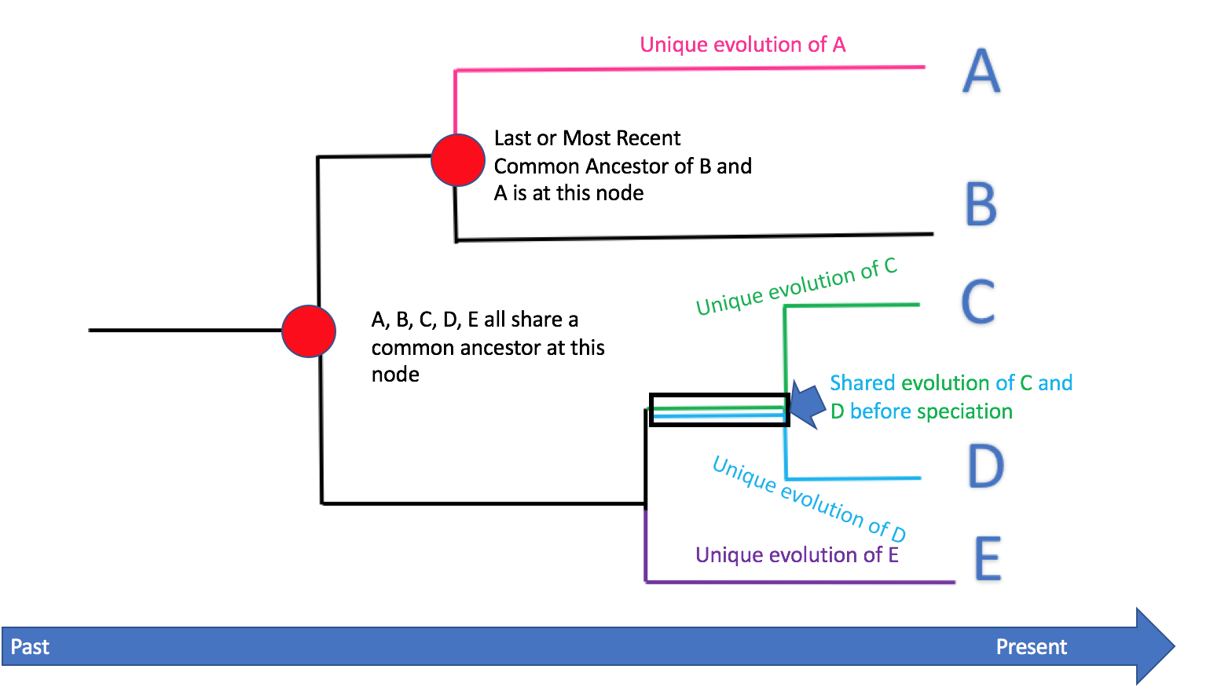
figure 1
A second type of tree diagram is called a cladogram. Cladograms also show related organisms, but unlike phylogenetic trees, the organisms are arranged in the order their traits evolved. Cladograms always have 2-way branch points that separate at the point a specific characteristic appears.
• Go to this website https://learn.genetics.utah.edu/content/evolution/diagrams
• Click PLAY arrow at bottom left. Stop the video to write answers to these questions in your lab folder:
1) What do the branches on a tree diagram represent?
2) What does the base of a cladogram represent?
3) What do the organisms at the end of branches represent?
4) How many reproductive lineages are shown on this cladogram?
5) Each branch splits off due to differences in…?
6) How many branch points are on this cladogram?
7) Do the branch points represent a common ancestor?
8) If an organism has many traits in common with a different organism, do the two organisms have a common ancestor?
9) Can tree diagrams be redone if new information is found?
• Go to this website
https://learn.genetics.utah.edu/content/evolution/evidence/
• Click BEGIN. Click ANCESTRY OF LAND PLANTS. Click ARROW to advance slide and answer these questions:
1) What is the ancestor of land plants?
2) Were the first land plants tall or short?
3) Have some plants from 400 million years ago become extinct?
4) When did the first plants with seeds appear?
5) How are the seeds of flowering plants protected?
6) Flowering plants are most closely related to which other type of plant?
• Click MAIN MENU. Click TIKTAALIC. Click ARROW to advance slide and answer these questions:
7) Tiktaalic is related to which two animal groups?
8) Do fish and amphibians share a common ancestor?

Clean-up Return all materials to the proper place in your house.

Answers to Classification Activity – Should be emailed to Miss Ferguson by Sunday, April 19th at 11:59 pm.
RECAP:
PART A Write the names of your domain, kingdom, phyla, classes. Next, list all the objects under each class. (OPTIONAL)
PART B Write the scientific names of all the fish. List the two fish that are the most closely related. How did you decide?
PART C Answer the questions.

