Name: __________________________________RG 17.1 Genes and Variation
Directions: Read Section 17.1 in your textbook. Then, answer the following questions.
Lesson Objectives
- Define evolution in genetic terms.
- Identify the main sources of genetic variation in a population.
- State what determines the number of phenotypes for a trait.

Lesson Summary
Genetics Joins Evolutionary Theory - Darwin’s original ideas can now be understood in genetic terms.
- Researchers discovered that traits are controlled by genes and that many genes have at least two forms, or alleles. The combination of different alleles is an individual’s genotype. Natural selection acts on phenotype, not genotype.
- Genetic variation and evolution are studied in populations. Members of a population share a common group of genes, called a gene pool.
- Allele frequency is the number of times an allele occurs in a gene pool compared with the number of times other alleles for the same gene occur. In genetic terms, evolution is any change in the allele frequency in a population.

Sources of Genetic Variation - The three main sources of genetic variation are mutations, genetic recombination during sexual reproduction, and lateral gene transfer.
- A mutation is any change in a sequence of DNA.
- Most heritable differences are due to genetic recombination during sexual reproduction. This occurs during meiosis when each chromosome in a pair moves independently. Genetic recombination also occurs during crossing-over in meiosis.
- Lateral gene transfer is the passing of genes from one organism to another organism that is not its offspring.

Single-Gene and Polygenic Traits - The number of different phenotypes for a given trait depends on how many genes control the trait.
- A single-gene trait is controlled by one gene. An example in snails is the presence or absence of dark bands on their shells.
- A polygenic trait is controlled by two or more genes, and each gene often has two or more alleles. An example of a human polygenic trait is height.

Genetics Joins Evolutionary Theory
Complete each statement by writing the correct word or words.
- Natural selection works on an organism’s rather than its .
- A(n) consists of all the genes, including the alleles for each gene, that are present in a population.
- A gene pool typically contains different for each heritable trait.
- The number of times that an allele occurs in a gene pool compared with the number of times other alleles for the same gene occur is called the of the population.

Use the circle graph of a sample mouse population to answer the following questions.
- In the diagram below, use circles to represent the alleles within each segment of the population. Draw the B alleles as solid circles and the b alleles as outline circles.
  - The total number of individuals in this population is ; the total number of alleles is .
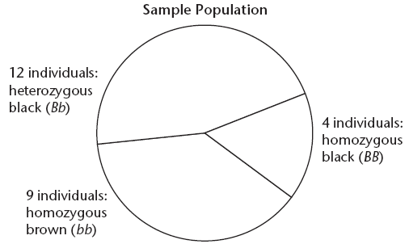

  - How many alleles for black fur are in the sample population and what percentage of allele frequency does that represent?

  - How many alleles for brown fur are in the sample population and what percentage of allele frequency does that represent?

  - Describe how a geneticist might be able to tell that this population is evolving.

  - Can you determine whether an allele is dominant or recessive on the basis of the ratio of phenotypes in the population? Explain your answer.

Sources of Genetic Variation
- What are mutations? When do they affect evolution?

- How does sexual reproduction affect a population’s genetic variation?

- Identify two ways in which genes can be recombined during meiosis.

- Why is genetic variation important to the process of evolution?
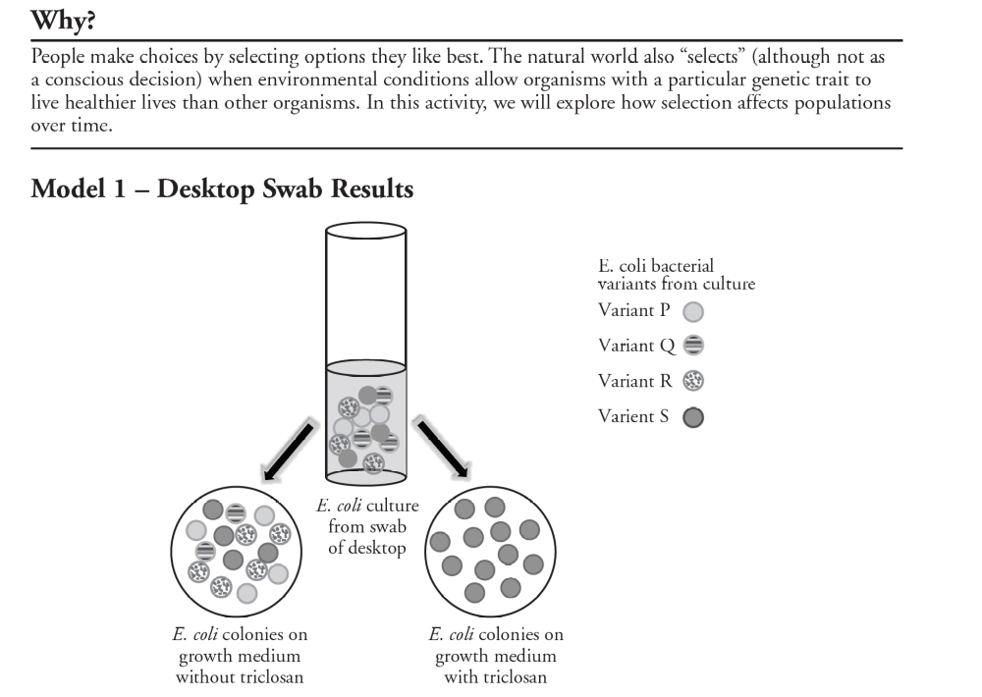

10. What is the source of the bacteria in the culture tube in Model 1?

11. How many genetic variants of E.coli were present in the culture from the initial swab?

12. What variants of E.coli are found on the dish grown without triclosan?

13. Refer to the dish in Model 1 with the medium that included triclosan.
a. What variants of E.coli are found on the dish grown with triclosan?

b. What likely happened to the other variants of E.coli on the dish with the medium containing triclosan?

14. Based on its effect on E.coli, why is triclosan used as a cleaning agent?

15. Suppose the desktop swabbed earlier was cleaned with a solution containing triclosan. Would living E.coli remain? Support your answer.

16. Suppose the desktop was swabbed again after cleaning it with triclosan over a 9-month school year. When the sample was cultured only variant S was seen.
a. What characteristic does the variant S bacteria have that allows it to remain on the desktop even after several months of treatment with triclosan?

b. Is it likely that the bacteria in the new swab were on the desk 9-months ago, or are they offspring of the original bacteria?

c. Propose an explanation for the presence of only variant S on the desktop after so much time.

