Biochemical Evidence for Evolution
This activity will use a portion of the Relationships and Biodiversity State Lab.

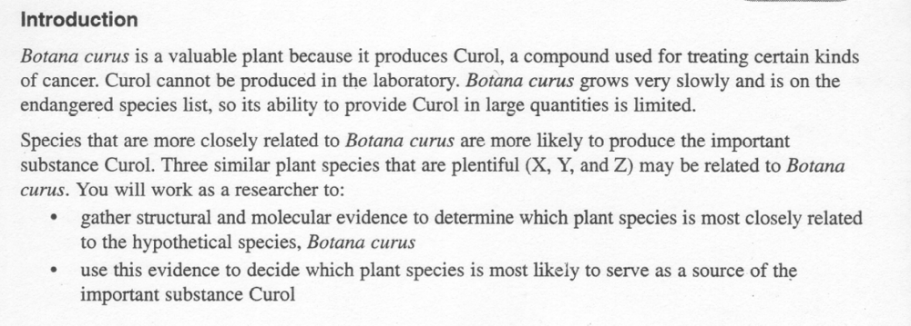

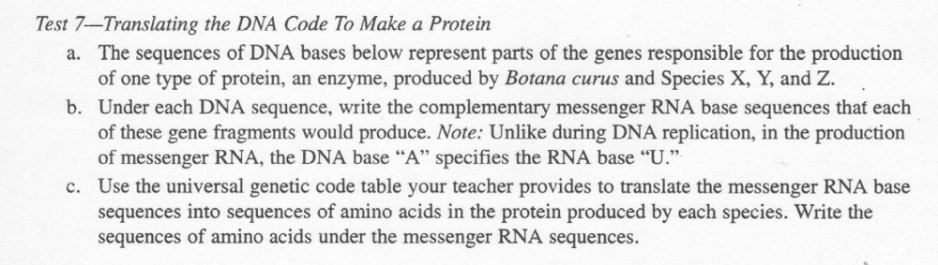

Complete the tables below, using the instructions above for Test 7. The amino acid conversion chart is on the next page.
Botana Curus
DNA Sequence | CAC | GTG | GAC | TGA | GGA | CTC | CTC
mRNA Sequence | GUG | CAC | CUG | ACU | CCU | GAG | GAG
Amino Acid Sequence | VAL | HIS | LEU | THR | PRO | GLU | GLU

Plant X
DNA Sequence | CAC | GTG | GAC | AGA | GGA | CAC | CTC
mRNA Sequence | GUG | CAC | CUG | UCU | CCU | GUG | GAG
Amino Acid Sequence | VAL | HIS | LEU | SER | PRO | VAL | GLU

Plant Y
DNA Sequence | CAC | GTG | GAC | AGA | GGA | CAC | CTC
mRNA Sequence | GUG | CAC | CUG | UCU | CCU | GUG | GAG
Amino Acid Sequence | VAL | HIS | LEU | SER | PRO | VAL | GLU

Plant Z
DNA Sequence | CAC | GTA | GAC | TGA | GGA | CTT | CTC
mRNA Sequence | GUG | CAU | CUG | ACU | CCU | GAA | GAG
Amino Acid Sequence | VAL | HIS | LEU | THR | PRO | GLU | GLU

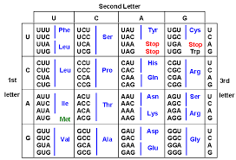

1. Do all the plants have the same DNA sequence for this protein? Explain why that is.
No, they do not. All plants, even members of the same species (unless they are the result of asexual reproduction) are going to have variations, or differences, in their DNA. These variations result from mutations or through recombination of genes through sexual reproduction.

2. What do you look for in a DNA or amino acid sequence of two different species to decide whether or not they are closely related?

You would look for similarities in the base pairs of DNA or the amino acid sequence. The closer the similarities are, the more closed related the species.

3. Based on molecular evidence, which Plant (X,Y,or Z) is most closely related to Botana curus? Explain your choice.

Plant Z – even though there were some differences in the DNA compared to Botana curus, it had the same amino acid sequence. Both plants X and Y had 2 differences in their amino acid sequences.

