Biochemical Evidence for Evolution
This activity will use a portion of the Relationships and Biodiversity State Lab.

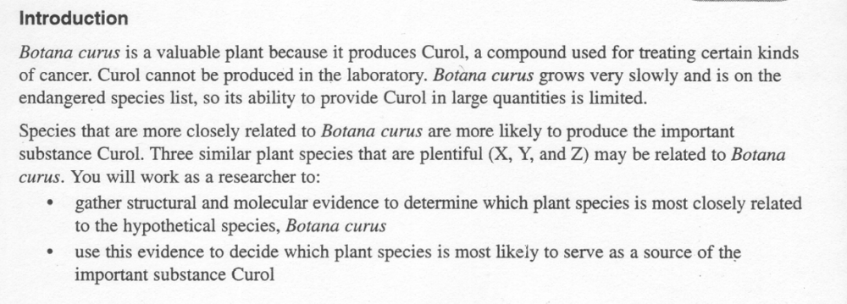

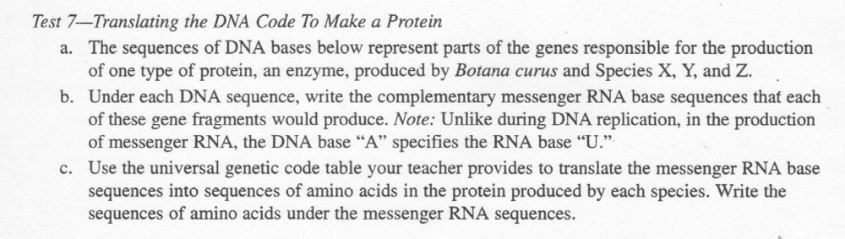

Complete the tables below, using the instructions above for Test 7. The amino acid conversion chart is on the next page.
Botana Curus
DNA Sequence | CAC | GTG | GAC | TGA | GGA | CTC | CTC
mRNA Sequence
Amino Acid Sequence

Plant X
DNA Sequence | CAC | GTG | GAC | AGA | GGA | CAC | CTC
mRNA Sequence
Amino Acid Sequence

Plant Y
DNA Sequence | CAC | GTG | GAC | AGA | GGA | CAC | CTC
mRNA Sequence
Amino Acid Sequence

Plant Z
DNA Sequence | CAC | GTA | GAC | TGA | GGA | CTT | CTC
mRNA Sequence
Amino Acid Sequence

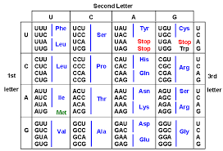

1. Do all the plants have the same DNA sequence for this protein? Explain why that is.

2. What do you look for in a DNA or amino acid sequence of two different species to decide whether or not they are closely related?

3. Based on molecular evidence, which Plant (X,Y,or Z) is most closely related to Botana curus? Explain your choice.

