Name: __________________________________________________ Evolution Assignment 4

Evidence for Evolution
Directions: Read Section 16.4 in the text. For each of the terms listed below, summarize in 1-2 sentences how each provides evidence to support the theory of evolution.

- Fossil Record - This supports Darwin's theory of evolution, which states that simple life forms gradually evolved into more complex ones. Evidence for early forms of life comes from fossils. By studying fossils, scientists can learn how much (or how little) organisms have changed as life developed on Earth.

- Biogeographical Evidence - Biogeography describes the distribution of lifeforms over geographical areas, both in past and present times. Biogeographical distribution supports the theory of evolution as it is found that closely related species are usually found in close physical proximity to one another, and that fossils from these regions resemble modern organisms. This suggests that these species share a common lineage (if speciation was random, distribution would be expected to be scattered). Examples of biogeographical distribution indicating shared ancestry can be seen in the fact that: Most modern marsupials are found almost exclusively in Australia (~ 70% of the extant species). Australian has few placental mammals compared to South America, even though environmental conditions are similar between the two regions

- Anatomical Structures - Homologous structures possess a similar underlying anatomy as a result of a shared evolutionary origin but have evolved into a variety of distinct forms due to the presence of different selective pressures. An example is the pentadactyl limb structure in vertebrates, whereby many animals show a common bone composition, despite the limb being used for different forms of locomotion (e.g. whale fin for swimming, bat wing for flying, human hand for manipulating tools, horse hoof for galloping, etc.)

Vestigal Structures - Some organisms show the presence of functionless and reduced remnants of organs that were once present and functional in their ancestors. Changes to the environment have rendered these organs redundant and so over time they have lost their functionality. These structures are called vestigial organs and demonstrate the evolutionary divergence of a species from a past behavior or activity.
An example of a vestigial organ is the pelvic bone in a whale - this bone serves no current purpose and is a remnant of a time when whales were terrestrial mammals
- Embryology - Studying the growing embryo in animals and plants shows that closely related organisms go through similar stages of development. All terrestrial animals have non-functional gill slits (pharyngeal slits) as early embryos (indicating an aquatic origin). Many vertebrates (including humans) demonstrate a primitive tail at certain stages of embryonic development.

- Biochemical Evidence - Molecular evidence involves identifying conservation in DNA and protein sequences as a basis for determining evolutionary relationships. The more similar DNA sequences, amino acid sequences (proteins), or pigments are, the more closely related the species are to each other. It also indicates that they have a more recent common ancestor.

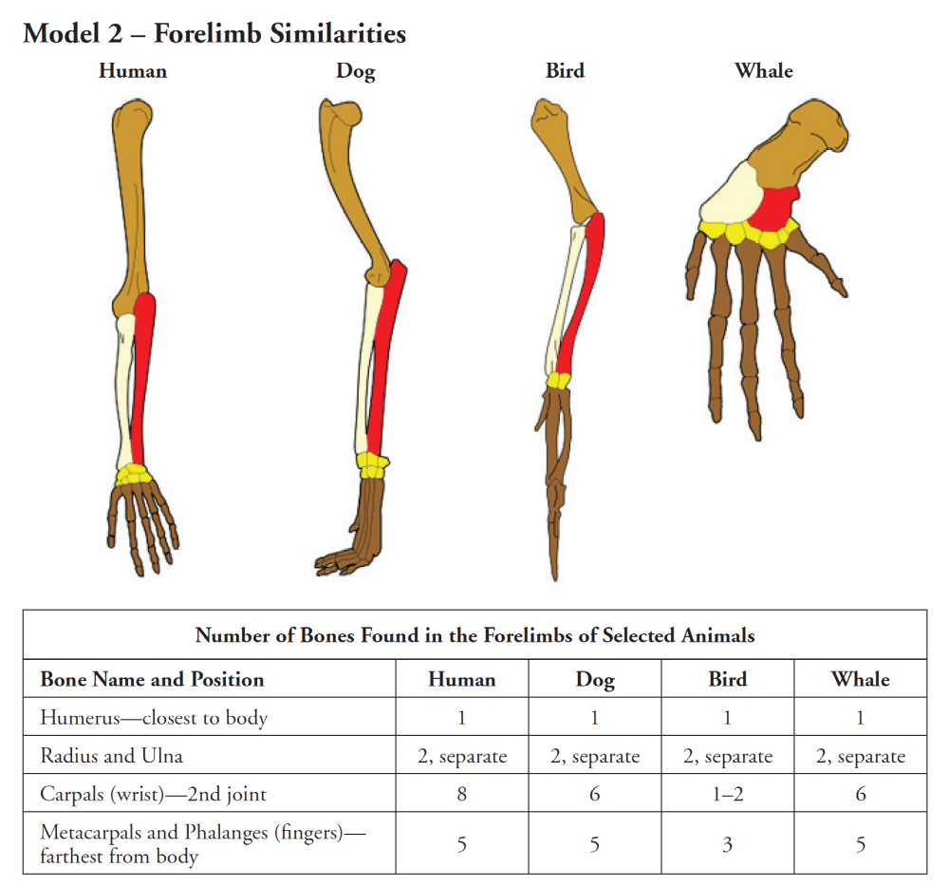

- Label the bones in each animal forelimb in Model 2.
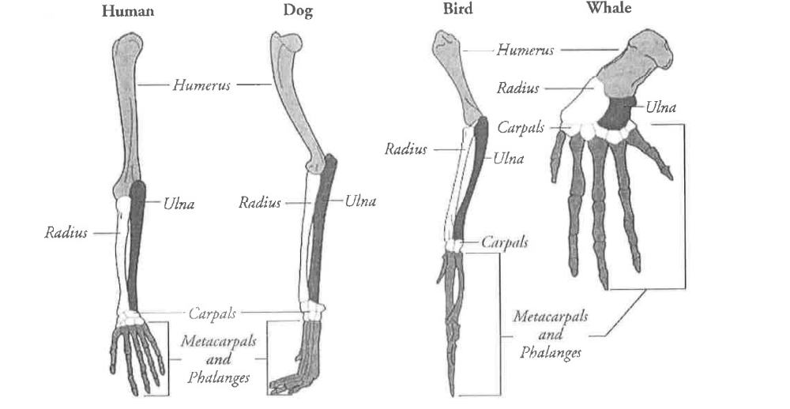

7. List the variety of ways in which the organisms in the table use their forelimbs.

8. Model 2 shows several homologous structures. These are limbs or body parts that are similar in structure due to shared ancestry, but that may be or may not be similar in function.
a. List two or more similarities in the bone structure of the four animals shown.

b. List three or more differences in the bone structure of the four animals shown.

9. Describe the location of the “blue print” that determines the structure of each of these forelimbs as the organism develops from embryo to infant.

10. What do the similarities among the forelimb bone arrangement of these diverse animals imply about their ancestry?

11. Which two animals in Model 2 would you predict have the most DNA sequences in common? Explain.

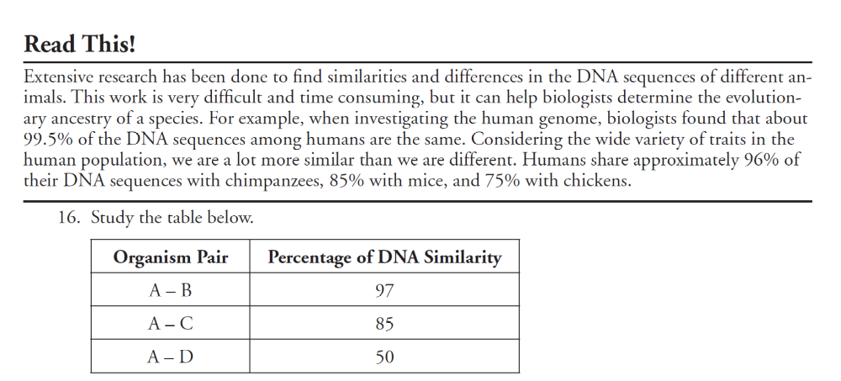

12 a. To which organism, B, C or D, is organism A most closely related? Support your answer.

b. Which pair of organisms in the table is least closely related? Support your answer.

c. Which pair of organisms most likely shares a recent common ancestor? Support your answer.
Pair A-B (95% identical)

13. Suppose another organism, organism X, is discovered. Suggest how scientists would use DNA comparison to classify organism X?

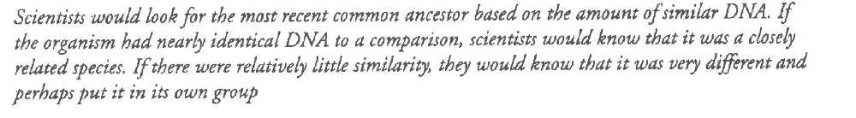

REVIEW: Color Variation in Moths

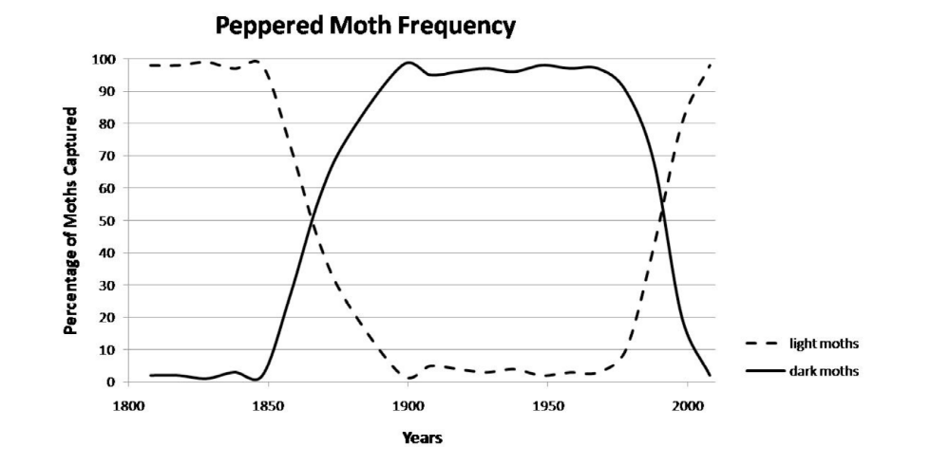

14. Describe the change in the number of light colored moths over the whole time period shown.

15. Describe the change in the number of dark colored moths over the whole time period shown.

16. Describe the change in the numbers of light colored moths and dark colored moths between
1850 and 1900.

17. Describe the change in the numbers of light colored moths and dark colored moths between
1950 and 2000.

18. During the Industrial Revolution and up through the mid-20th century, factories and power
plants which burned coal produced large quantities of soot and smog. Near industrialized areas,
black powder covered surfaces, including the moth habitat.
a. Which color moth would have a better chance of surviving predation on this dark
surface?

b. How does this help explain the change in the colors of the moth population shown in
Model 2?

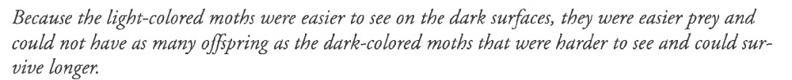

19. Clear Air Acts were passed by governments of industrialized nations beginning in the mid-
1950s.

20.Use this information to explain why the color of the moth population shifted again.

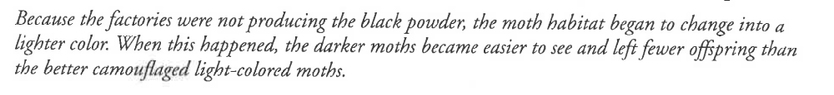

21. In one or two grammatically correct sentences, summarize how the environment influenced the color of the moth population in this area of Great Britain.

The color of the trees was the selecting agent that influenced the frequency of the color of the moth populationin Great Britain. When pollution levels were high, the tree color was darker from the soot. The dark color of the moth was the favorable adaption. They were less likely to be seen and eaten by predators, such as birds. As a result, the frequency of dark moths were high and light colored moths (who had a better chance of being seen and eaten) were low. As thedark colored moths had a better chance of survival, more of them lived to reproductive age and were able to pass on the gene for dark colration to their offspring.
When pollution controls were more recently put into place, the tree color turned lighter. This change in the environment favored the trait of light coloration in moths. As a result, for the same reasons explained above, the light colored moths increased in frequency and the darker moths declined in the population.

