Name: __________________________________________________ Evolution Assignment 4

Evidence for Evolution
Directions: Read Section 16.4 in the text. For each of the terms listed below, summarize in 1-2 sentences how each provides evidence to support the theory of evolution.

- Fossil Record

- Biogeographical Evidence

- Anatomical Structures

- Embryology

- Biochemical Evidence

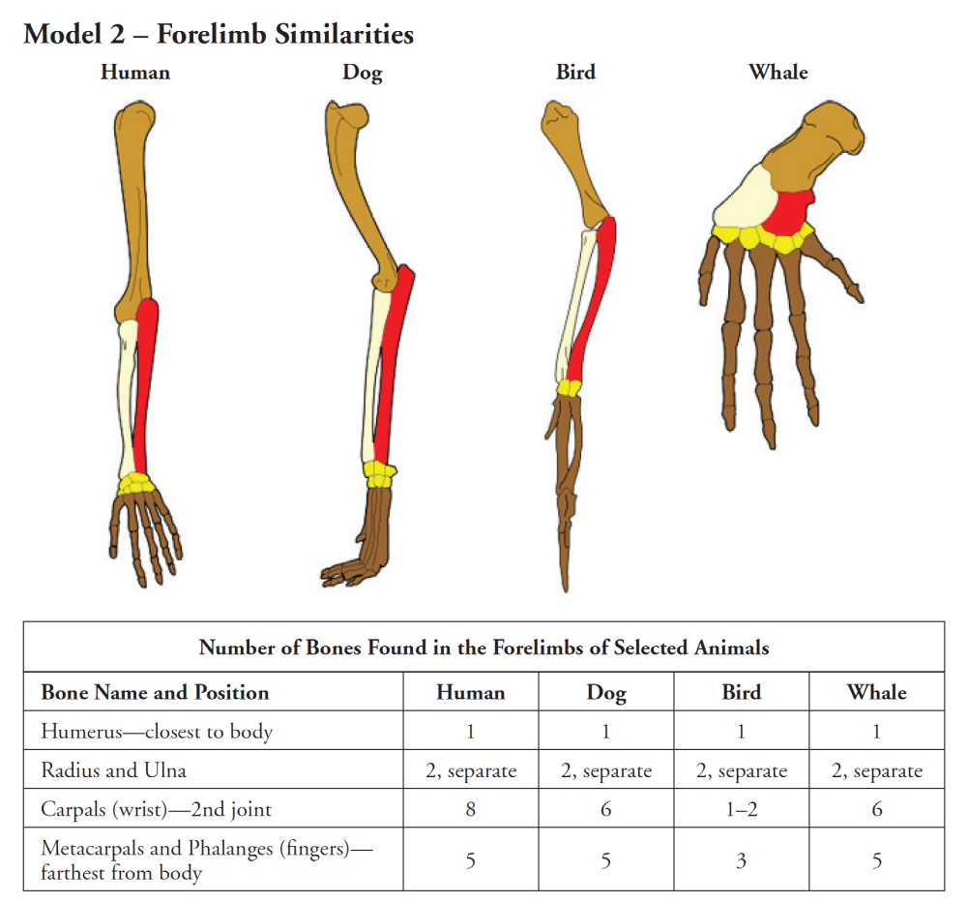

6. Label the bones in each animal forelimb in Model 2.

7. List the variety of ways in which the organisms in the table use their forelimbs.

8. Model 2 shows several homologous structures. These are limbs or body parts that are similar in structure due to shared ancestry, but that may be or may not be similar in function.
a. List two or more similarities in the bone structure of the four animals shown.

b. List three or more differences in the bone structure of the four animals shown.
9. Describe the location of the “blue print” that determines the structure of each of these forelimbs as the organism develops from embryo to infant.

10. What do the similarities among the forelimb bone arrangement of these diverse animals imply about their ancestry?

11. Which two animals in Model 2 would you predict have the most DNA sequences in common? Explain.

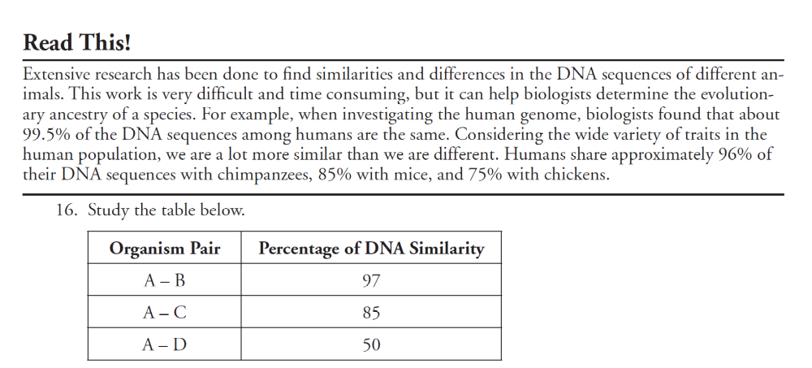

12 a. To which organism, B, C or D, is organism A most closely related? Support your answer.

b. Which pair of organisms in the table is least closely related? Support your answer.

c. Which pair of organisms most likely shares a recent common ancestor? Support your answer.

13. Suppose another organism, organism X, is discovered. Suggest how scientists would use DNA comparison to classify organism X?
REVIEW: Color Variation in Moths

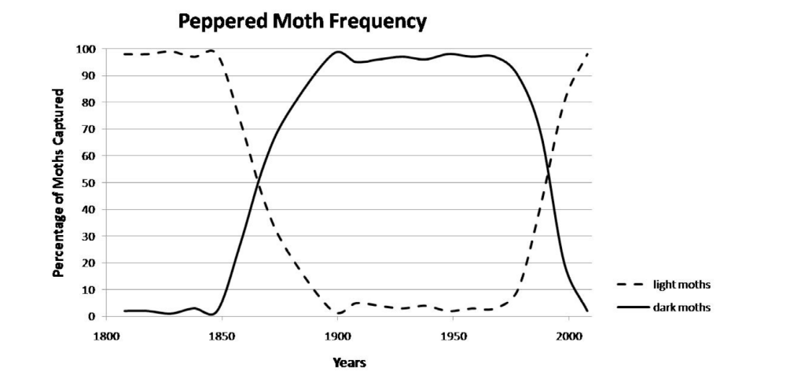

14. Describe the change in the number of light colored moths over the whole time period shown.

15. Describe the change in the number of dark colored moths over the whole time period shown.

16. Describe the change in the numbers of light colored moths and dark colored moths between
1850 and 1900.

17. Describe the change in the numbers of light colored moths and dark colored moths between
1950 and 2000.

18. During the Industrial Revolution and up through the mid-20th century, factories and power
plants which burned coal produced large quantities of soot and smog. Near industrialized areas,
black powder covered surfaces, including the moth habitat.
a. Which color moth would have a better chance of surviving predation on this dark
surface?

b. How does this help explain the change in the colors of the moth population shown in
Model 2?

19. Clear Air Acts were passed by governments of industrialized nations beginning in the mid-
1950s.

20.Use this information to explain why the color of the moth population shifted again.

21. In one or two grammatically correct sentences, summarize how the environment influenced the color of the moth population in this area of Great Britain.

